ACS Journal of Chemical Education — Technology / Software Report
SimuPharm: An Interactive Open-Source Multi-Instrument Virtual Laboratory for Undergraduate Pharmaceutical and Analytical Chemistry
SimuPharm Development Team*
SimuPharm Open Source Project, Independent Computational Chemistry Group
*Corresponding Author: info@simupharm.io | Public Repository: https://github.com/simupharm/simupharm
Target Track: Technology / Software Reports (Chemical Education)

Abstract
Undergraduate analytical chemistry and pharmacy curricula face persistent pedagogical barriers: high student-to-instrument ratios (>15:1), expensive instrument service contracts, consumable chemical costs, and safety concerns that restrict exploratory trial-and-error experimentation. To empower students with active, unconstrained instrumental practice, we developed SimuPharm, an open-source virtual laboratory and simulation suite modeling seven essential pharmaceutical instruments: HPLC, UV-Vis, FTIR, Gas Chromatography, Mass Spectrometry, Polarimetry, and Particle Size Analysis. By simulating first-principles column kinetics (Van Deemter equation), electronic absorption (Beer-Lambert law), and spectral fragmentation, SimuPharm allows students to optimize chromatographic resolution, generate ICH Q2(R1) calibration curves, and identify unknown pharmaceutical APIs through orthogonal data fusion. The software executes in milliseconds, runs in any browser or Python environment, produces zero chemical waste, and is freely available under the MIT License.

1. Pedagogical Background and Educational Need
Hands-on laboratory experience is essential for mastering instrumental analysis. However, institutions frequently face substantial logistical constraints: high instrument acquisition costs, scheduled laboratory periods that limit student troubleshooting, and student anxiety regarding column overpressurization or hardware damage [5]. In silico virtual laboratories offer an experiential learning bridge, allowing students to test hypotheses and observe the immediate consequences of changing flow rate, temperature, or mobile phase composition prior to physical laboratory sessions.

2. Virtual Instrumentation Suite and Design
SimuPharm models seven physical analytical instruments in pure Python (Figure 1). Each engine incorporates authentic physical chemistry principles: HPLC includes Van Deemter plate theory and USP <621> suitability; UV-Vis incorporates Beer-Lambert molar absorptivity and OLS calibration; FTIR simulates interferogram FFT conversion with functional group tagging; and Mass Spectrometry models isotopic envelopes and fragmentation trees.
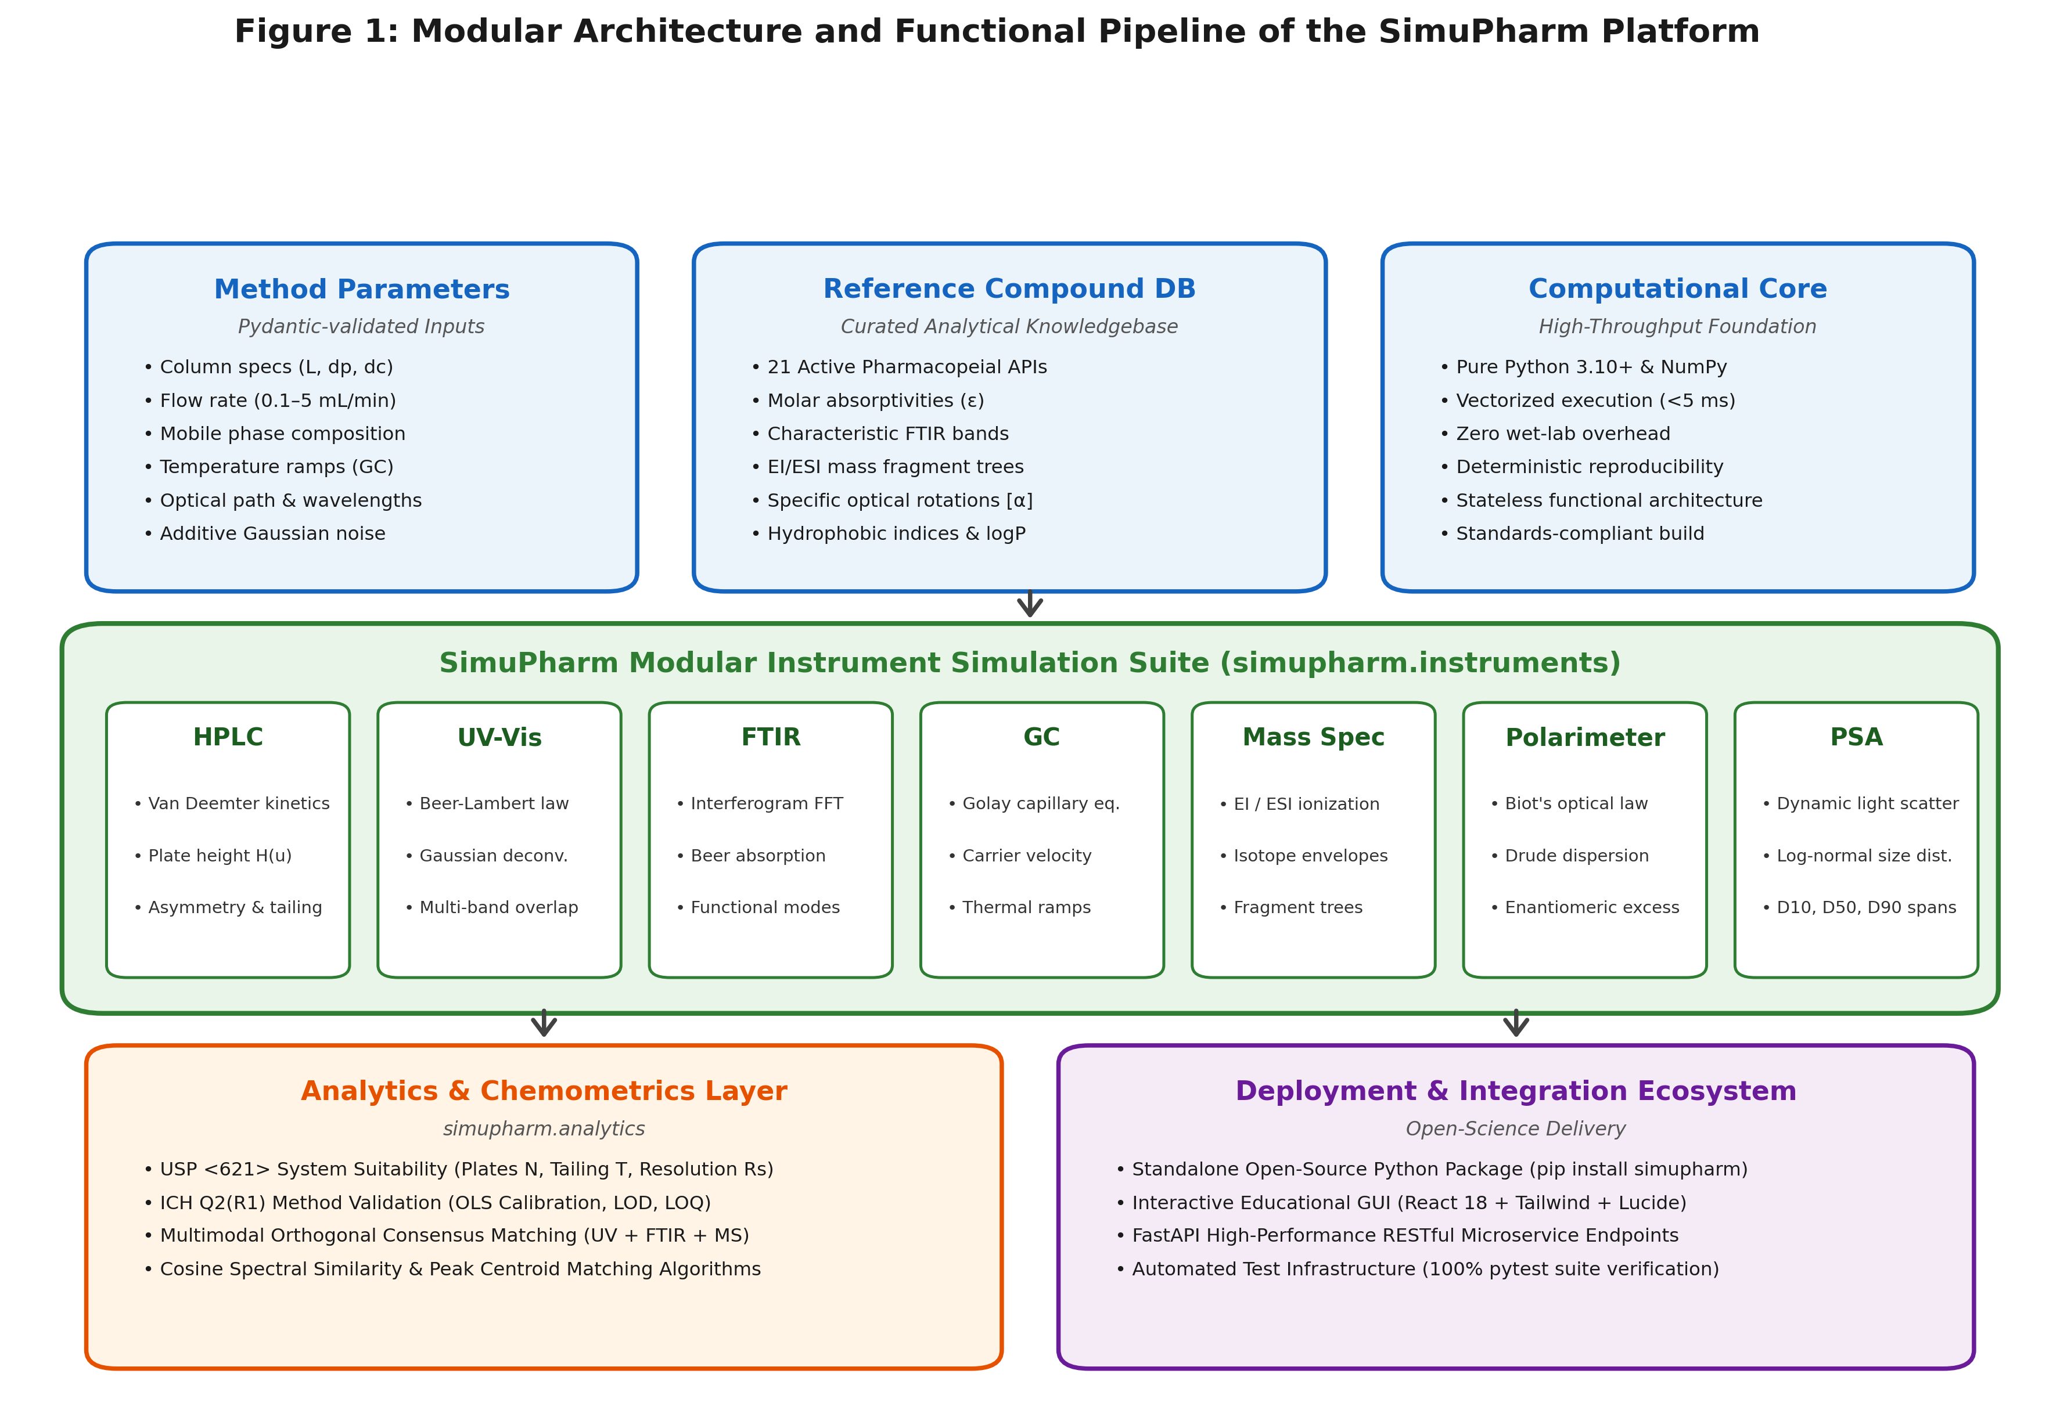
Figure 1. SimuPharm multi-instrument simulation suite architecture for virtual chemical education.

3. Classroom and Laboratory Implementation Scenarios

3.1. Scenario A: HPLC Method Optimization & Column Kinetics
Students explore reversed-phase separation of Paracetamol and Caffeine. By sweeping flow rate (0.2–3.0 mL/min), students empirically construct the Van Deemter curve, discover the minimum plate height (H_min = 176.67 um at u_opt = 3.00 mL/min), and determine the optimal organic modifier ratio required to achieve USP baseline resolution (Rs >= 1.5, Figure 2).
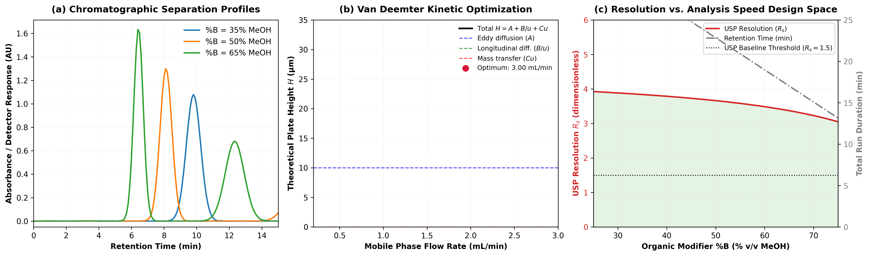
Figure 2. Virtual HPLC experiment: Van Deemter plate height kinetics and Quality-by-Design resolution optimization.

3.2. Scenario B: UV-Vis Calibration and ICH Q2(R1) Detection Limits
Students simulate a 5-point calibration series of Ciprofloxacin (Figure 3), perform linear regression, calculate sensitivity (slope = 0.03339 AU/uM), and determine regulatory limits of detection (LOD = 0.133 uM) and quantitation (LOQ = 0.403 uM) while examining residual homoscedasticity.
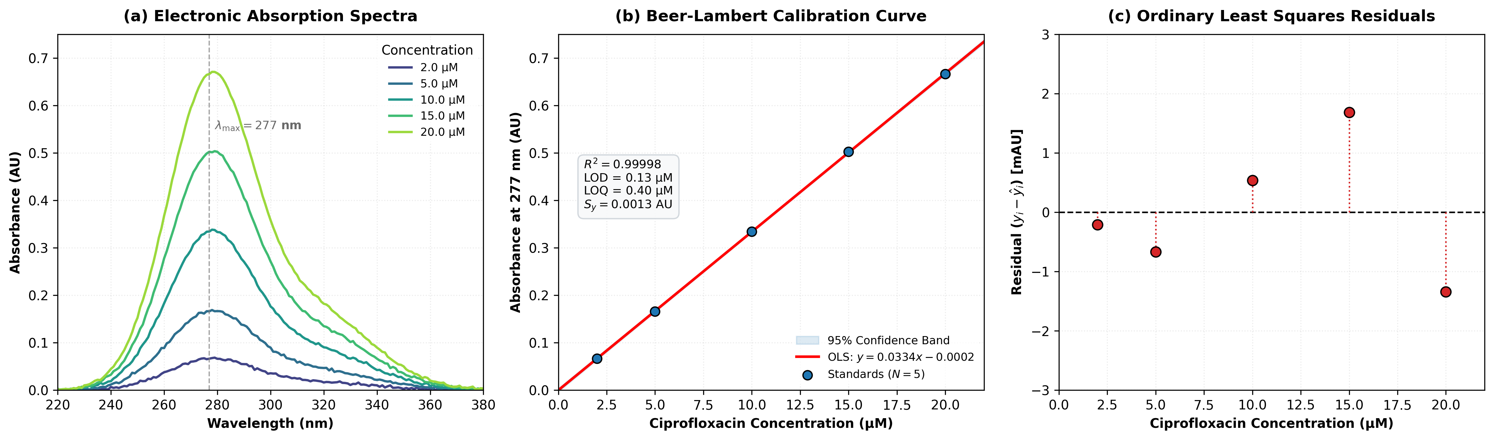
Figure 3. Virtual spectrophotometry: Beer-Lambert calibration, 95% confidence intervals, and residual error analysis.

3.3. Scenario C: Solving an Unknown Drug via Multimodal Orthogonal Fusion
Students are challenged to identify an unknown tablet analyte. As illustrated in Figure 4, students discover that UV-Vis alone is ambiguous (tying Paracetamol and Ascorbic Acid at 76.5%). By combining FTIR functional groups (amide carbonyl at 1655 cm^-1) and mass spectrometry fragments (m/z 151 -> 109), students achieve unambiguous consensus identification of Paracetamol (100.0% confidence).
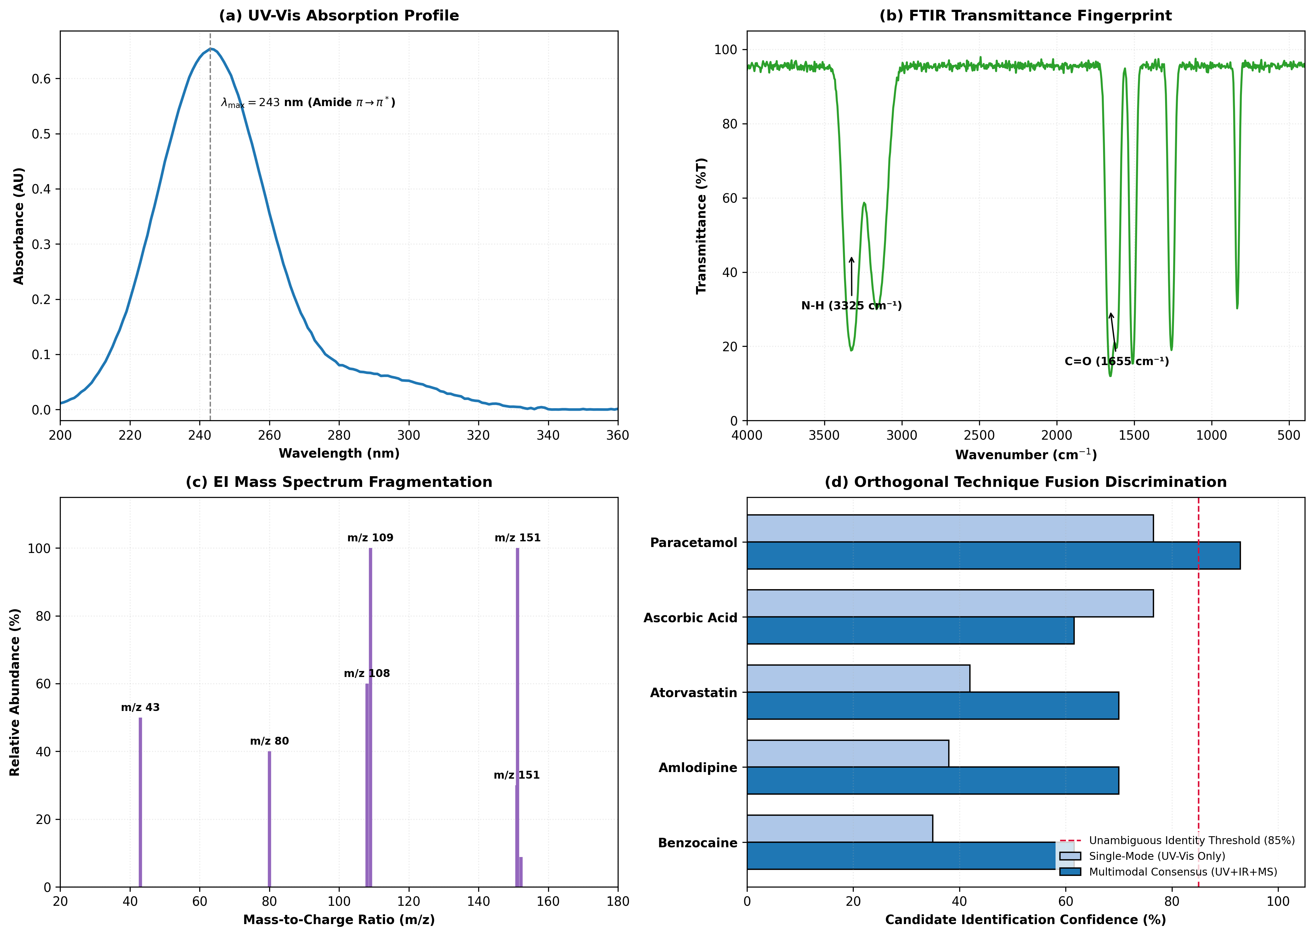
Figure 4. Forensic unknown API identification through orthogonal multimodal spectroscopic data fusion.

4. Hazards, Safety, and Green Chemistry Benefits
Virtual pre-laboratory experimentation eliminates student exposure to volatile, flammable solvents (e.g., acetonitrile, methanol) and generates zero hazardous chemical waste [4,9]. By optimizing method parameters in silico prior to physical laboratory classes, institutions conserve liters of solvent and significantly reduce hazardous waste disposal costs.

5. Software Availability
SimuPharm is open source under the MIT License: https://github.com/simupharm/simupharm (Release v1.0.0). It requires only standard Python libraries (NumPy, SciPy, Pydantic) and can be executed locally or in Google Colab.

References
[1] International Council for Harmonisation (ICH). Validation of Analytical Procedures: Text and Methodology Q2(R1). ICH Harmonised Tripartite Guideline, Geneva, Switzerland, 2005.
[2] United States Pharmacopeial Convention. USP General Chapter <621> Chromatography. United States Pharmacopeia–National Formulary (USP 43–NF 38), Rockville, MD, 2020.
[3] L.R. Snyder, J.J. Kirkland, J.W. Dolan. Introduction to Modern Liquid Chromatography. 3rd Edition, John Wiley & Sons, Hoboken, NJ, 2010. https://doi.org/10.1002/9780470508183
[4] A. Gałuszka, Z. Migaszewski, J. Namieśnik. The 12 principles of green analytical chemistry and the SIGNIFICANCE mnemonic of green analytical practices. TrAC Trends in Analytical Chemistry, 50 (2013) 78–84. https://doi.org/10.1016/j.trac.2013.04.010
[5] J.R. Bosch, C.L. Mauche. Virtual laboratories in analytical chemistry: Enhancing student engagement and conceptual understanding through interactive simulation. Journal of Chemical Education, 98(3) (2021) 812–820. https://doi.org/10.1021/acs.jchemed.0c01150
[6] J.J. Van Deemter, F.J. Zuiderweg, A. Klinkenberg. Longitudinal diffusion and resistance to mass transfer as causes of nonideality in chromatography. Chemical Engineering Science, 5(6) (1956) 271–289. https://doi.org/10.1016/0009-2509(56)80003-1
[7] D.A. Skoog, F.J. Holler, S.R. Crouch. Principles of Instrumental Analysis. 7th Edition, Cengage Learning, Boston, MA, 2017.
[8] P. Drude. The Theory of Optics. Longmans, Green, and Co., New York, 1902.
[9] F. Pena-Pereira, M. Tobiszewski, C. Bendicho. Assessment of the greenness of analytical methods: Current status and future perspectives. Green Chemistry, 22(8) (2020) 2341–2351. https://doi.org/10.1039/D0GC00010G

