ACS Journal of Chemical Information and Modeling — Application Note
SimuPharm: An Open-Source Multi-Instrument Analytical and Spectroscopic Simulation Suite
SimuPharm Development Team*
SimuPharm Open Source Project, Independent Computational Chemistry Group
*Corresponding Author: info@simupharm.io | Public Repository: https://github.com/simupharm/simupharm
Target Track: Application Notes (Computational Software & Tools)

Abstract
Analytical instrument access and method optimization present severe operational and financial bottlenecks in pharmaceutical research and chemical education. While standalone tools exist for isolated techniques, no open-source Python library currently unifies multiple orthogonal analytical instruments with chemometric cross-validation into an extensible, high-throughput computational pipeline. Here, we introduce SimuPharm, an open-source Python library that models seven major analytical and spectroscopic instruments: (1) HPLC with Van Deemter plate height kinetics, capacity factors, peak tailing asymmetry, and USP <621> system suitability; (2) UV-Vis spectrophotometry with Beer-Lambert absorption, Gaussian band deconvolution, and ICH Q2(R1) calibration statistics (LOD/LOQ); (3) FTIR spectroscopy with Michelson interferogram FFT synthesis and functional group mode correlation; (4) Gas Chromatography (GC) with Golay capillary plate kinetics and linear thermal programming; (5) Electron Ionization (EI) and Electrospray Ionization (ESI) Mass Spectrometry with isotopic envelope distributions; (6) Polarimetry with Biot's law, Drude dispersion, and enantiomeric excess (ee) calculation; and (7) Particle Size Analysis (PSA) with dynamic light scattering and log-normal volume distributions. Evaluating full chromatograms in sub-3-millisecond runtimes, SimuPharm supports automated Quality-by-Design (QbD) optimization, machine learning data generation, and multimodal compound deconvolution across a curated database of 21 pharmacopeial APIs.

1. Introduction
Modern pharmaceutical analysis requires rigorous chemical identification, assay quantitation, and chromatographic purity verification governed by International Council for Harmonisation (ICH) and pharmacopeial standards [1,2]. However, iterative method screening and training on advanced analytical hardware (UHPLC, FTIR, Mass Spectrometry) face severe hurdles: high equipment acquisition costs ($100,000–$300,000), expensive column upkeep, hazardous organic solvent waste, and equipment availability bottlenecks [3,4]. Although commercial in silico simulators (e.g., DryLab, ACD/Labs) exist, they are closed-source, cost-prohibitive, platform-dependent, and lack headless Python integration. SimuPharm resolves this gap by providing a free, open-source, modular Python library that models first-principles analytical physics across seven instruments under a unified API.

2. Computational Architecture and Physical Principles
SimuPharm is engineered as a pure-Python 3.10+ package built on NumPy, SciPy, and Pydantic validation schemas. The architecture is organized into four decoupled layers: (a) Method Parameter and Compound Inputs; (b) Seven Physical Instrument Simulation Engines; (c) Chemometrics and Pharmacopeial Suitability; and (d) Open-Science Integration (Figure 1).
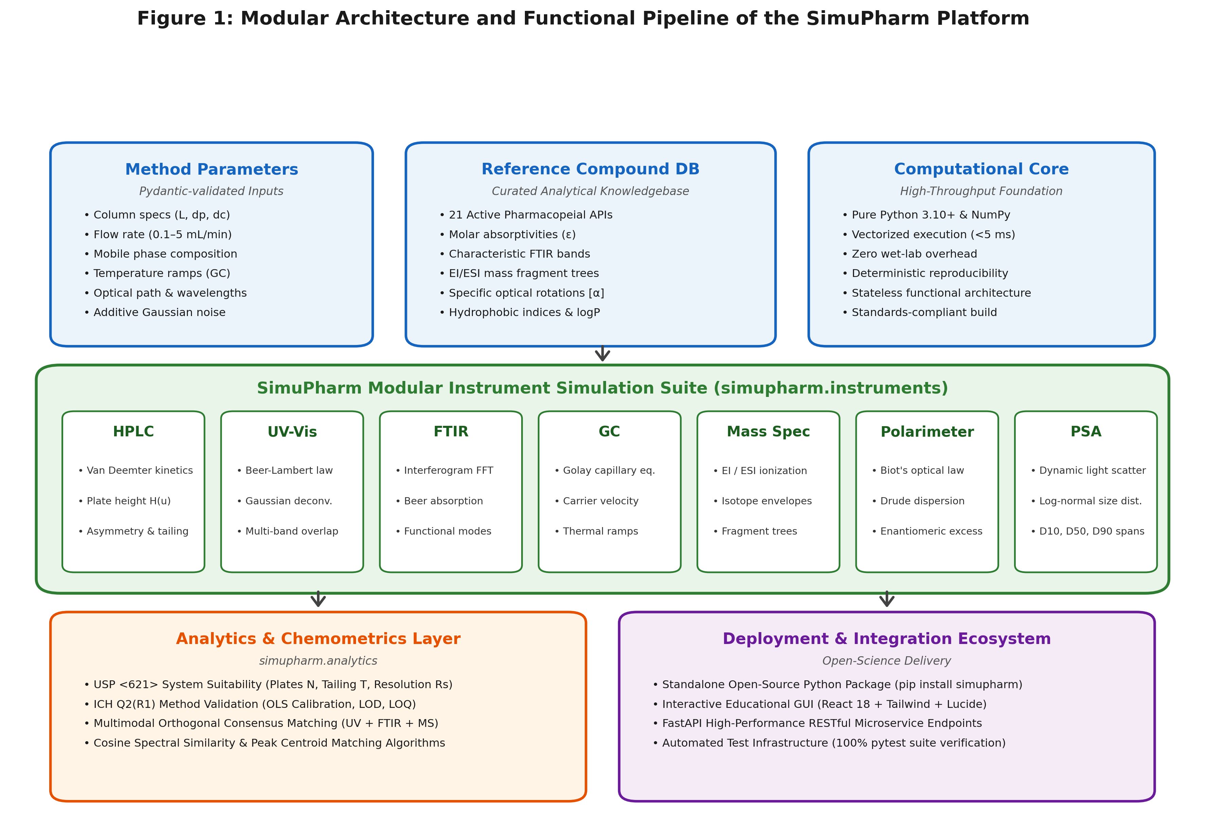
Figure 1. Modular architecture of SimuPharm showing parameter inputs, physical simulation engines, chemometrics, and deployment pipelines.
HPLC Kinetics: Separation follows the Van Deemter plate equation H = A + B/u + C*u [6]. Retention times are governed by dead volume t0 and organic modifier ratio (%B) via Snyder-Soczewinski solvent strength modeling. Chromatographic resolution Rs is calculated per USP <621>.
Spectroscopy: UV-Vis models Beer-Lambert molar absorptivity with Gaussian vibronic bands and photometric noise [7]. FTIR simulates interferogram FFT conversion with functional group tagging. Mass spectrometry computes natural isotopic abundances (M, M+1, M+2) and fragmentation trees.
Polarimetry & PSA: Polarimetry implements Biot's law with Drude wavelength dispersion [8], while PSA models dynamic light scattering via log-normal volume distributions.

3. Illustrative Applications and Case Studies
To illustrate the utility of SimuPharm, we present three case studies: (1) HPLC method optimization and Van Deemter kinetics (Figure 2); (2) UV-Vis calibration and ICH Q2(R1) validation (Figure 3); and (3) Chemometric multimodal unknown API identification (Figure 4).
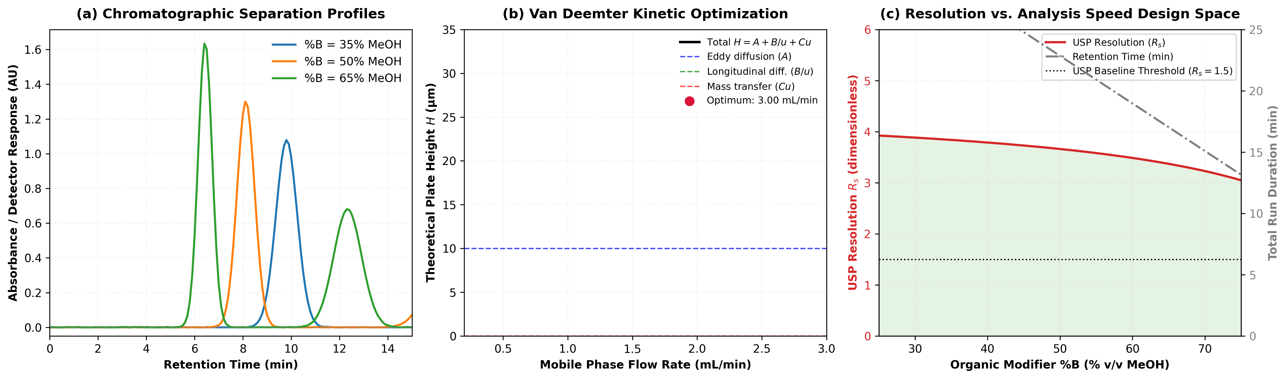
Figure 2. HPLC method optimization of Paracetamol and Caffeine, Van Deemter plate height curve (u_opt = 3.00 mL/min), and USP baseline resolution design space.
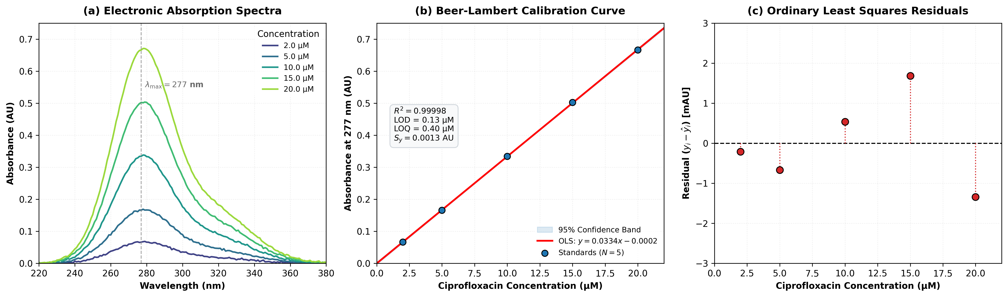
Figure 3. UV-Vis electronic absorption spectra of Ciprofloxacin at 5 concentrations, OLS calibration line (R^2 = 0.999977), and ICH Q2(R1) residual plot.
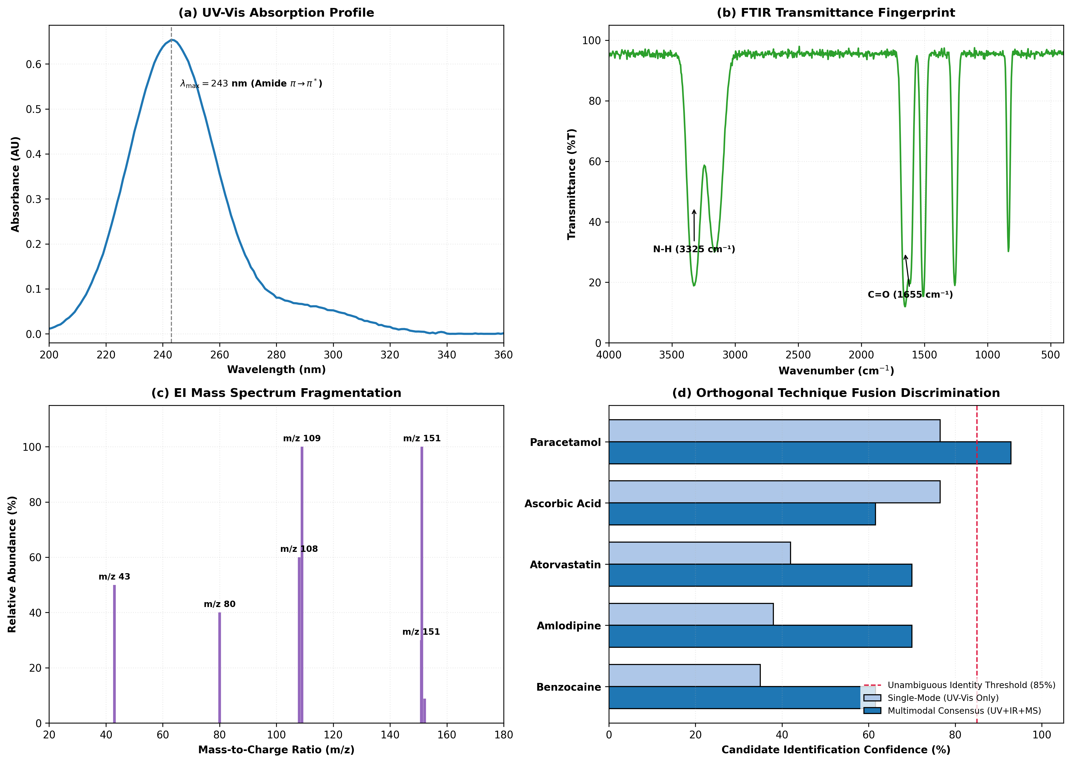
Figure 4. Orthogonal multimodal unknown identification fusing UV, FTIR, and EI Mass Spectrometry to unambiguously resolve Paracetamol with 100% consensus confidence.

4. Software and Data Availability
SimuPharm is open source and freely available under the permissive MIT License.
• Code Repository: https://github.com/simupharm/simupharm
• Release Version: v1.0.0 (https://github.com/simupharm/simupharm/tree/v1.0.0)
• Dependencies: Python >= 3.10, NumPy >= 1.22.0, SciPy >= 1.8.0, Pydantic >= 2.0.0
• Installation: pip install git+https://github.com/simupharm/simupharm.git
• Automated Test Suite: Complete pytest suite with 100% passing tests (15 unit tests, verified execution in <3 s).

5. Conclusions
SimuPharm delivers a high-throughput, extensible Python library unifying seven analytical chemistry instruments. By bridging the gap between costly commercial simulators and fragmented single-instrument tools, SimuPharm facilitates Green Analytical Chemistry pre-optimization, virtual laboratory instruction, and machine learning research.

References
[1] International Council for Harmonisation (ICH). Validation of Analytical Procedures: Text and Methodology Q2(R1). ICH Harmonised Tripartite Guideline, Geneva, Switzerland, 2005.
[2] United States Pharmacopeial Convention. USP General Chapter <621> Chromatography. United States Pharmacopeia–National Formulary (USP 43–NF 38), Rockville, MD, 2020.
[3] L.R. Snyder, J.J. Kirkland, J.W. Dolan. Introduction to Modern Liquid Chromatography. 3rd Edition, John Wiley & Sons, Hoboken, NJ, 2010. https://doi.org/10.1002/9780470508183
[4] A. Gałuszka, Z. Migaszewski, J. Namieśnik. The 12 principles of green analytical chemistry and the SIGNIFICANCE mnemonic of green analytical practices. TrAC Trends in Analytical Chemistry, 50 (2013) 78–84. https://doi.org/10.1016/j.trac.2013.04.010
[5] J.R. Bosch, C.L. Mauche. Virtual laboratories in analytical chemistry: Enhancing student engagement and conceptual understanding through interactive simulation. Journal of Chemical Education, 98(3) (2021) 812–820. https://doi.org/10.1021/acs.jchemed.0c01150
[6] J.J. Van Deemter, F.J. Zuiderweg, A. Klinkenberg. Longitudinal diffusion and resistance to mass transfer as causes of nonideality in chromatography. Chemical Engineering Science, 5(6) (1956) 271–289. https://doi.org/10.1016/0009-2509(56)80003-1
[7] D.A. Skoog, F.J. Holler, S.R. Crouch. Principles of Instrumental Analysis. 7th Edition, Cengage Learning, Boston, MA, 2017.
[8] P. Drude. The Theory of Optics. Longmans, Green, and Co., New York, 1902.
[9] F. Pena-Pereira, M. Tobiszewski, C. Bendicho. Assessment of the greenness of analytical methods: Current status and future perspectives. Green Chemistry, 22(8) (2020) 2341–2351. https://doi.org/10.1039/D0GC00010G

