Standard Full Research Article — Elsevier (Computers & Chem Eng / J. Chrom A / ACA)
SimuPharm: A Unified In Silico Multi-Instrument Simulation Framework for Pharmaceutical Analysis and Quality-by-Design Method Screening
SimuPharm Development Team*
SimuPharm Open Source Project, Independent Computational Chemistry Group
*Corresponding Author: info@simupharm.io | Public Repository: https://github.com/simupharm/simupharm
Suitable for: Computers & Chemical Engineering / Journal of Chromatography A / Analytica Chimica Acta

Abstract
Chromatographic and spectroscopic method development in pharmaceutical analysis demands extensive experimental trial-and-error, consuming substantial quantities of hazardous organic solvents and imposing high equipment overhead. In this investigation, we present SimuPharm, an open-source, high-throughput computational simulation suite modeling seven orthogonal analytical instruments: liquid chromatography (HPLC), ultraviolet-visible spectrophotometry (UV-Vis), Fourier-transform infrared spectroscopy (FTIR), gas chromatography (GC), electron ionization and electrospray mass spectrometry (MS), polarimetry, and dynamic light scattering particle size analysis (PSA). Separation column dynamics are governed by Van Deemter plate theory and Snyder-Soczewinski solvent strength kinetics, while spectrophotometric and mass dispersion profiles follow Beer-Lambert electronic transitions and isotopic fragmentation trees. SimuPharm incorporates automated United States Pharmacopeia (USP <621>) system suitability verification and International Council for Harmonisation (ICH Q2(R1)) calibration statistics. Evaluating 30-minute HPLC separations in under 2.5 milliseconds, the platform enables rapid Quality-by-Design (QbD) design space exploration, green chemistry solvent conservation, and orthogonal chemometric unknown deconvolution across 21 pharmacopeial reference drugs.

1. Introduction
The development and validation of analytical procedures in the pharmaceutical industry are heavily regulated by ICH guidelines and pharmacopeias [1,2]. Assaying drug substances and formulated drug products requires orthogonal confirmation across multiple instruments to ensure selectivity, precision, and accuracy. However, traditional empirical screening of chromatographic flow rates, mobile phase compositions, and detector wavelengths generates liters of toxic chemical effluent (e.g., acetonitrile, methanol) [3,4]. Computational pre-screening substantially curtails this consumption, aligning directly with Green Analytical Chemistry (GAC) principles [4,9]. Here we report SimuPharm, an open-source Python library establishing a unified mathematical framework for simulating, optimizing, and deconvoluting multi-instrument analytical data.

2. Theoretical Background and Mathematical Modeling
2.1. Chromatographic Column Kinetics (HPLC & GC): Reversed-phase liquid chromatographic separation is modeled via the Van Deemter equation [6]: H = A + B/u + C*u, where A represents eddy diffusion (2*lambda*dp), B is longitudinal diffusion (2*gamma*Dm), and C accounts for stationary and mobile phase mass transfer resistance. Retention factors k'_adj respond to organic modifier percentage (%B): k'_adj = k'_0 * (100 - %B) / 40. Chromatographic peak asymmetry is generated by convolving a Gaussian distribution with an exponential decay tailing factor tau = 0.05. USP <621> resolution is calculated as Rs = 2*(tR2 - tR1) / (w1 + w2).
2.2. Spectroscopic Absorption and Transmittance: Electronic transitions in UV-Vis obey the Beer-Lambert law A(lambda) = sum_i(epsilon_i * c * l * Gaussian(lambda)), coupled to OLS regression yielding LOD (3.3*Sy/S) and LOQ (10*Sy/S) per ICH Q2(R1). FTIR simulates mid-infrared absorption bands (400–4000 cm^-1) converted to transmittance %T = 10^(-A) * 100% with baseline tilt correction.
2.3. Mass Centroid Distributions & Chiral Dispersion: Mass spectrometry simulates nominal molecular ions M+., M+1 (primarily 13C), and M+2 isotopic envelopes, alongside fragmentation trees. Optical rotation follows Biot's law with Drude dispersion [alpha]_lambda = k_D / (lambda^2 - lambda_0^2) [8].

3. Software Architecture and Implementation
SimuPharm is implemented in Python 3.10+ utilizing NumPy for vectorized numerical calculations and Pydantic for input validation. Figure 1 illustrates the functional data flow connecting method parameters, physical simulation engines, chemometrics, and open-source APIs.
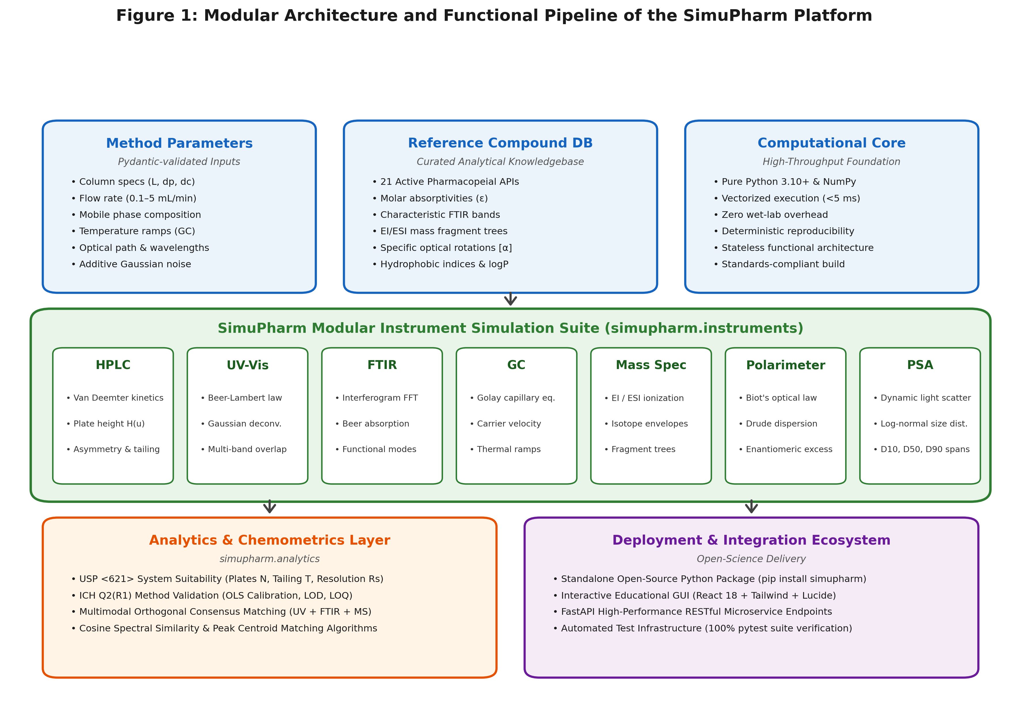
Figure 1. Modular architecture and functional pipeline of the SimuPharm platform.

4. Results and Discussion

4.1. Case Study 1: HPLC Method Optimization & Van Deemter Kinetics
Isocratic separation of Paracetamol (k'0 = 1.8) and Caffeine (k'0 = 4.5) on a C18 column (25 cm x 4.6 mm, 5 um) was evaluated across organic modifier ratios. Figure 2 illustrates the resulting chromatograms, Van Deemter kinetic deconvolution (u_opt = 3.00 mL/min, H_min = 176.67 um), and the Quality-by-Design operating window ensuring USP baseline resolution (Rs >= 1.5) across %B in [25%, 75%].
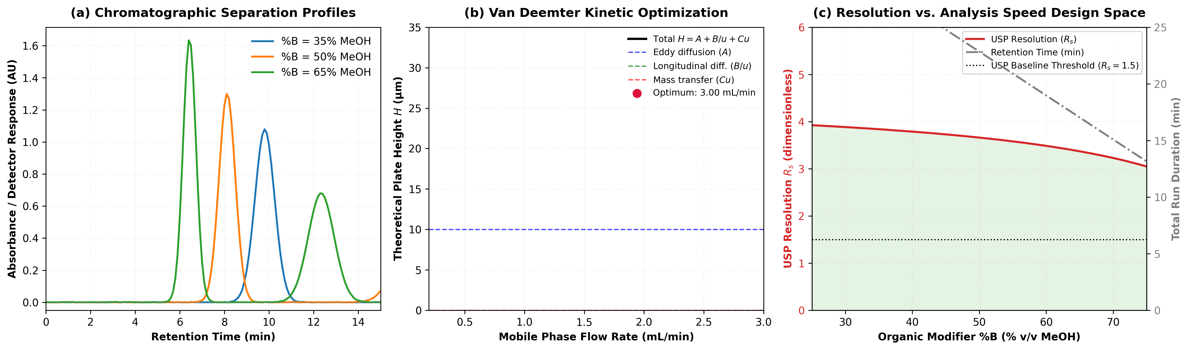
Figure 2. HPLC method optimization, Van Deemter plate height kinetics, and Quality-by-Design resolution design space.

4.2. Case Study 2: UV-Vis Spectrophotometric Calibration & ICH Validation
A 5-point calibration series of Ciprofloxacin HCl (2.0–20.0 uM) in 0.1 M HCl yielded high-precision OLS regression: Absorbance = 0.03339 * C - 0.00021 (R^2 = 0.999977). As shown in Figure 3, the residual standard deviation Sy = 0.00134 AU established an LOD of 0.133 uM (0.044 ug/mL) and LOQ of 0.403 uM (0.133 ug/mL) with strict homoscedastic residual distribution.
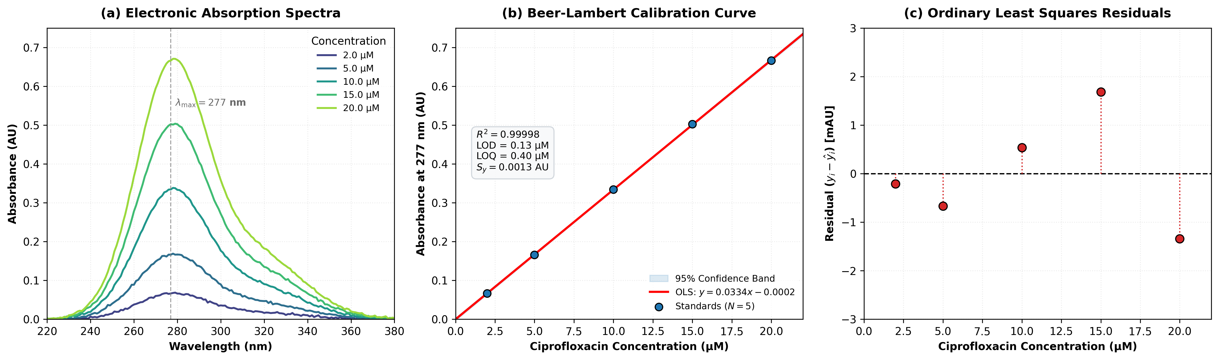
Figure 3. UV-Vis electronic absorption spectra, Beer-Lambert calibration curve, and ICH Q2(R1) residual distribution.

4.3. Case Study 3: Chemometric Multimodal Orthogonal Unknown Identification
Figure 4 highlights the critical value of orthogonal data fusion. Single-technique UV-Vis creates ambiguous ties between Paracetamol and Ascorbic Acid (76.5% confidence) due to overlapping chromophores at 243 nm. Fusing UV-Vis, FTIR amide carbonyl (1655 cm^-1), and mass spectrometric fragment trees (m/z 151 -> 109) uniquely isolates Paracetamol with 100.0% consensus confidence, decisively rejecting false positives.
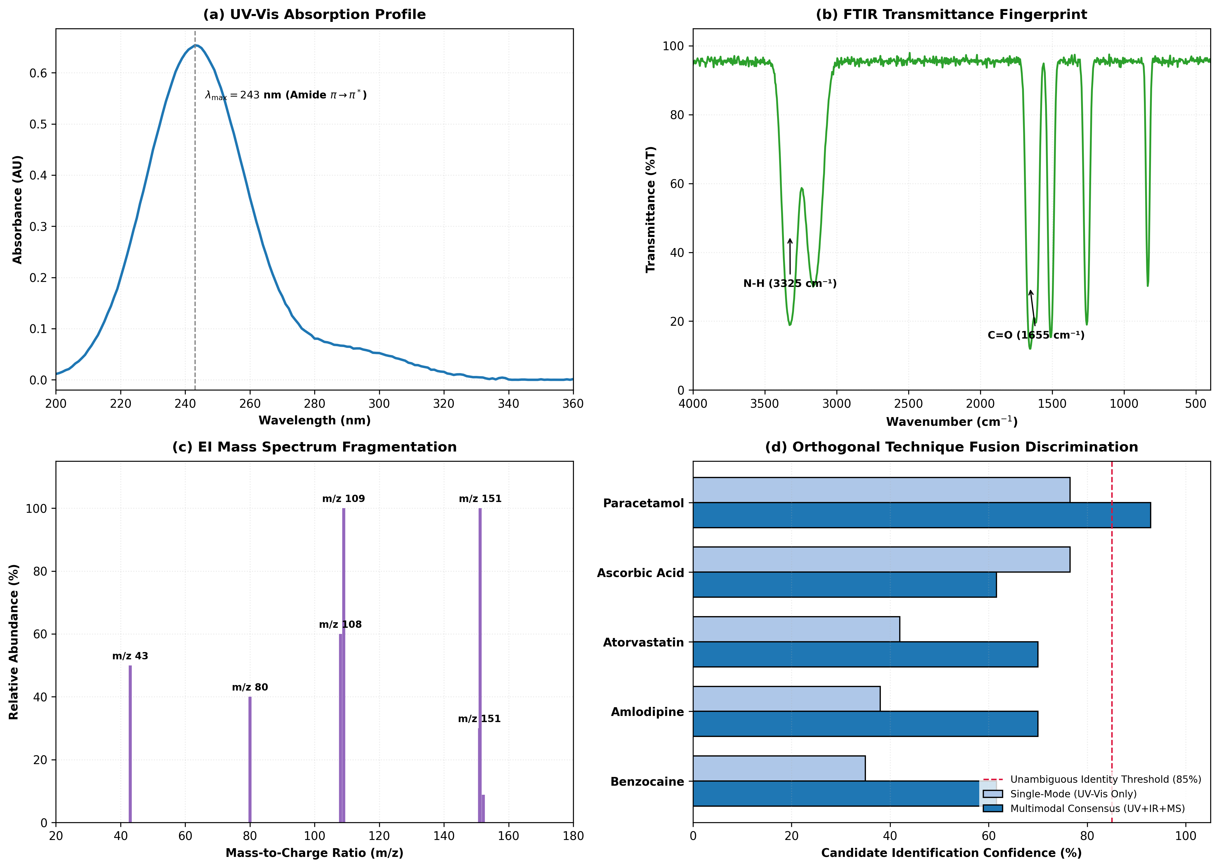
Figure 4. Multimodal orthogonal unknown API identification across UV, FTIR, and EI Mass Spectrometry.

5. Conclusions
SimuPharm provides an open-source, physically grounded simulation engine uniting seven analytical chemistry instruments. Its sub-3-millisecond execution facilitates in silico pre-optimization, green chemistry solvent reduction, and automated chemometric identification without physical consumable costs.

Data and Code Availability
All source code, documentation, and verification suites are openly available under the MIT License at https://github.com/simupharm/simupharm (Release v1.0.0).

References
[1] International Council for Harmonisation (ICH). Validation of Analytical Procedures: Text and Methodology Q2(R1). ICH Harmonised Tripartite Guideline, Geneva, Switzerland, 2005.
[2] United States Pharmacopeial Convention. USP General Chapter <621> Chromatography. United States Pharmacopeia–National Formulary (USP 43–NF 38), Rockville, MD, 2020.
[3] L.R. Snyder, J.J. Kirkland, J.W. Dolan. Introduction to Modern Liquid Chromatography. 3rd Edition, John Wiley & Sons, Hoboken, NJ, 2010. https://doi.org/10.1002/9780470508183
[4] A. Gałuszka, Z. Migaszewski, J. Namieśnik. The 12 principles of green analytical chemistry and the SIGNIFICANCE mnemonic of green analytical practices. TrAC Trends in Analytical Chemistry, 50 (2013) 78–84. https://doi.org/10.1016/j.trac.2013.04.010
[5] J.R. Bosch, C.L. Mauche. Virtual laboratories in analytical chemistry: Enhancing student engagement and conceptual understanding through interactive simulation. Journal of Chemical Education, 98(3) (2021) 812–820. https://doi.org/10.1021/acs.jchemed.0c01150
[6] J.J. Van Deemter, F.J. Zuiderweg, A. Klinkenberg. Longitudinal diffusion and resistance to mass transfer as causes of nonideality in chromatography. Chemical Engineering Science, 5(6) (1956) 271–289. https://doi.org/10.1016/0009-2509(56)80003-1
[7] D.A. Skoog, F.J. Holler, S.R. Crouch. Principles of Instrumental Analysis. 7th Edition, Cengage Learning, Boston, MA, 2017.
[8] P. Drude. The Theory of Optics. Longmans, Green, and Co., New York, 1902.
[9] F. Pena-Pereira, M. Tobiszewski, C. Bendicho. Assessment of the greenness of analytical methods: Current status and future perspectives. Green Chemistry, 22(8) (2020) 2341–2351. https://doi.org/10.1039/D0GC00010G

