Environment:
Humble ROS2 – Ubuntu 22.04

Command:
Window1
ros2 run rqt_robot_steering rqt_robot_steering

Window2
ros2 run turtlesim turtlesim_node

Result:

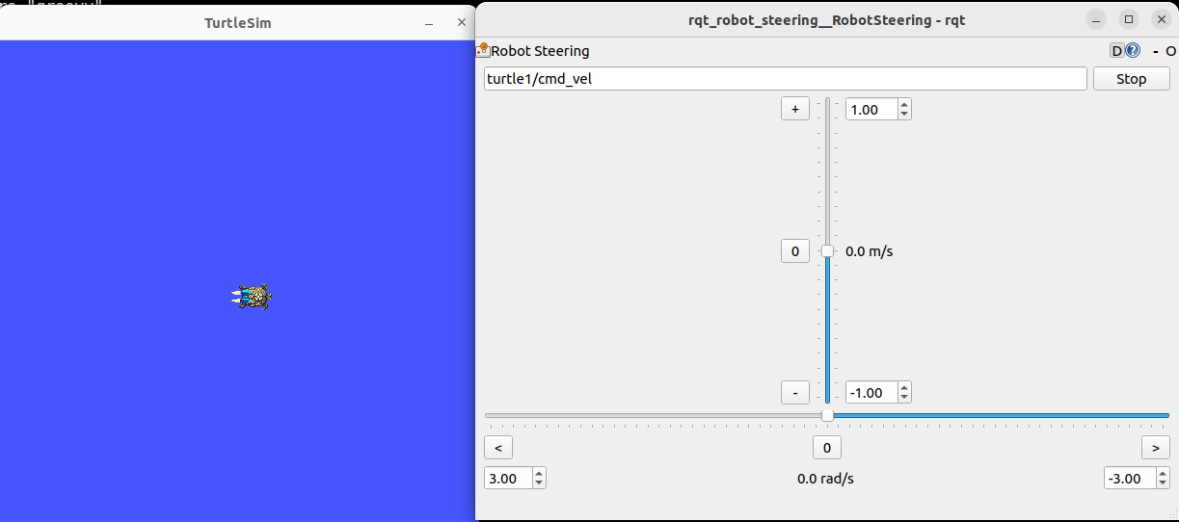
Movement:
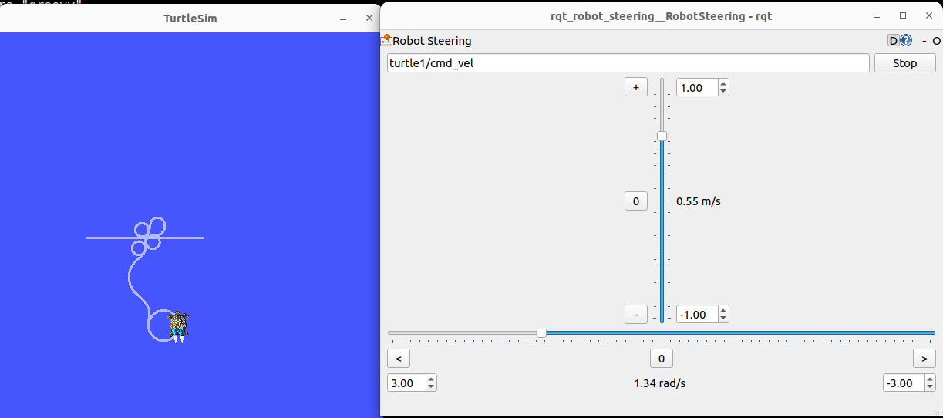
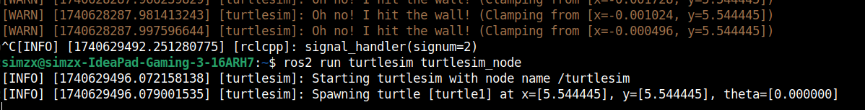

Beginner tutorial 1:
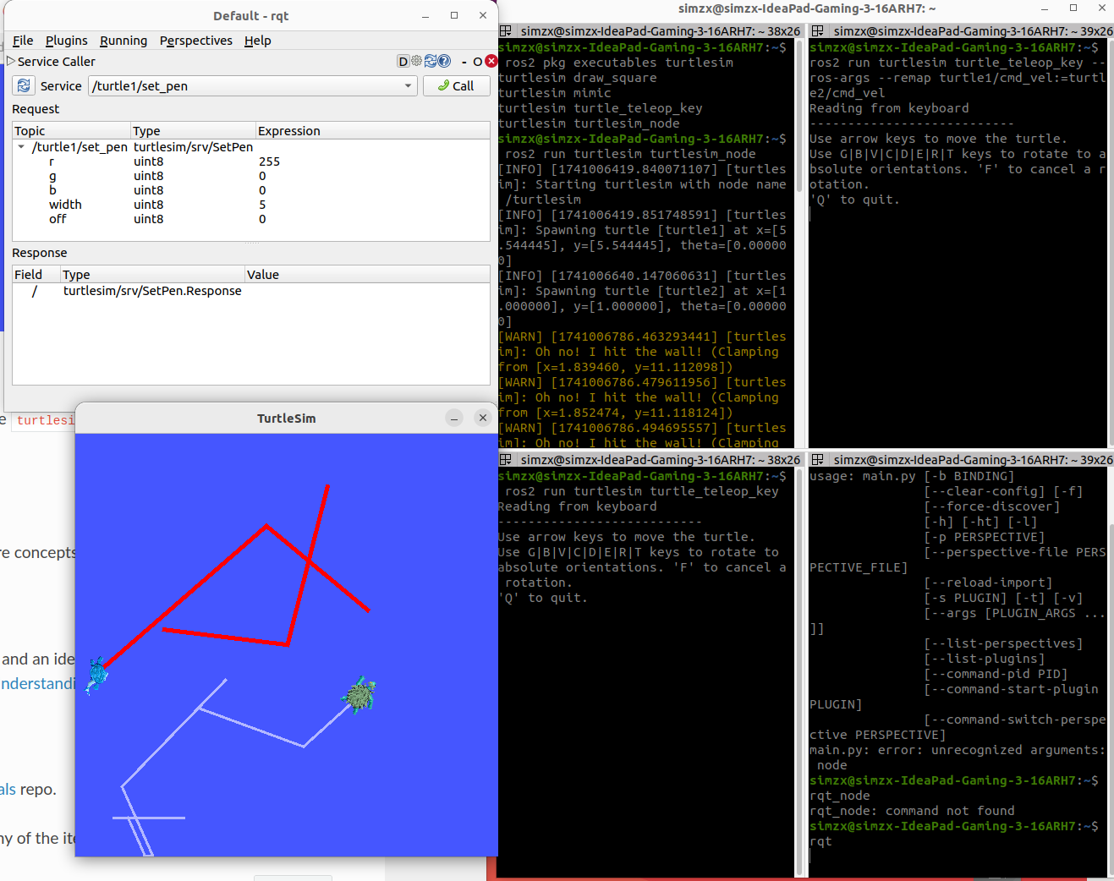
Beginner tutorial 2:

