**Serverless-web-app-on-AWS**

**Steps to build the Project:**

**Step 1: S3 Bucket**

1. **Login into your AWS account using Login Id and Password.**

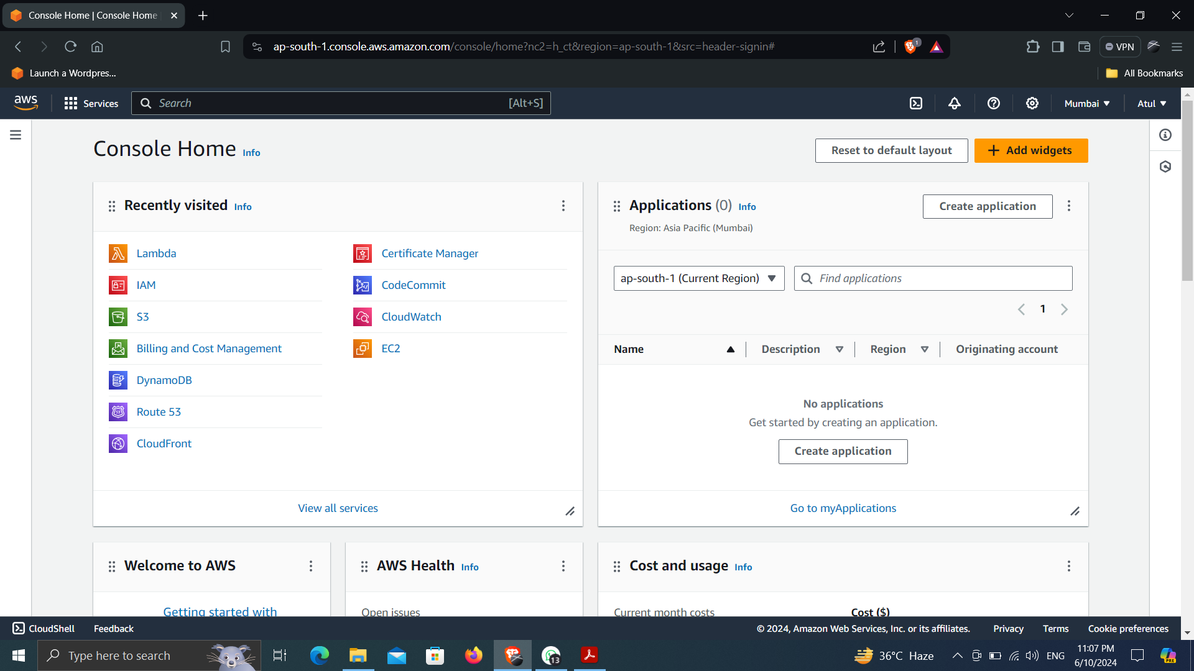

1. **Search for S3 Bucket**
2. **Create S3 bucket. Give a name to the bucket as “serverless-bucket-web-application” and set the region as “ap-south-1”**
3. **Click Create Bucket.**

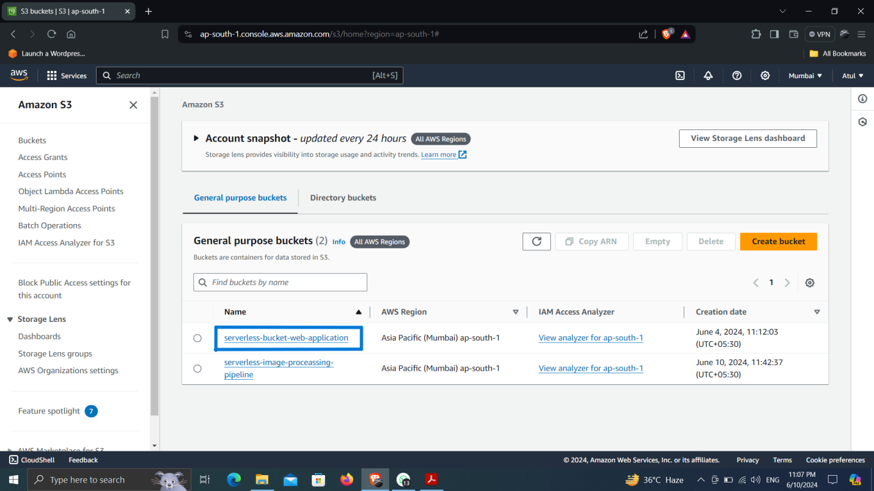

1. **Open the bucket, then click on upload and then upload the html,css & js file to the bucket.**

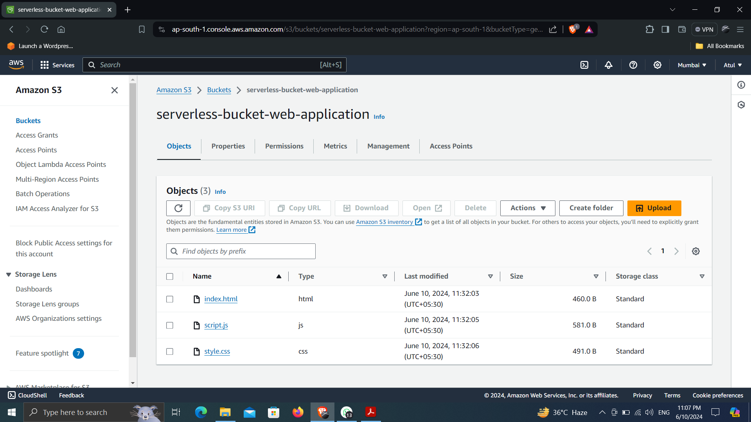

**Step 2: Create Amazon CloudFront**

1. **Search for CloudFront in search bar in aws console.**
2. **Click Create CloudFront Distribution. Select Origin domain as “serverless-bucket-web-application.s3.amazonaws.com”.**
3. **Give name to the distribution as “serverless-bucket-web-application.s3.ap-south-1.amazonaws.com”**
4. **Change Origin Access to Origin access control settings which is recommended.**
5. **Click create control setting. Give a name to setting as “serverless-bucket-web-application.s3.ap-south-1.amazonaws.com-1” and keep Origin Type as S3 and then create.**
6. **Then click on create distribution. It will take some time to deploy the distribution.**

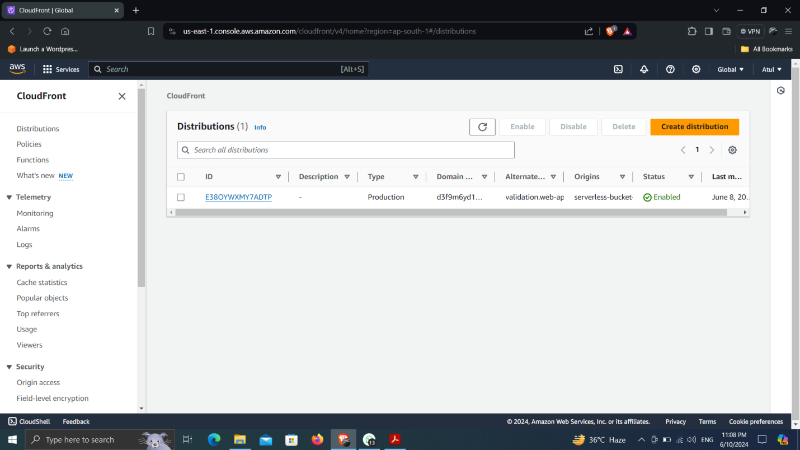

1. **Open the distribution. Then go to Origins then open the origin by selection the origin and then click edit. Then scroll down then click on Copy policy in blue box.**
2. **Then navigate to s3 bucket then open created bucket. Go to permissions tab, scroll down then you see the Bucket Policy box, select that and then click on edit and paste the copied policy and then save the changes.**
3. **Then come back to the cloudfront scroll down you see the settings, click on edit, then scroll down “Default root object - optional”, set it to “index.html” which is your html file name and which is the main entry point for your web application. Then save changes.**

**Step 3: Create Route 53**

1. **Get a domain name, you can have free domain name from various domain providers like(freenom), i have taken name from wordpress.**
2. **In aws console search for Route 53, click on create hosted zone. Give name to the zone which is your domain name you get for free or you buy. Named as “web-app.net.in” then create.**
3. **Then you will get two records in hosted zone, one record have four nameserver named as “value/route traffic to”, copy them and edit in your domain from where you buy domain name.**

