INTERACTIVE FRACTAL PATTERN GENERATOR

Name: Sinchana K

Problem Statement

This project aims to develop a system that generates complex fractal patterns using iterative linear transformations. The system allows user-defined parameters and visualizes how fractal patterns evolve over iterations. It also compares how variations in transformation parameters affect the generated patterns.

Input Description

The system takes the following inputs:
  - Transformation Matrix (A): Defines how points are transformed
  - Translation Vector (b): Adds shift to transformation
  - Number of Iterations (N): Controls complexity of fractal

Example input:
A = [[0.85, 0.04], [-0.04, 0.85]]
b = [0, 1.6]
N = 10000

References: https://numpy.org/doc/ https://matplotlib.org/
https://en.wikipedia.org/wiki/Fractal

Approach / Methodology

Step 1: Matrix Representation
The transformation is represented using a matrix AAA and a vector bbb. Concept Used: Matrices as Linear Transformations
Purpose: To mathematically represent geometric transformations such as rotation, scaling, and translation
Outcome: A system that transforms points in 2D space

Step 2: Iterative Transformation

The transformation is applied repeatedly using the equation:
xn+1=Axn+bx_{n+1} = A x_n + bxn+1 =Axn +b Concept Used: Matrix Multiplication and Iteration
Purpose: To generate complex patterns from repeated application of a simple transformation
Outcome: Formation of fractal structures

Step 3: Point Generation and Storage
Each transformed point is stored during iteration. Concept Used: Vector Representation
Purpose: To maintain all generated points for visualization Outcome: A dataset representing the fractal pattern

Step 4: Visualization
The stored points are plotted using a graph. Concept Used: Coordinate Geometry
Purpose: To visually interpret the generated fractal pattern Outcome: A graphical representation of the fractal

Step 5: Iteration Snapshots
Snapshots of the fractal are taken at different iteration levels. Concept Used: Progressive Approximation
Purpose: To observe how the fractal evolves over time Outcome: Visual understanding of pattern formation

Step 6: Parameter Variation
The transformation matrix is modified and the fractal is regenerated. Concept Used: Linear Transformation Variation
Purpose: To analyze how changes in transformation parameters affect the output Outcome: Comparison of different fractal patterns

Step 7: Eigenvalue Analysis
Eigenvalues of the transformation matrix are computed. Concept Used: Eigenvalues and Eigenvectors
Purpose: To understand scaling and rotational behavior of the transformation Outcome: Mathematical interpretation of fractal structure

Implementation Details
The project is implemented using Python programming language.

Tools and Libraries Used:

  - NumPy: Used for matrix operations and numerical computations
  - Matplotlib: Used for plotting and visualizing fractal patterns Code Structure:
The implementation is divided into separate modules:

  - Fractal Generation: Generates the main fractal pattern using iterative transformations
  - Iteration Snapshots: Captures fractal progression at different iteration levels
  - Parameter Comparison: Generates fractals with different transformation matrices and compares them
  - Eigenvalue Analysis: Computes eigenvalues of the transformation matrix Execution:
Each module is implemented as an independent Python script. The scripts generate output images and numerical results which are stored in a results folder.

Results
EXPECTED RESULTS:
The system is expected to generate visually complex fractal patterns. As the number of iterations increases, the fractal should become more detailed and structured.
Changing the transformation parameters should produce different fractal shapes, demonstrating sensitivity to input values.

ATTAINED RESULTS:

Generated fractal image:

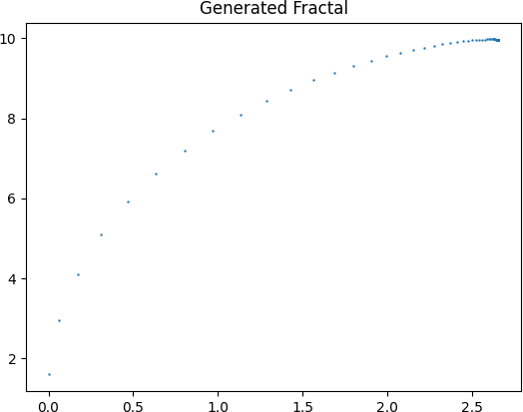

The generated fractal shows a complex structure formed through repeated transformations. The pattern becomes dense and detailed as iterations increase.

Iteration Progression Output:
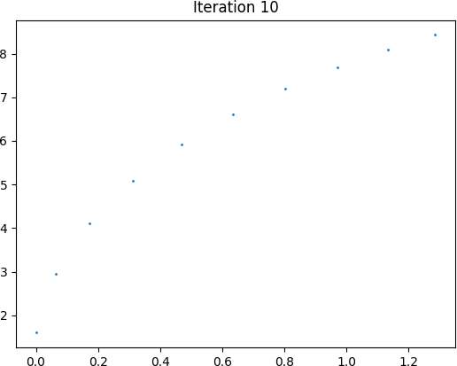

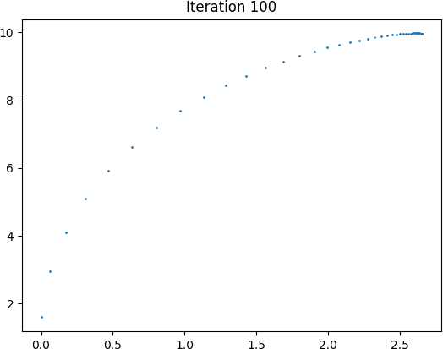

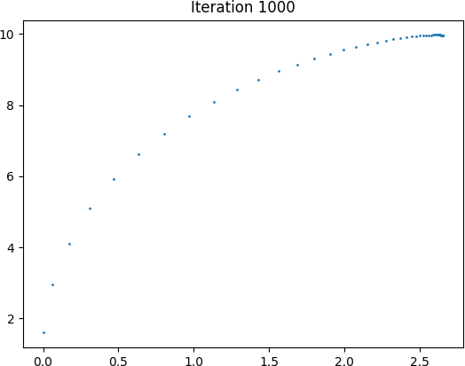

- At iteration 10, only a few points are visible
- At iteration 100, the structure begins to form
- At iteration 1000, the fractal becomes more detailed This demonstrates how complexity emerges through iteration.

Parameter Variation Comparison:
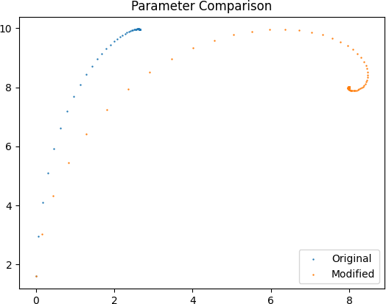

Changing the transformation matrix results in a different fractal pattern. This shows that small variations in parameters significantly affect the output.

Eigen Value Analysis:
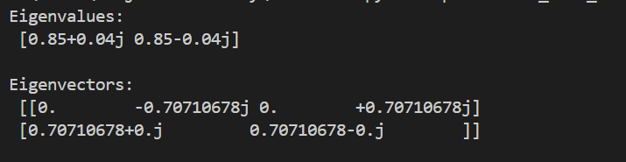
Computed Eigenvalues:
The eigenvalues indicate how the transformation affects scaling and rotation. Complex eigenvalues introduce rotational behaviour, which contributes to the formation of fractal patterns.

Deliverables:
The following deliverables were generated:
- Fractal image
- Iteration snapshots
- Parameter comparison

Conclusion
This project demonstrates how linear algebra concepts such as matrices, iterative transformations, and eigenvalues can be used to generate complex fractal patterns. The results show that simple mathematical rules can produce highly detailed and visually appealing structures. The project also highlights how parameter variations influence the final output.

