Software Requirements Specification (SRS)
Enterprise Conference Room Booking System
Project: Enterprise Conference Room Booking System (CRB)
Version: 0.1 (Draft for team review)
Authors: SINCHANA K PES1UG24AM405
DIRAN SOMANNA PES1UG24AM364
DISHANTH GOWDA H D PES1UG24AM365
PAVAN D C PES1UG24AM383
Team : Team 15
Date: 11-09-2026
Status: Draft - for internal team discussion before Sept 21 submission

Revision History
Version | Date | Author | Change Summary
0.1 | 11-09-2026 | SINCHANA K  DIRAN SOMANNA DISHANTH GOWDA  PAVAN D C | Initial draft generated from template for team discussion / scope selection

Approvals
Role | Name | Signature / Email | Date
Course Coordinator

Table of Contents
- 1. Introduction
- 2. Overall Description
- 3. External Interface Requirements
- 4. System Features (Detailed)
- 5. Non-Functional Requirements (Detailed)
- 5.1 Security
- 6. Quality Attributes & Acceptance Tests
- 7. UML Use-Case Diagrams
- 8. Requirements Traceability Matrix (RTM)

1. Introduction

1.1 Purpose
This document specifies the functional and non-functional requirements for the Enterprise Conference Room Booking System (CRB), a web-based application that allows employees across one or more corporate office locations to search, reserve, modify, and cancel conference rooms, and allows facilities administrators to manage room inventory. It is intended for use by developers, QA engineers, and evaluators as the authoritative reference for what the system must do.

1.2 Scope
The CRB system covers: employee-facing room search and booking, recurring bookings, booking modification/cancellation, admin-facing room and equipment inventory management, automated email notifications, and basic utilization reporting. It integrates with corporate identity (SSO) for authentication. Out of scope for v1: physical access control / door locks, catering or facilities ticketing systems, and cross-organization (external partner) room sharing.

1.3 Audience
Developers, QA Engineers, Facilities Administrators, IT Security reviewers, and course evaluators.

1.4 Definitions
- CRB - Conference Room Booking (system short name)
- RBAC - Role-Based Access Control
- SSO - Single Sign-On
- SLA - Service Level Agreement
- PII - Personally Identifiable Information
- RTM - Requirements Traceability Matrix
- TTL - Time To Live (used for booking hold expiry)

2. Overall Description

2.1 Product Perspective
The CRB system is a browser-accessible web application backed by a central booking service and a relational database of rooms, bookings, and users. It authenticates against the corporate identity provider, exposes a REST API consumed by the web front end, and sends outbound notifications via the corporate email/SMTP gateway. It is a new, standalone system that reads organizational data (employee directory, department) but does not modify it.

2.2 Major Product Functions
- Authenticate users and enforce role-based permissions
- Search rooms by location, time window, capacity, and equipment
- Create single and recurring bookings with real-time conflict detection
- Modify (reschedule) and cancel existing bookings
- Manage room inventory, capacity, equipment metadata, and maintenance blocks (Admin)
- Send automated confirmation, reminder, and cancellation notifications
- Generate room utilization reports for administrators

2.3 User Roles and Characteristics
- Employee: books rooms for themselves and their meetings; basic system familiarity; expects a fast, conflict-free booking flow comparable to Outlook/Google Calendar room booking.
- Facilities Admin: manages room inventory, equipment metadata, and maintenance windows; needs bulk-edit and reporting views.
- IT/Security Auditor (read-only): reviews access logs and admin action history.

2.4 Operating Environment
Modern evergreen web browsers (Chrome, Edge, Firefox, Safari) on desktop and tablet; backend hosted on corporate/cloud infrastructure behind the enterprise firewall; connectivity via corporate LAN/VPN or managed internet access.

2.5 Constraints
- Must integrate with existing corporate SSO / identity provider
- Must comply with internal data-handling policy for employee PII
- Must operate within standard business-hour SLA windows across time zones for multi-location offices
- No dedicated on-site hardware beyond optional room-display tablets (out of scope for v1 mandatory set)

3. External Interface Requirements

3.1 User Interfaces
Responsive web UI with: a calendar/grid search view, a room detail and booking form, a 'My Bookings' management view, and an Admin console. High-contrast mode and screen-reader-friendly labels are required (see NFR - Accessibility).

3.2 Hardware Interfaces
None mandatory for v1. Optional (add-on): room-mounted tablet/kiosk display for QR check-in, treated as a future hardware interface.

3.3 Software Interfaces
- Identity Provider (SSO/OAuth2/SAML) - user authentication
- Corporate Email/SMTP gateway - booking notifications
- Employee Directory API (read-only) - name, email, department lookup
- (Add-on) Outlook/Google Calendar API - two-way calendar sync

3.4 Communications
All client-server and service-to-service traffic shall use TLS 1.2 or higher. Session tokens are transmitted via secure, HTTP-only cookies or bearer tokens over HTTPS only.
<< Target for this SRS: at least 15 Functional Requirements overall, 5 Non-Functional Requirements, 2-4 Security Objectives, and 5 Security Requirements. See Section 4, 5 and 5.1. >>

4. System Features (Detailed)
Each requirement includes acceptance criteria (Given/When/Then) and a reference test case ID. Requirement IDs follow CRB-F-###, grouped by module in blocks of 10 so each of the 4 team members owns a contiguous ID range.

4.1 Authentication & Access Control (Owner: Auth & Access Lead)
Req ID | Requirement | Type | Priority | Source | Acceptance Criteria / Test Ref | Comments / Dependencies
CRB-F-001 | The system shall authenticate users via corporate SSO before granting access to any booking function. | Functional | High | IT Security | Given valid corporate credentials, When user logs in via SSO, Then an authenticated session is created. Test: TC-Auth-01 | Requires IdP integration
CRB-F-002 | The system shall enforce role-based access control distinguishing Employee, Facilities Admin, and Auditor roles. | Functional | High | Security / Product | Given a user with Employee role, When they attempt to access the Admin console, Then access is denied with a 403 message. Test: TC-Auth-02 | Server-side enforcement, not UI-only
CRB-F-003 | The system shall lock a user account for 15 minutes after 5 consecutive failed login attempts. | Functional | Medium | Security | Given 5 failed attempts, When a 6th attempt is made, Then login is blocked and a lockout message is shown. Test: TC-Auth-03 | Applies to local fallback auth if SSO is unavailable

4.2 Room Search (Owner: Booking Engine Lead)
Req ID | Requirement | Type | Priority | Source | Acceptance Criteria / Test Ref | Comments / Dependencies
CRB-F-010 | The system shall allow an employee to search rooms by office location, date, time range, and minimum capacity. | Functional | High | Employee | Given a location, date, time window, and capacity, When search is executed, Then only matching rooms are returned. Test: TC-Search-01 | Core search index
CRB-F-011 | The system shall allow filtering search results by required equipment (projector, video conferencing, whiteboard). | Functional | Medium | Employee | Given equipment filters selected, When search runs, Then results include only rooms with all selected equipment. Test: TC-Search-02 | Depends on room equipment metadata (4.5)
CRB-F-012 | The system shall exclude rooms with an overlapping confirmed booking or maintenance block from search results for the requested time window. | Functional | High | Employee | Given a room has an existing booking overlapping the requested window, When search runs, Then that room is not shown as available. Test: TC-Search-03 | Shares conflict logic with 4.3

4.3 Booking Creation (Owner: Booking Engine Lead)
Req ID | Requirement | Type | Priority | Source | Acceptance Criteria / Test Ref | Comments / Dependencies
CRB-F-020 | The system shall prevent two confirmed bookings from overlapping on the same room. | Functional | High | Business | Given Room A is booked 2-3pm, When a second user attempts to book Room A 2:30-3:30pm, Then the booking is rejected with a conflict message. Test: TC-Book-01 | Highest-complexity requirement - concurrency/race condition handling required
CRB-F-021 | The system shall place a temporary hold on a selected room for 2 minutes while the user completes checkout. | Functional | Medium | UX | Given a user selects a room and time, When checkout begins, Then the room is held from other bookings for 2 minutes. Test: TC-Book-02 | Hold must auto-expire (see 4.4)
CRB-F-022 | The system shall allow the booking owner to add internal employees as meeting attendees. | Functional | Medium | Employee | Given a valid booking in progress, When attendees are added by employee email, Then they are stored and notified on confirmation. Test: TC-Book-03 | Depends on Employee Directory API
CRB-F-023 | The system shall generate a unique booking ID and display a confirmation upon successful reservation. | Functional | High | Employee | Given all booking details are valid, When the booking is submitted, Then a unique ID is generated and a confirmation screen is shown. Test: TC-Book-04

4.4 Booking Modification (Owner: Booking Engine Lead)
Req ID | Requirement | Type | Priority | Source | Acceptance Criteria / Test Ref | Comments / Dependencies
CRB-F-030 | The system shall allow the booking owner to reschedule a booking to a new time or room, subject to availability. | Functional | Medium | Employee | Given a valid existing booking, When the owner selects a new time/room with no conflict, Then the booking is updated and attendees notified. Test: TC-Mod-01 | Reuses conflict-check logic from 4.3
CRB-F-031 | The system shall allow the booking owner or an Admin to cancel a booking. | Functional | High | Employee / Admin | Given a valid booking, When cancel is confirmed, Then the booking status changes to Cancelled and the room is released. Test: TC-Mod-02
CRB-F-032 | The system shall automatically release a room hold if checkout is not completed within the hold TTL. | Functional | Medium | System | Given a room hold with 2-minute TTL, When the TTL expires without confirmation, Then the room becomes available again. Test: TC-Mod-03 | Requires background expiry job

4.5 Recurring Bookings (Owner: Booking Engine Lead)
Req ID | Requirement | Type | Priority | Source | Acceptance Criteria / Test Ref | Comments / Dependencies
CRB-F-040 | The system shall support creation of daily or weekly recurring bookings up to a configurable maximum horizon (default 90 days). | Functional | Medium | Employee | Given a recurrence pattern and end date within the horizon, When submitted, Then individual booking instances are created for each occurrence with no conflicts. Test: TC-Rec-01 | High complexity - series vs. instance data model
CRB-F-041 | The system shall allow a user to edit or cancel a single occurrence of a recurring series without affecting other occurrences. | Functional | Medium | Employee | Given a recurring series, When one occurrence is edited, Then only that instance changes and the rest of the series is unaffected. Test: TC-Rec-02 | Depends on 4.5's series data model

4.6 Admin Room & Equipment Management (Owner: Room/Resource Admin Lead)
Req ID | Requirement | Type | Priority | Source | Acceptance Criteria / Test Ref | Comments / Dependencies
CRB-F-050 | The system shall allow a Facilities Admin to add, edit, or deactivate a room, including capacity and equipment metadata. | Functional | High | Facilities | Given valid room details, When an admin saves a new room, Then it becomes searchable by employees. Test: TC-Admin-01
CRB-F-051 | The system shall allow a Facilities Admin to block a room for maintenance over a specified time window, preventing new bookings during that window. | Functional | Medium | Facilities | Given a maintenance block is set, When an employee searches that window, Then the room does not appear as available. Test: TC-Admin-02 | Shares conflict logic with 4.2/4.3

4.7 Notifications (Owner: Notifications/Integration Lead)
Req ID | Requirement | Type | Priority | Source | Acceptance Criteria / Test Ref | Comments / Dependencies
CRB-F-060 | The system shall send an email confirmation to the booking owner and attendees upon successful booking creation. | Functional | High | Employee | Given a confirmed booking, When creation succeeds, Then an email is sent to owner and all attendees within 1 minute. Test: TC-Notif-01 | Depends on SMTP gateway
CRB-F-061 | The system shall send a reminder notification 10 minutes before a meeting's scheduled start time. | Functional | Medium | Employee | Given a confirmed booking, When 10 minutes remain before start, Then a reminder is sent to owner and attendees. Test: TC-Notif-02 | Requires scheduled job/queue
CRB-F-062 | The system shall send a cancellation notice to all attendees when a booking is cancelled. | Functional | High | Employee | Given a confirmed booking with attendees, When it is cancelled, Then all attendees receive a cancellation email. Test: TC-Notif-03

4.8 Reporting (Owner: Notifications/Integration Lead, with QA)
Req ID | Requirement | Type | Priority | Source | Acceptance Criteria / Test Ref | Comments / Dependencies
CRB-F-070 | The system shall provide Facilities Admins a room utilization report showing bookings per room over a selected date range. | Functional | Low | Facilities / Business | Given a date range, When an admin runs the report, Then booking counts and occupied hours per room are displayed. Test: TC-Report-01 | Read-only aggregation query

5. Non-Functional Requirements (Detailed)
NFRs below are measurable and map to entries in the Test Plan. IDs follow CRB-NF-###.
Req ID | Requirement | Category | Priority | Acceptance Criteria / Measurement
CRB-NF-001 | Room search results shall be returned within 2 seconds for 95% of requests under normal load. | Performance | High | 95th percentile <= 2s measured in load test. Test: TC-Perf-01
CRB-NF-002 | The system shall provide 99.5% availability during business hours (07:00-20:00, Mon-Fri, per office time zone), scheduled maintenance excluded. | Reliability | High | Uptime monitoring shows >=99.5% monthly during business hours. Test: Ops reports
CRB-NF-003 | The system shall support at least 500 concurrent users with no more than 20% degradation in response time. | Scalability | Medium | Load test at 500 concurrent users shows <=20% latency increase vs. baseline. Test: TC-Perf-02
CRB-NF-004 | The system shall retain booking records and admin action logs for a minimum of 2 years for audit purposes. | Audit / Data Retention | Medium | Automated retention and retrieval verified against policy. Test: TC-Ops-01
CRB-NF-005 | The system UI shall conform to WCAG 2.1 AA accessibility guidelines, including screen-reader labels and high-contrast mode. | Usability / Accessibility | Medium | Accessibility audit (e.g., axe/Lighthouse) shows no critical AA violations. Test: TC-UX-01
CRB-NF-006 | The system architecture shall allow a new office location and its rooms to be onboarded via configuration/data entry without a core code deployment. | Maintainability | Low | New location added via Admin console only, verified in staging. Test: TC-Ops-02

5.1 Security

5.1.1 Security Objectives
- Prevent unauthorized employees from viewing or booking rooms on access-restricted floors (e.g., executive areas).
- Protect employee PII captured in booking records (names, emails, department) from unauthorized access or disclosure.
- Ensure every administrative action is attributable to an identified user and independently auditable.

5.1.2 Security Requirements
Req ID | Requirement | Type | Priority | Acceptance Criteria / Test Ref
CRB-SR-001 | TLS 1.2 or higher shall be mandatory for all client-server and service-to-service network connections. | Security | High | TLS scan confirms no plaintext endpoints. Test: TC-Sec-01
CRB-SR-002 | Role-based access control shall be enforced on the server for every booking and admin API call, not solely in the UI. | Security | High | Direct API calls bypassing the UI with an Employee token are rejected for Admin-only endpoints. Test: TC-Sec-02
CRB-SR-003 | All administrative actions (room create/edit/deactivate, booking override/cancel) shall be logged with actor ID, timestamp, and action detail. | Security | High | Audit log entry exists and is complete for each admin action performed in test. Test: TC-Sec-03
CRB-SR-004 | User session tokens shall expire after 30 minutes of inactivity. | Security | Medium | Session becomes invalid and re-authentication is required after 30 idle minutes. Test: TC-Sec-04
CRB-SR-005 | All booking and admin form inputs shall be validated and sanitized server-side to prevent injection attacks. | Security | High | Automated injection test suite (e.g., SQLi/XSS payloads) is rejected/sanitized with no execution. Test: TC-Sec-05
CRB-SR-006 | PII fields in booking records (attendee names, emails) shall be encrypted at rest. | Security | Medium | Database inspection confirms PII columns are encrypted, not stored in plaintext. Test: TC-Sec-06

6. Quality Attributes & Acceptance Tests
Exit criteria for acceptance: all High-priority functional requirements implemented and verified, no critical NFR or Security failures, and the RTM shows all test cases executed with Pass status.
Acceptance test suites: Authentication & RBAC, Room Search, Booking Creation & Conflict Handling, Recurring Bookings, Admin Room Management, Notifications, Reporting, Security, and Accessibility.

7. UML Use-Case Diagrams
At least 2 UML use-case diagrams are required: (1) Employee actor - Search Room, Book Room, Modify/Cancel Booking, Receive Notification; (2) Facilities Admin actor - Manage Room Inventory, Block Room for Maintenance, View Utilization Report. Diagrams to be inserted here (PlantUML/draw.io) before submission - not auto-generated in this draft.
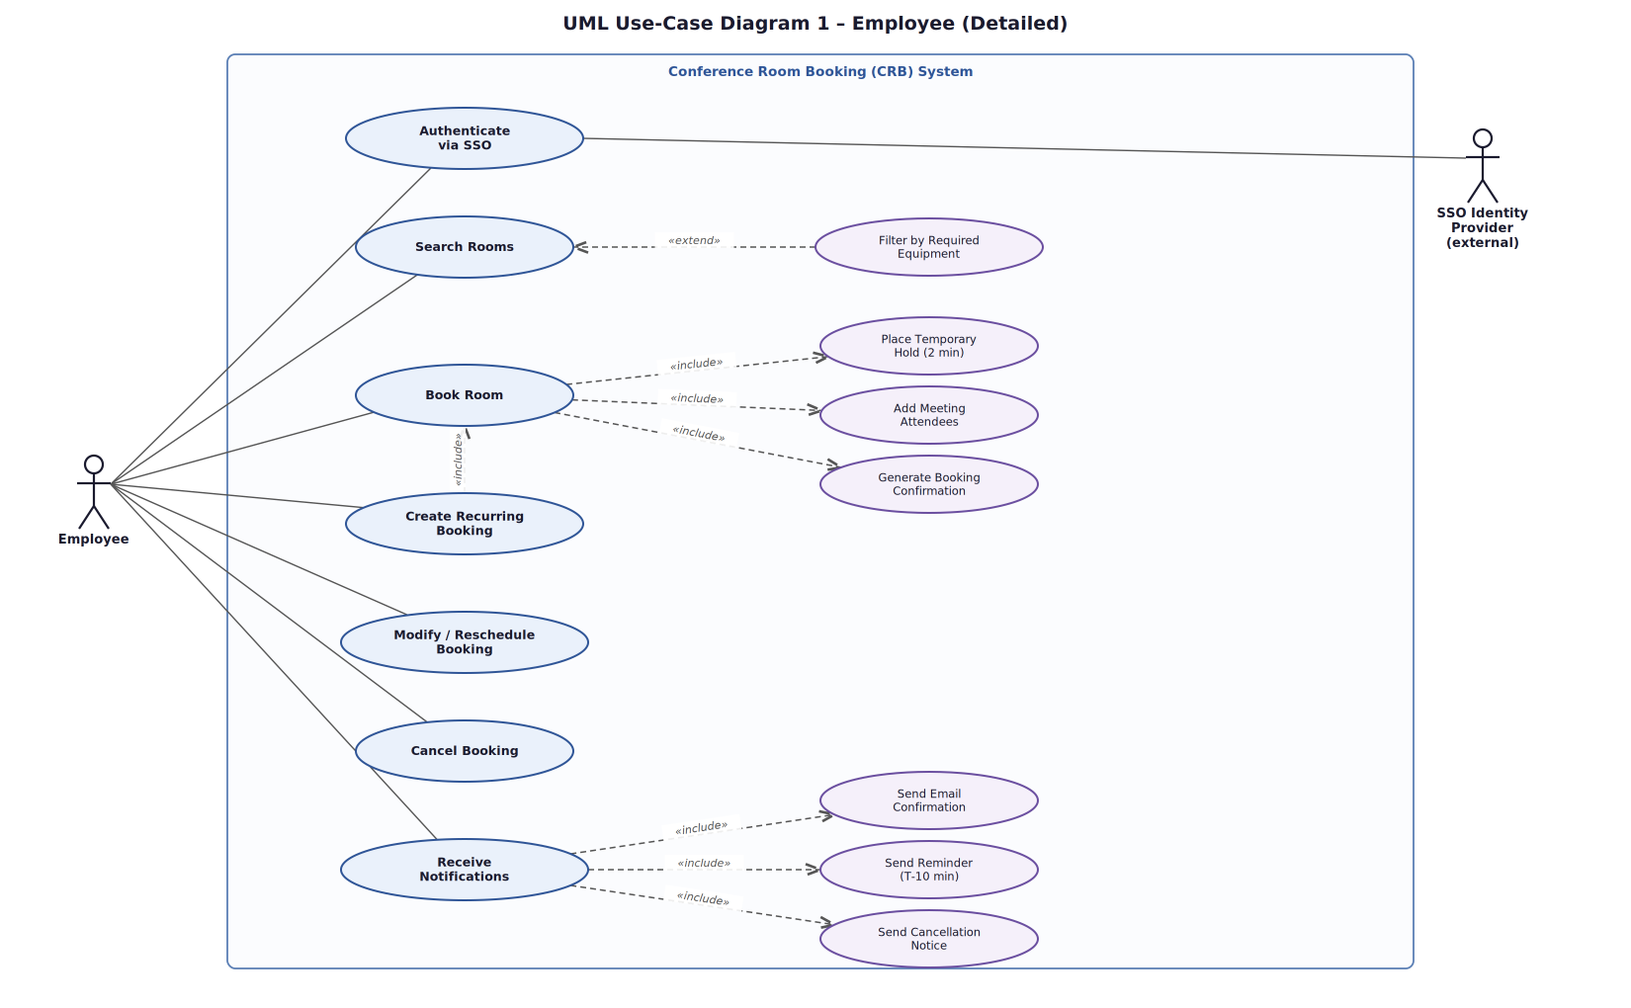
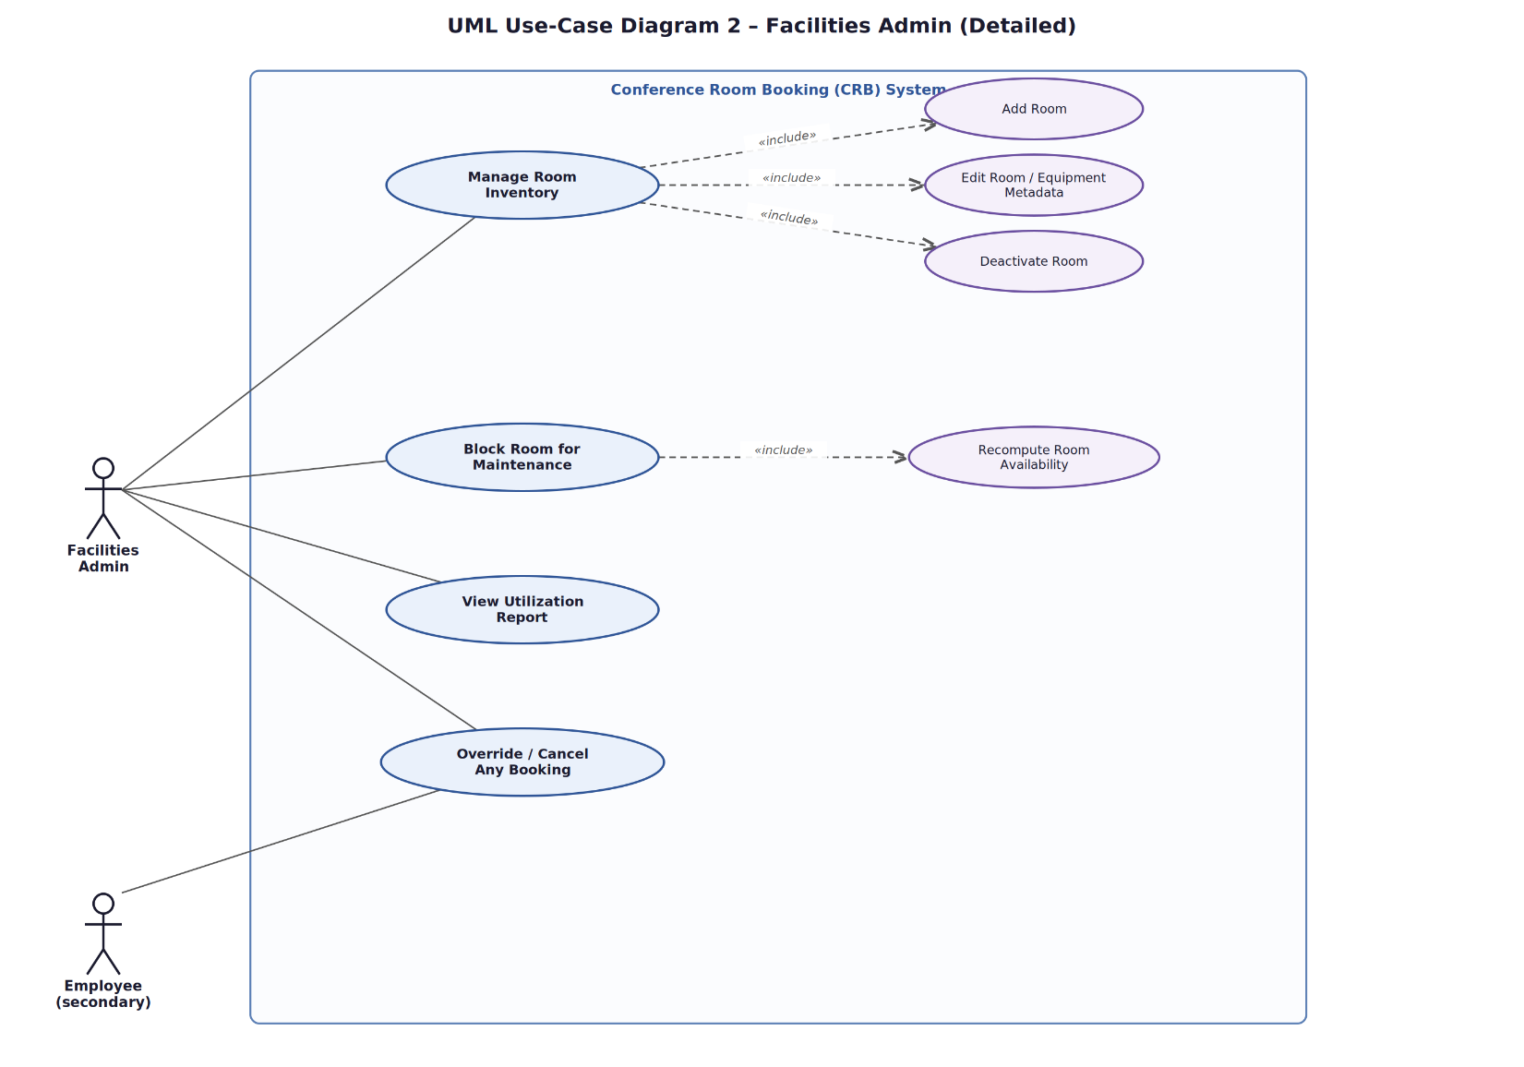

8. Requirements Traceability Matrix (RTM)
Sample RTM rows below - to be completed for all requirements by the QA/Integration lead before submission.
Req ID | Requirement (short) | Section Ref / Design Spec | Module | Test Case(s) | Status | Comments
CRB-F-001 | SSO authentication | 4.1 / DS-Auth-01 | AuthModule | TC-Auth-01 | N
CRB-F-020 | Prevent double-booking | 4.3 / DS-Book-01 | BookingEngine | TC-Book-01 | N | Highest priority to verify early
CRB-F-040 | Recurring bookings | 4.5 / DS-Rec-01 | BookingEngine | TC-Rec-01, TC-Rec-02 | N
CRB-F-050 | Admin room CRUD | 4.6 / DS-Admin-01 | RoomAdmin | TC-Admin-01 | N
CRB-NF-001 | Search response time | 5 / DS-Perf-01 | BookingEngine | TC-Perf-01 | N
CRB-SR-002 | Server-side RBAC enforcement | 5.1.2 / DS-Sec-01 | AuthModule / API Gateway | TC-Sec-02 | N
Status legend: N = Not run, P = Pass, F = Fail, A = Automated.

