Software Architecture and Design Specification
Enterprise Conference Room Booking System
Project: Enterprise Conference Room Booking System (CRB)
Version: 1.0 (Updated for Stack Change)
Authors: SINCHANA K PES1UG24AM405
DIRAN SOMANNA PES1UG24AM364
DISHANTH GOWDA H D PES1UG24AM365
PAVAN D C PES1UG24AM383
Date: 15-09-2026

Revision History
Version | Date | Author | Change Summary
0.1 | 15-09-2026 | SINCHANA K  DIRAN SOMANNA DISHANTH GOWDA  PAVAN D C | Initial SAD draft derived from the CRB SRS (v0.1)
1.0 | 12-10-2026 | SINCHANA K DIRAN SOMANNA DISHANTH GOWDA PAVAN D C | Updated tech stack to Python 3 + Flask + SQLite per ADR-07; added ADR-08 database schema extensions and engineering workflow guidelines

Approvals
Role | Name | Signature / Date
Course Coordinator

1. Introduction

1.1 Purpose
This document specifies the architecture and design of the Enterprise Conference Room Booking System (CRB). It translates the functional, non-functional, and security requirements defined in CRB_SRS.docx into a concrete component structure, technology stack, data model direction, API design, and security architecture.

1.2 Scope
Covers the CRB backend services (authentication/RBAC, room search, booking engine, admin room management, notifications, reporting), the web client, and their integration with the corporate SSO provider and email gateway. Excludes the identity provider's internal implementation and the employee directory's internal implementation - both are treated as external systems accessed via API.

1.3 Audience
Developers, QA engineers, security auditors, instructors, and the four-person team's Dev and Test tracks.

1.4 Definitions
- CRB - Conference Room Booking (system short name)
- RBAC - Role-Based Access Control
- SSO - Single Sign-On
- ADR - Architecture Decision Record
- TTL - Time To Live (booking hold expiry)
- STRIDE - Spoofing, Tampering, Repudiation, Information disclosure, Denial of service, Elevation of privilege
- PII - Personally Identifiable Information

2. Document Overview

2.1 How to Use This Document
Sections 3 and 4 are the architectural and design deliverables: UML diagrams (placeholders marked for the team to insert), component responsibilities, the chosen architecture pattern with rationale, the technology stack, API design, and the security architecture (STRIDE). Rationale for each significant choice is kept separately in CRB_Architecture_Decisions.md so this document stays a specification, not a debate.

2.2 Related Documents
- CRB_SRS.docx - functional, non-functional, and security requirements (source of truth for CRB-F-###, CRB-NF-###, CRB-SR-### IDs used throughout this document)
- CRB_Requirements_Catalog.docx - mandatory vs. add-on requirement discussion
- Test_Plan_Template for SE.docx - test strategy, to be filled once this SAD is approved
- CRB_Architecture_Decisions.md - rationale for each architectural and technology choice made in this document

3. Architecture

3.1 Goals & Constraints
Goals: conflict-free booking, 99.5% business-hours availability (CRB-NF-002), search responses within 2 seconds (CRB-NF-001), 500 concurrent users (CRB-NF-003).
Constraints: must integrate with the corporate SSO/identity provider, must comply with internal PII handling policy, must run within the enterprise network, no dedicated on-site hardware beyond an optional room-display tablet (out of scope for the mandatory feature set).

3.2 Stakeholders & Concerns
- Employees: fast, conflict-free booking; a search experience comparable to Outlook/Google Calendar room booking.
- Facilities Admins: reliable room inventory management, maintenance blocking, utilization visibility.
- IT Security / Auditors: RBAC enforcement, PII protection, attributable admin actions.
- Developers (4-person team): modular boundaries that map cleanly to the four ownership tracks - Auth, Booking Engine, Room/Resource Admin, Notifications/Integration.

3.3 Component (UML) Diagram
- shows Web UI, Flask Application & Request Guards, Booking Blueprint, Room Admin Blueprint, Notification Blueprint, Reporting Blueprint, Auth Blueprint, and SQLite Database, with arrows for: UI to Flask endpoints (HTTPS/REST), Application Factory / Guards dispatching to Blueprints with session-based RBAC, Blueprints reading/writing SQLite (rooms, bookings, attendees, users, outbox, audit log), Booking Blueprint placing 2-minute temporary holds as database rows with TTL expiry, Notification Blueprint saving email records to the outbox table, Auth Blueprint managing login/lockout lifecycles (replaces microservices and Redis per ADR-07 and ADR-08).

3.4 Component Descriptions
Component | Responsibility | Related Requirements
Web UI | Responsive client for search, booking, modification, and the Admin console; renders WCAG 2.1 AA-compliant views. | CRB-F-010/011/012, CRB-NF-005
API Gateway / Auth Filter | Terminates TLS, validates session tokens on every request, and enforces RBAC server-side before a request reaches any service. | CRB-SR-001, CRB-SR-002
Auth Service | Integrates with corporate SSO, issues/validates session tokens, applies account lockout and 30-minute idle timeout. | CRB-F-001/002/003, CRB-SR-004
Booking Service | Owns room search, booking creation with conflict detection, temporary holds, reschedule/cancel, and recurring series logic. | CRB-F-010-012, CRB-F-020-023, CRB-F-030-032, CRB-F-040/041
Room Admin Service | Owns room/equipment inventory CRUD and maintenance-block scheduling. | CRB-F-050, CRB-F-051
Notification Service | Sends confirmation, reminder, and cancellation emails via the corporate SMTP gateway on a scheduled/event basis. | CRB-F-060/061/062
Reporting Service | Aggregates booking data into the room utilization report. | CRB-F-070
SQLite (primary datastore) | Durable embedded datastore for rooms, bookings, users/roles, attendees, outbox, and the admin audit log; PII columns (attendee names and emails) encrypted at rest using Fernet encryption (CRB-SR-006, ADR-07, ADR-08). | CRB-NF-004, CRB-SR-003, CRB-SR-006
SQLite Hold Store / Transactional Lock (replaces Redis per ADR-07, ADR-08) | Stores the 2-minute booking hold as a database row with status 'held' and a 'hold_expires_at' timestamp; SQLite BEGIN IMMEDIATE transactional locking prevents race conditions during conflict-check-and-create without external cache dependencies. | CRB-F-020, CRB-F-021, CRB-F-032

3.5 Chosen Architecture Pattern and Rationale
Layered / modular monolith, deployed as a single backend application internally organized into the six services listed in 3.4 as separate modules (package-per-module, not process-per-module). Microservices were considered and rejected for this course scope - see CRB_Architecture_Decisions.md for the full comparison. The module boundaries in 3.4 map directly to the four team ownership tracks, so the pattern can be split into real microservices later without a redesign if utilization ever requires it.

3.6 Technology Stack & Data Stores
- Backend: Python 3, Flask (REST endpoints via Blueprints, session-based RBAC; replaces Java 17 and Spring Boot per ADR-07)
- Frontend: React, served as a static SPA behind the API Gateway
- Primary database: SQLite (rooms, bookings, users, roles, audit log; zero-configuration embedded datastore replacing PostgreSQL per ADR-07)
- Cache / distributed lock: In-process Python memory store / SQLite transactional locks (booking holds, rate limiting; replaces Redis per ADR-07)
- Identity: Corporate SSO via OAuth2/OpenID Connect (simulated with Keycloak in development)
- Email: Corporate SMTP gateway (or a local SMTP test double such as MailHog in development)
- Transport security: TLS 1.2+ terminated at the API Gateway [CRB-SR-001]

3.7 Risks & Mitigations
Risk | Mitigation
Race condition allows two users to double-book the same room (CRB-F-020) | SQLite transactional locking (BEGIN IMMEDIATE) around the check-and-create sequence, combined with query-level overlap checks against confirmed and held bookings to eliminate race conditions (replaces Redis distributed locks per ADR-07).
Corporate SSO/IdP unavailable, blocking all logins | Local fallback authentication path with the same lockout policy (CRB-F-003); IdP health check surfaced on the Admin console
Notification job backlog delays reminder emails past the 10-minute window (CRB-F-061) | Scheduled job runs on a short interval (e.g. every minute) and queries only upcoming bookings in the next reminder window, keeping each run's workload small
Recurring-booking series data model becomes a bottleneck for conflict checks at 90-day horizon | Materialize each occurrence as its own booking row at series-creation time rather than computing conflicts on the fly
PII exposure if database backups are mishandled | Column-level encryption at rest (CRB-SR-006) plus access-controlled backup storage

3.8 Traceability to Requirements
Req ID | Requirement (short) | Component
CRB-F-001/002/003 | SSO auth, RBAC, account lockout | Auth Service
CRB-F-010/011/012 | Room search, filter, availability | Booking Service
CRB-F-020/021/022/023 | Booking creation, hold, attendees, confirmation | Booking Service, SQLite Hold Store (ADR-07, ADR-08)
CRB-F-030/031/032 | Reschedule, cancel, hold auto-release | Booking Service, SQLite Hold Store (ADR-07, ADR-08)
CRB-F-040/041 | Recurring bookings and occurrence edits | Booking Service
CRB-F-050/051 | Room/equipment CRUD, maintenance block | Room Admin Service
CRB-F-060/061/062 | Confirmation, reminder, cancellation email | Notification Service
CRB-F-070 | Utilization report | Reporting Service
CRB-NF-001/002/003 | Performance, availability, scalability | Flask Application, SQLite (ADR-07)
CRB-SR-001-006 | TLS, RBAC enforcement, audit log, session timeout, input validation, PII encryption | Flask Application, Auth Blueprint, SQLite (ADR-07)

3.9 Security Architecture
Threat modeling (STRIDE), mapped to the CRB security requirements defined in the SRS:
Threat | Description in CRB Context | Mitigation
Spoofing | An attacker impersonates an employee or admin to book or manage rooms on their behalf. | Corporate SSO authentication (CRB-F-001); session tokens over TLS only
Tampering | A request is modified in transit, or a client-side RBAC check is bypassed by calling the API directly. | TLS 1.2+ (CRB-SR-001); server-side RBAC enforcement on every endpoint (CRB-SR-002)
Repudiation | An admin denies having deactivated a room or cancelled another user's booking. | All admin actions logged with actor ID, timestamp, and detail (CRB-SR-003)
Information disclosure | Attendee names/emails or booking details leak via an unencrypted channel or database export. | TLS in transit (CRB-SR-001); PII encrypted at rest (CRB-SR-006)
Denial of service | A flood of search or booking requests degrades availability for legitimate users. | Rate limiting at the API Gateway; horizontal scalability target of 500 concurrent users (CRB-NF-003)
Elevation of privilege | An Employee-role user calls an Admin-only endpoint directly, bypassing the UI. | Server-side RBAC enforcement rejects the call regardless of UI restrictions (CRB-SR-002)

4. Design

4.1 Design Overview
The system is designed as layered modules (presentation, API/gateway, service, data access) with clear module boundaries matching the four team ownership tracks defined in the SRS, so each track can develop and test its module with minimal cross-module coupling.

4.2 UML Sequence Diagrams
At least 2 sequence diagrams are required, covering flows specific to this project:
- Flow 1 - Booking creation with conflict detection: Employee -> Web UI -> Flask App / Auth Guard -> Booking Blueprint -> SQLite (BEGIN IMMEDIATE / check overlap) -> SQLite (insert held row with 2-min TTL) -> Booking Blueprint -> User Confirms -> SQLite (update status to confirmed) -> Notification Blueprint (write confirmation to outbox) -> Web UI.
- Flow 2 - Room maintenance block preventing a search result: Facilities Admin -> Web UI -> Flask App / Role Guard -> Room Admin Blueprint -> SQLite (insert maintenance block & log audit action) ... later ... Employee -> Web UI -> Search Blueprint -> SQLite (room search query excludes rooms with overlapping maintenance blocks or confirmed bookings) -> Web UI.
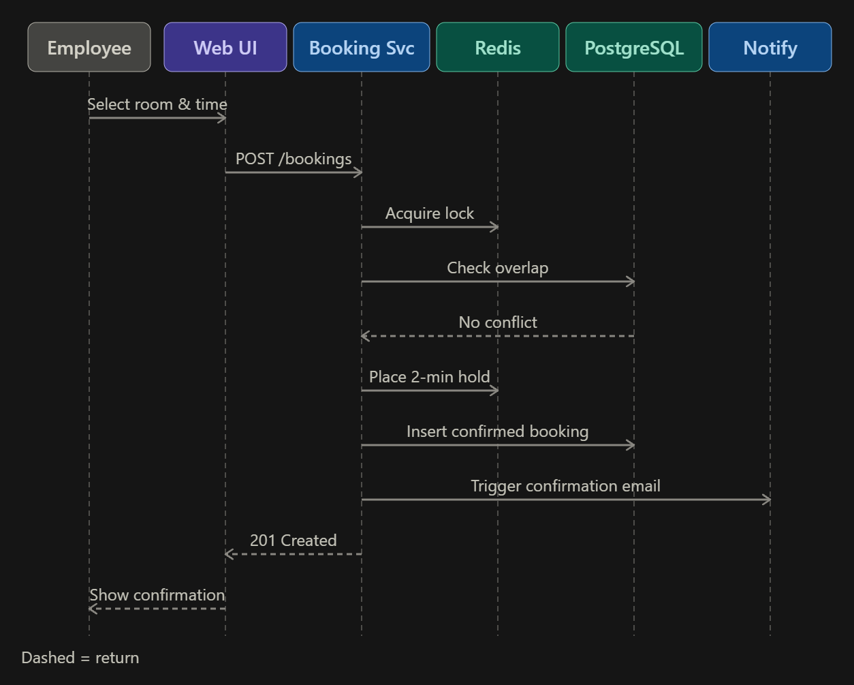
Booking creation

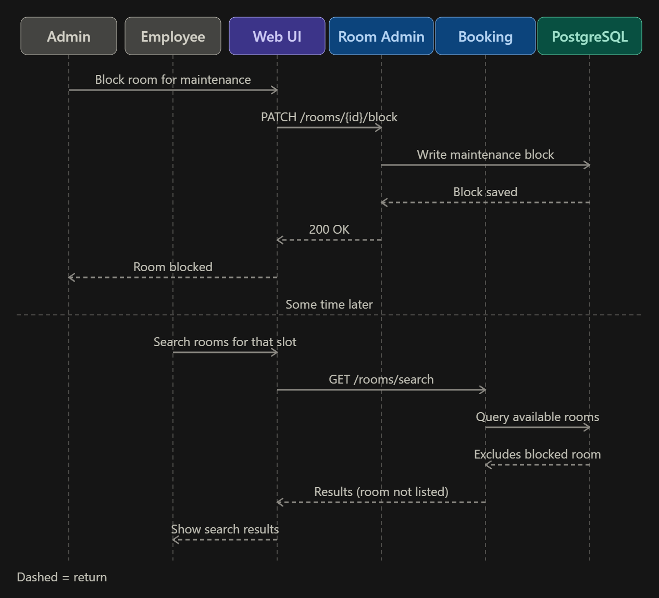
maintenance block

4.3 API Design
Interface definitions for three components (exceeds the template's 2-component minimum):
Field | Value
Endpoint | /bookings
Method | POST
Component | Booking Service
Request | { roomId, startTime, endTime, attendeeEmails[] }
Response | { bookingId, status, confirmationSentAt }
Errors | 401 Not authenticated, 404 Room not found, 409 Time slot conflict

Field | Value
Endpoint | /rooms/search
Method | GET
Component | Booking Service
Request | ?location&date&startTime&endTime&minCapacity&equipment[]
Response | [{ roomId, name, capacity, equipment[], location }]
Errors | 400 Invalid time range, 401 Not authenticated

Field | Value
Endpoint | /admin/rooms
Method | POST
Component | Room Admin Service
Request | { name, location, capacity, equipment[] }
Response | { roomId, status }
Errors | 401 Not authenticated, 403 Not an Admin, 400 Invalid room data

4.4 Error Handling, Logging & Monitoring
Standardized error response shape ({ code, message }) across all endpoints; no PII or session tokens in logs. Admin actions are logged separately to the audit table (CRB-SR-003). Monitoring tracks booking conflict-rejection rate, search response time (CRB-NF-001), notification delivery failures, and API availability against the 99.5% business-hours target (CRB-NF-002).

4.5 UX Design
Web UI follows WCAG 2.1 AA guidelines (CRB-NF-005): screen-reader labels on all interactive elements, a high-contrast mode, and keyboard-only navigation support for search, booking, and the Admin console.

4.6 Open Issues & Next Steps
- Final FR/add-on scope is pending team sign-off before the UML diagrams in 3.3 and 4.2 are finalized.
- Add-on candidates such as calendar sync, QR check-in, or IoT occupancy sensors would each require an ADR and a SAD update before implementation - none are committed in this draft.
- Load-testing plan for the 500-concurrent-user target (CRB-NF-003) is not yet defined - to be covered in the Test Plan.

5. Appendices

5.1 Glossary
CRB, RBAC, SSO, ADR, TLS, STRIDE, PII, TTL - see Section 1.4.

5.2 References
- IEEE 42010 (Architecture description)
- OWASP Top 10 / ASVS (application security baseline)
- NIST SP 800-160 (systems security engineering)
- WCAG 2.1 AA (accessibility)

5.3 Tools
- Diagramming: PlantUML, draw.io
- API design/documentation: Swagger / OpenAPI
- Issue tracking: GitHub Projects

6. Architectural Decision Records (ADRs)
This section formally records key architectural decisions made across the lifecycle of the Conference Room Booking (CRB) project, capturing context, rationale, and consequences so that documentation and implementation remain synchronized.

6.1 ADR-07: Use Python 3, Flask, and SQLite for the Course Build
Status: Accepted (12 Oct 2026). Supersedes ADR-02 (PostgreSQL) and ADR-03 (Redis) for the course build; ADR-01 (modular monolith) is unchanged.
Context: The project team consists of four students working toward a strict academic deadline with evaluation heavily weighted on software engineering process, commit hygiene, and requirement traceability. The initial stack specification (Java 17, Spring Boot, PostgreSQL, and Redis) introduced significant operational risk: requiring external build tools (Maven/Gradle), complex JVM environment configurations, local database server daemons, and distributed cache infrastructure. These added administrative overhead without increasing functional or evaluated value.
Decision: Adopt Python 3, Flask (modular Blueprints per feature area), SQLite embedded database via the standard library sqlite3 module, and pytest for automated test execution.
Consequences: 1. Simplified Deployment: Zero external database or cache services to install; dependencies are managed entirely via requirements.txt and pip.
2. In-Database Holds: Temporary 2-minute booking holds (CRB-F-021) are managed as database rows with status "held" and a hold_expires_at timestamp rather than transient Redis keys.
3. Concurrency Protection: Double-booking prevention (CRB-F-020) uses SQLite BEGIN IMMEDIATE transactional locks around check-and-insert sequences rather than distributed Redis locks.
4. Clean Upgrade Path: Database access is centralized in crb/db.py (get_db()). If production migration to PostgreSQL is desired, only db.py needs updating while application business logic remains untouched.
5. Cryptographic Sessions: Sessions utilize cryptographically signed cookies (HttpOnly, SameSite=Lax, and Secure under TLS) managed server-side.

6.2 ADR-08: Database Schema Extensions for Sprint 2 (Holds, Attendees, Outbox)
Status: Accepted (18 Oct 2026). Extends ADR-07 (Python/Flask/SQLite).
Context: Sprint 2 deliverables expanded functional requirements to include room checkouts with temporary holds (CRB-F-021), meeting attendee invitations (CRB-F-022), recurring reservations (CRB-F-040), reminder notifications (CRB-F-061), and email records (CRB-F-060).
Decision: Extend the relational schema within SQLite:
- bookings table: Add status column with CHECK constraint (held, confirmed, cancelled, expired), hold_expires_at, series_id (referencing the primary occurrence for recurring series), reminder_sent, and created_at.
- attendees table: Create table attendees (booking_id, user_id, name, email) with UNIQUE(booking_id, user_id). Field values for name and email are encrypted at rest using Fernet symmetric encryption (CRB-SR-006).
- outbox table: Create table outbox (to_username, subject, body, created_at) to record simulated outbound notifications without coupling to an external SMTP server.
- Indexes: Add composite indexes on (room_id, start_time, end_time) across bookings and maintenance_blocks to maintain sub-second response times under load (CRB-NF-001).
Consequences: Enables full end-to-end testing of checkout flows, holds, and encryption within isolated test databases. Database initialization and demo seeding are automated via the Flask CLI command: flask --app crb.app init-db.

6.3 Team Workflow & Engineering Process Guidelines
• Individual Account Commits: Every team member commits strictly from their own authenticated GitHub account. Commits must never be pushed under another person's credentials or backdated. Git commit history serves as an auditable record of individual contributions.
• Dependency-Aware Sequencing: Strictly follow the implementation order specified in the sprint plans (§3). Some feature commits depend on foundational modules ("Needs merged first"). If a dependency is pending review on main, developers must wait rather than copying unmerged files into feature branches.
• Trunk-Based Branching and PR Policy: Enforce: One commit = one branch = one Pull Request. Developers branch from the latest main, push the single commit, open a GitHub PR, receive at least one peer review, and merge using "Create a merge commit" (squash merging is prohibited to preserve granular commit history).
• Reviewer Rotation Schedule: To ensure balanced peer review and shared code ownership, PR reviews rotate systematically: Developer A's PRs are reviewed by B; Developer B's PRs are reviewed by C; Developer C's PRs are reviewed by D; Developer D's PRs are reviewed by A.
• Pre-Push Test Verification Gate: Every sprint task defines a "Before you push" verification gate. Developers must run the automated test suite locally (pytest) before pushing. If any test fails or collected counts differ from expectations, the commit must not be pushed until resolved.
• Test File Lifecycle: Unit-test files are created and committed alongside their corresponding feature implementation within the same commit. Temporary integration test suites (e.g. D6) are added at designated checkpoints and cleanly decommissioned in subsequent cleanup sprints via chore(test): remove temporary integration tests.
• Module Mastery and Live Defense: Each developer maintains deep mastery over their assigned ownership track. Team members must be prepared to explain their architectural choices and demonstrate live code modifications as rehearsed in the project plan (§10).

