Q1
Code :
/*Q1: Calculate square*/
val caluateSquare:(Int)->Int ={number-> number*number }
println("Q1 Output:")
println("Square of 7 = ${ caluateSquare(7)}")
println("Square of 15 = ${ caluateSquare(15)}")

Q1 Output :
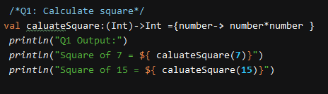
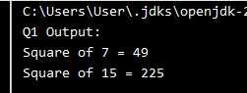

Q2
Code :
/*Q2: Odd Even*/
try {
println("Input your number :")
var number=readln().toInt()
var OddEven:(Int)->String={if(it %2 ==0) "Even" else "Odd"}
println("Q2 output : ${OddEven(number)}")
}catch (e : Exception){
println("Invalid input")
}

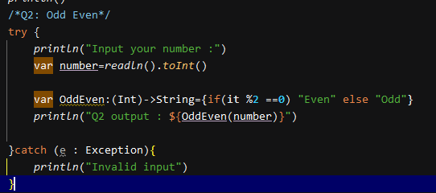
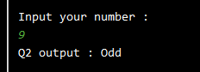

Q3
Code:
/*Q3: Deposit Interest Rate*/
var depositInterestRate :(Int, Float, Int) -> Unit = { principal, interest, year->
var totalAmount: Int
var afterInterest : Int
totalAmount = ((Math.pow((1+interest/100f).toDouble(),year.toDouble()))*principal).toInt()
afterInterest =totalAmount-principal
println("本金 ${principal} 存放${year}年的利息${afterInterest} 和本利和${totalAmount}")
}
println("Q3 Output : ")
println(depositInterestRate(50000, 1.75f, 10 ))
println(depositInterestRate(90000, 3.5f, 15 ))

Output :
