Q1
Code :
/*Q1*/
println("Input 1st number :")
var a=readln()?.toIntOrNull() ?: 0
println("Input 2nd number :")
var b=readln()?.toIntOrNull() ?: 0
var result : (Int, Int)-> Int = {a,b -> a+b}
println("a + b = ${result(a,b)}")
println("Input 1st number :")
a=readln()?.toIntOrNull() ?: 0
println("Input 2nd number :")
b=readln()?.toIntOrNull() ?: 0
result = {a,b -> a*b}
println("a x b = ${result(a,b)}")

Q1 Output :
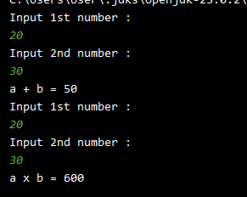

Q2
Code :
/*Q2*/
// in main func
println("Input Jack's score to calculate the total :")
student("Jack",10,{math,english,Science -> math+english+Science})
println("Input Mary's score to calculate the average :")
student("Mary",20,{math,english,Science -> (math+english+Science)/3})
//in student func
fun student(name: String, id: Int, score:(Int, Int, Int)-> Int) : Unit {
println("Please input the score of Math :")
var math=readln()?.toIntOrNull()?:0
println("Please input the score of English :")
var english=readln()?.toIntOrNull()?:0
println("Please input the score of Science :")
var Science=readln()?.toIntOrNull()?:0
println("$id - $name - score : ${score(math,english,Science)}")
}

Output:
