PAH Analysis
Add new empty folder „data“ to cd Documents/My_Codes/screen_analysis
on Nextcloud:
- rename the folder to be analyzed to „340K_Screen“
- add folder „analysis“ that contains the assignment table, the compound table and the TSA_Layout (will not automatically added to „data“!!)
cd Documents/My_Codes/screen_analysis
conda activate TSA
./nextcloud_download.sh data

data now looks like this:
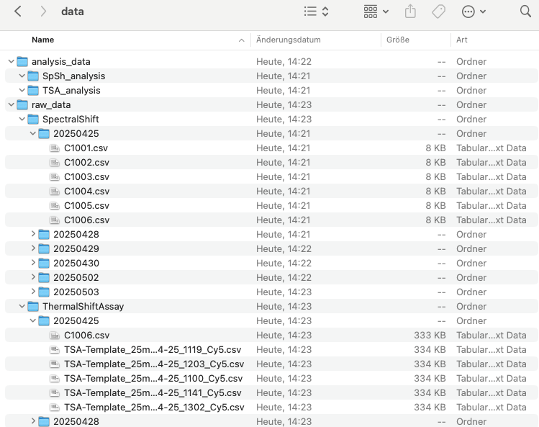
add into data/analysis_data: the assignment table, the compound table (CS…) and the TSA_Layout:
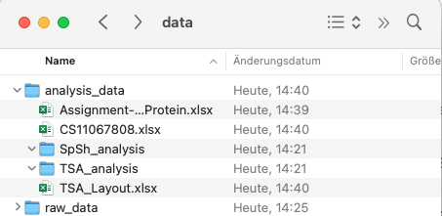
rename the compound table to PO-ini2810 (this is not so good)
./run_data_preparation.sh data
./run_data_analysis.sh PAH_screen_219

How to push changes to git:

git add --a
git commit
type something (that was changed)
write out (control o)
enter
exit (control x)

How to undo changes that I made:
git restore .
In jupyter lab the working directory is by default where the notebook (.ipynb) is located!!
In jupyter lab I can see the current directory with !pwd (the ! enables me to use it as terminal)

df_main = df_main.drop('Unnamed: 0', axis=1)
- axis=1 removes a column, axis=0 would remove a row
'Unnamed: 0', ist the name of the column
- for rows, ‚0‘, ‚1‘… would be the name

How to catch a value from a table:
- df_main.loc[[0, 2, 4], 'Protein']
outputs Entry 1, 3, 5 in column Protein
- df_main.loc[0, 'Protein']
outputs Entry 1 in column Protein
- df_main.loc[df_main['Protein'] == 'GCDH-V400M', 'Protein']
selects rows based on a condition
How to use „ersetzen“
df_main.loc[df_main['Protein'] == 'GCDH-V400M', 'Protein'] = 'GCDH-R227P'

