Reproducible Sentinel-2 Farmland Boundary Extraction with Objective Best-Image Selection and a Classical-vs-Foundation-Model Segmentation Comparison
Student: Sina Ahmadi
Context: Interdisciplinary Project — Earth Observation / Data Science
Date: 29 June 2026
Repository: https://github.com/sinaaat/interdisciplinary_project

1. Abstract
This project builds the optical front-end of a larger Earth-observation workflow: given a region of interest and a date range, it retrieves Sentinel-2 imagery from Google Earth Engine, picks the clearest acquisition automatically, and turns it into georeferenced farmland-boundary polygons. Three lightweight classical segmentation methods (NDVI thresholding, Otsu thresholding, and an NDVI + morphology refinement with watershed splitting) are compared against SAM (Segment Anything), a general-purpose foundation segmentation model used here as an advanced comparator. Because no ground-truth parcel boundaries were available, the evaluation relies on measurable proxy metrics and on pairwise agreement between methods rather than on supervised accuracy. The NDVI workflow was kept as the delivered method; SAM was retained as an experimental point of comparison. The headline finding is deliberately undramatic and useful: a large generic model did not beat a simple vegetation index on this task, and the reasons why are exactly the kind of trade-off a data scientist is expected to reason about.

2. Introduction
Satellite imagery on its own is not an answer to anything — it is a stack of pixels. Before any agronomic or geophysical question can be asked about a field, the field itself has to be located and turned into a discrete object with a boundary, an area, and a coordinate system. That conversion, from raw reflectance to structured geospatial features, is the part of the pipeline this project implements. It sits at the intersection of remote sensing, image processing, and software engineering, which is what makes it an interdisciplinary data-science problem rather than a pure modelling exercise.

3. Interdisciplinary motivation
The work touches several disciplines at once. Remote sensing supplies the physics of why NDVI separates vegetation from bare soil. Image processing supplies the thresholding, morphology, and watershed steps. Software engineering supplies the configuration, reproducibility, and packaging that let the whole thing run with a single command. The data-science contribution is the glue: deciding how to score image quality, which segmentation method to trust, what to measure when there is no ground truth, and how to package the result so a downstream consumer can use it without reverse-engineering the pipeline. None of those decisions are settled by the model alone.

4. Problem statement and scope
The implemented scope is the optical Sentinel-2 retrieval and farmland-polygon extraction stage. Given user coordinates, a start date, an end date, and a time step, the system produces a validated set of farmland boundary polygons derived from the best available image in that interval, together with a defensible comparison of the segmentation methods used to produce them.
What is explicitly not implemented: SAR / Sentinel-1 retrieval, backscatter analysis, calibrated soil-surface roughness, and any temporal roughness inversion. Those belong to a downstream stage and are treated here only as future work that the polygon output is designed to feed.

5. Data source and study setup
Imagery comes from the COPERNICUS/S2_HARMONIZED collection through the Google Earth Engine Python API. The region of interest is a roughly 2.3 km × 1.5 km block of agricultural land east of Vienna, Austria, defined by four corner coordinates in the configuration file. The analysis interval runs from 1 April 2019 to 1 September 2019 and is split into 30-day windows. For each window the least-cloudy scene is exported as a four-band GeoTIFF holding red, green, blue, and near-infrared (B4, B3, B2, B8) at 10 m resolution. Keeping the NIR band is what makes NDVI possible while still allowing an RGB preview. Six windows produced six candidate observations.

6. Image retrieval and quality scoring
Rather than choosing an image by eye, the pipeline scores every retrieved observation and ranks them. The score combines four normalised components — low cloud cover, high valid-pixel coverage, a usable vegetation signal, and reasonable scene contrast:
quality_score = 0.45·cloud_score + 0.25·valid_pixel_score + 0.15·vegetation_score + 0.15·contrast_score
The weighting puts most of the emphasis on cloud and coverage, then rewards images where vegetation is actually visible. The full ranking is saved to image_quality_scores.csv. The clear winner was the late-spring window:
Field | Value
Selected window | 2019-05-31 → 2019-06-30
Image ID | COPERNICUS/S2_HARMONIZED/20190625T100039_20190625T100216_T33UXP
Cloud cover | 0.75 %
Vegetation fraction | 0.80
Quality score | 0.963 (highest of 6)

7. Methodology
Four segmentation methods were run on the selected image:
- NDVI threshold — computes (B8 − B4) / (B8 + B4) and keeps pixels above a vegetation threshold.
This is the most physically motivated method: it directly uses the red/NIR contrast that separates growing crops from soil.
- Otsu threshold — automatic grayscale thresholding on the RGB composite. A reasonable baseline,
but blind to the vegetation signal.
- NDVI + morphology — the NDVI mask cleaned with morphological closing and small-component
removal. This is the refinement step.
- SAM (Segment Anything) — run through its automatic mask generator. SAM's masks are filtered to
drop the background-scale segment and tiny fragments, then written to a labeled raster aligned with the GeoTIFF so it can be vectorized through the same code path as the classical methods.
For the classical methods, a distance-transform watershed splits merged blobs before vectorization. SAM produces instance-like masks directly. Every method ends in the same place: GeoJSON polygons in EPSG:4326.

8. Evaluation design
There were no reference parcel boundaries for this region, so the project does not report supervised IoU and does not pretend to. The evaluation instead uses two honest categories of metric.
Category | Metrics | What it tells you
Real measured | cloud %, valid-pixel ratio, vegetation fraction, quality score, coverage %, polygon count, area (m²), runtime, geometry validity | Directly computed from the data / real inference
Proxy quality | fragmentation score, edge density, valid-polygon % | Describes the *structure* of a result, not its correctness
Method agreement | pairwise mask IoU | How much two automatic methods agree — not accuracy
Not reported | ground-truth IoU, calibrated roughness, SAR backscatter | No reference data / out of scope

For a course project at this stage, proxy and agreement metrics are the defensible choice: they are fully reproducible, they expose real differences between methods, and they do not dress up an unvalidated result as if it had been checked against truth.

9. Results
Image-quality ranking (6 windows):
Rank | Window | Cloud % | Vegetation frac | Quality score
1 | 2019-05-31 → 2019-06-30 | 0.75 | 0.80 | 0.963
2 | 2019-07-30 → 2019-08-29 | 1.79 | 0.65 | 0.939
3 | 2019-06-30 → 2019-07-30 | 0.00 | 0.82 | 0.908
4 | 2019-08-29 → 2019-09-01 | 0.68 | 0.58 | 0.877
5 | 2019-04-01 → 2019-05-01 | 0.00 | 0.43 | 0.851
6 | 2019-05-01 → 2019-05-31 | 2.54 | 0.50 | 0.824

Segmentation / model comparison (on the selected image):
Method | Coverage % | Polygons | Median area (m²) | Fragmentation | Valid % | Runtime (s) | Role
ndvi | 59.9 | 23 | 26,100 | 0.22 | 82.6 | 0.14 | classical (final)
otsu | 24.3 | 27 | 10,000 | 0.56 | 92.6 | 0.08 | classical
ndvi_morph | 61.2 | 21 | 32,300 | 0.33 | 90.5 | 0.06 | classical
sam | 70.1 | 33 | 48,300 | 0.00 | 100.0 | 214.1 | experimental

Pairwise mask IoU (method agreement):
 | ndvi | otsu | ndvi_morph | sam
ndvi | — | 0.05 | 0.97 | 0.55
otsu | 0.05 | — | 0.06 | 0.20
ndvi_morph | 0.97 | 0.06 | — | 0.55
sam | 0.55 | 0.20 | 0.55 | —

Final polygon output:
Output | Path | Features | CRS | Validity | Role
Classical farmland polygons | outputs/vectors/farmland_polygons.geojson | 18 | EPSG:4326 | 100 % valid | delivered
SAM polygons | outputs/vectors/sam/sam_polygons.geojson | 33 | EPSG:4326 | 100 % valid | experimental

Both layers carry per-field attributes (field_id, area_m2, pixel_count, segmentation_method, source_window, source_image_id, image_quality_score).

10. Visual results
The figures below are generated by the pipeline and stored under outputs/figures/ and outputs/images/.
Ranked contact sheet of all six retrieved images:
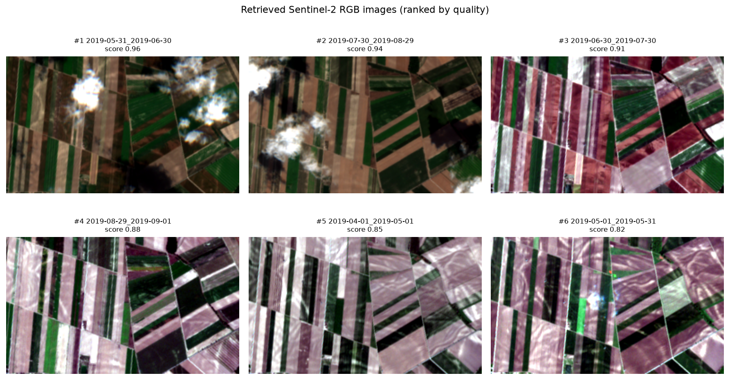
Retrieved RGB contact sheet
Selected best image and the image-quality ranking:
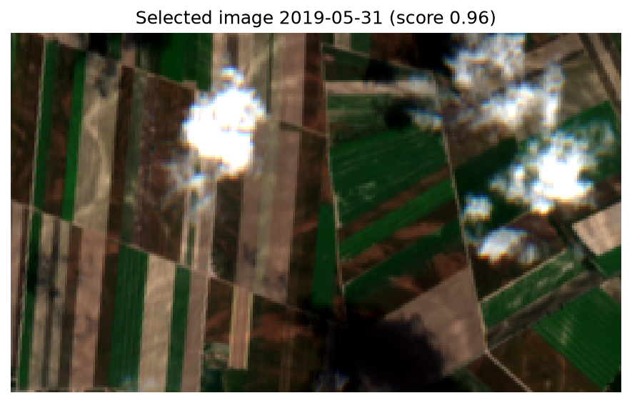
Selected RGB image
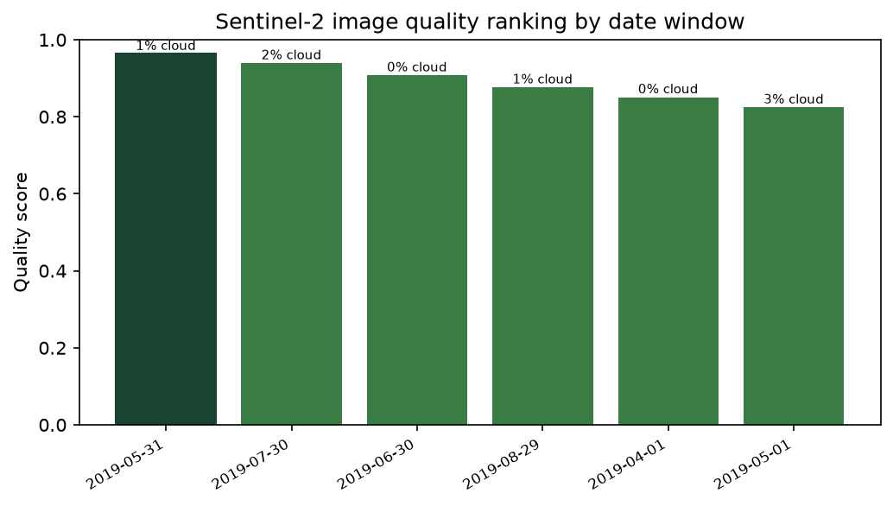
Image quality scores
Classical segmentation masks side by side:
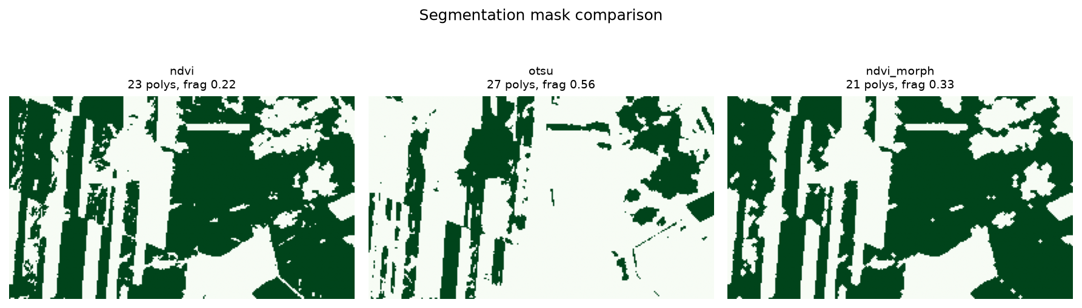
Segmentation comparison
Classical NDVI polygons next to the SAM mask, and the full method comparison:
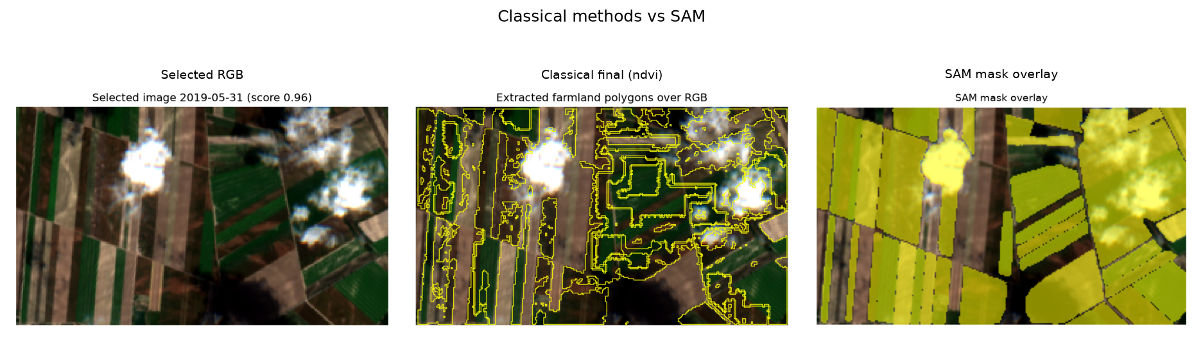
Classical vs SAM
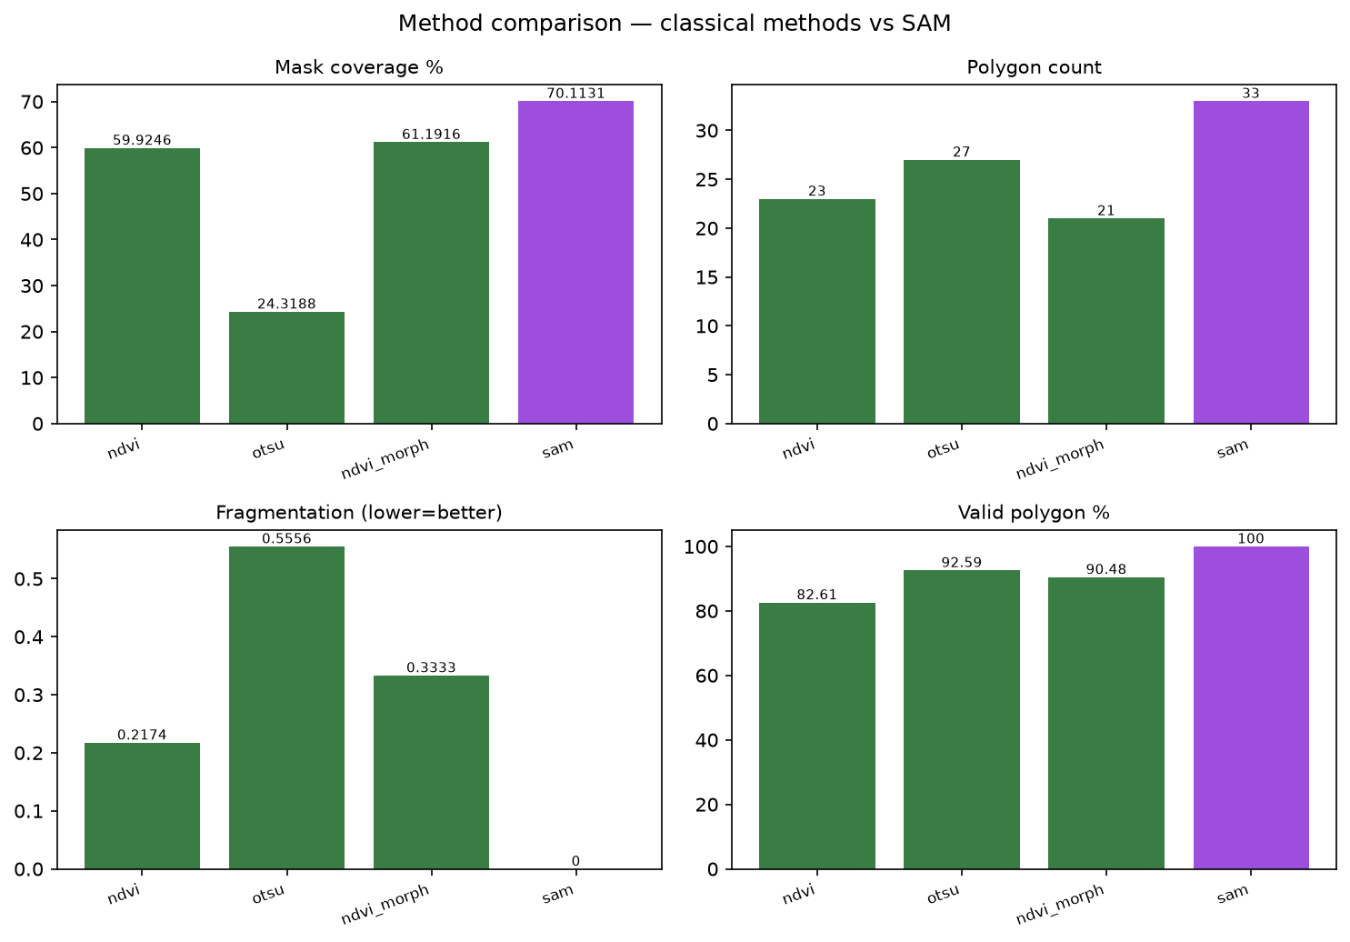
Model comparison extended
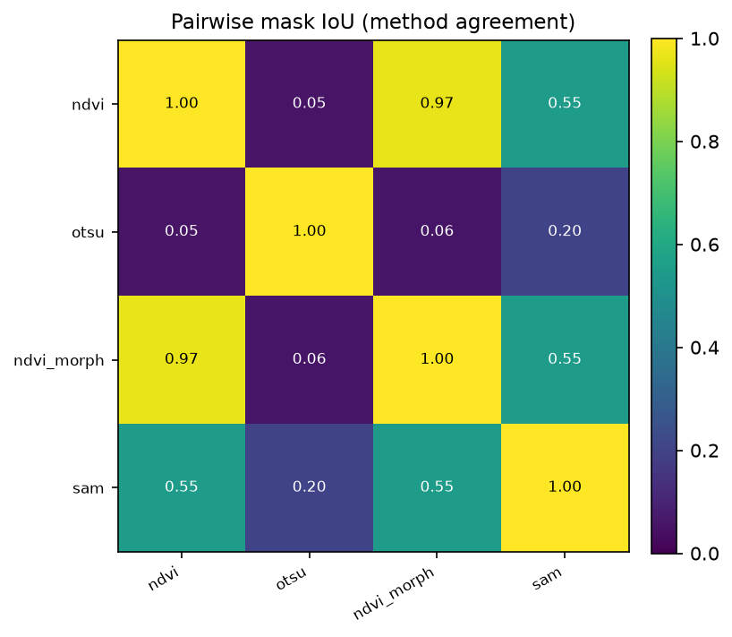
Method agreement heatmap
Final classical farmland polygons over the selected image, and their area distribution:
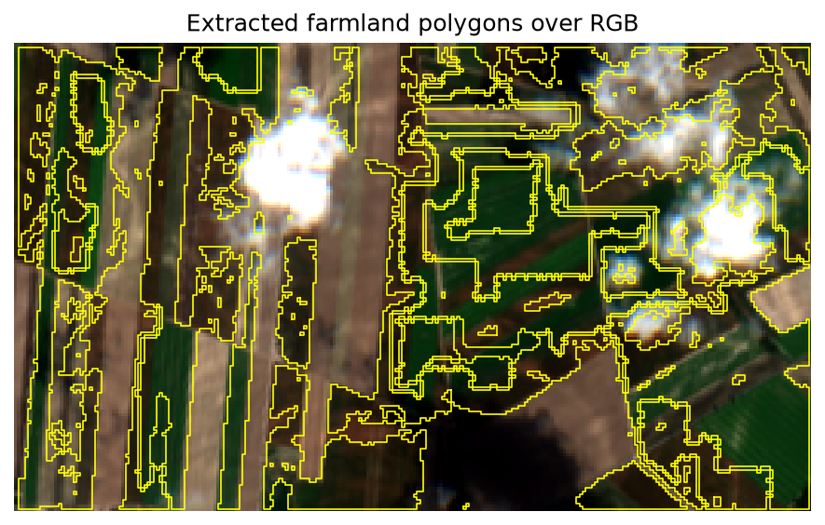
Final polygon overlay
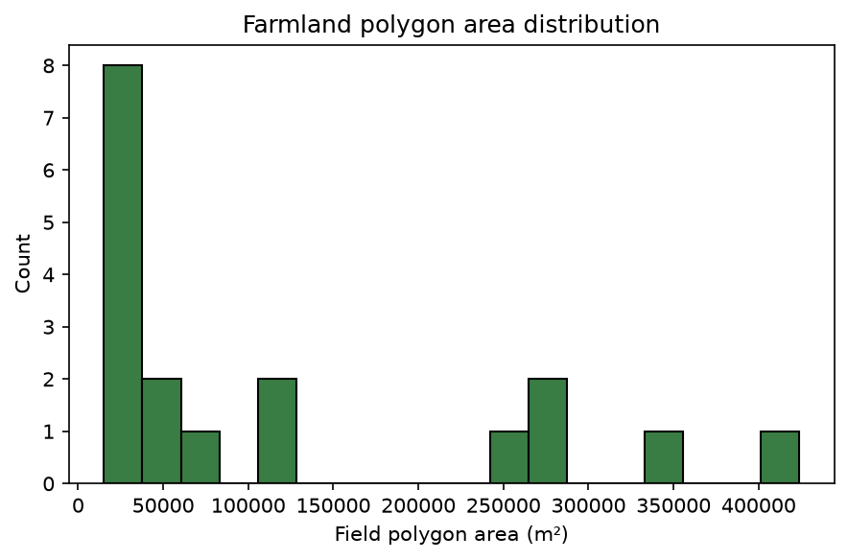
Polygon area distribution

11. Discussion
The most interesting result is the one that looks, at first, like SAM winning. SAM produced the cleanest geometry of any method — 70 % coverage, no small fragments, every polygon topologically valid. Taken alone, those numbers flatter it. But its agreement with the NDVI result was only 0.55, and the reason matters: SAM is a generic segmenter. It carves the whole scene into tidy regions regardless of what is growing there, so its "fields" include bare-soil parcels, tracks, and other blocks that NDVI deliberately leaves out. Clean geometry is not the same as farmland-specific correctness.
The two NDVI variants, by contrast, agreed almost perfectly (IoU 0.97), which is the expected and reassuring outcome: morphological refinement tidied the mask without changing what it was looking at. Otsu agreed with essentially nothing (0.05–0.06) and was the most fragmented method, consistent with a grayscale threshold latching onto brightness rather than vegetation.
Cost sealed the decision. SAM took 214 seconds on CPU against NDVI's 0.14, and it needs a 2.4 GB model checkpoint to run at all. For a 10 m image where the vegetation signal is already cleanly available in the NIR band, paying three orders of magnitude more time and a multi-gigabyte dependency to get a less task-specific result is not a good trade.
So although SAM produced geometrically valid segments and showed that a foundation segmentation model is feasible here, it was slower and less task-specific than the NDVI-based workflow. The NDVI/watershed pipeline stayed as the final method because it directly exploits the spectral vegetation signal in the Sentinel-2 RGB/NIR data and produces farmland-oriented polygons that fit the downstream use case. That is the data-science lesson worth taking from this project: choosing a model is not about reaching for the largest one, but about matching the method to the data resolution, the domain signal, the task objective, the runtime budget, and how the output will actually be used.

12. Limitations
- Sentinel-2 resolution is 10 m, so boundaries follow pixel edges and small features are lost.
- There were no external parcel boundaries, so no supervised IoU is reported; all metrics are proxy or
agreement metrics.
- The thresholds, watershed parameters, and quality-score weights are sensible heuristics, not values
tuned against ground truth.
- The selected scene contains a few small clouds inside the ROI even though its tile-level cloud
metadata is low; NDVI excludes those pixels, but it is an honest weakness of tile-level scoring.
- SAM depends on a large checkpoint and is slow on CPU; it was run once for the comparison.
- The reference run covers a single ROI and a single five-month interval.

13. Future work
- Bring in external reference parcels (for example the Austrian INVEKOS dataset) to compute a real
supervised IoU.
- Feed the polygons into the originally intended downstream stage: per-field Sentinel-1 SAR backscatter
extraction as a proxy for soil-surface roughness change.
- Evaluate across multiple regions and seasons rather than one ROI.
- If labelled masks become available, train or fine-tune a supervised segmentation model, or prompt SAM
with NDVI-derived seed points instead of a blind grid.

14. Conclusion
The project delivers a working, reproducible optical pipeline: it retrieves Sentinel-2 imagery for a user-defined area and period, selects the clearest image by an objective score, compares three classical segmentation methods against a foundation model with measurable metrics, and exports 18 validated farmland polygons in EPSG:4326, alongside 33 experimental SAM polygons. The classical NDVI method was chosen as the delivered output for clear, defensible reasons rather than by default. The result is a clean, attribute-rich field-boundary layer and an honest method comparison — exactly the optical stage a downstream SAR-based roughness study would need to build on.

