Data Engineering Training

- Phase I - access to data sources

Twitter API overview

The Twitter API enables programmatic access to Twitter in unique and advanced ways. It can be used to analyze, learn from, and interact with Tweets, Direct Messages, users, and other key Twitter resources. Every day, developers around the world work with the Twitter API to create, study, and improve the public conversation happening on Twitter.
The Twitter API is a set of programmatic endpoints that can be used to understand or build the conversation on Twitter. With Essential access, you can get access to Twitter API v2 which includes:
- Retrieve 500,000 Tweets per month
- 1 Project per account
- 1 App environment per Project
- Limited access to standard v1.1 (only media endpoints)
- No access to premium v1.1, or enterprise
Tweets are the basic building block of all things Twitter. The Tweet object has a long list of ‘root-level’ fields, such as id, text, and created_at. Tweet objects are also the ‘parent’ object to several child objects including user, media, poll, and place. Use the field parameter tweet.fields when requesting these root-level fields on the Tweet object.

Object model contents:

- Tweet object
- User object
- Space object
- List object
- Media object
- Pool object
- Place object

Tweet object fields are id (default), text (default), attachments, author_id, context_annotations, conversation_id, created_at, entities, geo, in_reply_to_user_id, lang, non_public_metrics, organic_metrics, possibly_sensitive, promoted_metrics, public_metrics, referenced_tweets, reply_settings, source, withheld.
The User object contains Twitter user account metadata describing the referenced user. The user object is the primary object returned in the users lookup endpoint. When requesting additional user fields on this endpoint, simply use the fields parameter user.fields
User object fields are id (default), name (default), username (default), created_at, description, entities, location, pinned_tweet_id, profile_image_url, protected, public_metrics, url, verified, withheld.

Twitter tool for generating API requests:
https://developer.twitter.com/apitools/api
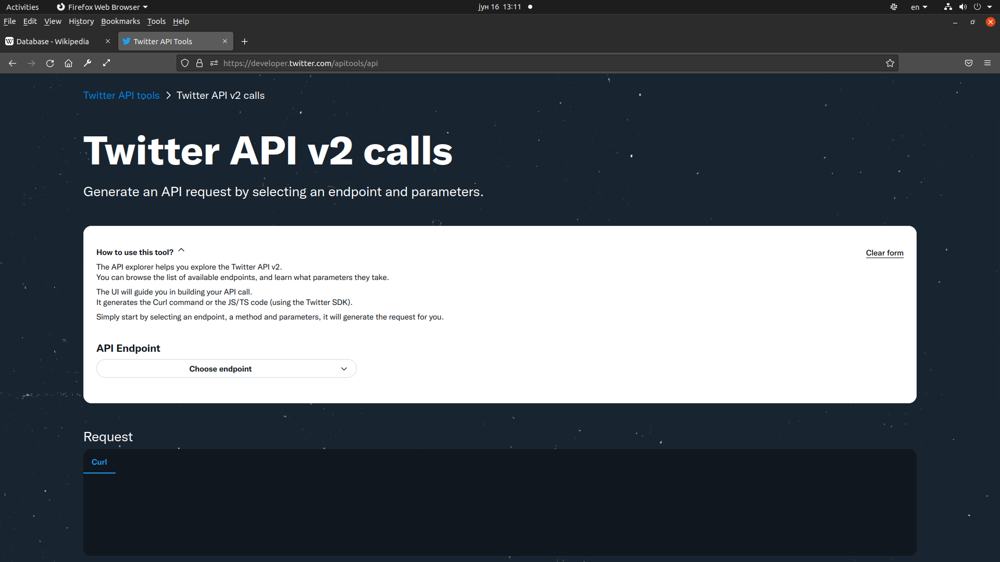
- Phase II – data collection

The project used data obtained from the Twitter Api, which allows access to Twitter through various endpoints. For batch data, api.twitter.com/2/tweets/search/recent endpoint was used, which allows access to tweets from the last 7 days, according to a given filter (content of some word in the text, hashtag, etc.), as well as a combination of 2 and more criteria. The results arrive in the form of a JSON response containing:
- data, which contains a series of Tweet objects (maximum 100 per page)
- includes, which contains additional data, which are defined in the request, e.g. data about the users who created the tweet or are mentioned in it, data about the media (images, video) included in the tweet, etc. In this project, User and Media data were included.
- meta, which contains, among few other things, a next_token field containing a token for the next page of results.

Apache NiFi with InvokeHttp processor was used to connect to the endpoint, data and includes were separated, and files were stored in HDFS in the order they arrived. Since some of the tweets with the same ID were repeated in more then one response pages, first, using Apache NiFi, a field last_modified was added to the tweets, which contained the lastmodified time of the file from HDFS containing the tweet, then, using the Apache Spark program, the list of users and media is extracted from the includes field, and stored in HDFS, the tweets with the same ID that had the older timestamps were discarded, a username field with a username of a creator of a tweet was added into tweet, and the cleaned tweet data was repartitioned into 60-80 MB files and saved back to HDFS.

- Phase III - batch data processing

The obtained cleaned batch data was ingested into Apache Druid, for further analysis, and also the Apache Spark application was implemented, which saved the obtained aggregated data into tables in the PostgreSQL database.

- Phase IV - streaming data processing

For streaming data, a Docker container containing a python program was used, which connects to api.twitter.com/2 /tweets/search/stream, and writes incoming tweets to files in the folder named files, from where they are downloaded by Apache NiFi with the GetFile processor, and writen to the Kafka topic. For streaming processing, data from Kafka was ingested into Apache Druid, and the Spark Streaming application was implemented, which appends the obtained results to the tables in the PostgreSQL database.

- Phase V - presentation of result

For presentation of results, Apache Superset and Metabase BI tools were used, with connections to Apache Druid and PostgreSQL databases.

Technologies used:

- Apache Kafka
- Apache NiFi
- Apache Spark
- Spark Streaming
- HDFS
- Apache Druid
- PostgreSQL
- Docker, Docker-Compose
- Apache Superset
- Metabase

