Compact Spiral Dielectrophoretic Microfluidic Design for Continuous Live/Dead Cell Sorting
Analytical Design Project - IEEE-style simulation manuscript draft
Abstract - This manuscript draft presents a compact spiral dielectrophoretic (DEP) microfluidic design for continuous live/dead cell sorting. The work responds to a specific modeling gap: spiral microchannels and DEP separators are well established separately, and spiral DEP devices exist, but a compact spiral DEP live/dead sorter requires defensible device geometry, mechanism controls, thermal checks, and clear visualization. The final reduced-order V12 operating point reaches 0.940 +/- 0.013 target correct, 0.880 live recovery, 1.000 dead removal, 0.000 wall loss, 0.547 uL/min flow rate, and 2.86 mW active Joule-power proxy. A same-length straight DEP control gives 0.809 target correct, leaving a topology gain of 0.131. The result is framed as a computational design candidate rather than experimental proof.
Index Terms - dielectrophoresis, spiral microfluidics, live/dead sorting, numerical design, OpenFOAM-oriented workflow.
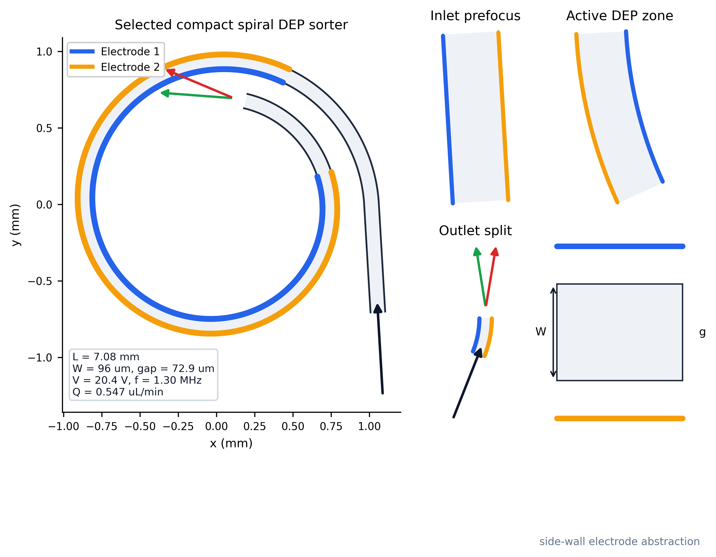
Fig. 1. Selected device-level V14 schematic. Unlike earlier centerline-only figures, this panel shows channel ribbon, two side-wall electrode traces, inlet, two outlet branches, and operating dimensions.
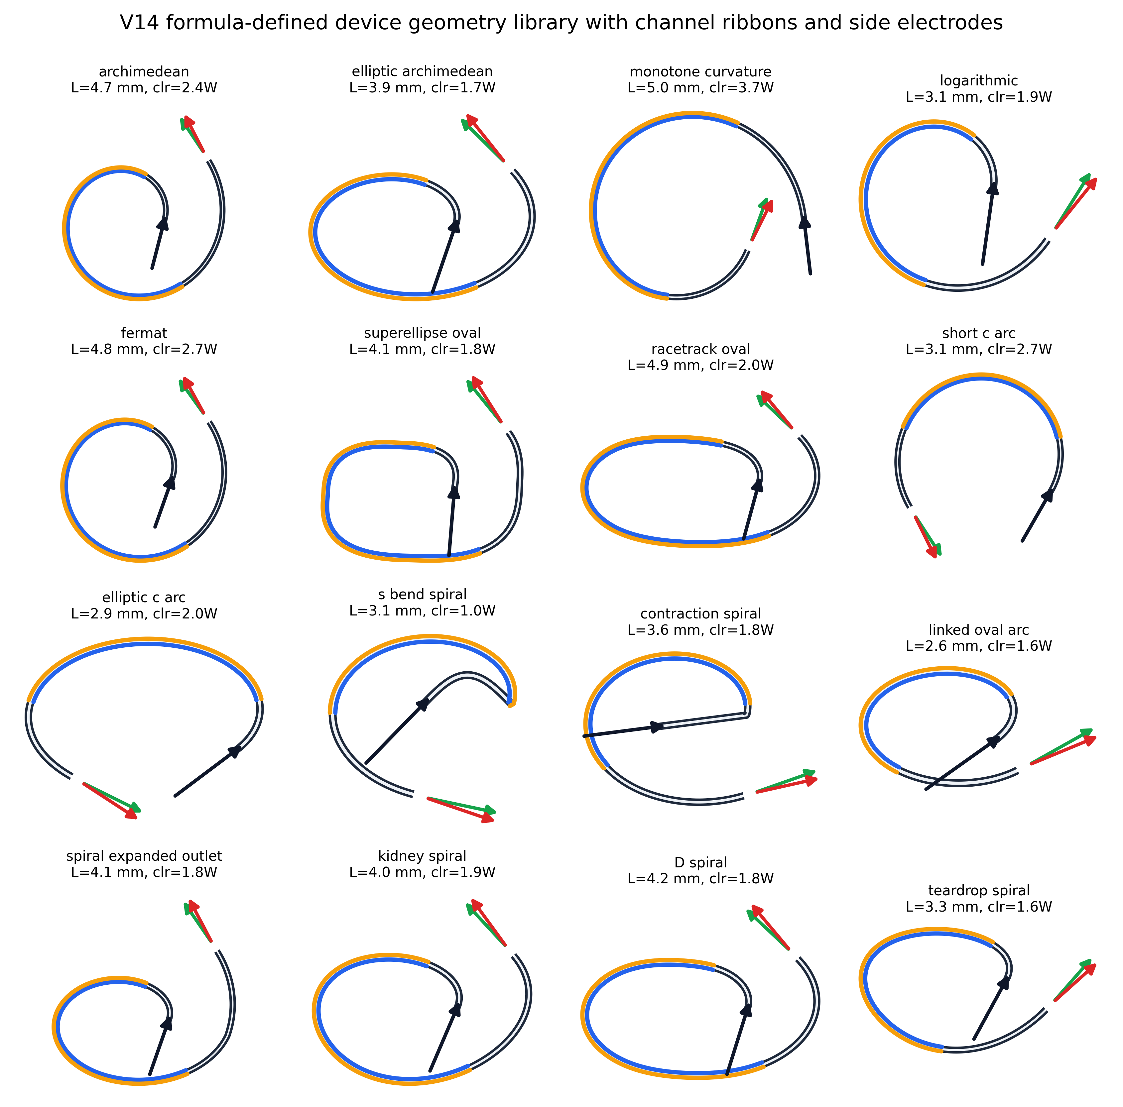
Fig. 2. V14 clean geometry library. Every candidate is drawn as a finite-width device channel with side electrodes and inlet/outlet markers; the CSV file stores formula, length, footprint, and clearance gate.

I. INTRODUCTION
Live/dead cell sorting is important in cell processing, bioreactor monitoring, and label-free sample preparation. Passive spiral microchannels can provide compact curved-channel focusing, but viability contrast is weak when live and dead cells have overlapping size distributions. DEP provides an orthogonal electrical-property contrast through the complex Clausius-Mossotti factor. The design hypothesis is therefore not simply that a longer spiral improves separation, but that a compact curved channel and staged DEP activation can provide useful topology gain beyond a same-length straight DEP channel.
The 2026 spiral DEP numerical paper in the local literature set is used as a figure-language reference: clean channel boundaries, electrode labels, inlet/outlet details, and annotated device regions. V14 adopts that style while keeping the project's own result bounded. The current model remains reduced order and must not be read as electrode-resolved CFD/FEM validation.
II. DEVICE GEOMETRY AND MODEL
The selected topology is a monotone-curvature spiral generated by r(theta)=r0/(1+k theta)^p with a smooth outer entry segment. Side-wall DEP electrodes are abstracted as two active traces along the channel boundaries, with active coverage between the optimized DEP start and end fractions. The outlet is represented as a two-branch splitter that maps lateral position into live-rich and dead-rich outlets.
The final channel length is 7.08 mm. The optimized operating point uses 20.36 V, 1.30 MHz, 72.9 um electrode gap, and 0.547 uL/min flow. Population-level trajectories are sampled from live/dead dielectric and size distributions used in the V12 package.
III. FORMULA-DEFINED GEOMETRY LIBRARY
Earlier versions over-emphasized centerlines and visually irregular curves. V14 therefore records a larger formula-defined library using channel ribbons, as shown in Fig. 2: Archimedean, elliptic, monotone-curvature, logarithmic, Fermat, superellipse/oval, C-arc, S-bend-prefocused, contraction-entry, expanded-outlet, D-shaped, and smooth kidney-like variants. These are not claimed as all simulated finalists; they are the clean topology candidates that can be carried into the next high-fidelity mesh stage.
IV. OPTIMIZATION AND ML USE
ML is used as a surrogate optimizer, not as a black-box claim generator. ExtraTrees regression ranks formula-parameter candidates from reduced-order simulations. The objective penalizes unrealistic apparent maxima by checking same-length straight DEP controls, no-DEP controls, inlet-focus controls, wall loss, thermal proxy, pressure proxy, and geometry clearance. This prevents the trivial route of increasing channel length or voltage until the reduced-order model reports near-perfect separation.
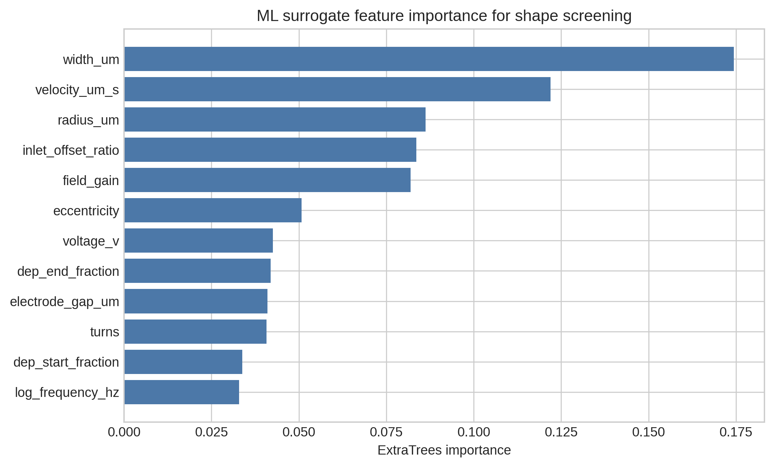
Fig. 3. Existing V12 surrogate feature-importance plot retained for traceability of the ML-assisted optimization stage.
V. RESULTS
The final selected point deliberately sacrifices some apparent maximum accuracy for lower thermal load and stronger device plausibility. It passes the target gate, retains positive topology gain, and keeps wall loss at zero in the held-out validation set. The trajectory overlay in Fig. 4 is generated on the device ribbon rather than on a bare centerline, making the outlet mapping and electrode region easier to inspect.
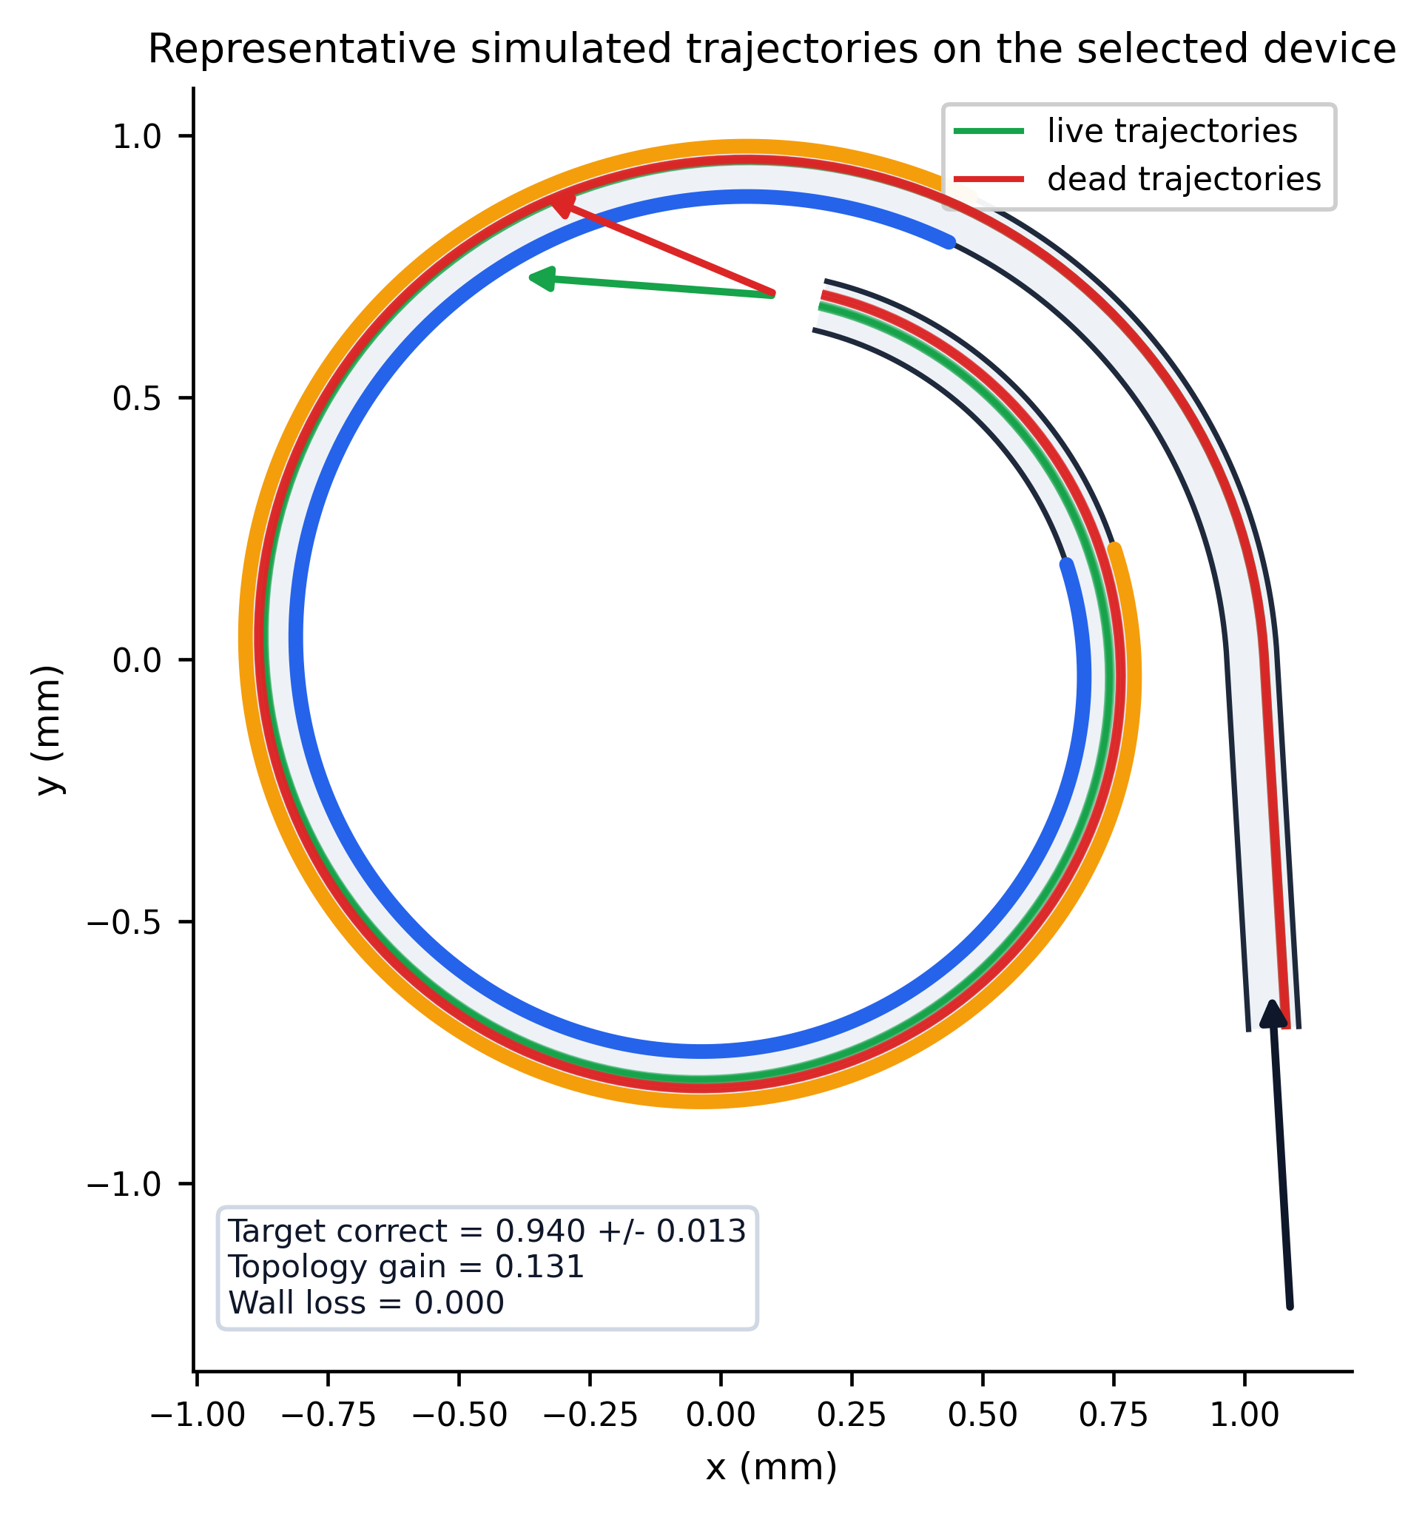
Fig. 4. Representative live/dead trajectory overlay on the selected V14 device schematic. Green and red lines show sampled live and dead paths from the V13 trajectory table mapped onto the final channel ribbon.
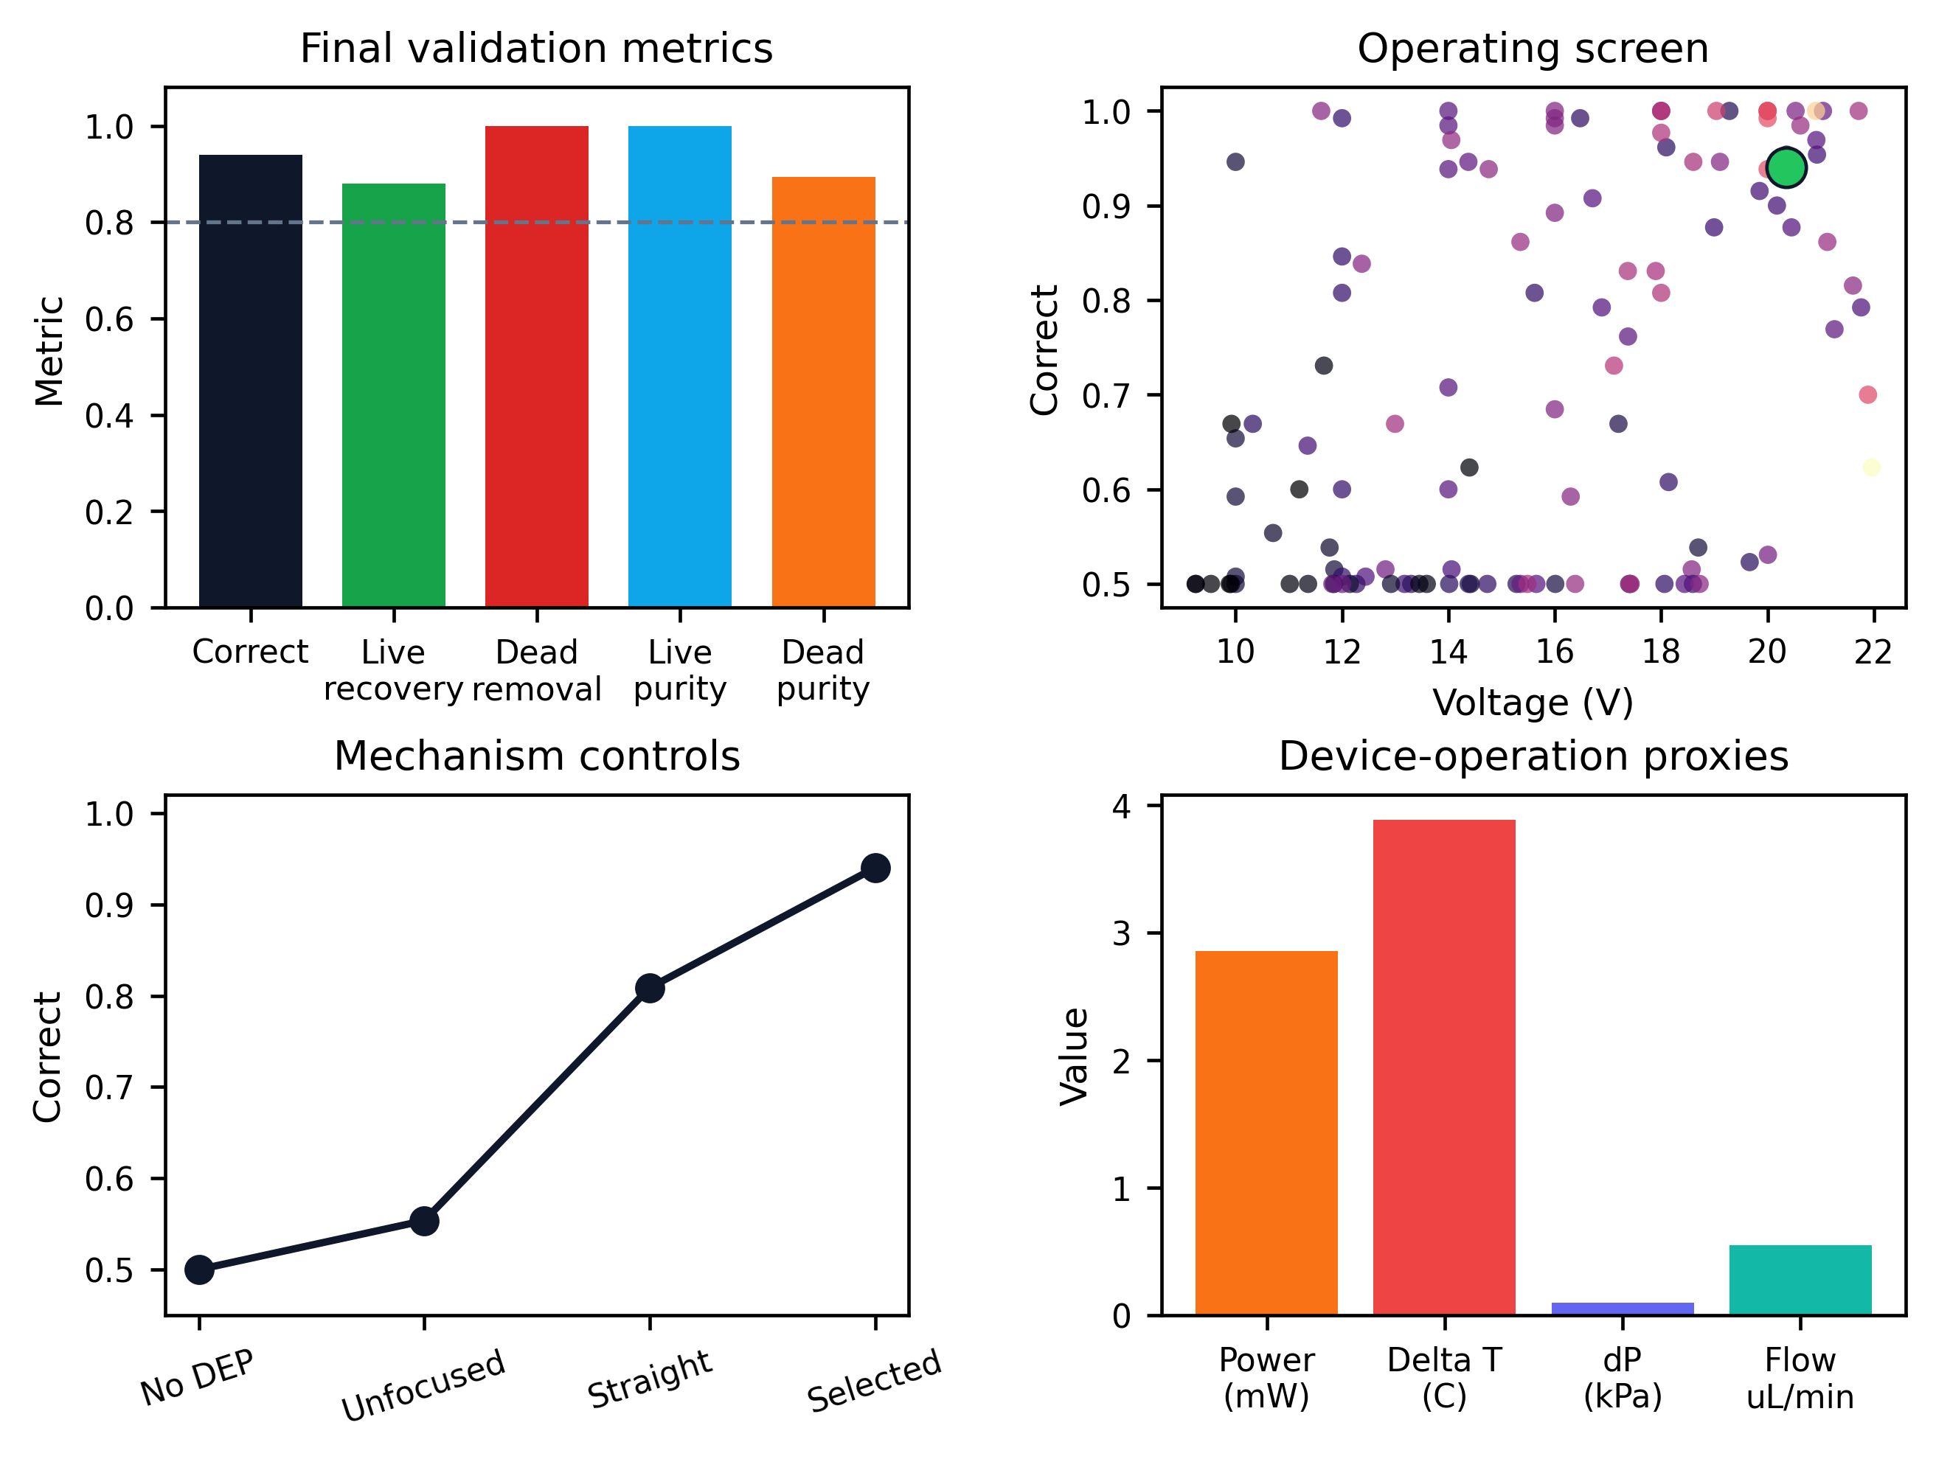
Fig. 5. IEEE-style compact result plate: validation metrics, voltage-performance screen, mechanism controls, and device-operation proxies.
Metric | Value
Target correct | 0.940 +- 0.013
Live recovery | 0.880
Dead removal | 1.000
Wall loss | 0.000
Topology gain | 0.131
Voltage | 20.36 V
Flow rate | 0.547 uL/min
Joule power proxy | 2.86 mW
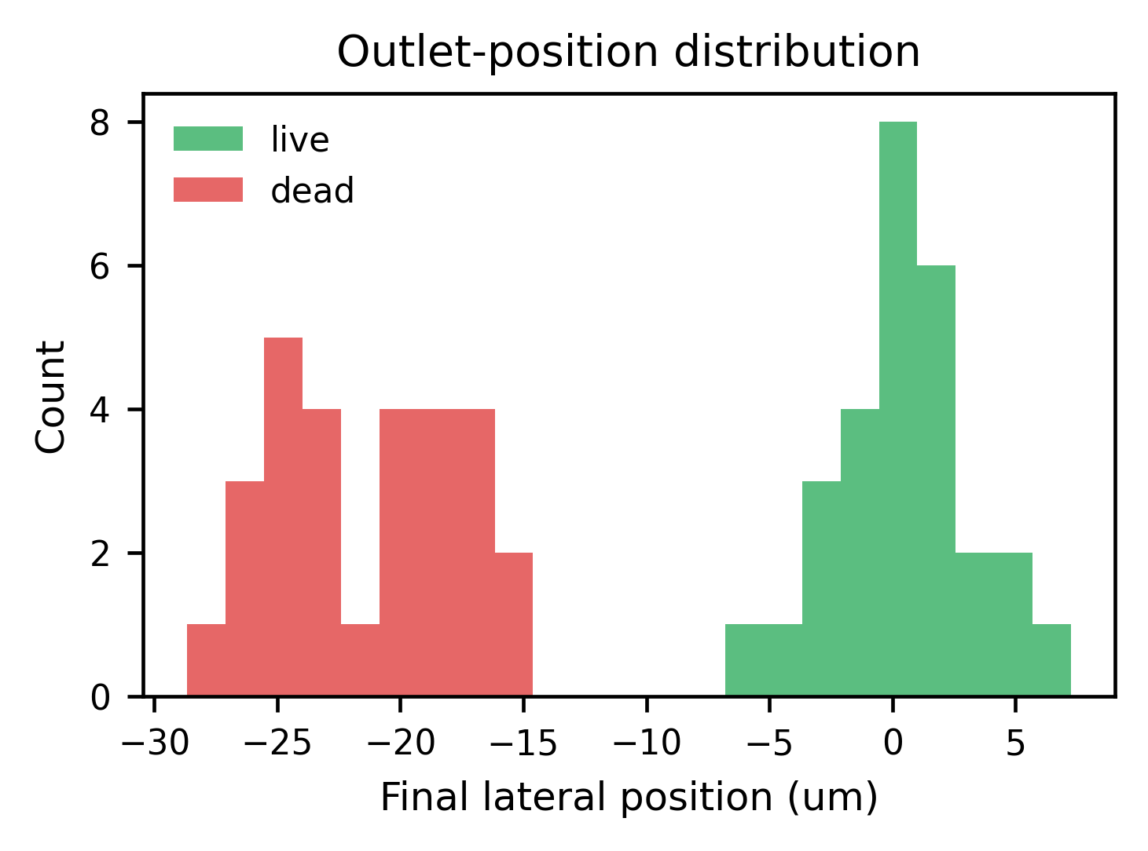
Fig. 6. Final lateral-position distribution from the V13 visualization run.
VI. THERMAL AND HYDRAULIC PLAUSIBILITY
The thermal model remains a conservative ranking proxy. Active Joule power is estimated from medium conductivity, field proxy, active volume, and active DEP fraction; the steady substrate delta-T value is not a validated chip temperature. This is sufficient for early-stage school-project screening because it prevents high-voltage over-selection, but a final paper would still require electrode-resolved electric-field and heat-transfer simulation.
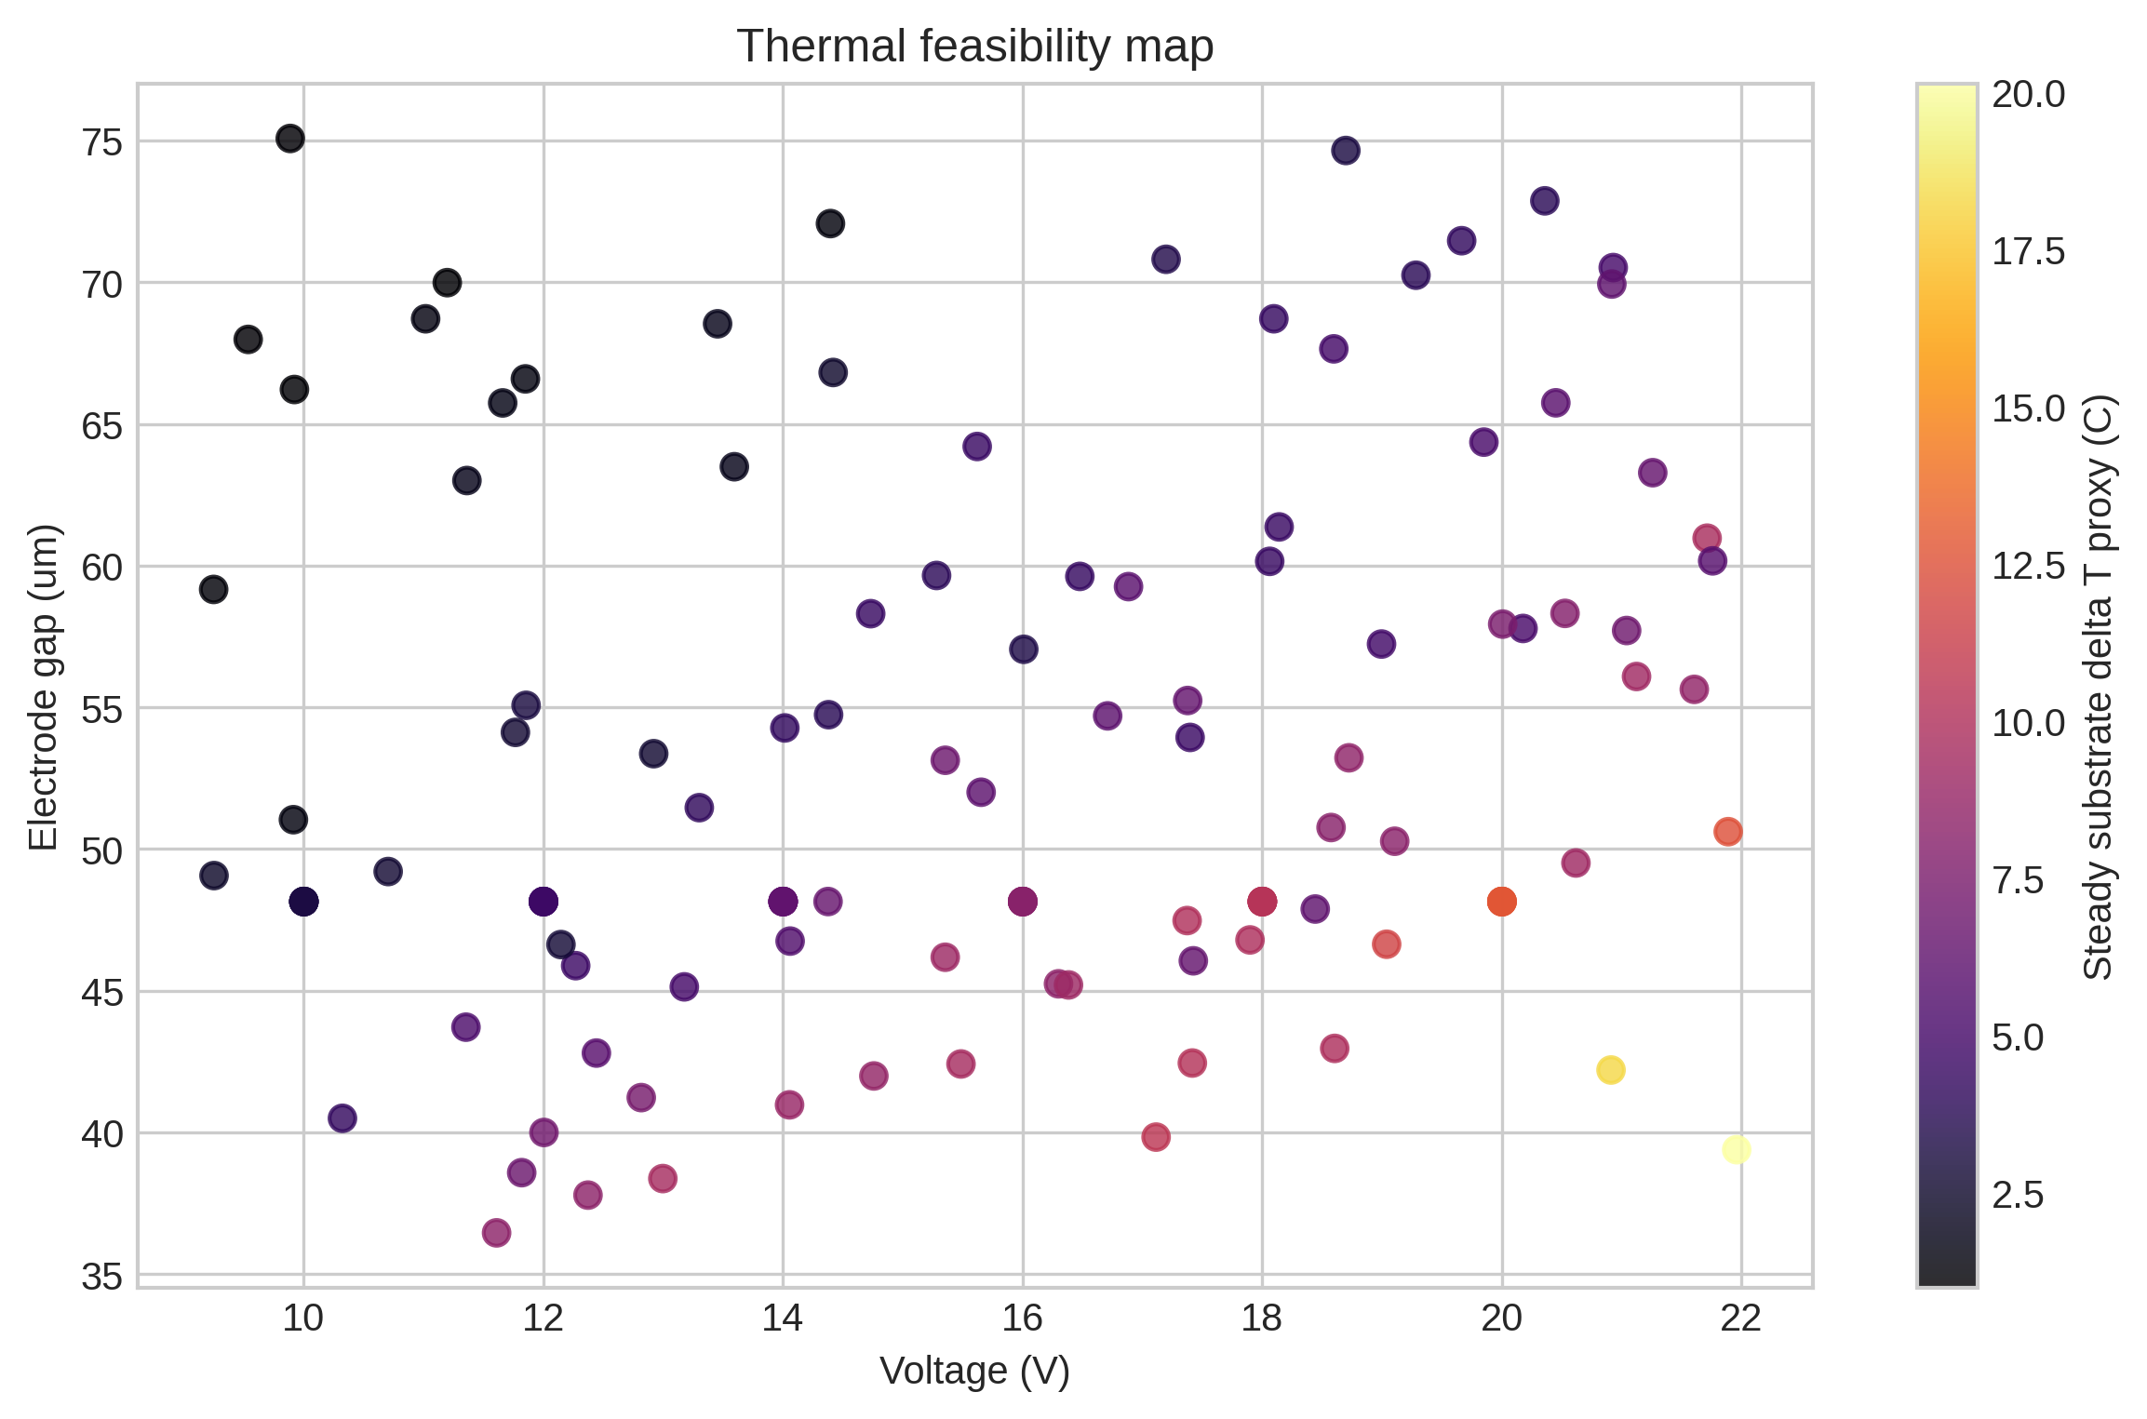
Fig. 7. V12 thermal feasibility map retained as the operating-window safety check for voltage and electrode gap.
VII. DISCUSSION AND LIMITATIONS
The most important interpretation is negative as well as positive. A high correct value alone is not academically persuasive because the reduced-order model can be made over-deterministic by increasing residence time or field strength. The useful result is the comparison against controls: no DEP is near chance, same-length straight DEP is lower than the selected spiral, and the selected design keeps thermal and wall-loss proxies within plausible ranges.
Remaining limitations are substantial: the current electric field is not solved from explicit electrode geometry, thermal transport is simplified, cell deformation and cell-cell interaction are omitted, and dielectric parameters require calibration for a real cell line. Therefore V14 is visually and structurally closer to a manuscript, but the scientific claim should remain: a candidate device and optimization workflow have been identified for high-fidelity validation.
VIII. CONCLUSION
V14 produces a cleaner IEEE-style manuscript draft and a more credible device figure package. The final candidate is a compact monotone-curvature spiral DEP sorter with explicit electrodes, inlet, outlet, dimensions, trajectory overlay, and multi-objective operating metrics. The next technical step is to convert the selected ribbon geometry into an electrode-resolved OpenFOAM/FEM case and test whether the reported topology gain survives the higher-fidelity field model.
REFERENCES
[1] S. Betyar and A. Ramiar, Numerical Simulation of Biological Particle Separation in a Spiral Microchannel Using the Dielectrophoresis Mechanism, 2026.
[2] A. Shafiee et al., Contactless dielectrophoresis for selective live/dead cell isolation, Lab on a Chip, 2010.
[3] S. Elitas et al., Dielectrophoretic separation of live and dead monocytes using 3D carbon electrodes, Sensors, 2017.
[4] T. Kwon and S. Choi et al., continuous removal of small nonviable suspended mammalian cells and debris using inertial microfluidics, Lab on a Chip, 2018.
[5] V12 local analytical-design package, final optimization validation summary and controls, 2026.

