Literature-Bounded Computational Design Envelope and Feature Importance for Spiral DEP Live/Dead Cell Sorting
Feasibility and model-reality analysis for the next optimization stage
ABSTRACT
This report defines a literature-bounded design envelope and an interpretable feature-importance analysis for a continuous spiral dielectrophoretic device intended for live/dead cell sorting. The objective is not to claim final device performance, but to prevent the optimization from becoming an unconstrained numerical exercise. Feasible ranges are derived from spiral DEP, live/dead DEP, facing-electrode DEP, and thermal/ACET literature. Existing reduced-order simulation outputs are then combined and analyzed with decision-tree regressors to identify the dominant parameters controlling outlet classification and a penalized design score. The analysis indicates that channel width, velocity/residence-time variables, electrical field variables, inlet focusing, and geometry class currently dominate the reduced-order model. Turn count and ellipticity must therefore be isolated in the next experiment, rather than mixed with voltage and velocity changes.
1. LITERATURE-BOUNDED FEASIBLE ENVELOPE
The feasible envelope was not selected arbitrarily. Betyar and Ramiar [R1] provide the closest spiral DEP/OpenFOAM precedent: one inlet, two outlets, side-wall electrodes, 100 um channel width, 1-5 spiral turns, and inlet velocities of 1000, 3000, and 5000 um/s. Elitas et al. [R5] provide a mammalian live/dead DEP anchor with 20 Vpp, 300 kHz, 1 uL/min, and approximately 90% dead-cell removal. Nguyen et al. [R10] provide a modern facing-electrode numerical workflow with explicit separation efficiency and purity, plus sweeps over voltage, velocity ratio, channel height, and electrode number. Jiang et al. [R15] motivate thermal gates because Joule heating and AC electrothermal flow can disturb DEP manipulation.
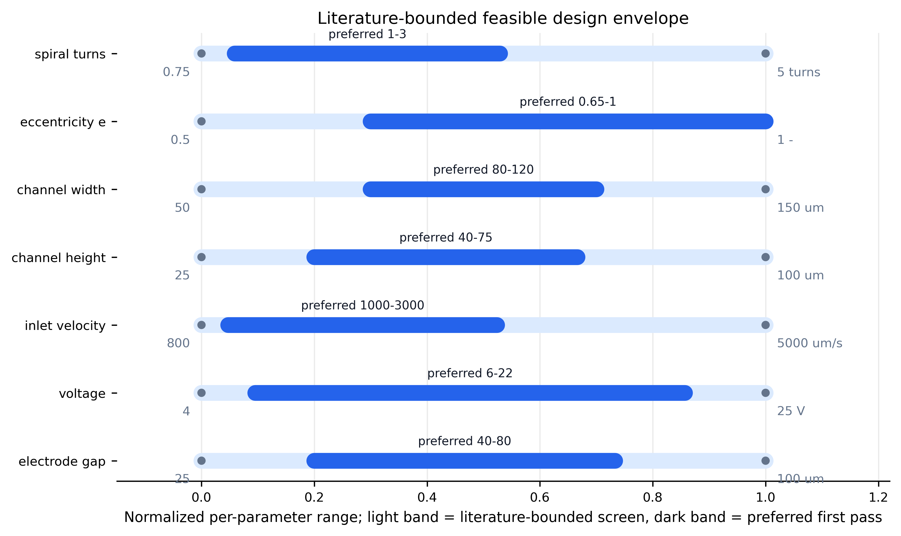
Figure 1. Literature-bounded feasible design envelope. The broad band is the screening range; the darker band is the preferred first-pass range for computational optimization.
Parameter | Screen range | Preferred range | Refs | Reason
spiral_turns (turns) | 0.75-5.00 | 1.00-3.00 | R1, R2 | Turns must be swept directly because prior spiral DEP work shows voltage decreases with turn count, but extra turns may only add residence time.
eccentricity_e (dimensionless) | 0.50-1.00 | 0.65-1.00 | R16 | Ellipticity is a controlled, formula-defined way to test compactness and curvature distribution without arbitrary curves.
channel_width (um) | 50-150 | 80-120 | R1, R2 | Width near 100 um is compatible with the spiral DEP precedent and with 20-25 um cells without excessive wall loss.
channel_height (um) | 25-100 | 40-75 | R10 | Height changes DEP field exposure and flow resistance; 40-75 um is a conservative first range.
inlet_velocity (um/s) | 800-5000 | 1000-3000 | R1 | The model must include velocity because higher inlet velocity increases required voltage and reduces residence time.
flow_rate (uL/min) | 0.1-10 | 0.2-3.0 | R5 | Flow-rate targets should be feasible but not selected so low that the model becomes trivially deterministic.
voltage (V or Vpp depending on electrode convention) | 4-25 | 6-22 | R1, R5, R9, R10 | Voltage must be optimized with heating and over-deflection checks rather than maximized.
frequency (Hz) | 50 kHz-3 MHz | 100 kHz-1.5 MHz | R5, R10 | Frequency is required because live/dead DEP contrast is viability-dependent and can reverse or collapse outside the useful CM window.
electrode_gap (um) | 25-100 | 40-80 | R1, R5 | Gap is a field-strength control and a fabrication constraint; too small increases field and heating risks.
medium_conductivity (S/m) | 0.002-0.055 | 0.002-0.020 | R5, R10, R15 | Conductivity should be low in the first DEP model unless thermal/ACET coupling is explicitly included.
thermal_gate (C, mW) | DeltaT proxy <5; power proxy <10 | DeltaT proxy <3; power proxy <5 | R15 | Thermal constraints are used as gates so the optimizer cannot choose unrealistic voltage/conductivity combinations.
Table 1. Feasible parameter ranges extracted from the local literature set and converted into optimization bounds.
2. MATHEMATICAL MODEL STORED IN LATEX
All equations used by the computational model are stored in results/final_v1/latex_equations.tex. The next stage should keep the formula family deliberately simple: an Archimedean spiral with elliptic scaling. This makes turn count and ellipticity testable instead of hiding them inside arbitrary curves.
r(\theta)=r_0+p\theta,\quad 0\leq\theta\leq2\pi N
x(\theta)=r(\theta)\cos\theta,\quad y(\theta)=e\,r(\theta)\sin\theta
\mathbf{F}_{DEP}=2\pi\epsilon_m r_p^3\operatorname{Re}\{K(\omega)\}\nabla|\mathbf{E}|^2
K(\omega)=\frac{\epsilon_p^\ast-\epsilon_m^\ast}{\epsilon_p^\ast+2\epsilon_m^\ast},\quad \epsilon^\ast=\epsilon-\frac{j\sigma}{\omega}
3. FEATURE CATALOGUE AND DECISION-TREE METHOD
The feature catalogue separates geometry, electrical, flow, inlet/outlet, and output variables. A decision-tree regressor was fitted to existing screening simulations from the clean-shape and final operating datasets. Two targets were analyzed: raw target_correct and a penalized design_score that subtracts wall-loss, power, length, and thermal-risk penalties. This is intentionally interpretable; the purpose is to expose model dependence, not to produce a black-box optimizer.
The decision tree for target_correct used 513 rows and 39 numeric features. Test R2 was 0.373 with test MAE 0.077. Because this is observational reduced-order data, feature importance should be read as model sensitivity, not causal proof.
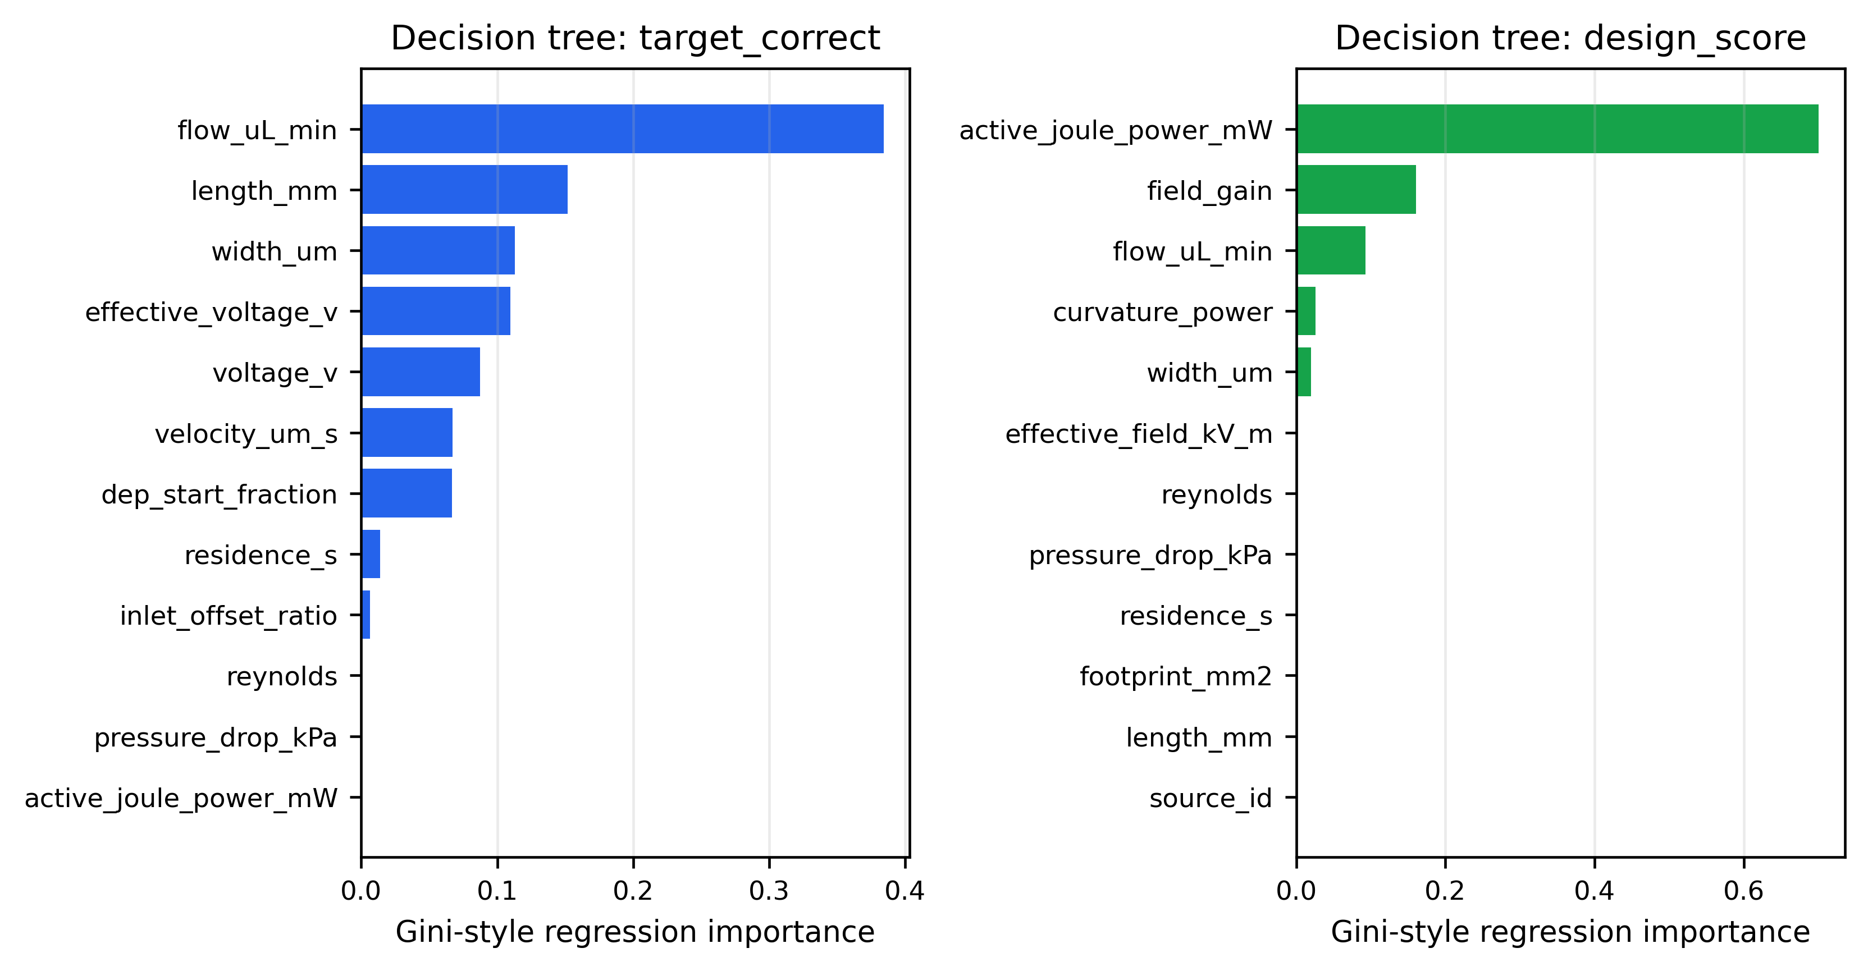
Figure 2. Decision-tree feature importance for raw target_correct and penalized design_score.
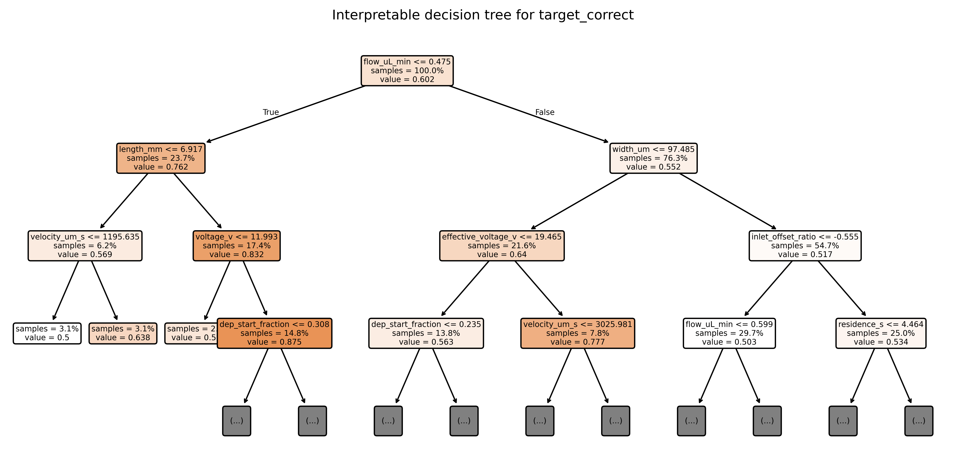
Figure 3. Interpretable decision-tree structure for target_correct. The tree is intentionally shallow to avoid opaque overfitting.
4. TURN COUNT AND ELLIPTICITY REALITY CHECK
The current data do include variation in turn count and ellipticity, but those variables are not yet isolated cleanly. They are mixed with geometry family, velocity, width, voltage, active DEP coverage, and residence time. Therefore, a high-accuracy candidate cannot yet be used as evidence that a larger number of turns or a more elliptical spiral is intrinsically superior.
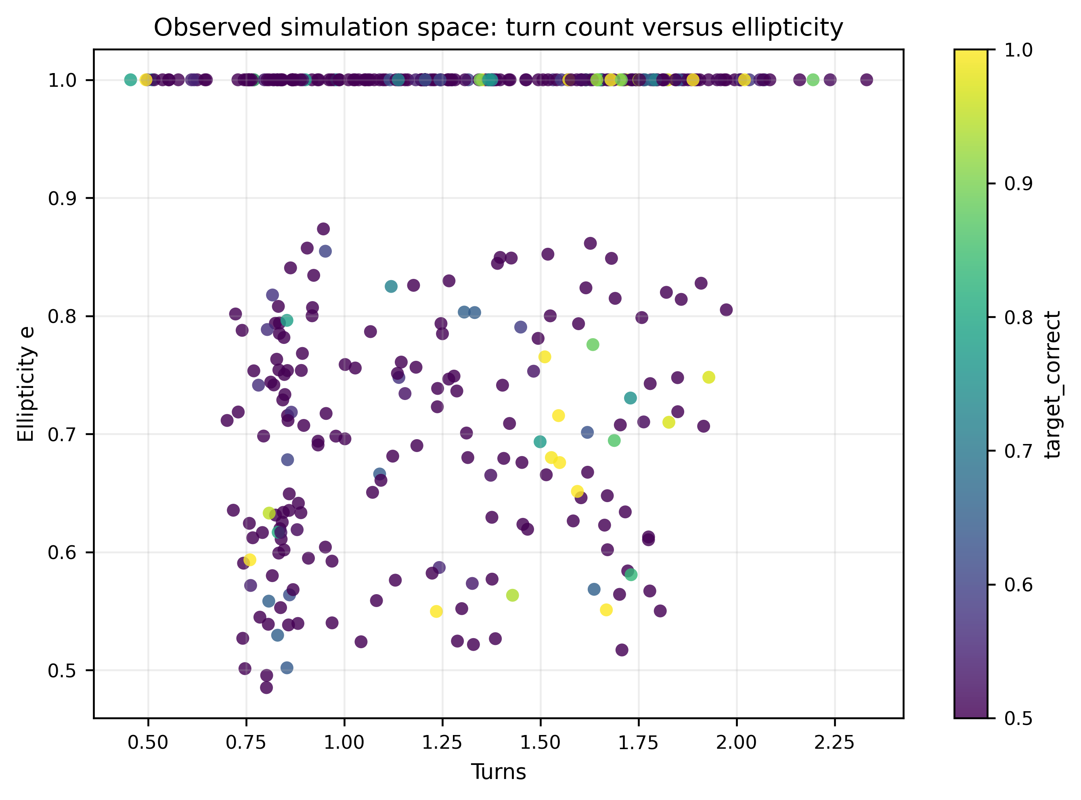
Figure 4. Observed simulation space for turn count and ellipticity. This plot motivates a controlled turn-by-ellipticity sweep.
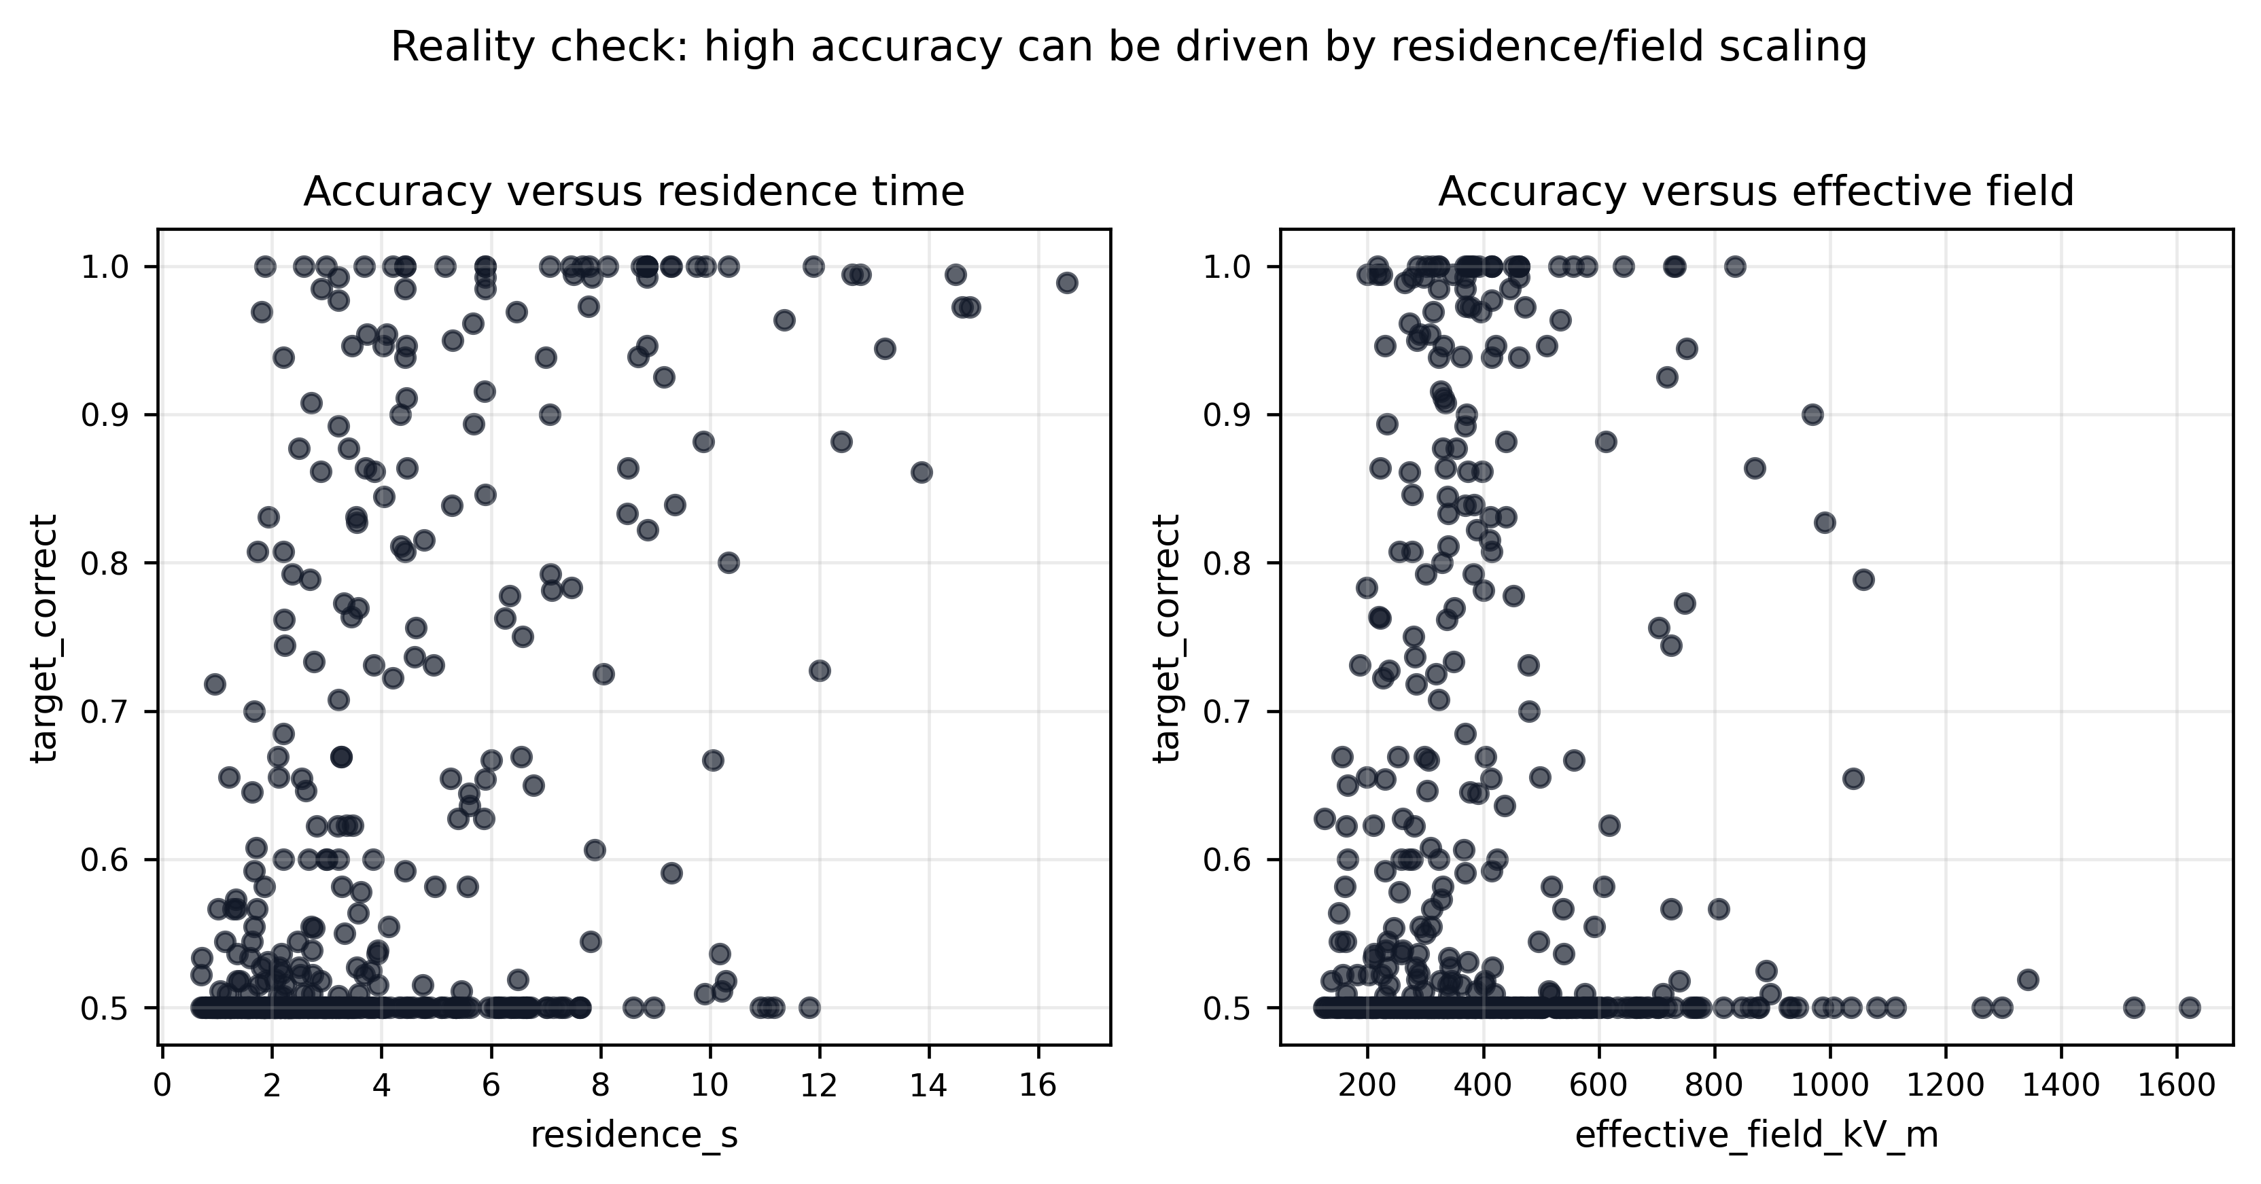
Figure 5. Reality check showing why accuracy alone is insufficient: residence time and field strength can drive apparent separation in the reduced-order model.
5. MOST IMPORTANT FEATURES
- flow_uL_min: importance 0.384
- length_mm: importance 0.152
- width_um: importance 0.113
- effective_voltage_v: importance 0.110
- voltage_v: importance 0.087
- velocity_um_s: importance 0.067
- dep_start_fraction: importance 0.067
- residence_s: importance 0.014
The immediate implication is that the next experiment must control confounding. Turn count should be swept at fixed voltage, velocity, width, frequency, electrode gap, and outlet split; ellipticity should be swept at fixed length or analyzed with length-normalized performance. Otherwise, the optimizer will rediscover the trivial rule: increase residence time or effective field until particles separate.
6. PROPOSED NEXT COMPUTATIONAL EXPERIMENT
The next design experiment should be a structured grid rather than a broad random search. Recommended variables are: turns N in {0.75, 1.0, 1.5, 2.0, 2.5, 3.0, 4.0, 5.0}; ellipticity e in {0.55, 0.70, 0.85, 1.00}; voltage in a narrow feasible band around the literature-supported low-voltage region; and velocity fixed initially at 1000 and 3000 um/s. Each point should be compared with same-length straight DEP and no-DEP controls. Only after the turn/eccentricity mechanism is clean should ML be used for fine tuning.
7. REFERENCES
[R1] S. Betyar and A. Ramiar, Numerical Simulation of Biological Particle Separation in a Spiral Microchannel Using the Dielectrophoresis Mechanism, 2026.
[R2] N. Lewpiriyawong, C. Yang, and X. Xuan, Particle separation by charge in spiral microchannels, Biomicrofluidics, 2011.
[R5] Y. Yildizhan et al., Dielectrophoretic Separation of Live and Dead Monocytes Using 3D Carbon-Electrodes, Sensors, 2017.
[R9] Huang et al., Label-free Live and Dead Cell Separation Method Using a High-Efficiency ODEP Force-based Microfluidic Platform, 2025.
[R10] Nguyen et al., Facing-electrode DEP cell separation, Scientific Reports, 2024.
[R15] Jiang et al., Numerical simulations of combined DEP and AC electrothermal flow, Micromachines, 2024.
[R16] Petruzzellis et al., Lab-on-Chip Systems for Cell Sorting and Spiral Microchannels, Micromachines, 2024.

