V12 Final Optimization Report
Compact spiral DEP microfluidic design for live/dead cell sorting
Prepared from the analytical-design repository. Date: 2026-05-26.
This report consolidates the V9-V11 geometry studies and adds a V12 operating-window optimization. The selected geometry is a non-intersecting monotone-curvature spiral. The final claims remain numerical and reduced-order until electrode-resolved field simulation and experimental validation are completed.

Executive Summary
- Selected family: monotone_curvature_spiral.
- Validated target correct: 0.940 +/- 0.013.
- Topology gain versus same-length straight DEP: 0.131.
- Length and footprint: 7.08 mm and 3.67 mm2.
- Flow rate, voltage, electrode gap: 0.547 uL/min, 20.36 V, 72.9 um.
- Thermal proxies: 2.86 mW active Joule power and 3.89 C substrate delta-T proxy.
- Main limitation: DEP remains represented by an electrode-gap field-gain proxy; V12 is a design-screening package, not final CFD/FEM proof.

Literature and Novelty Position
The project combines three literature clusters: spiral microchannels for compact inertial handling of cells [R4, R8, R16], DEP live/dead or viability-selective separation [R5-R7, R9, R12], and spiral or circular DEP numerical device studies [R1-R3, R17]. The working novelty window is not a claim of experimental first demonstration; it is a numerical design study for a continuous spiral DEP live/dead sorting architecture with explicit recovery, purity, topology-control and thermal checks.
This framing prevents a weak claim based only on longer channels. Throughout V10-V12, a same-length straight DEP control is used to test whether a curved/spiral topology contributes beyond residence time.

Final Geometry
The selected shape is a monotone-curvature spiral with a smooth low-curvature entry. The formula avoids arbitrary local wiggles and supports clean fabrication discussion.
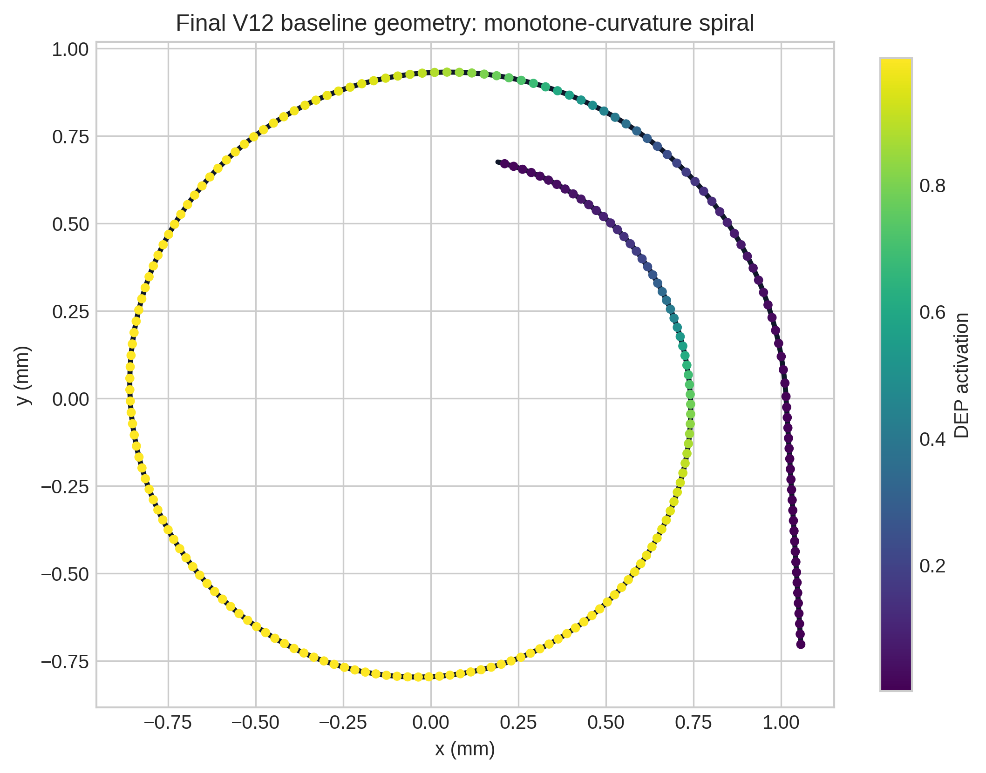
Figure 1. Final V12 baseline geometry. Color marks the smooth DEP activation window used in the reduced-order particle model.

Geometry Candidate Controls
Candidate geometries were not accepted by accuracy alone. Designs with high accuracy but equal same-length straight-control performance were rejected as weak topology evidence.
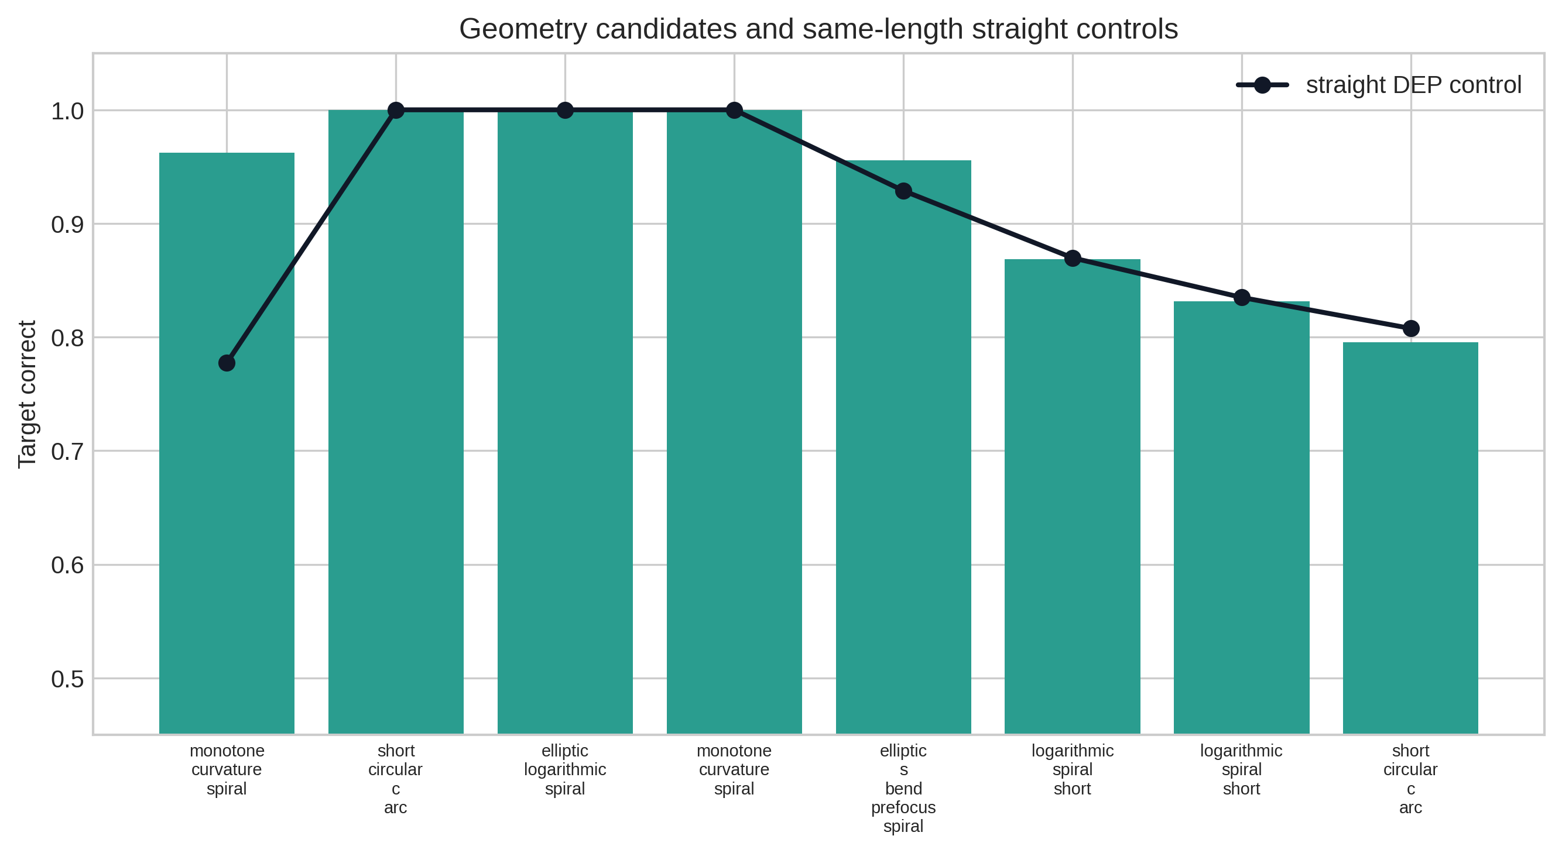
Figure 2. V11 geometry candidates and same-length straight DEP controls.

Design Evolution
V9 introduced formula-defined spirals, V10 imposed short clean shape families, and V11 added non-intersection filtering. V12 selects the operating point around the V11 geometry.
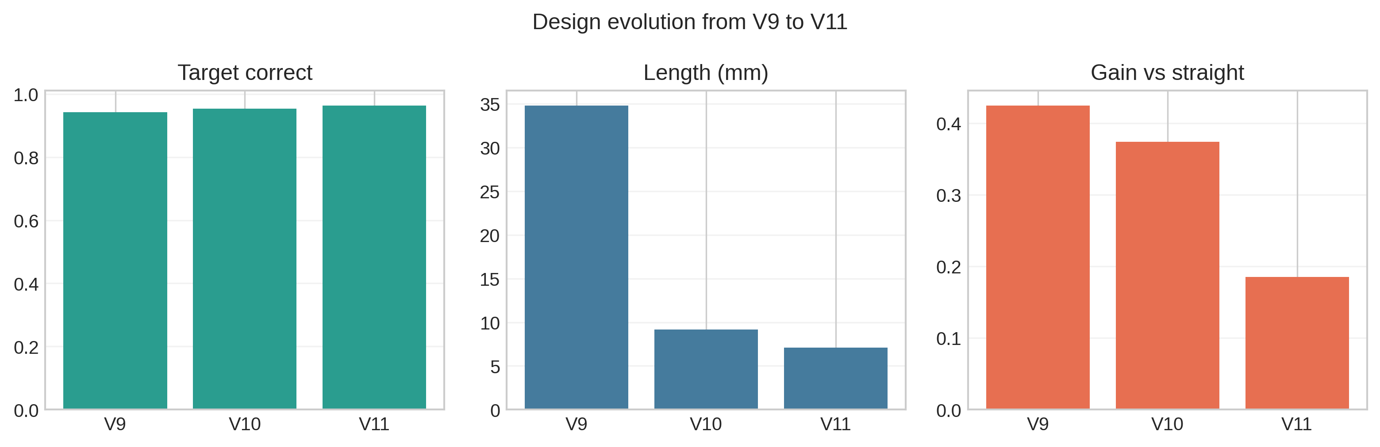
Figure 3. Evolution of correct classification, length, and topology gain across design versions.

ML Shape Optimization
The ML model is a surrogate ranker over formula parameters. It does not draw arbitrary curves. The optimized variables have physical meaning and are exported in JSON and CSV.
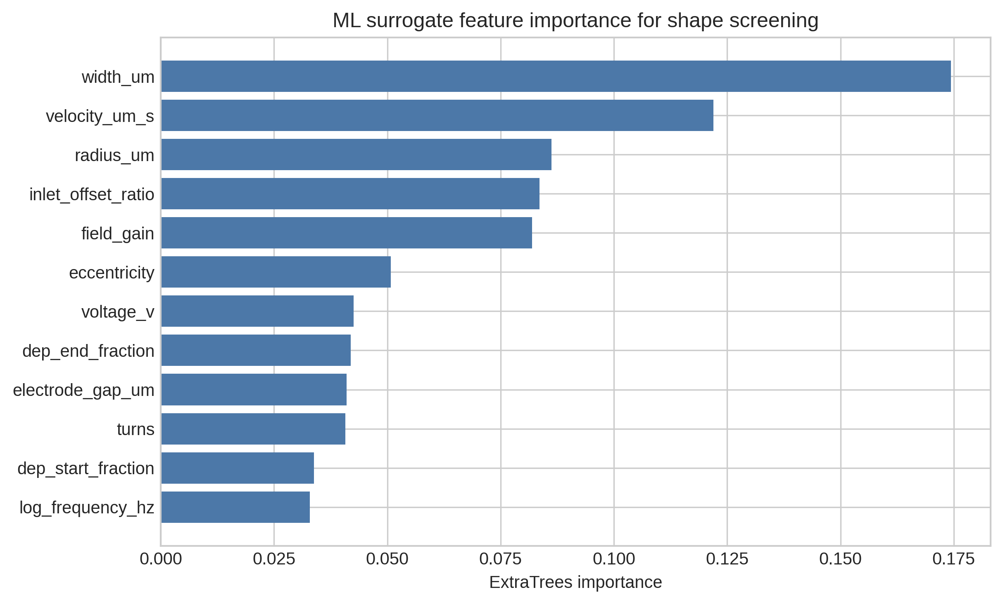
Figure 4. ExtraTrees feature importance for the V11 shape optimization screen.

Operating Pareto Screen
The V12 operating-window screen balances classification against Joule-heating proxy. Points above 0.90 target correct and below about 10 mW are preferred.
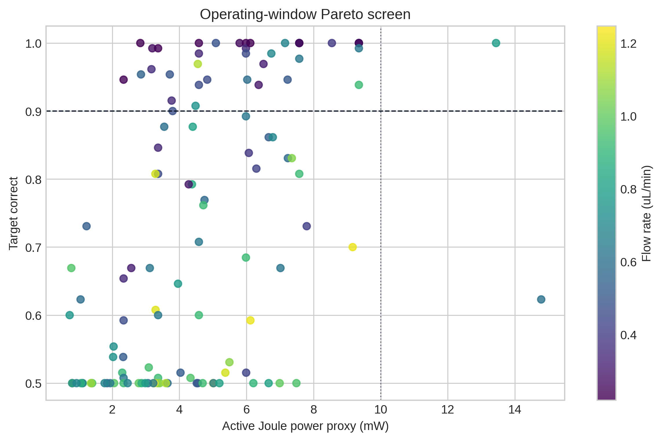
Figure 5. Target correct versus active Joule power proxy for the V12 operating sweep.

Flowrate and Residence Time
Flowrate cannot be maximized blindly. Higher flow improves throughput but can reduce residence time and separation. The selected point stays in a moderate-flow region.
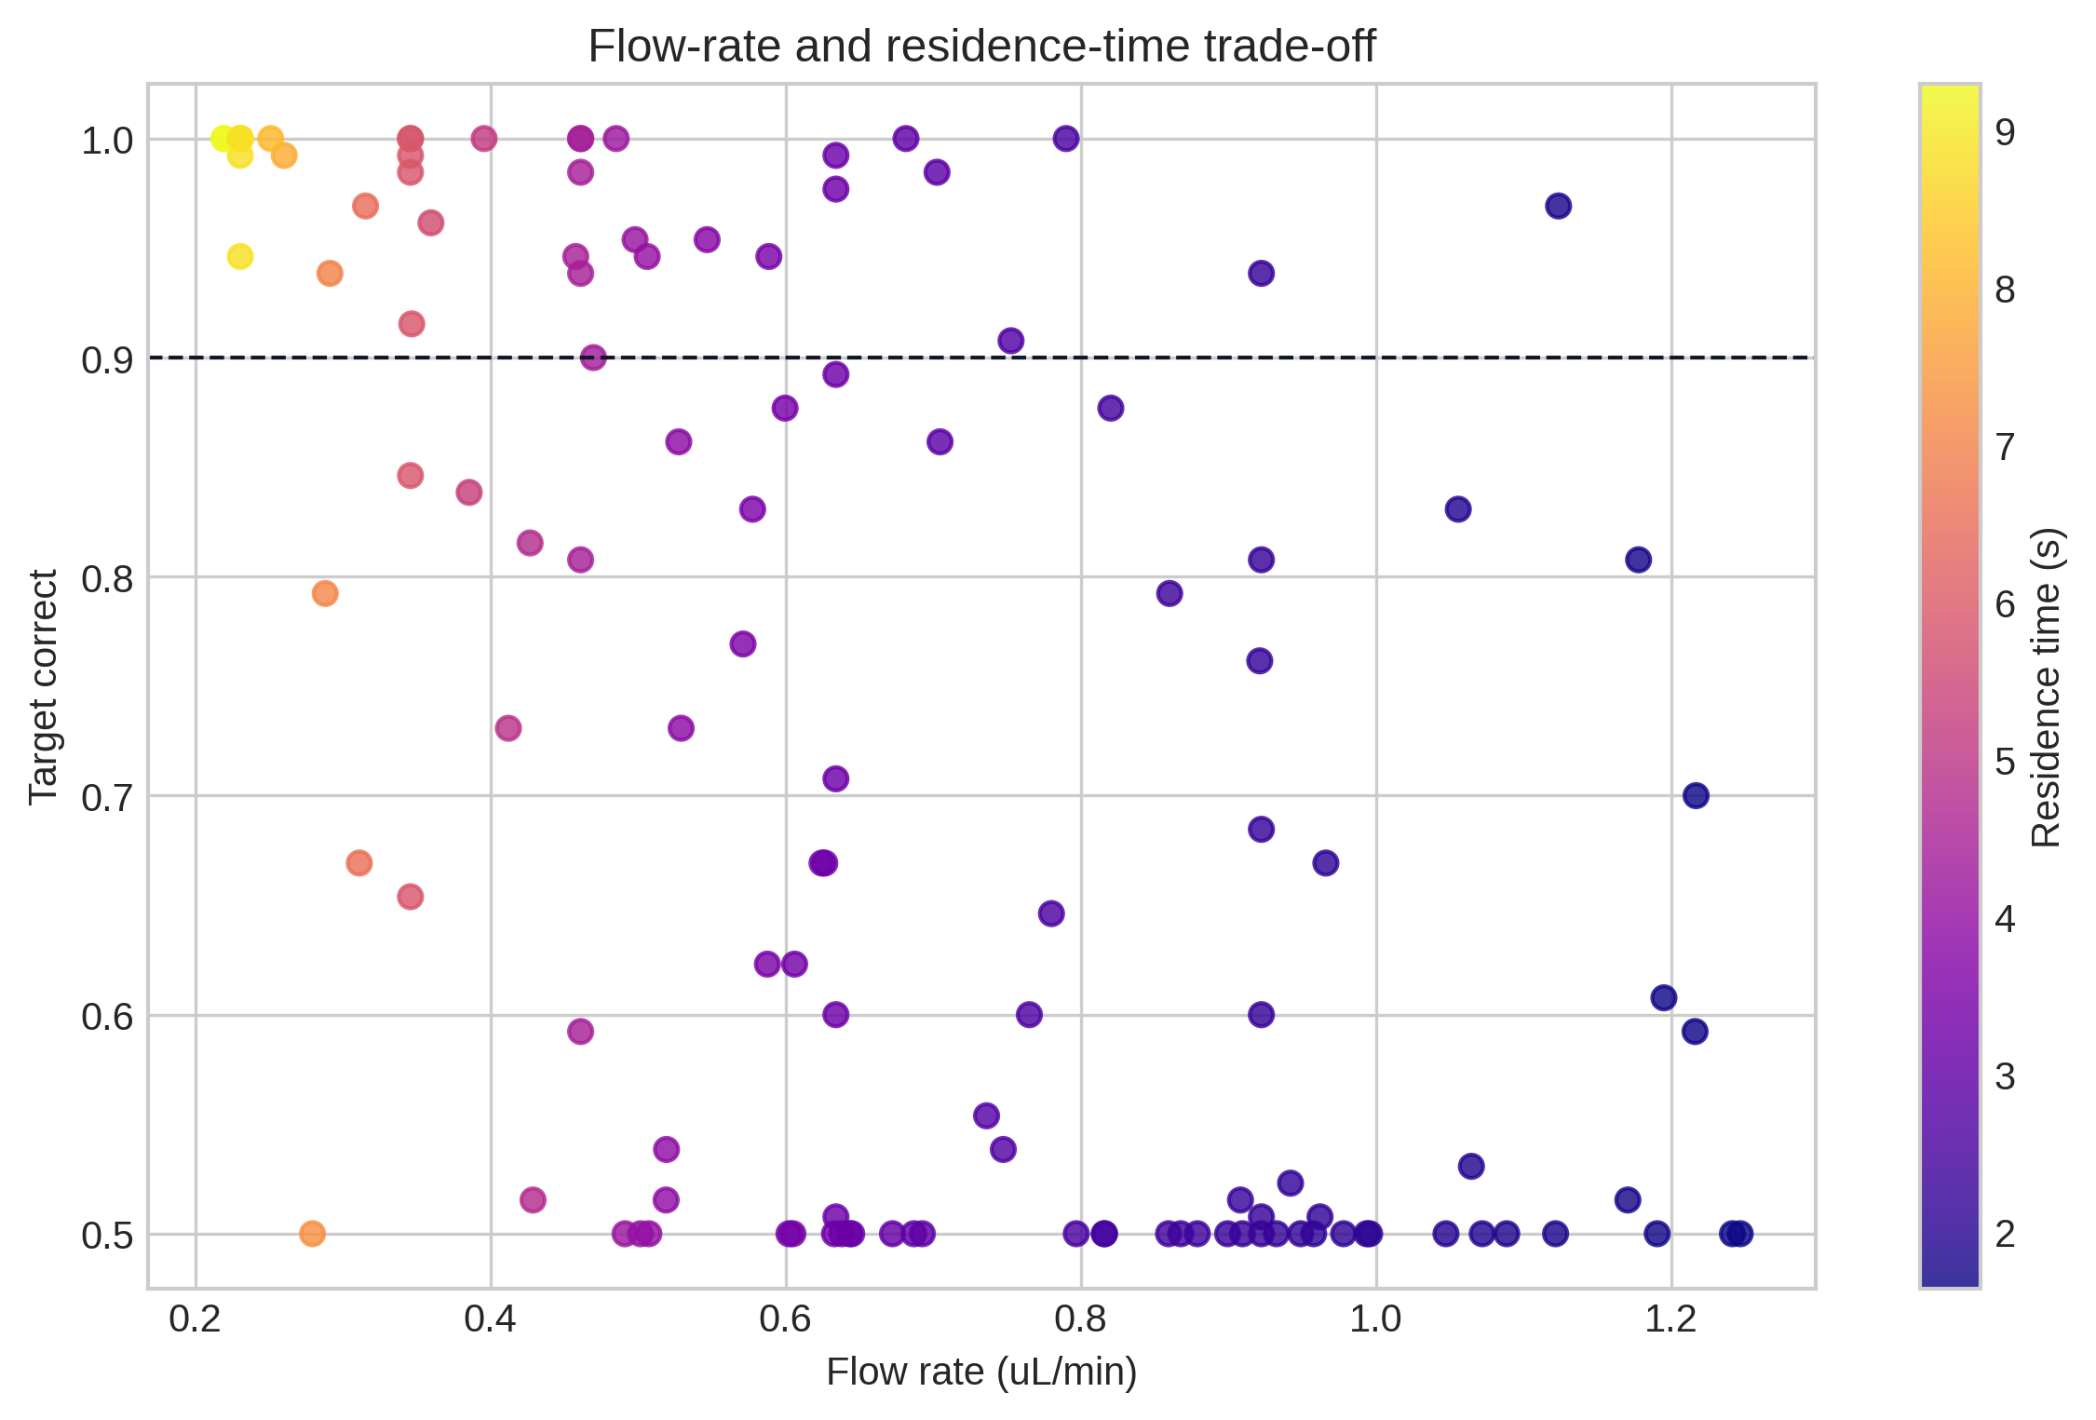
Figure 6. Flowrate, residence time, and target correct trade-off.

Thermal Feasibility
Thermal screening uses a Joule power proxy and a simple substrate heat-loss proxy. This is not a substitute for heat-transfer CFD, but it flags unsafe operating regions.
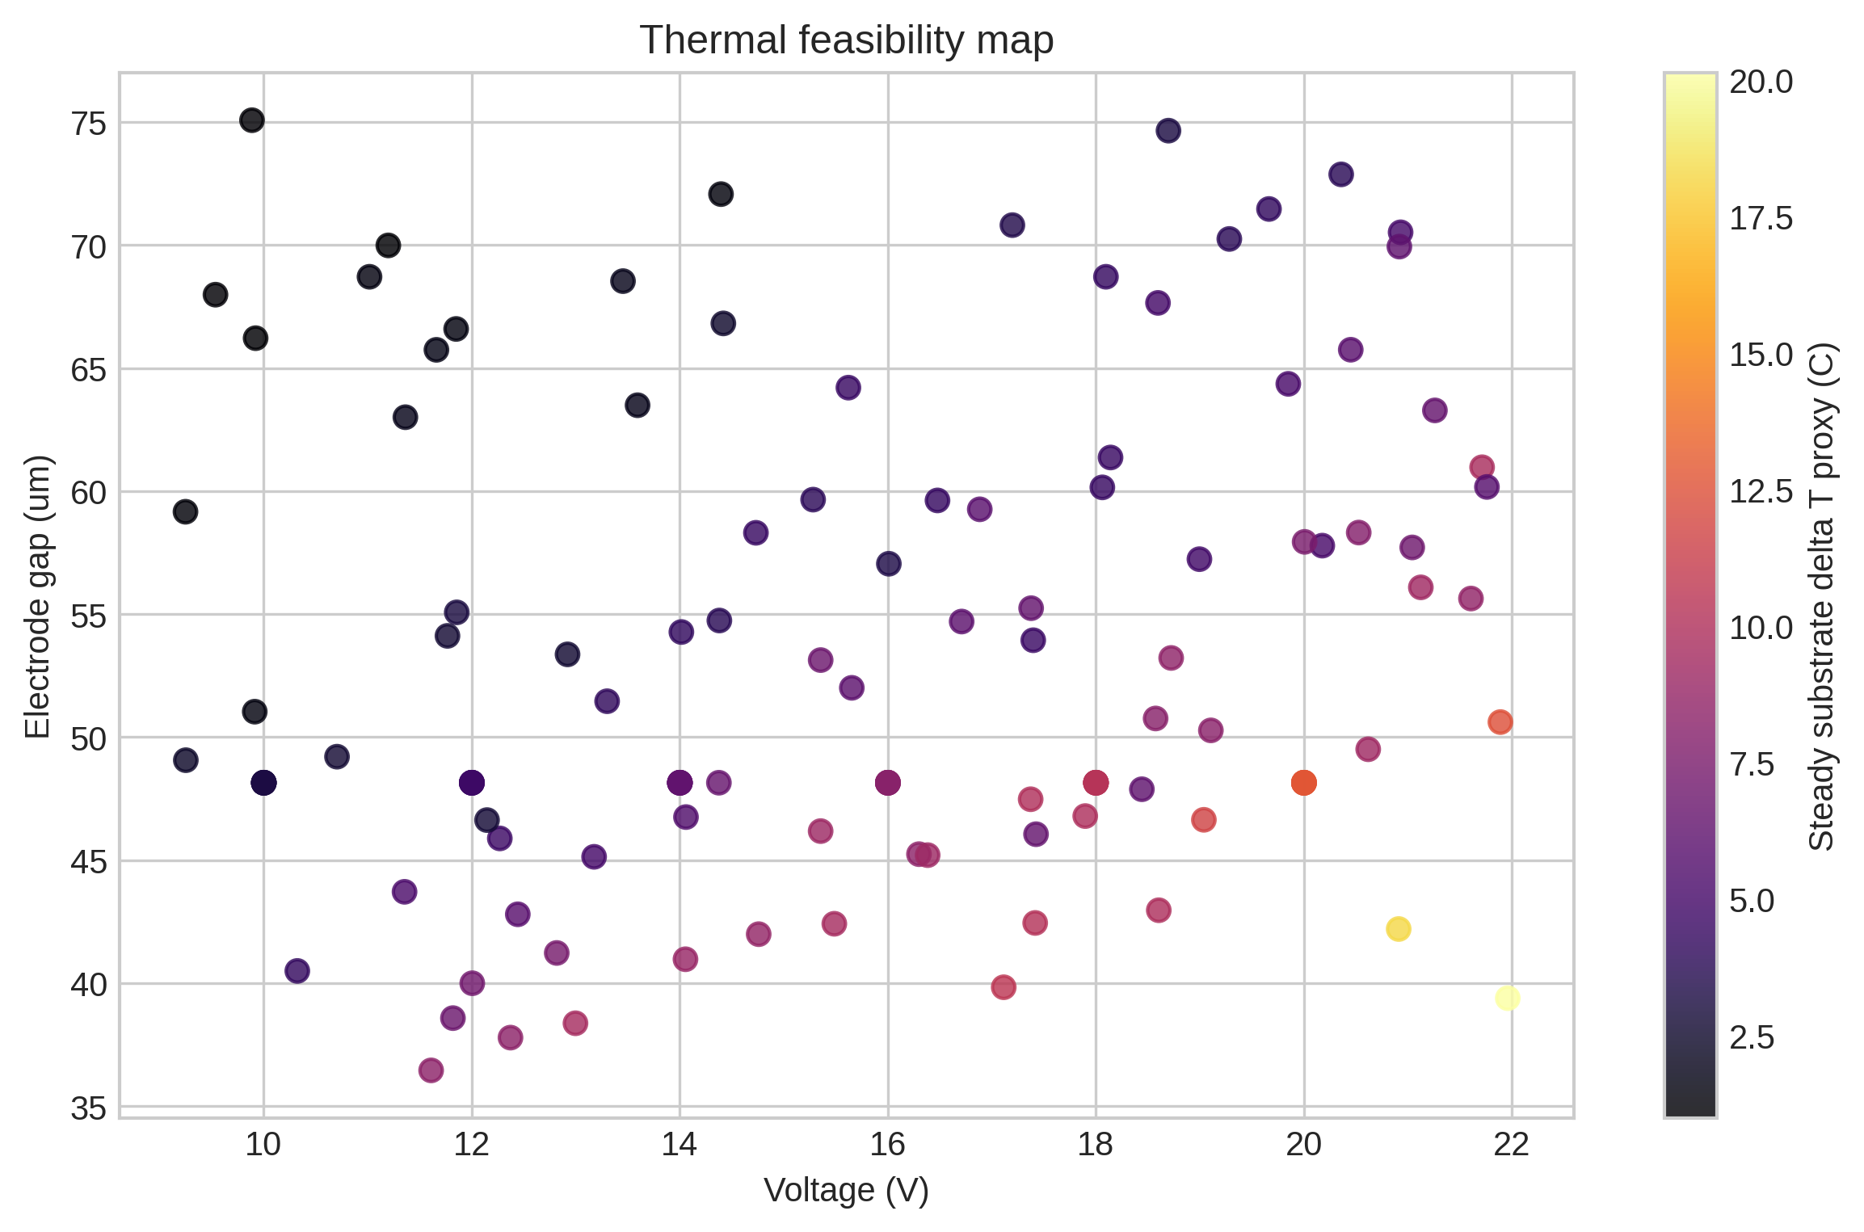
Figure 7. Voltage-gap operating map colored by steady substrate temperature-rise proxy.

Hydraulic Envelope
Pressure drop and flowrate were tracked to keep the proposal device-like rather than only numerically separable.
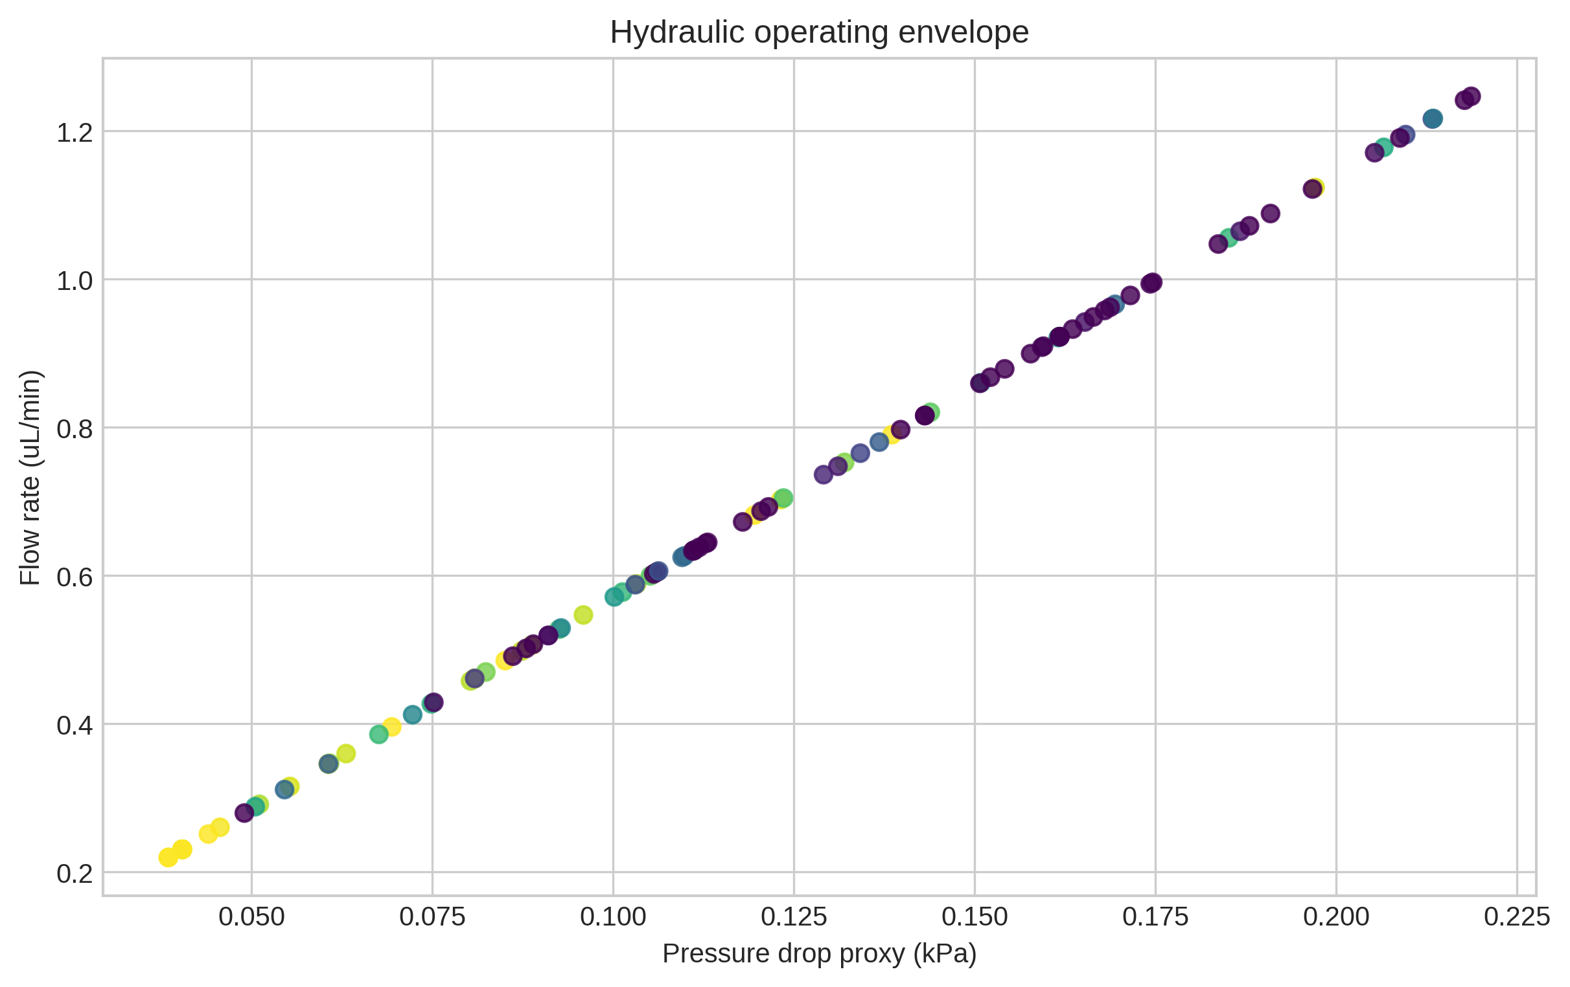
Figure 8. Pressure-drop proxy versus flowrate for the V12 operating sweep.

Recovery, Removal, and Purity
The final evaluation reports live recovery, dead removal, and outlet purity. Accuracy alone is intentionally not the only endpoint.
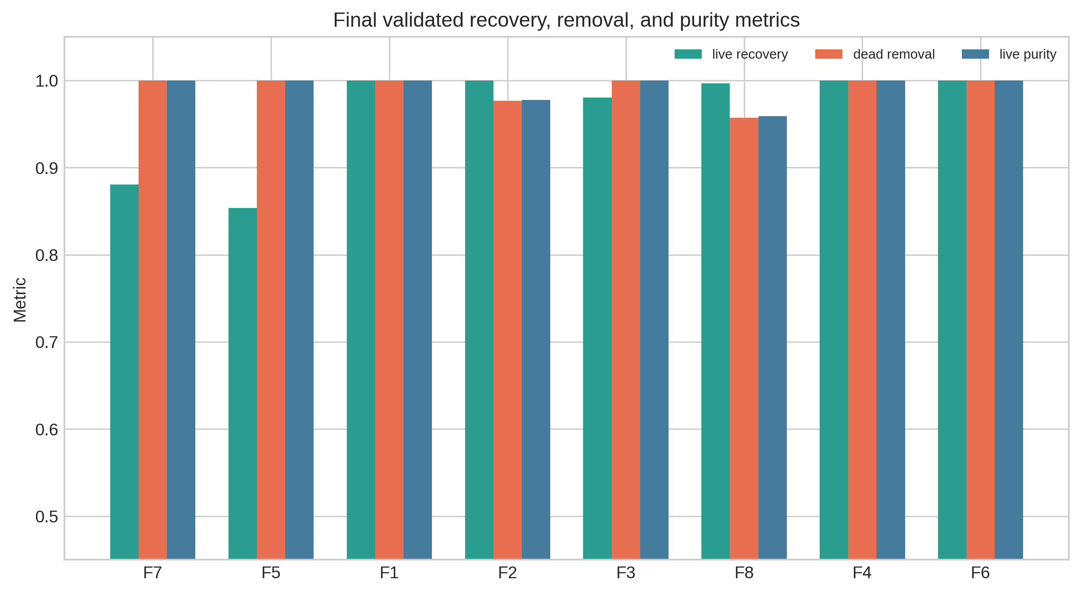
Figure 9. Final validation metrics for the top V12 operating candidates.

Mechanism Controls
The same-length straight DEP, no-DEP, and unfocused-inlet controls are central to the academic argument. They test topology, field mechanism, and inlet-preparation dependence.
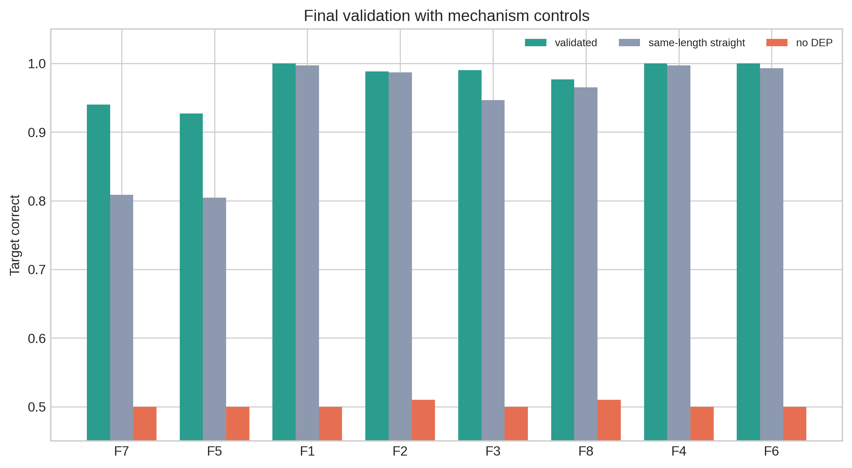
Figure 10. Final validated candidates with mechanism controls.

Selected Operating Point
The chosen point is selected by multi-objective score, not by maximizing accuracy alone. It balances classification, power, thermal proxy, pressure and wall loss.
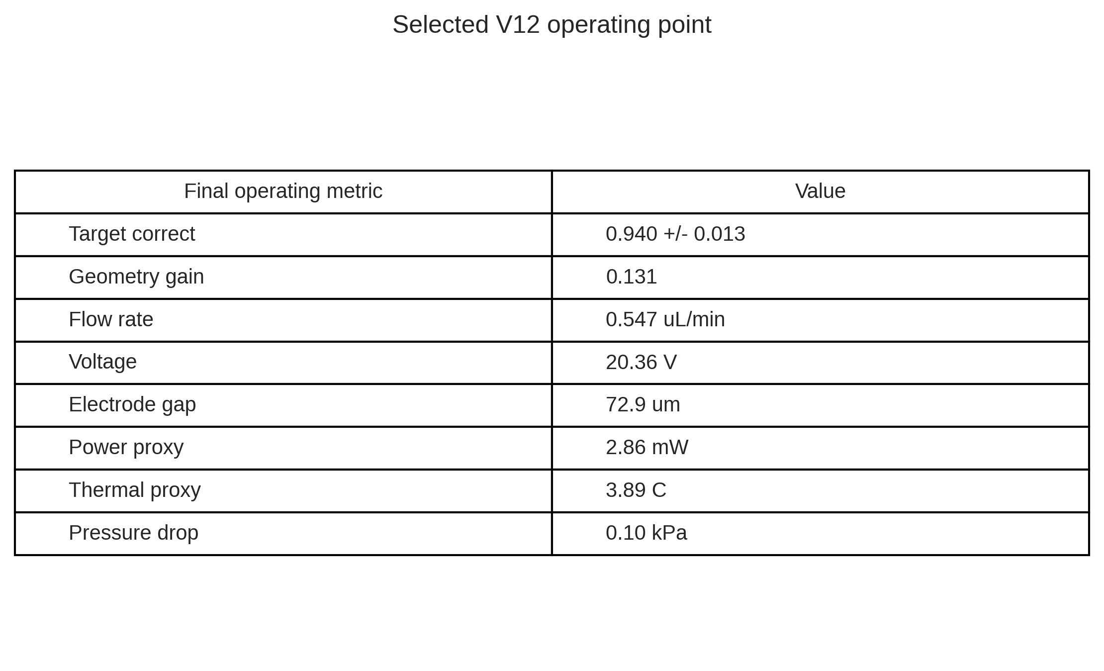
Figure 11. Key values for the selected V12 operating point.

Computational Workflow
The report structure follows the intended manuscript workflow: literature gap, formula design, ML ranking, held-out validation and mechanism controls.
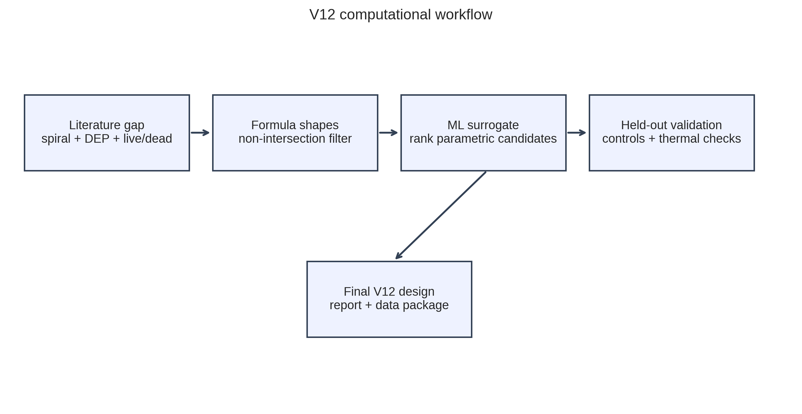
Figure 12. V12 computational workflow.

Final Candidate Table
Rank | Target correct | Topology gain | Flow (uL/min) | Power (mW) | Delta T proxy (C) | Gate
7 | 0.940 | 0.131 | 0.547 | 2.86 | 3.89 | True
5 | 0.927 | 0.122 | 0.360 | 3.17 | 4.31 | True
1 | 1.000 | 0.003 | 0.220 | 2.84 | 3.86 | False
2 | 0.988 | 0.001 | 0.260 | 3.19 | 4.35 | False
3 | 0.990 | 0.044 | 0.231 | 3.37 | 4.58 | False
8 | 0.977 | 0.012 | 0.498 | 3.71 | 5.06 | False
4 | 1.000 | 0.003 | 0.231 | 4.58 | 6.24 | False
6 | 1.000 | 0.007 | 0.485 | 5.09 | 6.93 | False
Interpretation: the selected point is the highest-scoring candidate that preserves topology contribution and avoids high thermal-risk flags.

Data Package and Reproducibility
The V12 package is organized so that manuscript figures, supplementary tables and rerun scripts can be traced without manual reconstruction.
Artifact | Path
Operating sweep | results/design_v12_final_package/v12_operating_screen.csv
Held-out validation | results/design_v12_final_package/v12_final_validation_replicates.csv
Final summary | results/design_v12_final_package/v12_final_validation_summary.csv
Figures | results/design_v12_final_package/figures/
Report source script | scripts/design_v12_final_package.py
Baseline geometry | results/design_v11_shape_ml_nonintersection/rank1_monotone_curvature_spiral_formula.json
For a publication-grade next pass, the exact V12 geometry should be converted into a mesh/electrode definition and solved with an electrode-resolved field model. The current package is intentionally transparent about this remaining step.

Model Validity and Limits
- The current device result is a reduced-order numerical design screen.
- OpenFOAM is used in the workflow for field/thermal case support, but the final V12 DEP forcing still uses a field-gain proxy rather than a full electrode-resolved 3D field.
- The cell model includes population variability, Brownian diffusion, inlet distributions and wall-loss probability, but not cell deformation or cell-cell interaction.
- Thermal output is a proxy intended for ranking. A heat-transfer solve is needed before claiming safe absolute temperature.
- The strongest current claim is design plausibility and a prioritized geometry/operating point for higher-fidelity simulation.

Manuscript-Ready Claims
Claim 1: A monotone-curvature spiral provides a compact, non-intersecting geometry for DEP-based viable/nonviable sorting in the reduced-order model.
Claim 2: The selected design performs better than a same-length straight DEP control, supporting a topology contribution rather than a pure residence-time explanation.
Claim 3: Accuracy, recovery, purity, wall loss, flowrate, pressure drop and thermal proxies are all needed for a credible device-design argument.
Claim 4: The next required validation is electrode-resolved field simulation and a more rigorous thermal solve for the V12 rank-1 geometry.

References Used for Framing
- R1. Betyar and Ramiar, numerical simulation of biological particle separation in a spiral microchannel using DEP, 2026.
- R4. Kwon/Choi et al., continuous removal of small nonviable mammalian cells and debris using spiral inertial microfluidics, Lab on a Chip, 2018.
- R5. Elitas et al., DEP separation of live and dead monocytes using 3D carbon electrodes, Sensors, 2017.
- R9. Huang et al., ODEP live/dead separation platform, 2025.
- R10. Nguyen et al., facing-electrode DEP cell separation numerical design, Scientific Reports, 2024.
- R11. Tian et al., on-chip DEP single-cell manipulation review, 2024.
- R15. DEP and AC electrothermal-flow numerical simulation, Micromachines, 2024.
- R16. Spiral inertial cell sorting review, Micromachines, 2024.

