We chose the JAD(Joint Application Development) method to elecition the system requirements.

|  |  |
| --- | --- |
| JAD PARTİCİPANTS | Definiation Of Role |
| Session Leader | Organizes and runs the JAD meetings |
| User | Represents end users perspective with regard to proposed system |
| Manager | Represents managments perspective with regard to proposed system |
| Project Sponsor | Represents all parties responsible for funding and supporting the development effort |
| Analyst | Observation and listening to better understand the needs of the Project. |
| Scribe | Takes the notes and records important informations in JAD meetings |
| Information System  Staff | Clarififcation on technical questions and issues |
|  |  |

JAD MEETİNG ROOM:

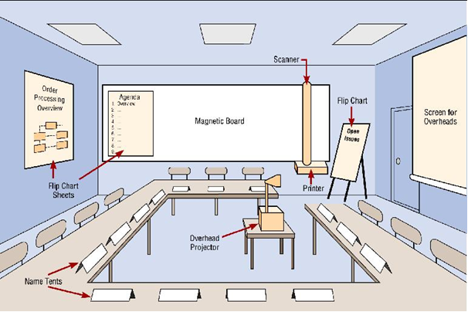

JAD MEETİNG REPORT;

1-)STRENGTHS

->User’s feedback is clearly understood.

-> Feedbacks recorded in writing.

-> Well coordinated between users and other project members.

2-)WEAKNESSES

->Time can be used more efficiently