|  |
| --- |
| Team NN: |
| MySystem Analysis and Design  MySystem Analysis and Design |
| CSIS 2200 Term Project |

|  |
| --- |
| Team Member Names Here |

MySystem Analysis and Design

1. Table of Contents

2 Executive Summary 2

3 Business Case (Phase One) 2

3.1 MySystem Description 2

3.2 Rationale and Need for MySystem 2

3.3 Feasibility 2

3.4 Preliminary Investigation 2

4 System Planning (Phase One) 2

4.1 Project Deliverables 2

4.2 Project Scope 2

4.3 Project Plan and Resources 3

4.4 Project Budget 3

4.5 Project Risks 3

5 System Analysis (Phase Two) 3

5.1 System Requirements 3

5.2 Ongoing System Costs and Benefits 3

5.3 Data and Process Modeling 3

5.4 Object Modeling 4

5.5 System Development Approach 4

6 System Design (Phase Three) 4

6.1 User Interface Design 4

6.2 Reports 4

6.3 Security and Control 4

6.4 Data Design 4

7 System Architecture (Phase Four) 5

8 System Implementation (Phase Four) 5

# Executive Summary

Write this last! Only when all other phases are complete. Last part of project.

# Business Case

Describe approach to business case.

## MySystem Description

Brief description of the proposed system

## Rationale and Need for MySystem

Include SWOT Analysis and strategic importance of the system.

## Preliminary Investigation

Show why this system is necessary. Convince management to proceed.

### Problem or Opportunity

What are the users requesting? Show how you would go about fact-finding.

### Scope and Constraints

### Costs and Benefits

### Feasibility

#### Technical

#### Operational

#### Cost

#### Schedule

# System Planning

## Project Deliverables

Describe the project/system outcome.

## Project Scope

Boundaries for the project: what is in and, more importantly, what is out. Refine what was described in preliminary investigation.

## Project Roles

Org chart for the project. Who is involved? What is their role function? Stakeholder or doer?

## Project Plan and Resources

Include WBS and GANTT chart. Provide project plan overview, with resource assignments (programmers, etc). Describe project team needed.

## Project Budget

Provide simple budget. This will get modified as operational costs are factored in.

## Project Risks

Create risk table, and rank order the risks. Include mitigation.

# System Analysis

Provide overall approach to the analysis for MySystem.

## System Requirements

Include approach to using surveys and other methods to determine requirements from stakeholder groups.

## Ongoing System Costs and Benefits (Include in Assignment Three)

Revise budget accordingly

## Data and Process Modeling

Include Context Diagram and DFD here. Make sure you provide an overall summary of these as well (not just the diagrams).

Provide data dictionary and decision tables as needed.

## Object Modeling

Provide an object model for the proposed system. Include use case diagram.

## System Development Approach (Include in Assignment Three)

Buy or build?

Use of cloud services?

Refine budget and project plan accordingly given your decision.

# System Design

Provide approach to design of MySystem. Make sure the project plan is updated as you provide more detail.

## User Interface Design

Show screens and describe approach

## Reports

Show sample output reports (screen output is fine)

## Security and Control

## Data Design

1. Customer can register to portal
2. Customer can pay for analysis
3. Customer can send samples for analysis
4. Customer can send feedback
5. Customer can view analysis results
6. Laboratory can verify/deny register request
7. Laboratory can receive payment
8. Laboratory can receive samples
9. Laboratory can review feedback
10. Laboratory can analyze samples
11. Laboratory can update analysis results

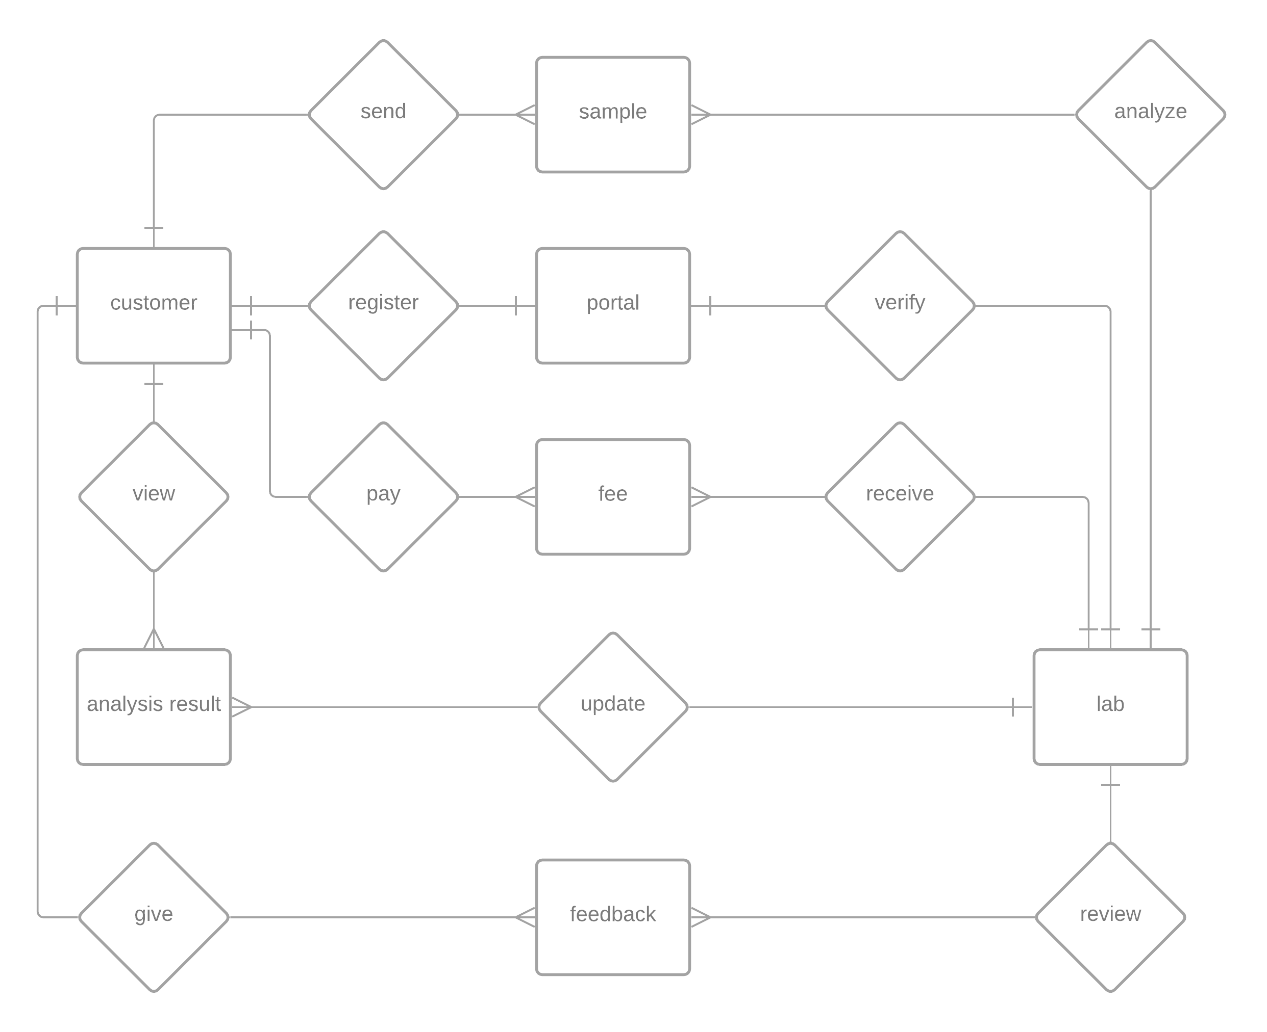

*figure 6.4.1: ERD Diagram*

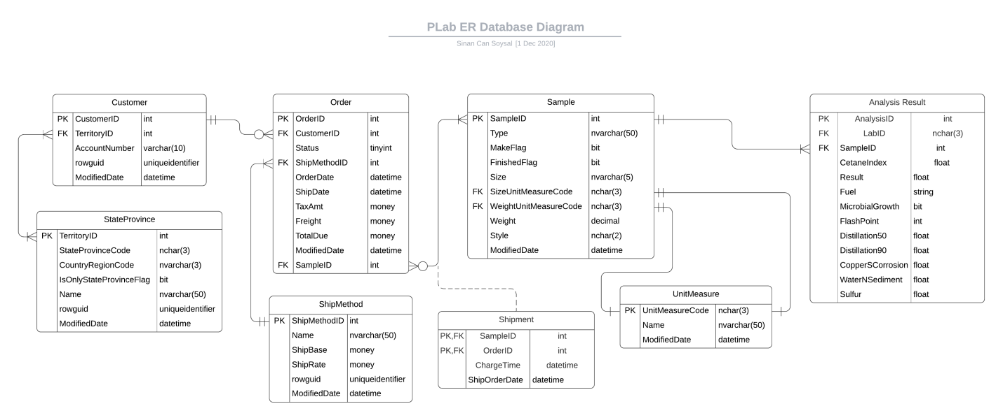

*figure 6.4.2: Database Design Model*

# System Architecture

## Architecture Design

This portal will provide a bridge between customer and PLab Laboratories. The client must be able to see the results of a sent sample easily. Client logs into the PLab Portal in order to reach analysis results. One client can have multiple samples sent at the same time and the system must be able to handle all of them without malfunctioning. Laboratories across the country can update analyzed sample results throughout this portal. After analysis result uploaded, client can view it’s analysis reports visually.

There are 3 main packages of this comprised system:

1. User Interface
2. Data Storage
3. Business Services

User interface will provide user interaction to the system. User interface must be able to support login, create sample requests, generate graphical representation of an analysis result, view results and send feedback to the system.

Data storage must provide reliable and secure data storage for the system. Client details, sample details, shipment details, fees, analysis results must be safely stored in the data storage. Business management and clients can reach needed data at any time from anywhere.

Business services contains the details of billing system, reading/updating data from database and managing client-business interactions.

Proposed system shall integrate with existing legacy system.

Our application works with large amounts of data provided by the labs around the country. In this situation, data will be accessed frequently by laboratories and clients. In order to accomplish this we must architect our application as a data-oriented system. The main reason of this architecture is to achieve integrality of data.

A centralized data repository will store all of the analysis results and it will be accessed through client side and business side API s. API’s will create queries according to the user’s needs.

**Advantages of this architecture:**

1. Data integrity
2. Backup and restore features ( this is the most important feature because our clients’ must reach their data whenever they want and wherever they want)
3. Decreases overflow of data between software components

**Disadvantages:**

1. The system is open to malfunction
2. Malfunctions will highly affect the clients

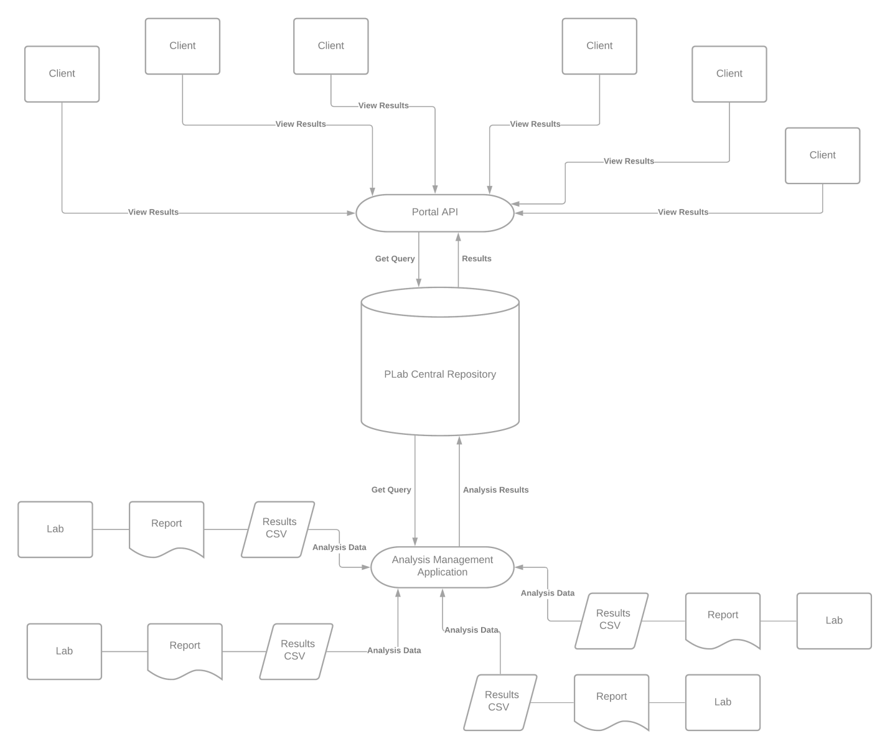

*figure 7.1.1: Architecture Design*

The system shall support up to 2000 simultaneous connections to central repository at any given time.

The system shall provide users to view older results with no more than 5 second latency.

The system must finish its transactions within 2 minutes.

According to these and previously evaluated requirements document:

The selected architecture design must support the sizing and timing requirements through client-server architecture. The client part is implemented on PCs and ensured to use minimal disk and memory.

**The architecture supports quality requirements:**

1. Linux, Windows, Mac OS support
2. User interface shall be designed for easy use
3. System must be available 24/7

## Software and Hardware Specification

To successfully accomplish the requirements of the project, some modern technologies have been suggested for the better service and security by having an online portal an an online sample registration system. This document contains all the software and hardware technology that has been proposed for the new system.

**Software Specifications:**

Application will be controlled by:

1. Python & ZingChart as front-end solution
2. PostgreSQL as database solution
3. GoLang as backend solution

Python is a rich programming language in terms of it’s data visualization libraries. User interface must be beautiful and simple at the same; ZingChart comes into play for the visuals of the portal. ZingChart is a free and powerful python library specifically developed for data visualization.

PostgreSQL is a free and open-source relational database which will get it’s job done in a fast and secure way.

GoLang is a programming language designed by Google. Go routines are GoLang’s most important future so far which allows concurrency in web based solutions.

**Hardware Specifications:**

We will support this project’s hardware by installing our own server rather than a subscription for cloud services.

**Dell PowerEdge R710 6B LFF Server**

R710 will be the main server for “PLab Analysis Laboratories” system. R710 will help us to operate efficiently and lower TCO with enhanced virtualization capabilities, improved energy efficiency, and innovative system management tools. It provides railings for easy installation and removing operations. Also it supports RAID operation with 12TB of storage. It’s CPU donated with 12-core Xeon processor and 12Mb of cache. The main unit manufactured by Dell, and the case is designed to allow accessing to hard disk drives easily. The server has got 2 power supply units for continuous working even if one of the power supply mulfunctions.

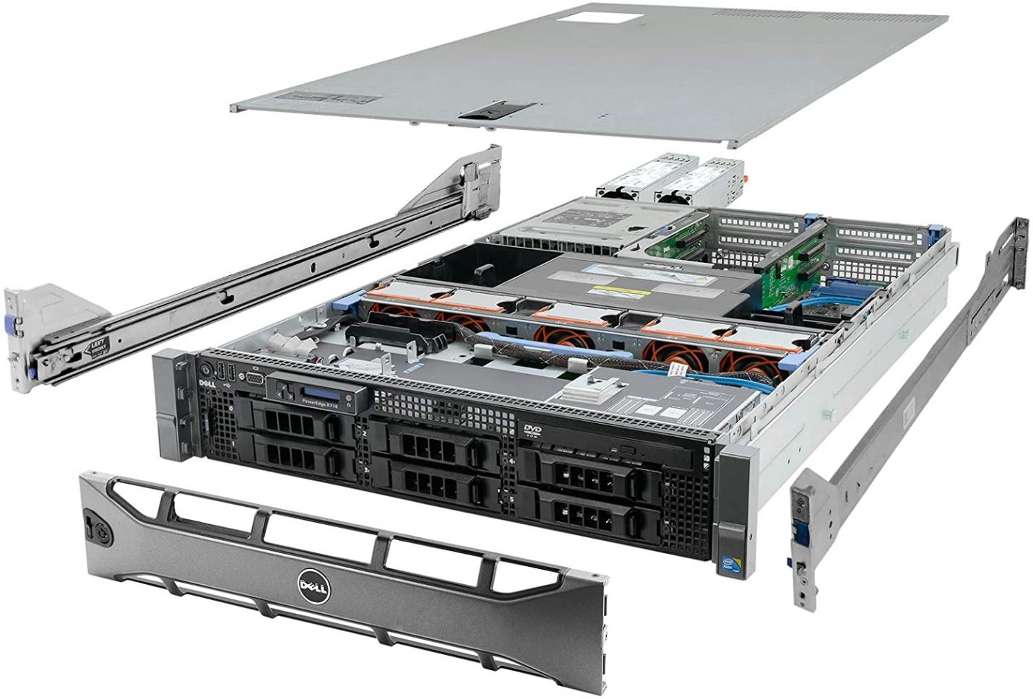

Figure 7.2.1: Dell PowerEdge R710 6B LFF Server

|  |  |
| --- | --- |
| Hardware: | Price: |
| System: Dell PowerEdge R710 6B LFF Server   * **Processors:** 2x 2.83GHz X5670 12-Cores Total * **Memory:** 144GB RAM * **Hard Drives:** 6x 2TB 3.5" HDD * **RAID:** H700 w/ 512MB * **Optical Drive:** DVD-ROM * **Power Supplies:** 2x PSU * **Bezel:** Yes * **Rails:** Yes * **Operating System:** None | $ 729.99 |

**Additional Hardware for Network:**

Every laboratory has its own central computer so, we won’t be buying new computing hardware to the existing laboratories instead we will deploy a new software to existing computers. A communication link will be needed between all the laboratories and the PLab’s central repository. The link will be provided by our existing ISP and the whole communication structure will be called as ‘Chiral Network’.

# System Implementation

Provide implementation plan, add to project plan.

Include coding approaches.

Update budget as necessary.

13-USER INTERFACE OF THE SYSTEM

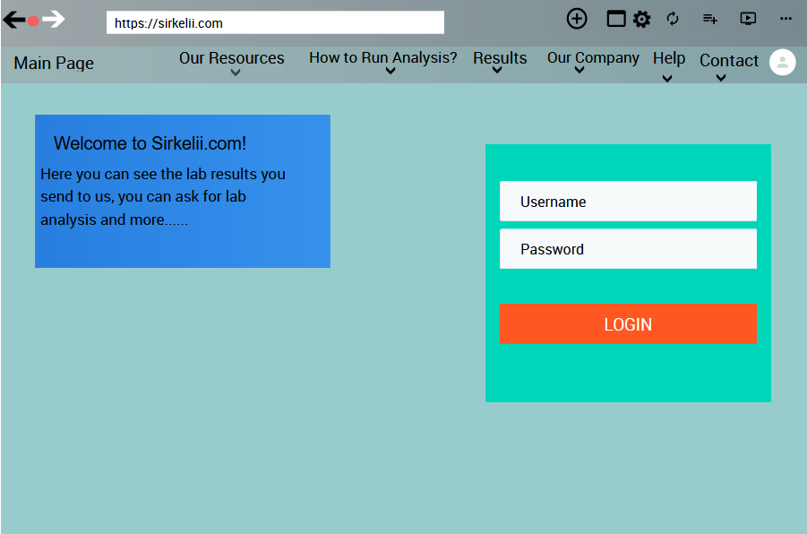

Register

In the photo above you see our system “Sirkelii.com’s” main page it may seem a bit dull but it is the most useful one we have ever used.In this format our users/costumers had the most efficiency in using it and our percentage of usage raised drastically.Without further ado let’s begin of explanation of the page:

1. Main Page Button:While in other pages that button leads you to the main page without dealing with back or forward buttons.
2. Our Resources:When someone touched to this it will show 2 sub-page buttons;”Our Psychical Sources and Our Online Sources”.
3. How to Run Analysis?:It redirects you to explanation page of how we run your analysis in the most clear way.
4. Results:This button redirects you to the our results page.In there you can see if your result has come out or not, can check old results, can see when your result is going to come.
5. Our Company:This button will show you two sections; “Our Company’s History” and “Our Purpose”.
6. Help:This button redirects to help page that has the all information about most common needs and problems and their solution,the questions about our company and about our way of doing the analysis.
7. Contact:This button redirects to our connection page that has the all info on how can you get contact with us.
8. Welcome to Sirkelii.com:It has the basic info about us.
9. Login/Register:It let’s you to login our page and if you are not registered it redirects you to registration page.

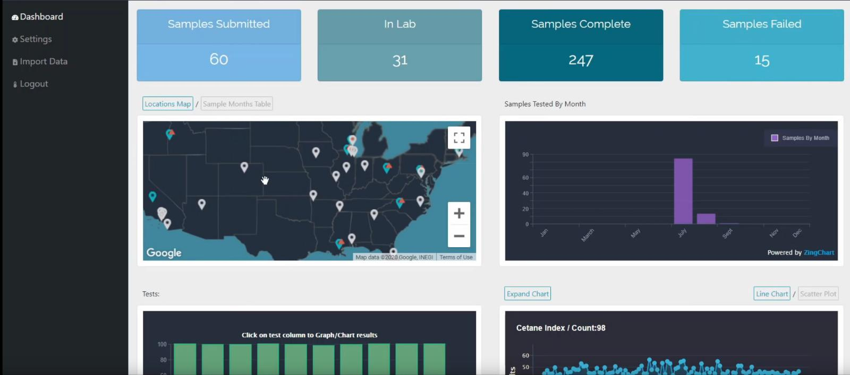

This page above is our “Results” page(only above part).This page includes:

1. Samples Submitted:It shows the submitted samples in a month.
2. In lab: Shows the current tests that are running in our labs.
3. Samples Complete:It shows the completed samples in total.
4. Samples Failed:It shows the failed samples in total.
5. Maps & Graphs:They show our usage and success in the areas and other companies.
6. Help Block:It has the data of the sections of Dashboard, settings, import data and logout:
7. Structure Chart

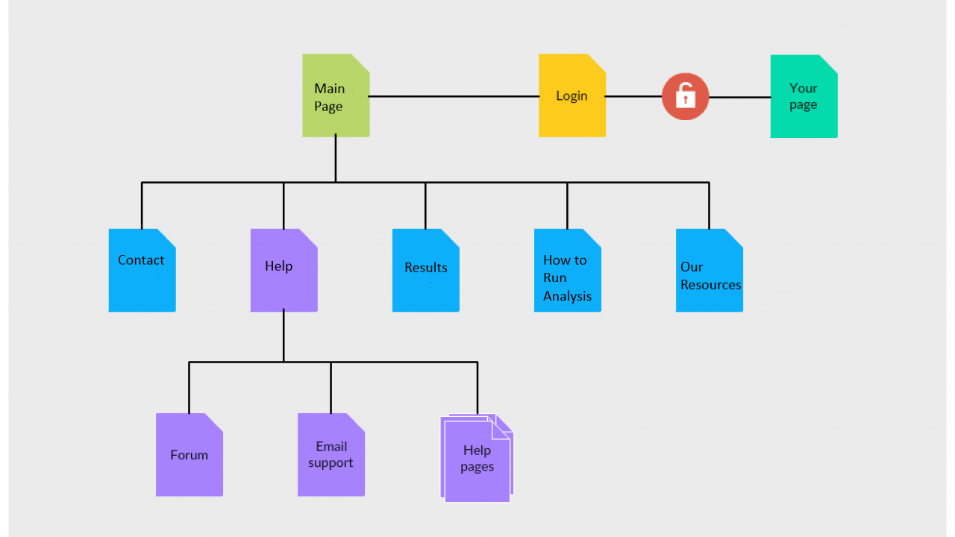

The Structure Chart:It has the basic info of our main page’s sections which are;”Main Page, Our Resources, How to Run Analysis,Results,Help,Contact”.

15)System Implementation:

To implement the system I need to understand it’s requirements, plan it’s process,develop and document it’s steps and needs,do a training of it,do the implement,test te system and due to results try to decide how to adjust and improve of it.

1)To fully know it’s requirements I must carefully search and learn it then I must document the requirements and make things crystal clear.

2)I should plan the process and see if these tasks are happens correctly or not:

-Evaluating and assessing unsuitability triggers like customer complaints, audit findings, process parameter,etc

- Identifying legitimate unsuitability related issues

- Capturing and entering issues into the corrective action process

- Investigating and getting to the root cause of an issue

- Determining and implementing solutions

- Reviewing, checking, and verifying the effectiveness of a problem resolution

· Using risk management protocols to ensure major nonconformances are top priority

· Establishing personnel responsibilities at various stages of the corrective action process

1. I should develop and document this process and see if it’s well developed and useful or not.After developing it I should make sure if the system works properly with conducting a test
2. After the test the real implementation begins.
3. After the implementation the real test of the system begins. In this test we check the system to see if it’s ready to use or not, can it do it’s objectives like it supposed to do,does it need any changes?According to the test results we decide to either it need any improvement and adjustment or not.
4. As in the final step we make adjustments to the system and make some proper improvements to it and make the system fully developed,functional and usable.

If we don’t do these steps with this order and form, the system implementation will be very risky with high chance of failure.So, to prevent this I must not be hasty and make this in the way it should be or our time,resources and our system will go to waste.

16)How to Support the System?

First of all our website “Sirkelii.com”and it’s system has one of the best software systems and designs in the entire world.We are proud of that because our system has won “The Best Website of the Year” from the Awwwards in the last 3 years.

If anyone asks how our system has become like this it was a difficult thing to achieve it.....Our system had a lot of bugs and glitches for months when we first opened it in 2014 but then after we found our current I.T. guys and asked them for their help and they started to work on our system then they are started to shine.The new duo figured out some of the biggest bugs in the system and thanks to them we have see our mistake and changed them with our old “I.T.” guys.

Since then our website has updating it’s software monthly.

Then after these bugs disappeared we had another troubles;website speed,HTML errors,.....

Our speed was quite low after all these bugfixes because it couldn’t handled the process of the new updates.So,we started to check it every week instead of month and our geniuses fixed the speed trouble shortly after founding it.They have made some improvements in the system’s very own core and thus our speed has become quite fast.

We had HTML troubles due to some code problems but ey were easy fix to our masterminds.

After our bugs so started to decrease intensely, we started to look for the other websites to improve ourselves and the results was quite impressive we saw a lot of improvements.

We have developed a lot of new content we have to our new sections:”Our Resources, How to Run Analysis, Results,Our Company”.

Secondly our biggest chance was our website had a lot of costumers/users that searched us in the search engines but they had troubles due to our first name...After changing it to “Sirkelii.com” and a successful “Search Engine Optimization” our website was quite easy to find and it made our website one of the biggest reached websites for that year(2015).

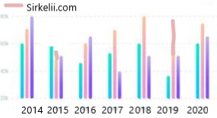

In 2017 our high numbered users/costumers had some trouble with the system’s design due to it was a little out of numbers so we have updated and improved our core design to this current version(below) and people started to use it more efficiently and easily.



Finally after all the needs of our costumers/users we have made a few changes in the design and links to our system with the costumers/user’s suggestions, thanks to our brilliant I.T. duo and great costumers/users we have one of the greatest systems and we still improve it day by day thanks to these steps we learned.