# **SOFTWARE & HARDWARE SPECIFICATIONS**

# **OF**

# **PLab PORTAL**

To successfully accomplish the requirements of the project, some modern technologies have been suggested for the better service and security by having an online portal an an online sample registration system. This document contains all the software and hardware technology that has been proposed for the new system.

Software Specifications:

Application will be controlled by:

* Python & ZingChart as front-end solution
* PostgreSQL as database solution
* GoLang as backend solution

Python is a rich programming language in terms of it’s data visualization libraries. User interface must be beautiful and simple at the same; ZingChart comes into play for the visuals of the portal. ZingChart is a free and powerful python library specifically developed for data visualization.

PostgreSQL is a free and open-source relational database which will get it’s job done in a fast and secure way.

GoLang is a programming language designed by Google. Go routines are GoLang’s most important future so far which allows concurrency in web based solutions.

Hardware Specifications:

**Dell PowerEdge R710 6B LFF Server**

R710 will be the main server for “PLab Analysis Laboratories” system. R710 will help us to operate efficiently and lower TCO with enhanced virtualization capabilities, improved energy efficiency, and innovative system management tools. It provides railings for easy installation and removing operations. Also it supports RAID operation with 12TB of storage. It’s CPU donated with 12-core Xeon processor and 12Mb of cache. The main unit manufactured by Dell, and the case is designed to allow accessing to hard disk drives easily. The server has got 2 power supply units for continuous working even if one of the power supply mulfunctions.

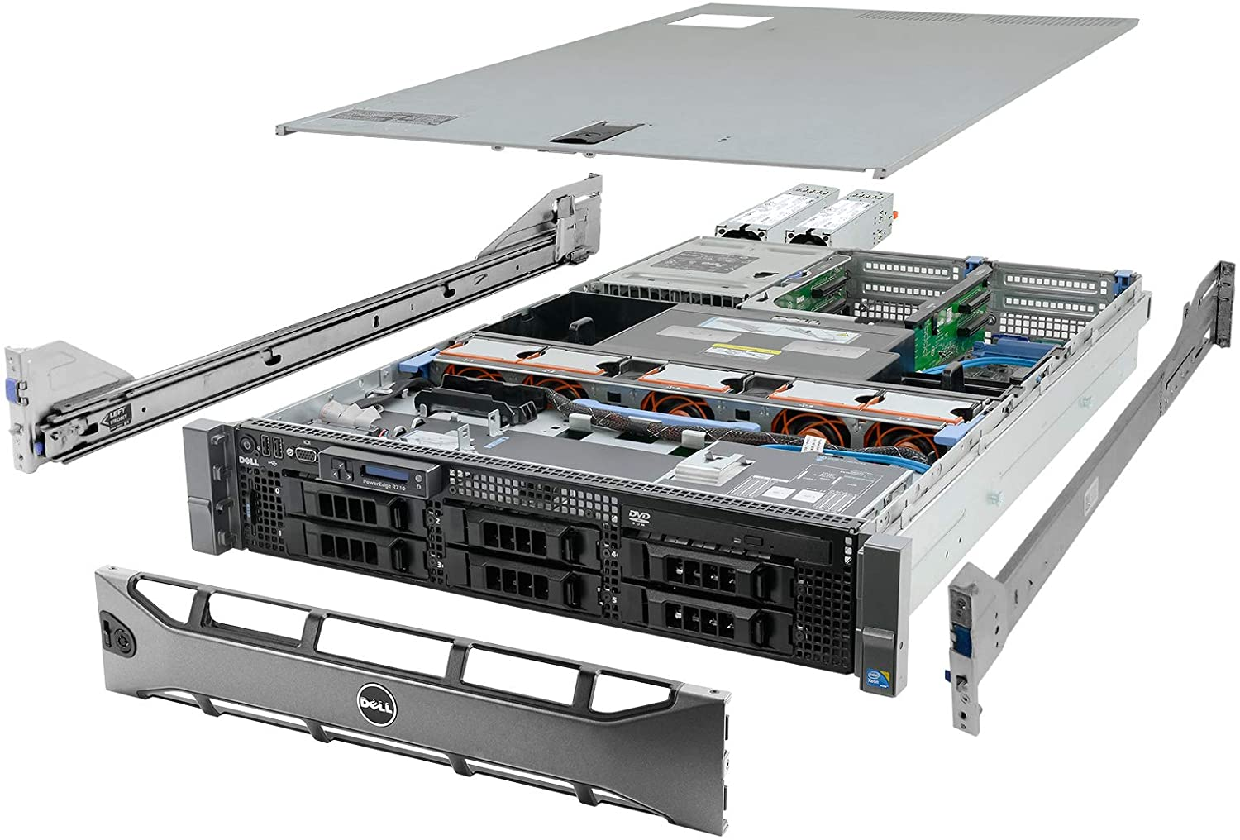

|  |  |
| --- | --- |
| Hardware Specification: | Price |
| System: Dell PowerEdge R710 6B LFF Server   * **Processors:** 2x 2.83GHz X5670 12-Cores Total * **Memory:** 144GB RAM * **Hard Drives:** 6x 2TB 3.5" HDD * **RAID:** H700 w/ 512MB * **Optical Drive:** DVD-ROM * **Power Supplies:** 2x PSU * **Bezel:** Yes * **Rails:** Yes * **Operating System:** None | $ 729.99 |

**Additional Hardware:**

Every laboratory has its own central computer so, we won’t be buying new computing hardware to the existing laboratories instead we will deploy a new software to existing computers. A communication link will be needed between all the laboratories and the PLab’s central repository. The link will be provided by our existing ISP and the whole communication structure will be called as ‘Chiral Network’.