+

Gebze Technical University
Computer Engineering

CSE 222 - 2018 Spring

HOMEWORK 01 REPORT

SİNAN ELVEREN
111044074

Course Assistant:
Fatma Nur Esirci, Tuğbagül Altan Akın

INTRODUCTION

Problem Definition
Design and implement simple hotel management system. The System has users that recepcionist and guests. Guests and recepccionist has abilities that can book a room, cancel booking. Recepcionist have also abilities that check in and check out. Program need to keep this all data on csv file. CSV file must include record that which rooms reserver by whom. So that, program will create 2 CSV files that first one is system user's login info and second one hotel, guest, checkin/out and room status info.System user can choose 2 choice that DefaultHotel(20 rooms) / CustomHotel(50Room) when login system. This custom otel will only create main class for tests.
When if users choose default hotel, they see login menu that Guest Login (1) and Recepcionist Login(2), they also can a choose that back to Hotels's Menu(0).
When if a user choose Guest Menu, program will ask guest name for login system. Guest can input onw name. Program will create a guestID, and will keep this informations. After enter own name, they can see 3 choose that Booking(1), Cancel Booking(2) and Go Back(0).
When if Guest choose Booking Menu, system will find first emty room and will reserved this room(System is checking from room number 1 until last). So if Guest has been booked succesfuly or not, program will show that on interface as recervation info(GuestID, GuestName, RoomNumber).
When if Guest choose Cancel Booking Menu, system will check if it's really reserved and will cancel booking. İf it 's succesfully(or not) end, prrogram will show that. Guest must know own gust ID if they can cancel booking.
When if users choose Recepcionist Menu, system will ask recepcionist login info. It's default as name:“admin” pass:“admin”. If recepcionist has been login succesfuly, will see 6 choose on recepcionist menu that Booking(1), Cancel Booking(2), CheckIn(3), CheckOut(4), ShowBooking(5), GoBack(0).
For Booking and Cancel Booking Menu is smilar like Guest. İf recepcionist choose booking progrom will ask guest name for make booking. At the same time,system will keep same information like guest.
If recepcionist choose checkIn orCheckOut menu, System will ask GuestID and RoomNumber. After system check this information, if there are a booking given info, system will make check in.if there are no booking, system will immediately create a boking and will make check in. If recepcionist choosed checkout, system will cancel reservation or delete guest record if there are a reservation.

System Requirements
Program have 2 main class that Hotel class implementing Hotel interface and System Users Abstract Class implementing SystemUsers Interface. Guest class and Recepcionist class extends System Users Class.
You can execute Hotel Management System on intellij 2017.3.4 with JDK-8. You will need to input file named “input.txt” in project folder. If you want to enter inputs on console, you need to change “Scaner” parameter as “System.in“ in Main class.
Program will create 2 CSV file each exexute program. If you execute program again, system will remove old datas.
CSV files will keep bookings info and users info who login that first one named “HotelID+statusOfRooms.csv” include :
“HotelID,GuestID,GuestName,RoomNo,isReserve,CheckInOrOut”
second one named “HotelID+systemUsers” inculde :
“HotelID,ID,Name”
If there are any wrong input program will catch error and will stop the program if need. If you want to change inputs, you must change to “input.txt” content. You can use all features said homework or problem definition. There are no known errors.
Don't exeute all test at the same time, exeute them one by one. Becouse program won't delete csv files for TA viewed. If you execute all at the same time, you can see some csv files in project folder.
You can follow menus while prepare inputs in input file for your tests. Menu look like that at Running Results in Result title. Browse it.

METHOD

Class Diagrams
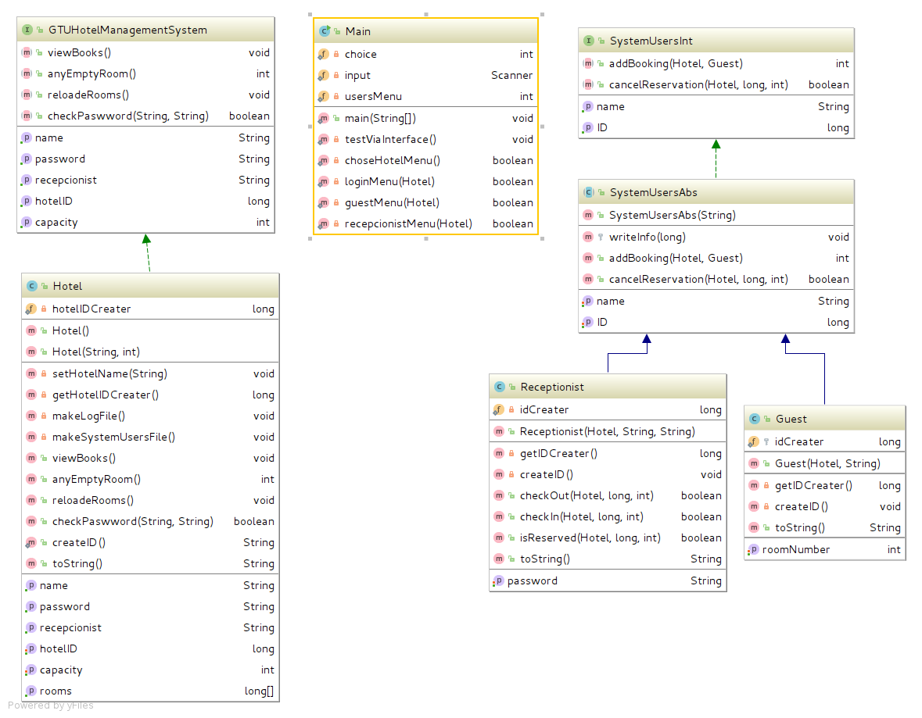
UML Diagram has been created by IntelliJ. Ther are 2 Interface for Hotel and SystemUsers classes. SystemUsers classs have 2 subclass that Recepcionist and Guest as realiteve Hotel Class.

Use Case Diagrams
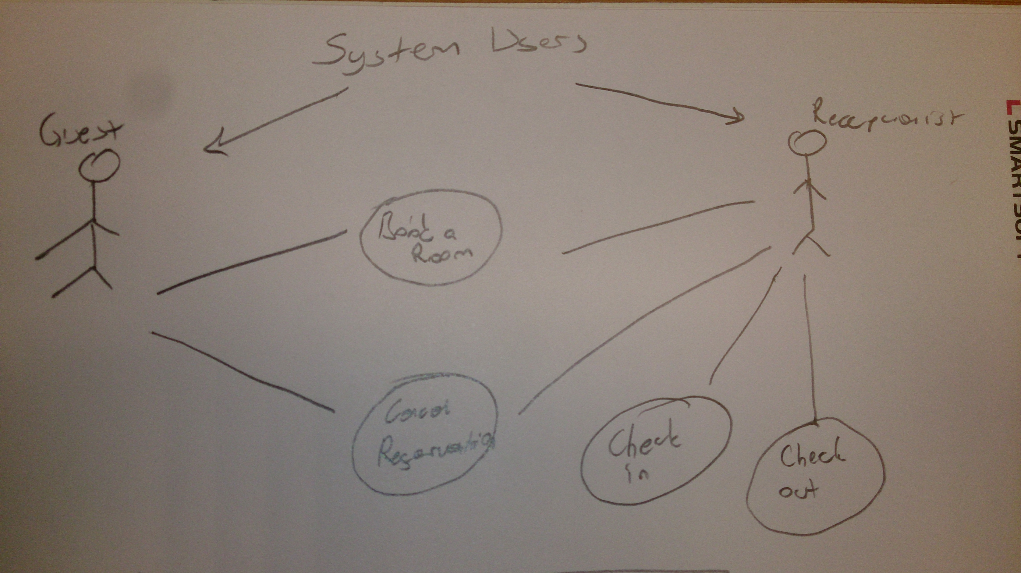

Other Diagrams (optional)
There are no diagram more.

Problem Solution Approach
All problems has been solving. All methot ise executing. There are no more, just woring correctly. You can see menu interface while running program.
Test file in Tests folders. Report and javadoc in project folder.

RESULT

Test Cases
All tests has been ended succesfully. If there are any error, it will catch exception.
For Guest;
Booking tested succesfuly
Cancel Reservation tested succesfuly
For Recepcionist
Booking tested succesfuly
Cancel Reservation tested succesfuly
Check in tested succesfuly
Check out Reservation tested succesfuly
Other tests(like polymorphism) in before terminate program.

Running Results
## Hotel Management System ##
Enter to NEW default Hotel
1 - Enter to NEW default Hotel
1 – Guest
1 - Book a room
2 - Cancel your reservation
Enter guest id :
Enter room number:
0 - Back to login menu
2 - Recepcionist
Enter recepcionist name(hint:'admin')
Enter recepcionist password(hint:'admin')
1 - Book a room
Enter guest name (only word):
2 - Cancel Booking
Enter guest id :
Enter room number:
3 - Check in
Enter guest id :
Enter room number:
4 - Check out
Enter guest id :
Enter room number:
5 - Show booking
Status of all rooms(printing)
0 - Back to login menu
0 - Back to hotel menu
2 - Create NEW hotel
0 - Exit

Screen Shoots (outut for default input)

## Hotel Management System ##

1 - Enter to NEW default Hotel
2 - Create NEW hotel
0 - Exit

## Hotel Management System - Sinan's Hotel ##

1 - Guest
2 - Recepcionist
0 - Back to hotel menu
Enter your name(only one word!)

## Hotel Management System - Sinan's Hotel - Guest##

1 - Book a room
2 - Cancel your reservation
0 - Back to login menu

## Hotel Management System - Sinan's Hotel - Guest - Booking##

GuestName1 has booked a new room succesfully.
Reservation info :
Guest ID : 101
Room Number : 1

## Hotel Management System - Sinan's Hotel - Guest##

1 - Book a room
2 - Cancel your reservation
0 - Back to login menu

1 - Guest
2 - Recepcionist
0 - Back to hotel menu
Enter your name(only one word!)

## Hotel Management System - Sinan's Hotel - Guest##

1 - Book a room
2 - Cancel your reservation
0 - Back to login menu

## Hotel Management System - Sinan's Hotel - Guest - Booking##

GuestName2 has booked a new room succesfully.
Reservation info :
Guest ID : 102
Room Number : 2

## Hotel Management System - Sinan's Hotel - Guest##

1 - Book a room
2 - Cancel your reservation
0 - Back to login menu
Enter to GUEST ID:
Enter to ROOM NUMBER that has booked:
Reservation has been canceled succesfuly

## Hotel Management System - Sinan's Hotel - Guest##

1 - Book a room
2 - Cancel your reservation
0 - Back to login menu

1 - Guest
2 - Recepcionist
0 - Back to hotel menu
Enter your name(only one word!)

## Hotel Management System - Sinan's Hotel - Guest##

1 - Book a room
2 - Cancel your reservation
0 - Back to login menu

## Hotel Management System - Sinan's Hotel - Guest - Booking##

GuestName3 has booked a new room succesfully.
Reservation info :
Guest ID : 103
Room Number : 1

## Hotel Management System - Sinan's Hotel - Guest##

1 - Book a room
2 - Cancel your reservation
0 - Back to login menu

1 - Guest
2 - Recepcionist
0 - Back to hotel menu
Enter recepcionist name(hint:'admin')
Enter recepcionist password(hint:'admin')

Wrong password

1 - Guest
2 - Recepcionist
0 - Back to hotel menu
Enter recepcionist name(hint:'admin')
Enter recepcionist password(hint:'admin')
##Hotel Management System - Custom Hotel - Recepcionist##

1 - Book a room
2 - Cancel Booking
3 - Check in
4 - Check out
5 - Show booking
0 - Back to login menu
##Hotel Management System - Custom Hotel - Recepcionist - Booking##
Enter guest name (only word):
GuestName4recepcionasked has booked a new room succesfully.
Reservation info :
Guest ID : 104
Room Number : 3
##Hotel Management System - Custom Hotel - Recepcionist##

1 - Book a room
2 - Cancel Booking
3 - Check in
4 - Check out
5 - Show booking
0 - Back to login menu
1. room is full.
2. room is full.
3. room is full.
4. room is empty.
5. room is empty.
6. room is empty.
7. room is empty.
8. room is empty.
9. room is empty.
10. room is empty.
11. room is empty.
12. room is empty.
13. room is empty.
14. room is empty.
15. room is empty.
16. room is empty.
17. room is empty.
18. room is empty.
19. room is empty.
20. room is empty.
##Hotel Management System - Custom Hotel - Recepcionist##

1 - Book a room
2 - Cancel Booking
3 - Check in
4 - Check out
5 - Show booking
0 - Back to login menu
##Hotel Management System - Custom Hotel - Recepcionist - Booking##
Enter guest name (only word):
GuestName5recepcionAsked has booked a new room succesfully.
Reservation info :
Guest ID : 105
Room Number : 4
##Hotel Management System - Custom Hotel - Recepcionist##

1 - Book a room
2 - Cancel Booking
3 - Check in
4 - Check out
5 - Show booking
0 - Back to login menu
##Hotel Management System - Custom Hotel - Recepcionist - Cancel Booking##
Enter guest id :
Enter room number:
cancelled
##Hotel Management System - Custom Hotel - Recepcionist##

1 - Book a room
2 - Cancel Booking
3 - Check in
4 - Check out
5 - Show booking
0 - Back to login menu
##Hotel Management System - Custom Hotel - Recepcionist - Check in##
Enter guest id :
Enter room number:
Checked in
##Hotel Management System - Custom Hotel - Recepcionist##

1 - Book a room
2 - Cancel Booking
3 - Check in
4 - Check out
5 - Show booking
0 - Back to login menu
##Hotel Management System - Custom Hotel - Recepcionist - Check in##
Enter guest id :
Enter room number:

There are NOT reservation, so get new record.

Checked in
109 has booked a new room succesfully.
Reservation info :
Guest ID : 106
Room Number : 4
##Hotel Management System - Custom Hotel - Recepcionist##

1 - Book a room
2 - Cancel Booking
3 - Check in
4 - Check out
5 - Show booking
0 - Back to login menu
##Hotel Management System - Custom Hotel - Recepcionist - Check in##
Enter guest id :
Enter room number:
Checked in
##Hotel Management System - Custom Hotel - Recepcionist##

1 - Book a room
2 - Cancel Booking
3 - Check in
4 - Check out
5 - Show booking
0 - Back to login menu
##Hotel Management System - Custom Hotel - Recepcionist - Check in##
Enter guest id :
Enter room number:
Checked in
##Hotel Management System - Custom Hotel - Recepcionist##

1 - Book a room
2 - Cancel Booking
3 - Check in
4 - Check out
5 - Show booking
0 - Back to login menu
##Hotel Management System - Custom Hotel - Recepcionist - Check out##
Enter guest id :
Enter room number:
checked out
##Hotel Management System - Custom Hotel - Recepcionist##

1 - Book a room
2 - Cancel Booking
3 - Check in
4 - Check out
5 - Show booking
0 - Back to login menu

1 - Guest
2 - Recepcionist
0 - Back to hotel menu

## Hotel Management System ##

1 - Enter to NEW default Hotel
2 - Create NEW hotel
0 - Exit
##Hotel Management System - Custom Hotel ##

1 - Guest
2 - Recepcionist
0 - Back to hotel menu
Enter your name(only one word!)

## Hotel Management System - Sinan's Hotel - Guest##

1 - Book a room
2 - Cancel your reservation
0 - Back to login menu

## Hotel Management System - Sinan's Hotel - Guest - Booking##

TA has booked a new room succesfully.
Reservation info :
Guest ID : 107
Room Number : 1

## Hotel Management System - Sinan's Hotel - Guest##

1 - Book a room
2 - Cancel your reservation
0 - Back to login menu

## Hotel Management System - Sinan's Hotel - Guest - Booking##

TA has booked a new room succesfully.
Reservation info :
Guest ID : 107
Room Number : 2

## Hotel Management System - Sinan's Hotel - Guest##

1 - Book a room
2 - Cancel your reservation
0 - Back to login menu

## Hotel Management System - Sinan's Hotel - Guest - Booking##

TA has booked a new room succesfully.
Reservation info :
Guest ID : 107
Room Number : 3

## Hotel Management System - Sinan's Hotel - Guest##

1 - Book a room
2 - Cancel your reservation
0 - Back to login menu

## Hotel Management System - Sinan's Hotel - Guest - Booking##

TA has booked a new room succesfully.
Reservation info :
Guest ID : 107
Room Number : 4

## Hotel Management System - Sinan's Hotel - Guest##

1 - Book a room
2 - Cancel your reservation
0 - Back to login menu

## Hotel Management System - Sinan's Hotel - Guest - Booking##

TA has booked a new room succesfully.
Reservation info :
Guest ID : 107
Room Number : 5

## Hotel Management System - Sinan's Hotel - Guest##

1 - Book a room
2 - Cancel your reservation
0 - Back to login menu

1 - Guest
2 - Recepcionist
0 - Back to hotel menu

## Hotel Management System ##

1 - Enter to NEW default Hotel
2 - Create NEW hotel
0 - Exit

- Main titles -> 16pt , 2 line break
- Subtitles -> 14pt, 1.5 line break
- Paragraph -> 12pt, 1.5 line break

