Sinan Liu

CS443 final project

An app of Periodic table

**Project Statement**

The purpose of my project would develop app can show the detail of chemical elements in periodic table.

It would help people use this app to look for the data of chemical element, such as the atomic mass, electron Affinity. I want to develop this app since I have course in chemistry. And, this app would help me quickly find out the information of chemical element I want.

I hope this app would help for student or chemical learner.

**Project Design Application && Implementation and Evaluation**

There was just two modules my app have, one is show the chemical element in a list follow the atomic number, like the follow picture show:

In chemical element list module, I used listview to show the chemical elements. And set a onclick listen when the user clicked the item in list. It would show the detail information of the element you click in a table, which would include atomic mass, group block, atomic number atomic radius, standard state, boiling point, bonding type, melting point, density, electron affinity electronegativity, electronic configuration, ion radius and ionization energy

The other module is search modules that people could search the atomic element by input text, like the follow picture show

This app require internet since its data is download from website. When you use this app without internet, it would send a notify for you at the bottom.

The resource website is "https://github.com/neelpatel05/periodic-table-api-go#methods".

In search modules, it is a simple fragment page with edittext and button. After user enter a correct input, atomic number, chemical name or chemical symbol, it would show the information you search like in list module show. If you input wrongly, it would clean the list and require you enter.

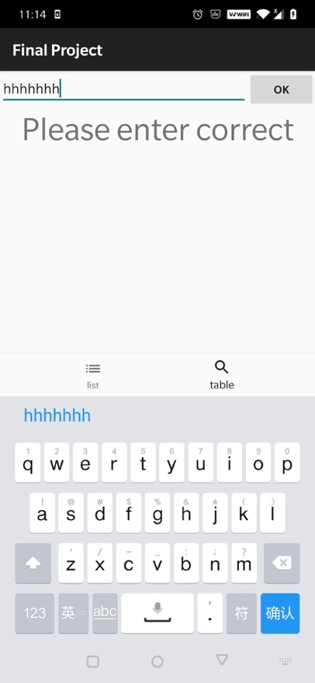

I use bottom navigation to spill these two modules. The left if the list module and the right is the search module.

And, for the back bottom of phone, if users press on the element detail in list module, it would return the home page. If user press two module, it would send a notification about second press quit.

**Experiences and Thoughts**

The funniest function that I can make a research that could search basing on three key word: name, atomic number and symbol. And, internet is useful that it could reduce the size of app and lots of work I need to do in app.

Since this app require internet, we need the time to download data from internet, during that time, there look like the app stuck, even though in fact it is working. I think I can add an anime during downing. The Ui design is simple I hope I can make it beautiful. At first, I want to build a gird view with a real periodic table however, it is so hard since the table is so big. And, it is hard to design before the due day.

The function is lack, there are only two module this app can do. For example, I hope I can make a new function on research that it could search the chemical element with some special information, for example search the element weight less or greater than a number.