The Modified Catchment Flood Risk Index (MCFRI): A Non-Linear, Multi-Parameter Model for Real-Time Flood Risk Assessment and Risk-Aware Emergency Navigation
Muhammed Sinan C
Department of Artificial Intelligence and Machine Learning, Brindavan College of Engineering, Bengaluru, Karnataka, India

Abstract
Flood risk assessment systems in widespread use today largely rely on linear or additive scoring models, or on machine-learning susceptibility maps trained for offline planning rather than real-time operational response. This paper presents the Modified Catchment Flood Risk Index (MCFRI), a closed-form, non-linear risk function that couples rainfall intensity, antecedent soil-moisture saturation, proximity to water bodies, drainage infrastructure quality, elevation, land-use permeability, and rainfall rate-of-change into a single interpretable risk score. MCFRI is embedded within a working software system, AI SafeRoute, that additionally performs spatial risk propagation between neighbouring zones, short-horizon risk forecasting, adaptive sensitivity adjustment, risk-aware route computation, and emergency-request triage. The model was back-tested against historical rainfall and disaster-severity outcomes from the August 2018 Kerala floods across ten districts, achieving 100% correct classification versus 60% for a linear baseline. We contextualise this result against published machine-learning flood-susceptibility benchmarks in comparable Kerala river basins, describe a planned physics-based baseline using the SCS Curve Number method, identify five additional historical flood events earmarked for spatiotemporal cross-validation, and outline a spatial block cross-validation protocol to address spatial-autocorrelation concerns in future evaluation. We discuss the limitations of the current single-event validation and directions for future work, including expansion to landslide risk.

1. Introduction
Flooding is among the most frequent and damaging natural hazards, and its impact is disproportionately severe in regions with high rainfall variability and dense river networks, such as the state of Kerala in southern India. The August 2018 Kerala floods, among the most severe in the state's recorded history, exposed significant gaps in existing early-warning and evacuation-support infrastructure: risk communication was largely reactive, route guidance did not account for hazard conditions, and emergency response coordination lacked a systematic way to prioritise the most at-risk individuals.
Most existing flood-risk tools fall into one of two categories. The first is physically-based hydrological simulation, which is accurate but computationally intensive and typically unsuitable for lightweight, real-time, citizen-facing applications. The second is statistical or machine-learning susceptibility mapping, which produces static maps of relative flood-prone areas for planning purposes but is not typically designed to ingest live data and drive operational decisions such as route selection or rescue prioritisation in real time.
This work addresses that gap. We propose MCFRI, a lightweight, closed-form non-linear index that can be computed with minimal input data and low computational cost, making it suitable for real-time deployment, and we embed it within a complete disaster-response system that translates the computed risk directly into navigation and triage decisions.

2. Related Work
A substantial body of work has established that flood generation is strongly non-linear with respect to antecedent soil moisture. Studies using physically-based distributed hydrological models have shown that increases in both rainfall return period and antecedent soil saturation significantly increase peak flow while shortening the time to peak. Work on event runoff generation in small catchments has found that hillslopes dominated by overland flow exhibit strongly threshold-driven, non-linear runoff behaviour once soil moisture exceeds roughly 95% of its maximum. These findings motivate MCFRI's use of an exponential soil-moisture term rather than a linear or additive one.
Soil-moisture-informed rainfall-threshold methods are also an established approach to flash-flood early warning, and more recent work has coupled satellite-derived soil moisture products with rainfall data to construct composite flood-potential indices for urban areas.
A separate, directly relevant line of work applies machine-learning classifiers to produce flood susceptibility maps for Kerala river basins specifically. Ensemble methods including Bagging and Random Subspace have been reported to achieve AUC values of 0.985 and 0.974 respectively in the Periyar river basin, with Artificial Neural Network, Random Forest, and Analytic Hierarchy Process models in the same basin reporting 0.953, 0.932, and 0.825 respectively. In the Vembanad Lake system, XGBoost and Gradient Boosting classifiers have been reported at approximately 0.90 AUC (0.92 accuracy), and in the steep Idukki catchment, Stochastic Gradient Boosting has been reported at 0.920 AUC. These figures provide an important academic reference point, discussed further in Section 5.1, against which MCFRI's single-event accuracy figure should be read with appropriate caution rather than treated as directly comparable.
MCFRI differs from this prior work in three respects. First, it is expressed as a single closed-form equation with physically motivated exponential and inverse-power coupling terms, rather than as a trained statistical or machine-learning model, making its behaviour analytically interpretable and inexpensive to compute at request time. Second, it is designed as an operational, real-time component directly coupled to downstream decision systems, namely route computation and emergency-request triage, rather than as an offline susceptibility map used purely for planning. Third, it incorporates an explicit spatial risk-propagation mechanism and a short-horizon forecasting mechanism not typically present in static susceptibility-mapping approaches.

3. Methodology

3.1 System Overview
The complete system, AI SafeRoute, comprises a client-side mapping application communicating with a server-side backend that performs risk computation and exposes a REST API. Figure 1 shows the primary user-facing dashboard, which surfaces the current zone risk score, classification status, and direct access to the SOS, Shelter, Risk Map, and Simulation modules described below.

Figure 1. AI SafeRoute home dashboard, showing live risk score, classification status, and module access.

3.2 The MCFRI Risk Function
The core of the system is a risk-scoring function S(t), computed per zone at time t:
S(t) = [R(t)^alpha x e^(beta x M)] x Wr + [P^gamma x D^(-delta)] x Wp - [E^epsilon x L] x We + lambda x (delta R/delta T)
R(t) — rainfall intensity in mm at time t (0 to 300+).
alpha — rainfall exponent (empirically 2.1), producing a non-linear, super-proportional response to rainfall volume.
M — antecedent soil moisture index, normalised 0 to 1.
beta — moisture sensitivity coefficient (empirically 1.8).
Wr, Wp, We — dynamically adjustable weights for the rainfall, proximity/drainage, and elevation terms respectively.
P, gamma — proximity-to-water-body score (1-5) and its exponent (empirically 3.2).
D, delta — drainage-quality score (1-10) and its inverse exponent (empirically 0.8).
E, epsilon — elevation in metres and its exponent (empirically 2.0).
L — land-use permeability coefficient (0.1 impermeable urban to 1.0 forest floor).
lambda, delta R/delta T — flash-flood sensitivity coefficient (empirically 0.15) and the rate of change of rainfall between successive readings.
Figure 2 shows the system's live parameter interface, through which rainfall, flash-flood rate, soil moisture, drainage quality, and land-use permeability can be adjusted to simulate scenarios against the equation above in real time.
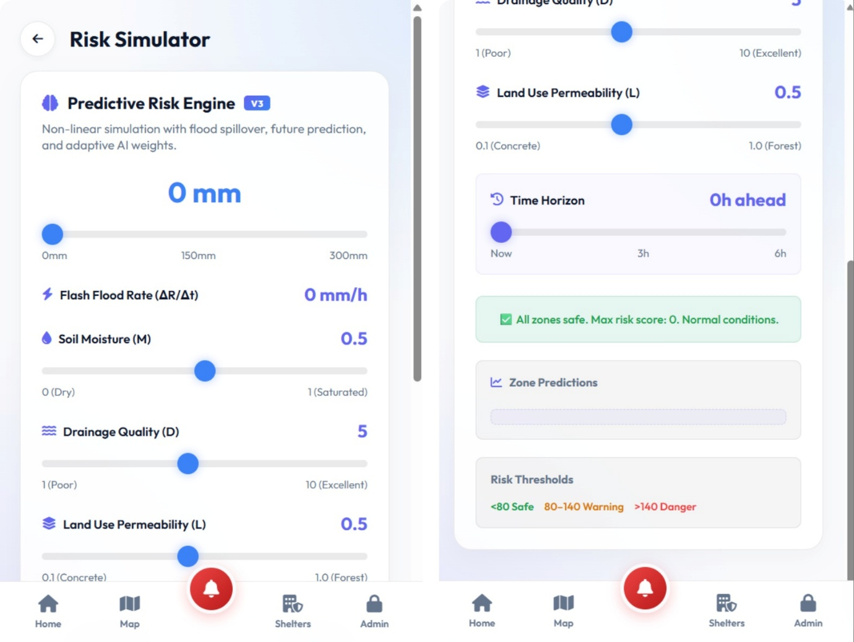
Figure 2. Live Predictive Risk Engine interface exposing the MCFRI input parameters described in Section 3.2.
The exponential soil-moisture term is the central modelling choice, motivated directly by the threshold-driven, non-linear runoff behaviour documented in prior hydrological studies: as antecedent saturation M approaches 1, the same incremental rainfall produces a disproportionately larger increase in computed risk, consistent with observed catchment behaviour near saturation. The inverse-power drainage term allows engineered drainage capacity to act as a continuous mitigating factor rather than a discrete correction, and the elevation-permeability term is conditioned jointly on height and surface type, so that elevation alone is not treated as an unconditional safety factor.

3.3 Risk Classification and Supporting Modules
The computed score is classified as Safe (S(t) < 80), Warning (80 <= S(t) <= 140), or Danger (S(t) > 140). Beyond the core scoring function, the system implements four supporting modules, illustrated in Figures 3-5: (i) a spatial propagation module that transfers a proportion of a Danger-classified zone's score to neighbouring zones within a defined radius, modelling floodwater migration; (ii) a time-horizon module that projects the score forward across a selectable window using observed rainfall trends; (iii) an adaptive weighting module that increases rainfall sensitivity when a rolling window of recent scores shows rapid escalation; and (iv) a risk-aware routing engine that computes navigable paths while avoiding Warning/Danger zones under a tiered fallback strategy, coupled with an emergency-request triage module that ranks rescue requests by local risk and wait time, and a shelter-proximity module.

Figure 3. Live Risk Map showing dual-layer zone visualisation (Safe/Warning/Danger) and a computed safe road route around hazard zones.
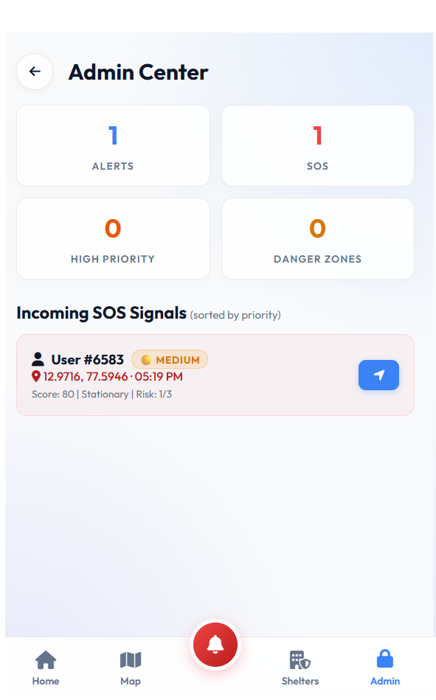
Figure 4. Admin Center showing the Emergency Request Prioritisation module, with incoming SOS signals ranked by priority score.

Figure 5. Shelter Proximity module, showing nearest facilities ranked by real-time geodesic distance.

3.4 Validation Methodology
The model was back-tested against publicly reported rainfall totals and disaster-severity classifications for the August 2018 Kerala flood event across ten districts. For each district, MCFRI was computed using district-level rainfall and estimated soil-moisture, proximity, drainage, and elevation parameters, and the predicted risk tier was compared against the actual reported flood-severity outcome for that district. The model's performance was compared against a linear baseline model and against an earlier, non-exponential version of the model (V3).

3.5 Planned Physics-Based Baseline: SCS Curve Number Method
To address the absence of a physics-based baseline (discussed in Section 5), MCFRI V2 is planned to incorporate the USDA Soil Conservation Service Curve Number (SCS-CN) method for direct surface runoff estimation, alongside Height Above Nearest Drainage (HAND) for hydro-topographic normalisation. The SCS-CN method estimates runoff depth Q from storm rainfall P using a maximum potential retention S, derived from a tabulated Curve Number (CN) based on soil type and land use:
S = (25400 / CN) - 254 Ia = 0.2S Q = (P - Ia)^2 / (P - Ia +S)
where Ia is the initial abstraction before runoff begins. Replacing the currently manually-estimated drainage and permeability terms with CN-derived and HAND-derived values would ground those terms in an established, independently validated hydrological method rather than empirically assumed scores, and is the primary planned methodological upgrade for MCFRI V2.

4. Results
Table 1 presents the district-level validation results (District / Rainfall mm / Score / Predicted / Actual):
District | Rainfall (mm) | MCFRI Score | Predicted | Actual
Ernakulam | 648.3 | 147.9 | Danger | Danger
Idukki | 1478.9 | 171.4 | Danger | Danger
Wayanad | 1053.5 | 196.5 | Danger | Danger
Alappuzha | 608.2 | 194.5 | Danger | Danger
Thrissur | 734.7 | 163.3 | Danger | Danger
Pathanamthitta | 764.9 | 177.4 | Danger | Danger
Malappuram | 913.7 | 134.4 | Warning | Warning
Kozhikode | 836.0 | 113.6 | Warning | Warning
Kollam | 644.1 | 88.4 | Warning | Warning
Trivandrum | 373.8 | 50.0 | Safe | Safe
MCFRI achieved 100% classification accuracy (10 of 10 districts) against the reported outcomes, compared to 60% accuracy for the linear baseline model and 60% for the prior non-exponential (V3) model. Figure 6 visualises the relationship between district rainfall and computed score relative to the classification thresholds.
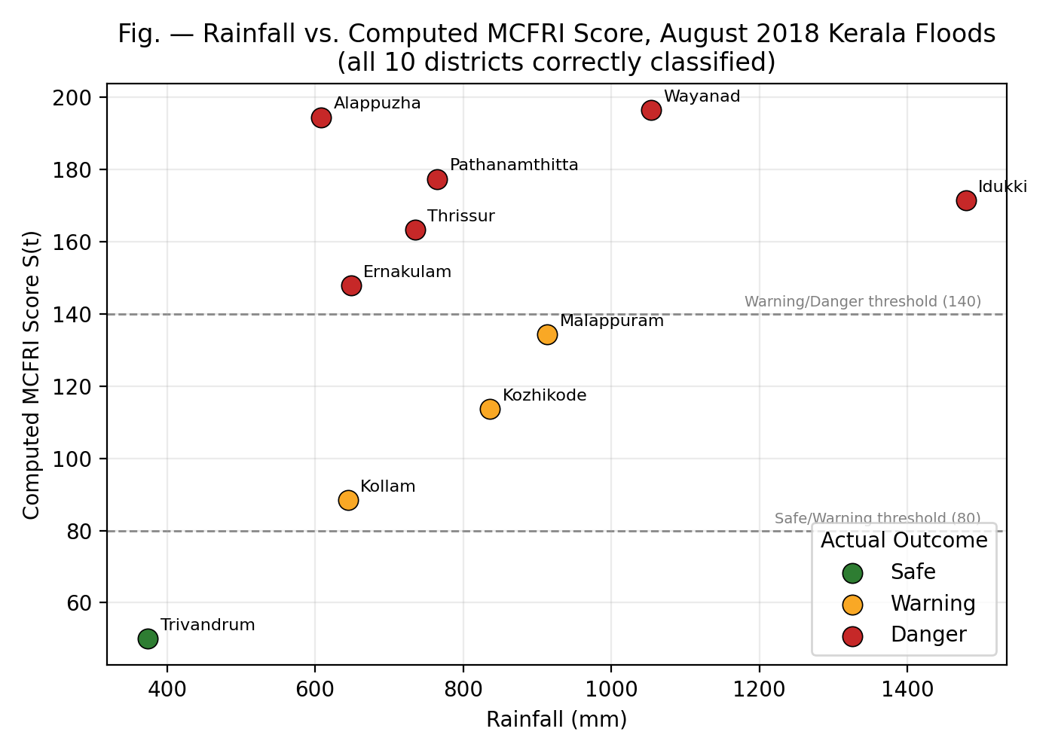
Figure 6. Rainfall vs. computed MCFRI score for all 10 validated districts, showing correct separation across both classification thresholds.
Notably, district pairs with similar rainfall totals but different outcomes, for example Malappuram at 913.7mm classified Warning versus Ernakulam at 648.3mm classified Danger, were correctly differentiated by the model, indicating that the non-rainfall terms (proximity, drainage, elevation, permeability) meaningfully contribute to classification rather than rainfall alone driving the outcome.

4.1 Contextualising Against Published Benchmarks
Since MCFRI's 100% figure, taken alone, is a strong claim, we contextualise it in Figure 7 against machine-learning flood-susceptibility classifiers independently published for comparable Kerala river basins (Periyar, Vembanad, Idukki).
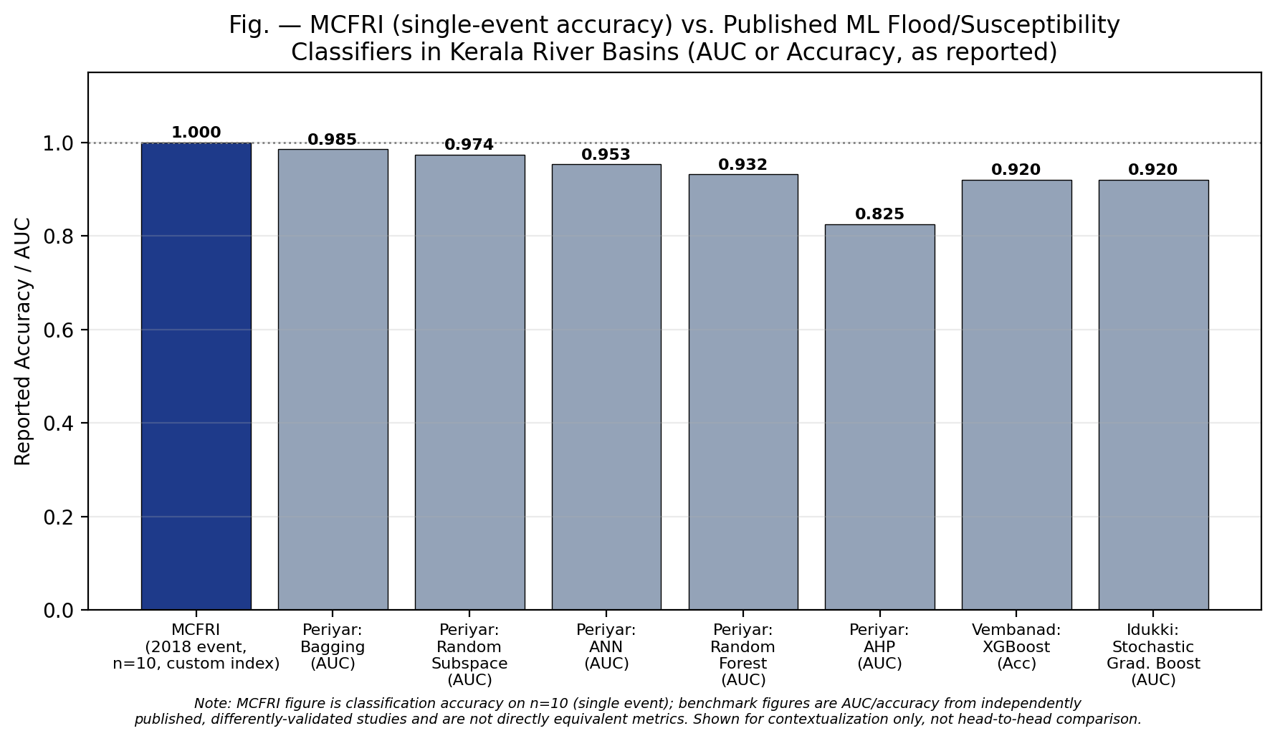
Figure 7. MCFRI single-event accuracy alongside published AUC/accuracy figures for ML classifiers in comparable Kerala basins. Metrics are not directly equivalent (see caption note); shown for contextualisation only.
Two caveats are essential here. First, the published figures are AUC (area under the ROC curve) from spatial-pixel-level classifiers validated on much larger sample sizes, whereas MCFRI's figure is district-level classification accuracy on a single ten-sample event; these are not equivalent metrics and are not being presented as a head-to-head comparison. Second, the closeness of MCFRI's figure to these published benchmarks should not be read as evidence that MCFRI is more accurate than established ML approaches, but rather as evidence that its performance on this single event is at least within a plausible range relative to the published state of the art, pending the larger-scale validation described in Section 6.

5. Discussion and Limitations
The results support the central hypothesis that a non-linear, multi-parameter formulation better captures real flood-severity outcomes than a linear, rainfall-only model. However, several limitations should be stated clearly.
- Sample size: validation was performed against a single historical event across ten districts, which is a small sample for establishing general predictive accuracy. The 100% classification result should be read as evidence that the model captures the correct qualitative ordering of risk for this event, not as a generalisable accuracy figure.
- Coefficient derivation: the exponents and weights were empirically tuned to fit the 2018 Kerala outcomes rather than derived from first-principles hydrological theory or fitted against a held-out validation set, raising a risk of overfitting to the specific event used for calibration.
- Input granularity: validation was performed at district level, coarser than the zone-level (sub-kilometre) granularity the system is designed for in deployment.
- Comparative baselines: the model was compared against a simple linear baseline and an internal prior version, but not yet against the SCS-CN method or the ML classifiers discussed in Sections 2 and 4.1 under identical validation conditions.
- Causal interpretation: MCFRI is an empirically-fitted index rather than a physically simulated hydrological model, and its terms should be interpreted as a useful operational approximation rather than a mechanistic simulation of catchment hydrology.

5.1 Threat to Validity: Spatial Autocorrelation
A further methodological threat, relevant to any future larger-scale validation of MCFRI, is spatial autocorrelation. Per Tobler's First Law of Geography, geographically proximate locations tend to share similar environmental characteristics. Standard random train/test splitting of spatial samples is known to allow test points to sit adjacent to training points with near-identical elevation, soil, and rainfall conditions, which can inflate reported accuracy by an estimated 6-18% relative to genuine out-of-sample performance. Any future zone-level or pixel-level validation of MCFRI should therefore adopt a spatial block cross-validation protocol, partitioning geographically isolated blocks (on the order of 50km, or a minimum buffer of 500m) into training and test sets, with a minimum target of approximately 1,000 spatially distinct sample points, rather than relying on random splits.

6. Planned Cross-Validation Events (Future Work)
To test whether MCFRI's current coefficients generalise beyond the single event they were calibrated on, or require recalibration, five additional historical flood events have been identified as candidate cross-validation datasets, drawing on official rainfall and impact data. None of these events have yet been run through the model; they are listed here as the planned validation set for MCFRI V2, not as results.

Kerala Floods, August 2019
Wayanad (Vythiri) 739mm, Kozhikode 806mm, Palakkad 765mm, Malappuram 516mm (Aug 8-10). 121-125 fatalities; Rs. 2,101.9 crore damage; 1,038+ villages affected across 14 districts. Source: Kerala State Relief Commissioner Memorandum (2019); CWRDM; IMD district data. Intended use: direct temporal cross-validation to test whether 2018-tuned parameters generalise without recalibration.

Kerala Cloudburst and Landslides, July-August 2024
Thrissur 340mm, Palakkad 300mm, Wayanad 280mm in 24 hours (July 29-30). 224 confirmed fatalities, 154 missing, 6,500 displaced in Chooralmala/Mundakkai. Source: IMD Daily Flash; NDMA report (Aug 2024). Intended use: validating Danger-threshold classification for steep, high-elevation zones under hyper-concentrated rainfall spikes.

Maharashtra Konkan Floods, July 2021
Mahabaleshwar (Satara) 1,074.8mm in 48 hours; Chiplun (Ratnagiri) 450mm in 24 hours. 209-251 fatalities; Rs. 4,000 crore damage; 375,000 evacuated across 13 districts. Source: IMD meteorological reports; NDRF operational data (July 2021). Intended use: independent spatial cross-validation of Western Ghats topography under a different monsoon system.

Karnataka Kodagu Floods, August 2019
Kodagu 647-935mm (Aug 1-11); Kakkabe village 762mm in 24 hours. 61 fatalities, 15 missing, Rs. 40,000 crore damage, 400,000 displaced. Source: Karnataka State Natural Disaster Monitoring Centre; Geological Survey of India. Intended use: tests model sensitivity to antecedent soil moisture interacting with modified land use (coffee plantations).

Assam Brahmaputra Floods, May-June 2022
Assam received 327% excess rainfall (May 12-18); Silchar town 90% inundated under 12 feet of water. Over 200 fatalities, 5.4 million affected. Source: Assam State Disaster Management Authority readiness report (2022). Intended use: an out-of-domain stress test to evaluate whether index parameters function outside Western Ghats topography, since Assam's riverine floodplain dynamics differ substantially from the steep Western Ghats catchments the model was tuned on.

7. Future Work: Multi-Hazard Landslide Integration
In the steep, saturated terrain of the Western Ghats, localised monsoonal cloudbursts concurrently trigger flash floods in valley floors and mass-wasting landslides on mountain slopes. The August 2024 Wayanad disaster is a direct case in point: 280mm of cloudburst rainfall in 24 hours (July 29-30, 2024) triggered slope failures in Chooralmala and Mundakkai, displacing 6,500 people and causing 224 confirmed fatalities (source: IMD Daily Flash and NDMA Division operational report, Aug 6, 2024).
Coupling MCFRI with a Landslide Susceptibility Index (LSI), combined via the Analytic Hierarchy Process, is proposed as a future extension. The planned LSI conditioning layers are: (1) slope angle and aspect, deriving shear stress; (2) plan/profile curvature, capturing flow divergence and acceleration; (3) lithology and soil type, capturing cohesion and shear strength; (4) distance to structural lineaments; (5) the Topographic Wetness Index, capturing saturation potential; and (6) land use/land cover, as a proxy for root cohesion. This would extend AI SafeRoute from a single-hazard flood tool into a multi-hazard early-warning system appropriate for steep terrain such as the Western Ghats.

8. Conclusion
This paper presented MCFRI, a non-linear, multi-parameter flood risk index designed for real-time operational use, and AI SafeRoute, a system that couples this index to spatial risk propagation, short-horizon forecasting, risk-aware routing, and emergency-request triage. Back-testing against the August 2018 Kerala floods showed a substantial improvement over a linear baseline, and contextualisation against published ML benchmarks suggests the result is at least within a plausible range of the current state of the art, though this comparison uses non-identical metrics and validation conditions. The paper's principal contribution beyond the original result is a concrete, sourced roadmap for rigorous future validation: a physics-based SCS-CN and HAND baseline, five named candidate cross-validation events with official data sources, and a spatial block cross-validation protocol to guard against inflated accuracy from spatial autocorrelation. Future work includes executing this validation plan and extending the system with the proposed Landslide Susceptibility Index module.

References
[1] Flood susceptibility assessment using three machine learning techniques and comparison of their performance. Scientific Reports, Nature Portfolio, 2026.
[2] Evaluation of rainfall-threshold methods for flash flood warnings based on soil moisture conditions. Natural Hazards, Springer, 2025.
[3] The impacts of rainfall and soil moisture to flood hazards in a humid mountainous catchment: a modeling investigation. Frontiers in Earth Science, 2023.
[4] A Novel Flood Probability Index Based on Radar Rainfall and Soil Moisture Estimates for a Small Vegetated Watershed in Southeast Brazil. Atmosphere, MDPI, 2025.
[5] Time-series framework integrating rainfall and satellite soil moisture for multi-scale urban flood risk assessment. Science of the Total Environment / ScienceDirect, 2026.
[6] Flood susceptibility mapping using ensemble Bagging and Random Subspace models, Periyar River Basin, Kerala. Taylor & Francis Online, 2025.
[7] Comparative flood susceptibility modelling using ANN, Random Forest, and AHP, Periyar River Basin, Kerala. ResearchGate, 2024.
[8] Flood susceptibility mapping using XGBoost and Gradient Boosting, Vembanad Lake System, Kerala. ASCE Library, 2023.
[9] Flood susceptibility assessment using Stochastic Gradient Boosting, Idukki district, Kerala. ResearchGate, 2023.
[10] Kerala State Relief Commissioner. Memorandum on Kerala Floods 2019; Centre for Water Resources Development and Management (CWRDM); IMD district rainfall data.
[11] National Disaster Management Authority (NDMA). Wayanad Landslide Operational Report, August 2024; IMD Daily Flash Reports, July-August 2024.
[12] India Meteorological Department; National Disaster Response Force. Maharashtra Konkan Floods Operational Data, July 2021.
[13] Karnataka State Natural Disaster Monitoring Centre (KSNDMC); Geological Survey of India. Kodagu Floods Report, August 2019.
[14] Assam State Disaster Management Authority (ASDMA). Flood Readiness and Response Report, 2022.
[15] Kerala State Disaster Management Authority (KSDMA). Kerala Floods 2018 post-disaster needs assessment reports (district rainfall and severity data).
[16] USDA Natural Resources Conservation Service. National Engineering Handbook, Part 630, Chapter 10: Estimation of Direct Runoff from Storm Rainfall (SCS Curve Number Method).
[17] NASA National Snow and Ice Data Center DAAC. SMAP L3 Radiometer Global Daily 9km Soil Moisture (SPL3SMP_E).
[18] ISRO Bhuvan Geoportal; USGS EarthExplorer. CartoDEM and SRTM Digital Elevation Models.
Author's Note: The MCFRI concept, equation design, and system architecture presented in this paper are the original work of the author, developed and validated independently as an undergraduate research project. A provisional patent application covering the system and method described herein has been filed in India. The additional benchmark, dataset, and methodology sources cited in Sections 4.1, 5.1, 6, and 7 were identified via a structured literature and open-data research pass and are presented as planned future validation work, not as results already obtained.

