**Digital Computer Design Laboratory**

**#8 Simple Data Path**

1. In this laboratory course, you will be creating a program counter and instruction memory to be used with the register file you have done in the previous lab.

Instruction memory accepts no input other than clock and at each clock positive edge PC will be increased with 1 and instruction memory will move the next instruction to the register file. It is acceptable that the four instructions are already in the memory of Instruction memory and these are;

00000000011111

01111100001110

10111111101101

11110111111011

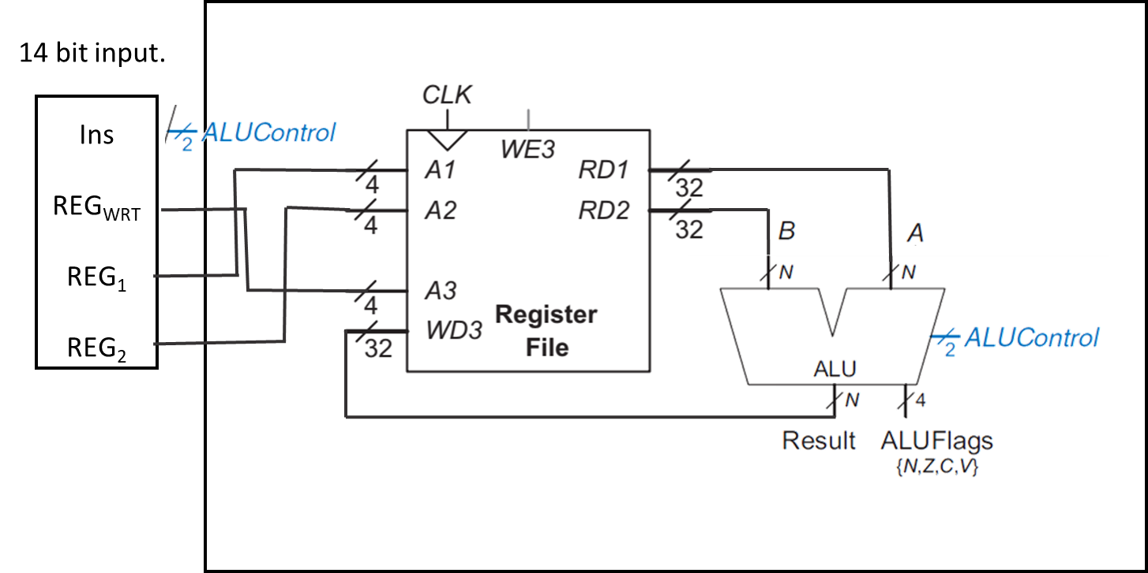

1

PCPlus1

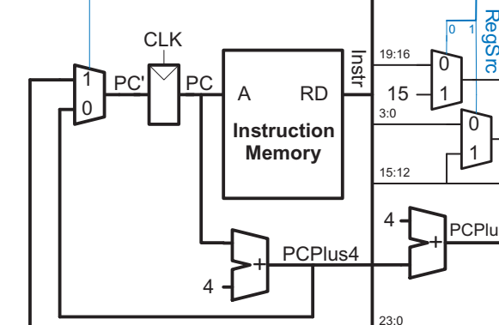

Instr13:10

Instr1:0

Instr5:2

Instr9:6