Digital Computer Design Laboratory

#ALU

1- Create the following files fulladder.sv, NbitFulladder.sv, MUX2.sv and MUX4.sv.

module fulladder(input logic a, b, cin,
output logic s, cout);

assign s=a^b^cin;
assign cout= a&b|b&cin|cin&a;
endmodule

fulladder.sv
module NbitFulladder( input logic [7:0] a, b,
input logic cin,
output logic [7:0] s,
output logic cout );
wire [6:0] c;

fulladder i_0 (a[0],b[0],cin,s[0],c[0]);
fulladder i_1 (a[1],b[1],c[0],s[1],c[1]);
fulladder i_2 (a[2],b[2],c[1],s[2],c[2]);
fulladder i_3 (a[3],b[3],c[2],s[3],c[3]);
fulladder i_4 (a[4],b[4],c[3],s[4],c[4]);
fulladder i_5 (a[5],b[5],c[4],s[5],c[5]);
fulladder i_6 (a[6],b[6],c[5],s[6],c[6]);
fulladder i_7 (a[7],b[7],c[6],s[7],cout);

endmodule

NbitFulladder.sv

module mux2(input logic [3:0] d0, d1,
input logic s,
output logic [3:0] y);

assign y = s ? d1 : d0;

endmodule

MUX2.sv

module mux4(input logic [3:0] d0, d1, d2, d3,
input logic [1:0] s,
output logic [3:0] y);

assign y = s[1] ?
(s[0] ? d3 : d2):
(s[0] ? d1 : d0);

endmodule

MUX4.sv

2- Create 8-bit ALU module given below using NbitFulladder, MUX2 and MUX4 modules and create a testbench for this module.

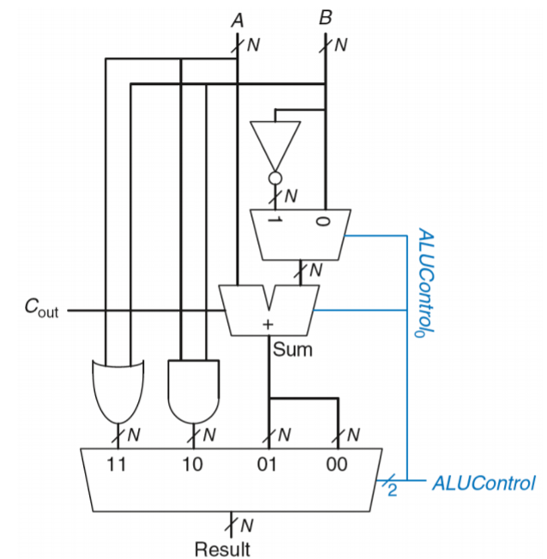

$${ALU Control }_{1:0}$$ | Function
00 | Add
01 | Subtract
10 | AND
11 | OR

