Digital Computer Design Laboratory

#2 Structural Design

1- Create the following two files MUX2.sv and MUX4.sv.
module mux2(input logic [3:0] d0, d1,
input logic s,
output logic [3:0] y);

assign y = s ? d1 : d0;

endmodule

MUX2.sv

module mux4(input logic [3:0] d0, d1, d2, d3,
input logic [1:0] s,
output logic [3:0] y);

assign y = s[1] ?
(s[0] ? d3 : d2):
(s[0] ? d1 : d0);

endmodule

MUX4.sv

2- Create a project, add these files, create testbenches to simulate the project and observe the outputs.

3- Recreate the 4x1 multiplexer with 2x1 multiplexer to simulate 4x1 MUX circuit given below.
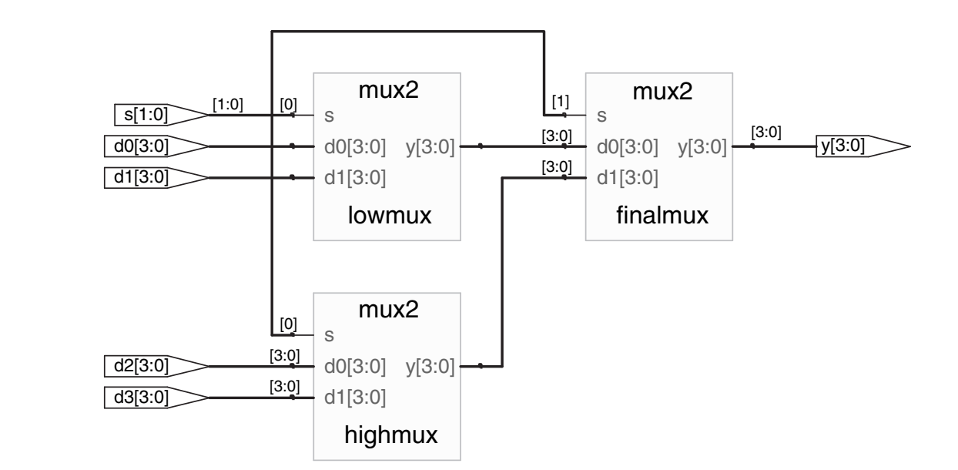

4x1 MUX Sythesized Circuit

4- Create a testbench for 4x1 MUX.

5- Create a project, add these files, simulate the project and observe the outputs.

