**Final Exam**

1. You just got hired to program a web site for an ISP. Since you know a lot about IP addresses they want to ask your opinion about the infrastructure of their network. The company is working in three different countries, USA, Canada and Australia. In each country there is at least 50 branches. The company is going to expand to maximum of 100 locations per country. They would like you to design the network subnets in two different ways.
   1. When you use a class A Private IP address of 10.x.x.x
   2. When you use a Class B Private IP address of 172.16.x.x

Providing that each location must have its own subnet answer the following questions for each scenario

1. What is the maximum number of subnets you can have
2. What is the maximum number of computers you can have
3. What is the subnet mask for your network
4. What is the IP range for subnet 1 and subnet 10
5. Can you solve the problem with only one Class C IP Address? Explain your answer
6. Does class B IP address work if the company wants to extend to 100 more countries each one with Maximum 100 locations?
7. Pete is investigating a domain hijacking attack against his company that successfully redirected web traffic to a third party website. Which one of the following techniques is the most effective way to carry out a domain hijacking attack?
   1. ARP poisoning
   2. Network eavesdropping
   3. DNS poisoning
   4. Social engineering
8. Kristen conducts a vulnerability scan against her organization's network and discovers a file server with the vulnerability shown below. Which one of the following actions is the best way to remediate this vulnerability?

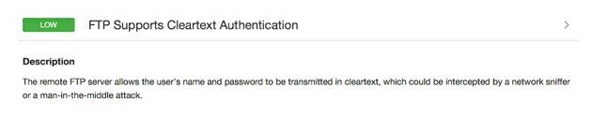

* 1. Discontinue the file transfer service
  2. Require strong passwords
  3. Switch to SFTP
  4. Require multifactor authentication

1. Explain the differences between SAN and NAS.
2. *What is the major difference between UDP and TCP.*
3. UDP is reliable and faster than TCP
4. TCP is reliable and faster than UDP
5. UDP is reliable, TCP is faster
6. UDP is faster, TCP is reliable
7. *Which layer of OSI do routers work in?*
8. Application
9. Session
10. Data Link Control/Media Access Control
11. Network

8. Which TCP or UDP protocol is associated with port 25 by default?

A. RDP

B. HTTPS

C. SSH

D. SMTP

9. Which of the following is a UDP-based protocol for file transfer that does not include security or error checking?

A. STFP

B. TFTP

C. IGMP

D. TLS

10. What network device forwards packets only to an intended port?

A. Hub

B. Switch

C. PPPoE

D. PPP

11. Explain the concept of Virtualization and advantages/disadvantages

Good Luck