

SCHOOL OF ADVANCED TECHNOLOGY

ICT - Applications & Programming

Computer Engineering Technology – Computing Science

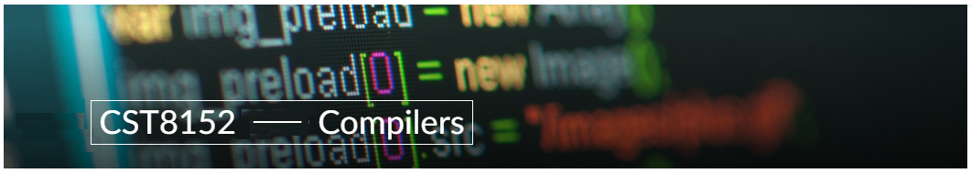

A21
Model Definitions (RE/Automaton)

Lab Professor / Lab Session:
[ Paulo Sousa / 301]

Team:
[Ark Gupte] - Id: [041061576] / [Sina Khodaveisi] - Id: [041066567]

Language Name [Nova Script]

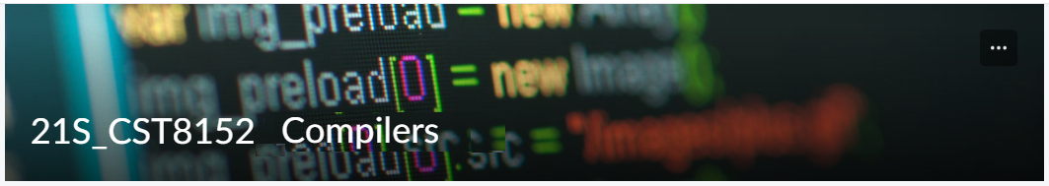

MODEL TASK FOR ASSIGNMENT 2.1 – Nova Script

Task 1: Language Symbols (2.0 marks)

List examples: Define main symbols to be used:
- Special symbols (ex: “{“, “(“, “<=”, etc.)
- Comments
- Variables
- Functions
- Literals (numbers, strings)
- Keywords
- Datatypes

Answer:
Special symbols- ‘{‘,’}’ , ‘(‘,’)’ , ‘$’ ,’&’ , ‘%’ , ‘*’ , ‘++’ , ‘- -‘ , ‘ == ‘ , ‘.’ , ‘<’ , ‘>’ , ‘<=’ , ‘>=’ ,
Comments- Single line ‘//’ , Multiline ‘/* ……… */’ .
Variables-
Integer variable: var a int
Float variable: var a float
Boolean variable: var a Boolean
String variable: var a string
Constant variable: var const a
Functions- func functionName (parameters datatype) return type { }
Literals-
Integer: ‘1’ , ‘123’
Float: ‘0.1’ , ‘3.14’
String: ‘Hello!!!’
Keywords- if , else , for , break , const , continue , func , import , package , return , var , struct , switch , type
Datatypes- int32 , float32 , Boolean , string.

Task 2: RE – Regular Expression (3.0 mark)

Lexeme Classes: Define the classes to be used in your regular expression:

Answer:
L(letters): [ A-Z, a-z]
D(Digits): [0-9]
U(Underscore): _
Q(Quotes): “
S(Slash): /
A (Asterisk): *
M (Method identifier): (
F (Floating point): .
O(Others): [^LDUMQSAF]

Define the RE to be used for: variables, literals and keywords:

Answer:
* Comment: S[S|A][^A]*[O|AS]
Single Line Comment: SS[L|D|U|Q|S|M]*
Multi Line Comment SA[L|D|U|Q|S|M]*AS
* VID (Variables): [L|U][L|D|U]*
* MID(Methods): [L|U][L|D|U]*M
* Literals:
- Numbers:
IL (Integer Literal): D*
FPL (Floating-Point Literal): D*FD*
- SL (Strings): Q[^Q]*Q
* KEY (Keywords): L[L]*

Task 3: TD – Transition Diagram (3.0 marks)

Activity: Starting from the previous lexeme classes and obeying the RE, it is possible to define the automata for your language:

Answer (draw / copy image of the automata):
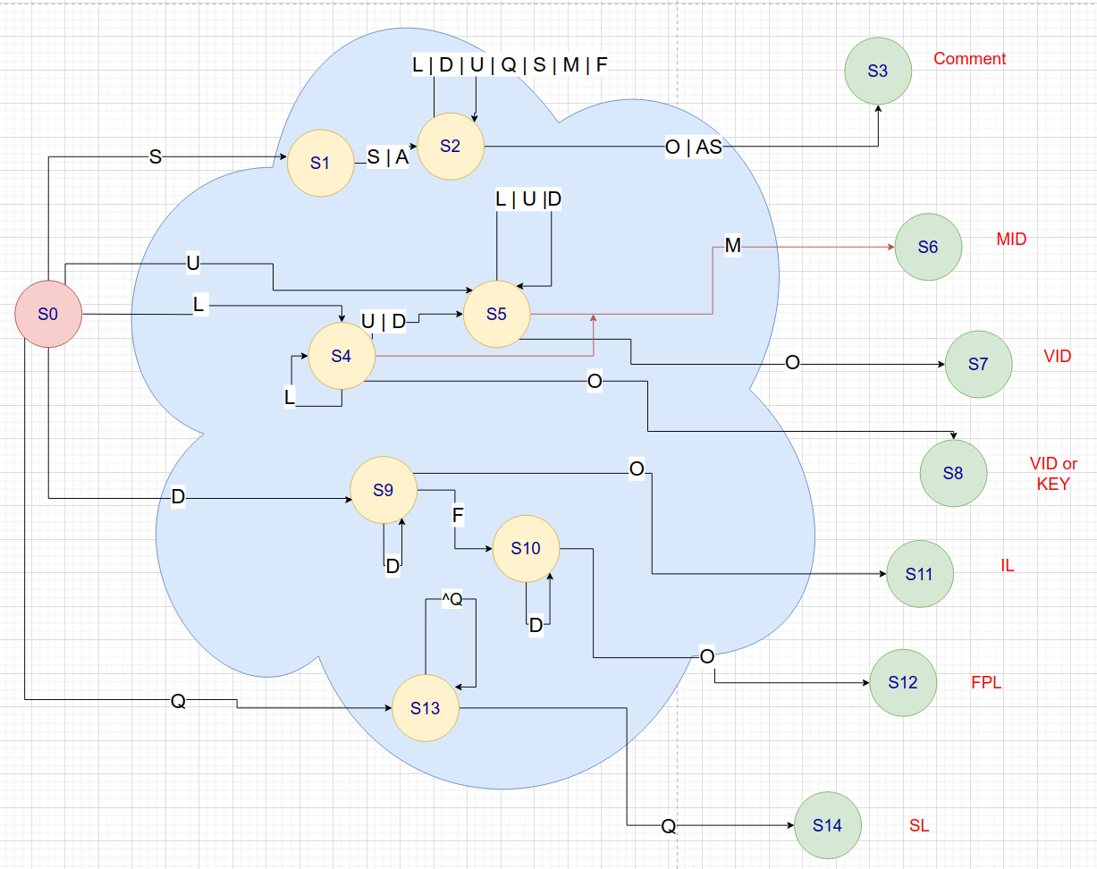

For simplifying we consider both single line and multi line comment as same. Also, state 2 needs another state to check if next character is * (A) and then check the S but it would have added to complexity.

Task 4: TT – Transition Table (2.0 marks)

Activity: Now, it is possible to define the TT for these lexemes:

Answer (Transition Table):

Input State | L | D | U | Q | S | A | M | F | O | OUTPUT
S0 | 4 | 10 | 5 | 9 | 1 | ES | ES | ES | ES | NOFS
S1 | ES | ES | ES | ES | 2 | 2 | ES | ES | ES | NOFS
S2 | ES | ES | ES | ES | ES | 3 | ES | ES | 3 | NOFS
S3 | FS | FS | FS | FS | FS | FS | FS | FS | FS
S4 | 4 | 5 | 5 | ES | ES | ES | 6 | ES | 8 | NOFS
S5 | 5 | 5 | 5 | ES | ES | ES | 6 | ES | 7 | NOFS
S6 | FS | FS | FS | FS | FS | FS | FS | FS | FS
S7 | FS | FS | FS | FS | FS | FS | FS | FS | FS
S8 | FS | FS | FS | FS | FS | FS | FS | FS | FS
S9 | 9 | ES | ES | ES | ES | ES | ES | 10 | 11 | NOFS
S10 | 10 | ES | ES | ES | ES | ES | ES | ES | 12 | NOFS
S11 | FS | FS | FS | FS | FS | FS | FS | FS | FS
S12 | FS | FS | FS | FS | FS | FS | FS | FS | FS
S13 | 13 | 13 | 13 | 14 | 13 | 13 | 13 | 13 | 13 | NOFS
S14 | FS | FS | FS | FS | FS | FS | FS | FS | FS

Update: Oct 10th 2023.

Adapted from resources developed by Prof. Svillen Ranev (Algonquin College, 2019)

