Output plot at a pressure of 101.325 kPa and temperatures ranging from 274.24K to 322.24K, 0.1K apart is shown as follows (Fig. 1).

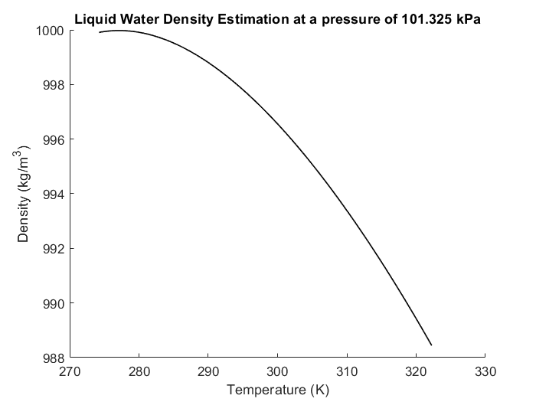

Fig.1

Three coding files constitute the program. Their respective functionality is explained as follows:

1. JingyuRenAssignment6v2.m

This is the execution entry file of the program.

Variable ‘Xp’, which denotes the pressure, and variable ‘Yp’, which denotes the temperature vector, should be defined manually. They formed the coordinates of points where we want to interpolate. Matrix ‘Zp’ is the output of density prediction.

First, the data file is imported to a matrix named ‘Cwaterdensity’. Second, a correlation analysis is conducted to discover the linear relationship among temperature, pressure and density. It turns out that temperature is probably negative-linearly dependent on density, so linear interpolation can be used as a predictor. Third, a self-defined bilinear interpolation function is called to get the predicted density at previously defined positions. Last, the curve of predicted density vs pressure is plotted.

2. jy_fit.m

This file consists of the function to do bilinear interpolation. Its output data is a matrix denoting data points where water density is Zp(j, i) when the temperature is Yp(j) and pressure is Xp(i).

3. jy_find.m

This file consists of the function to do a binary search. It is called within the function jy_fit() to get the lower neighbouring index of each data point. The input vector should be a sorted list.