YOUTUBE CREATOR GUIDE
WebBrain Settings
Beginner-first walkthrough with advanced configuration
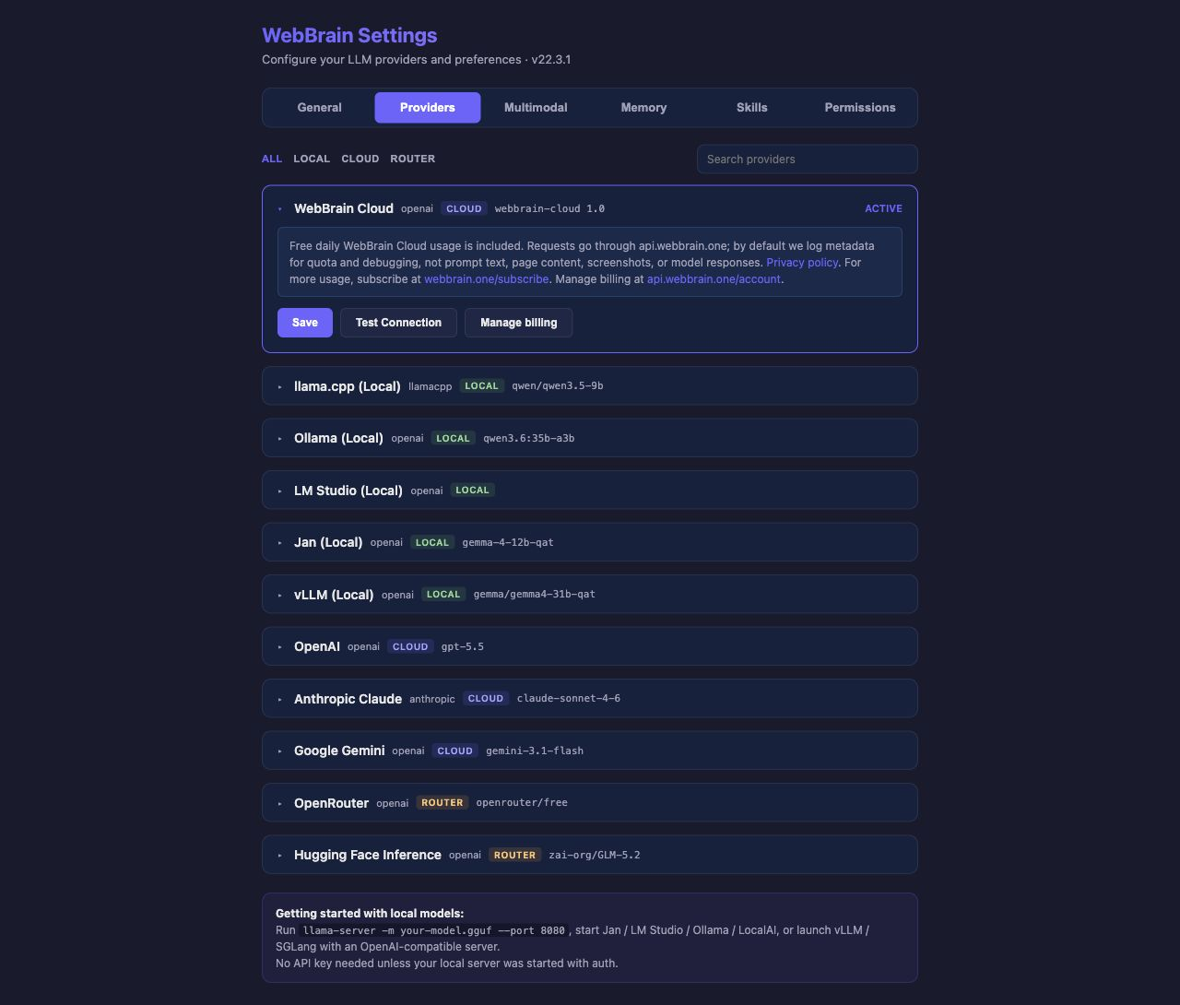
Opening frame: WebBrain Settings and the six-section navigation.
Target running time: 18-22 minutes
Includes chapter entry frames, exit frames, and mid-chapter close-ups

Recording setup
PRIVACY CHECK Record from a clean browser profile. Use dummy API keys, a fictional profile, harmless memory records, and demo permission entries. Never show a real sync email, provider credential, personal memory, or production trace.
RECORDING STYLE Keep the pointer movement slow. Pause briefly after every tab change. For dense sections, zoom the browser only if the text remains sharp and the layout still looks natural.
EDITING RHYTHM Use each chapter entry frame for the chapter title card. Use the exit frame while delivering the final sentence of that chapter, then cut directly to the next tab.

Run of show
0:00 Opening and mental model
1:05 Fastest possible setup
2:00 Everyday General settings
4:30 Providers in detail
7:30 Multimodal configuration
8:45 Memory and profile information
12:00 Skills
14:00 Permissions
15:30 Every Advanced setting
19:30 Recommended configurations and closing

CHAPTER 1 / 0:00

Opening and the six-part mental model

ENTRY FRAME Start on the Settings title, navigation, and active provider.
ON SCREEN Open WebBrain Settings. Move across the six tabs from left to right, then return to Providers.
NARRATION WebBrain has become much more configurable, which is great - but the Settings page can look a little intimidating at first.
NARRATION In this video, I will start with the few settings almost everyone needs. Then we will gradually move into providers, memory, skills, permissions, local models, security controls, and every option inside the Advanced section.
NARRATION You do not need to understand every setting to use WebBrain. For most people, choosing a provider and leaving the other defaults alone is a perfectly good starting point.

The six sections
ON SCREEN Point to each tab as it is named.
NARRATION The page is divided into six sections. General controls how WebBrain behaves. Providers selects the model that powers the agent. Multimodal lets you use separate models for screenshots and transcription. Memory controls persistent preferences and profile information. Skills adds specialized instructions and tools. Permissions controls which consequential browser actions WebBrain may perform.
NARRATION The page remembers the tab you last opened, so you may not always land on the same section.

EXIT FRAME End on the provider list to set up the transition into the practical setup chapter.

CHAPTER 2 / 1:05

The fastest possible setup

ENTRY FRAME Frame the active provider badge and the Save/Test controls.
ON SCREEN Expand the active provider card, then briefly open one other provider. Use only dummy credentials.
NARRATION If you only want to get started, this is the important part. The provider marked Active is the model WebBrain currently uses.
NARRATION WebBrain Cloud requires no manual provider configuration and includes a daily allowance. You can also use your own cloud API key, a model router, or a completely local model.
NARRATION To configure another provider, expand its card, enter the required information, click Save, and then Test Connection. Once the test succeeds, click Set Active. That is the basic setup. Everything after this is customization.
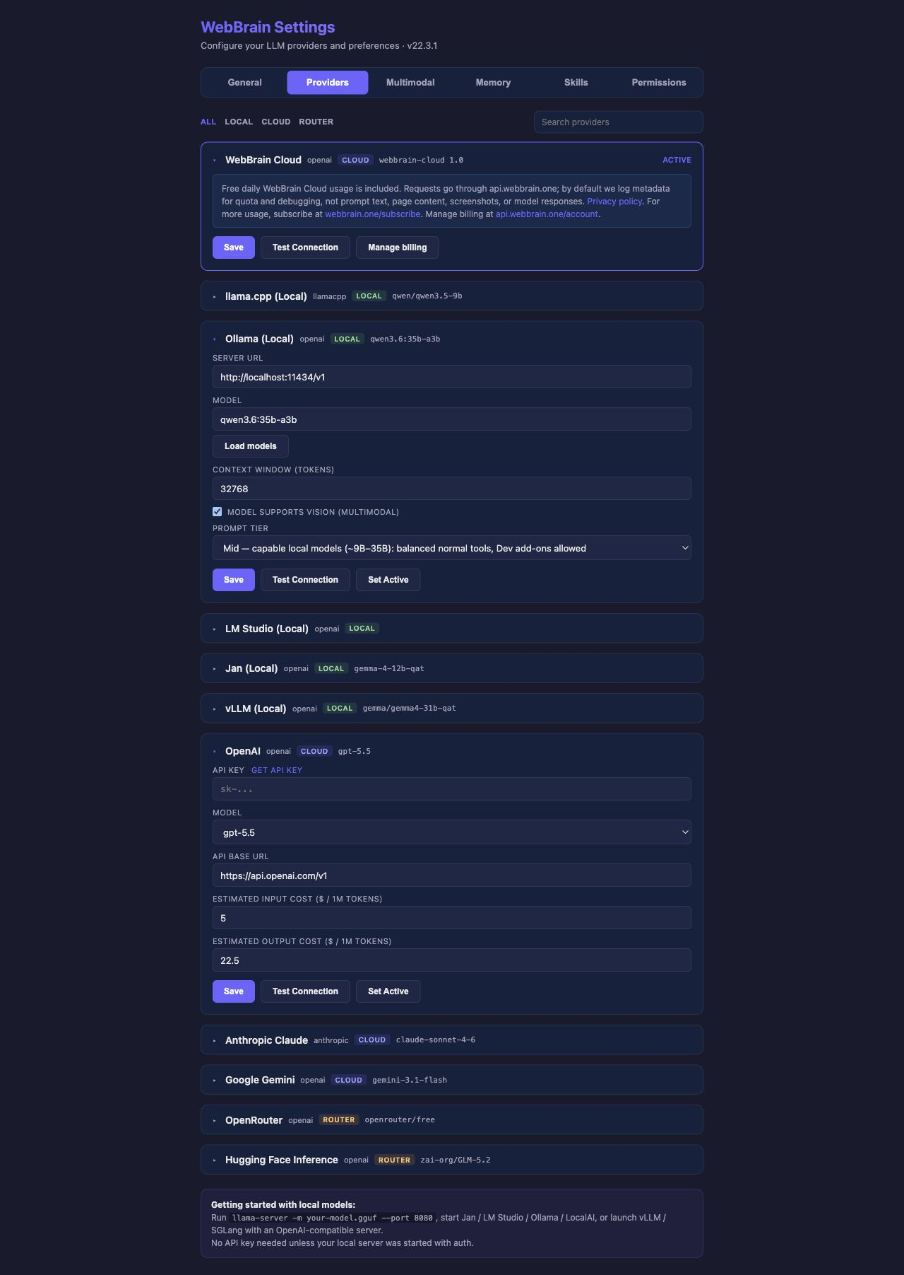
MID-CHAPTER Cloud-provider close-up with API key, model, base URL, cost estimates, and activation controls.

EXIT FRAME Finish on Save, Test Connection, and Set Active.

CHAPTER 3 / 2:00

Everyday General settings
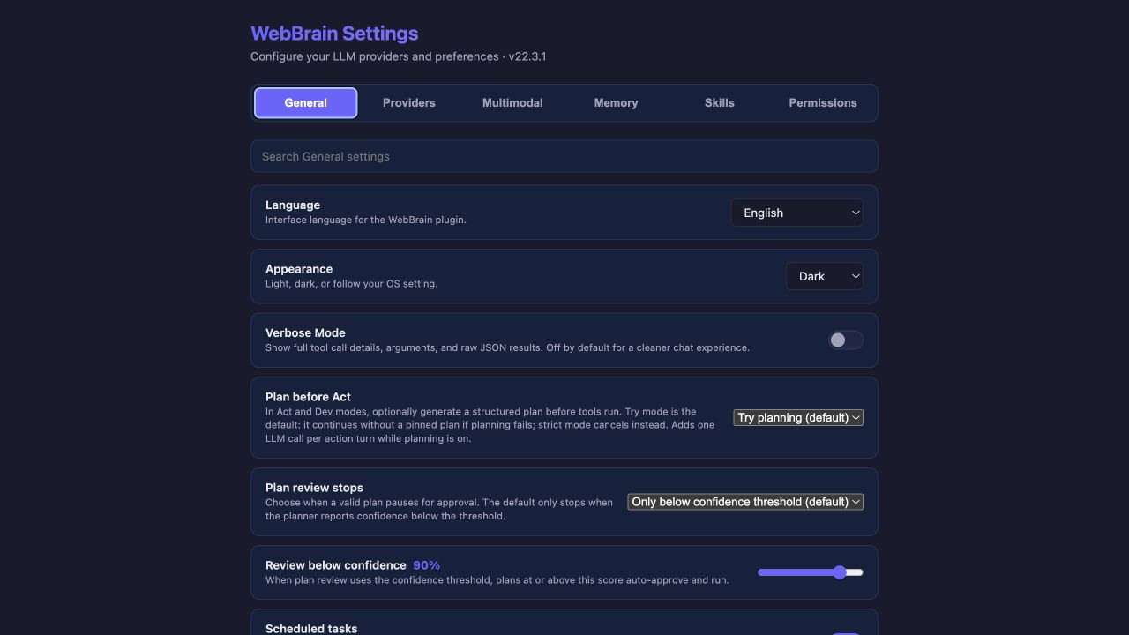
ENTRY FRAME Open General and establish the language, appearance, and behavior controls.
ON SCREEN Show Language, Appearance, and Verbose Mode first. Keep the pace brisk.
NARRATION Language changes WebBrain's interface language. Appearance can follow your operating system or stay in light or dark mode.
NARRATION Verbose Mode displays full tool arguments and raw results in the conversation. It is useful for debugging, but most people should leave it off for a cleaner chat.

Planning

MID-CHAPTER Planning close-up: Plan before Act, review policy, and the confidence threshold.
NARRATION Plan before Act controls whether WebBrain creates a structured plan before operating the browser. Try planning is the default: WebBrain attempts a plan, but can continue if planning fails. Strict planning cancels the run if a valid plan cannot be produced. Off skips planning.
NARRATION Plan review stops is separate. The default is confidence-based review. With the threshold at ninety percent, plans at or above ninety percent run automatically. Lower-confidence plans pause so you can review or change them. You can instead review every plan or never stop for review.
NARRATION A good general-purpose setup is Try planning with confidence-based review. It adds structure without interrupting you unnecessarily.

Scheduled tasks and completion behavior
NARRATION Scheduled tasks allows one-time and recurring jobs to run through browser alarms. Confirm scheduled consequential actions keeps permission checks active during unattended runs, and I recommend leaving it on.
NARRATION Completion sound plays a short chime. Completion confetti adds the success animation and can be disabled for a quieter finish.

Step limit, timeout, History, and Traces
NARRATION Max Agent Steps limits how many tool actions WebBrain can take for one message. The default is one hundred and thirty. Moving the slider to infinity removes the limit, which is best reserved for complex tasks you are actively monitoring.
NARRATION LLM request timeout controls how long WebBrain waits for a model to begin responding. The default is one hundred and twenty seconds. Large local models may need longer.
NARRATION Chat History opens locally saved conversations. Traces opens the debugging and model-comparison view; traces appear only after recording is enabled in Advanced settings.
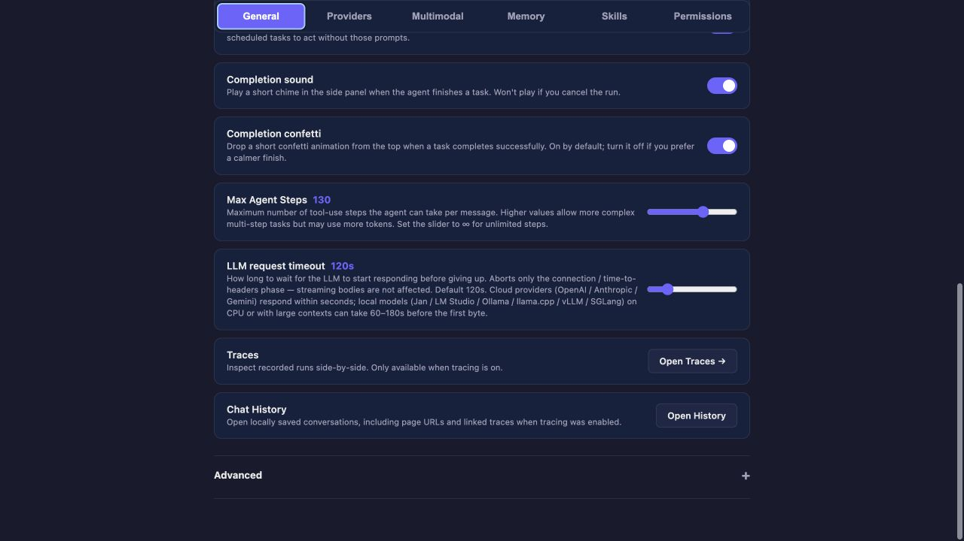
EXIT FRAME End on Max Agent Steps, timeout, Traces, History, and the collapsed Advanced section.

CHAPTER 4 / 4:30

Providers in detail

ENTRY FRAME Re-establish the filters, search field, active card, and collapsed provider headers.
NARRATION Providers are grouped into Local, Cloud, and Router categories. Use the filters to shorten the list, or search by provider, model, field, or category.
NARRATION The active provider remains visible even if it does not match the selected category. Its card begins expanded. Other headers still show the provider type, category, and configured model.

Local providers
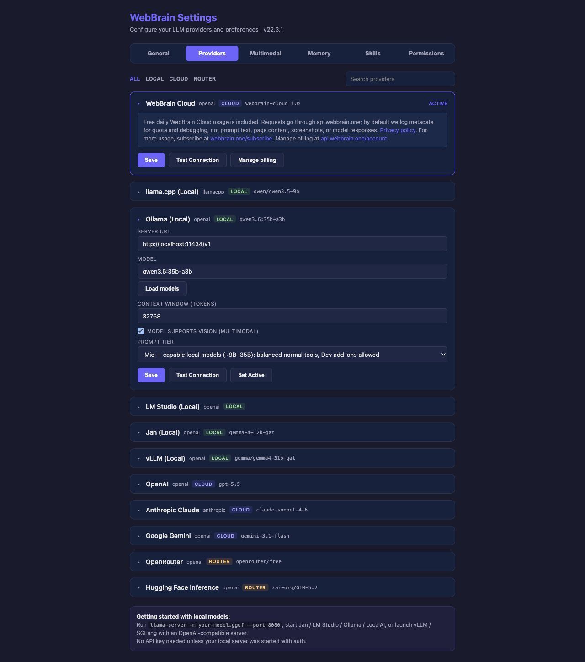
MID-CHAPTER Local-provider close-up showing server URL, model discovery, context window, vision, and prompt tier.
NARRATION WebBrain supports llama.cpp, Ollama, LM Studio, Jan, vLLM, SGLang, and LocalAI. Server URL is the address of the local service. Model identifies the loaded or served model; LM Studio can leave it blank to use the model already loaded.
NARRATION Load Models asks the local server for available model names. Context window is the number of tokens the model can handle. Local providers default conservatively to sixteen thousand three hundred and eighty-four tokens, and some backends can report a larger live value during model loading or connection testing.
NARRATION Model supports vision should be enabled only when the selected model accepts images. Prompt tier controls tool-surface size: Compact for small models, Mid for capable local models, and Full for large or frontier models. Dev mode is unavailable at Compact tier.

Cloud providers

MID-CHAPTER Cloud-provider close-up. Cost fields estimate usage; they do not change provider billing.
NARRATION A typical cloud provider asks for an API key and model. Many also expose an API base URL and estimated input and output prices. Those prices help WebBrain estimate cost when exact usage is unavailable; they do not alter what the provider charges.
NARRATION Azure adds a deployment name and API version. AWS Bedrock uses region and AWS credentials. Cloudflare Workers AI also needs an account ID. After any change, remember the separate steps: Save, Test Connection, and Set Active.

EXIT FRAME Close on the provider categories and the local-model quick-start note.

CHAPTER 5 / 7:30

Multimodal configuration
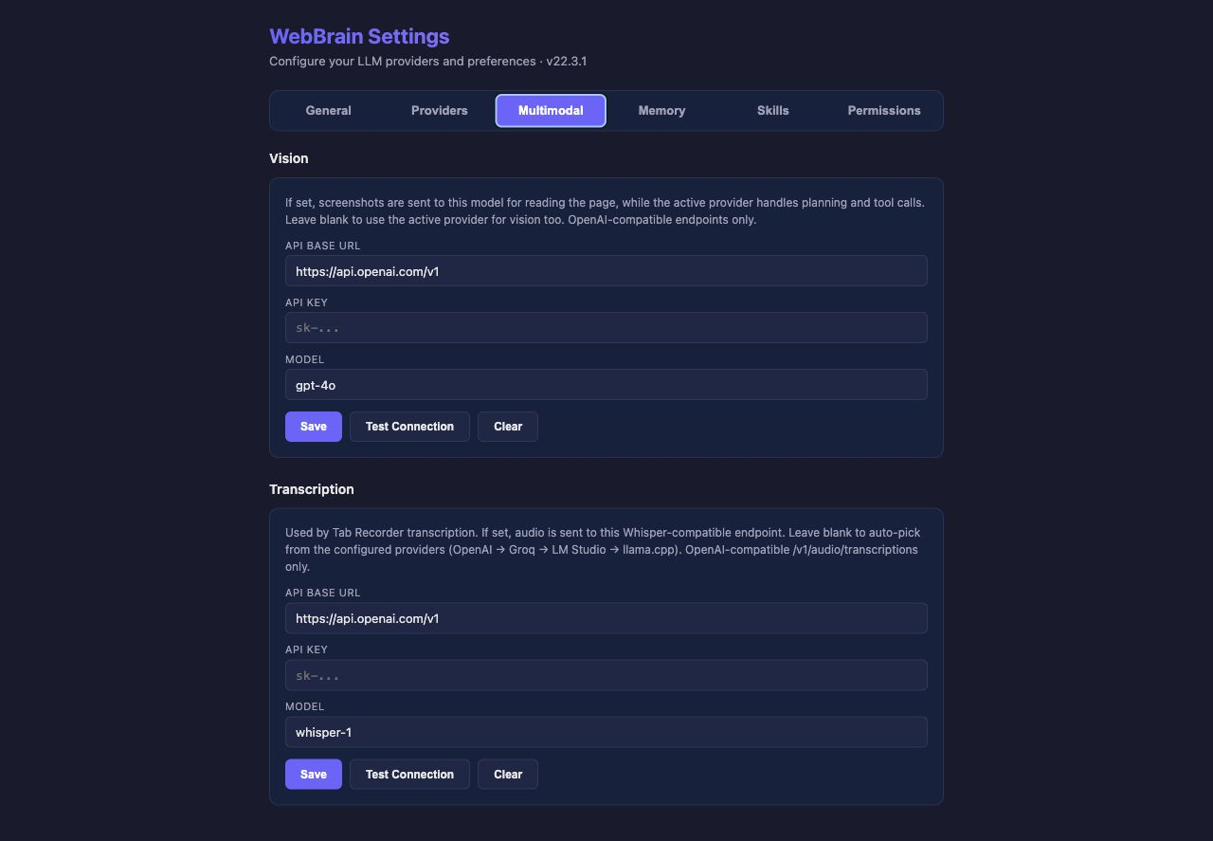
ENTRY FRAME Open Multimodal on the Vision configuration card.
NARRATION The Multimodal tab separates two supporting jobs from the main provider.
NARRATION Vision lets you send screenshots to a dedicated OpenAI-compatible vision model while the active provider continues handling planning and tool calls. This is useful when your preferred reasoning model does not support images, or when a cheaper vision model is available.
NARRATION Enter the base URL, API key, and model, then Save and Test Connection. Leave the fields blank to use the active provider for vision.

MID-CHAPTER Transcription uses a Whisper-compatible endpoint for recorded audio.
NARRATION Transcription is used by the recorder when converting audio into text. You can provide a Whisper-compatible endpoint here. If it is blank, WebBrain attempts to select a compatible configured provider automatically.

EXIT FRAME End on the Transcription card and its Save, Test Connection, and Clear controls.

CHAPTER 6 / 8:45

Memory and profile information
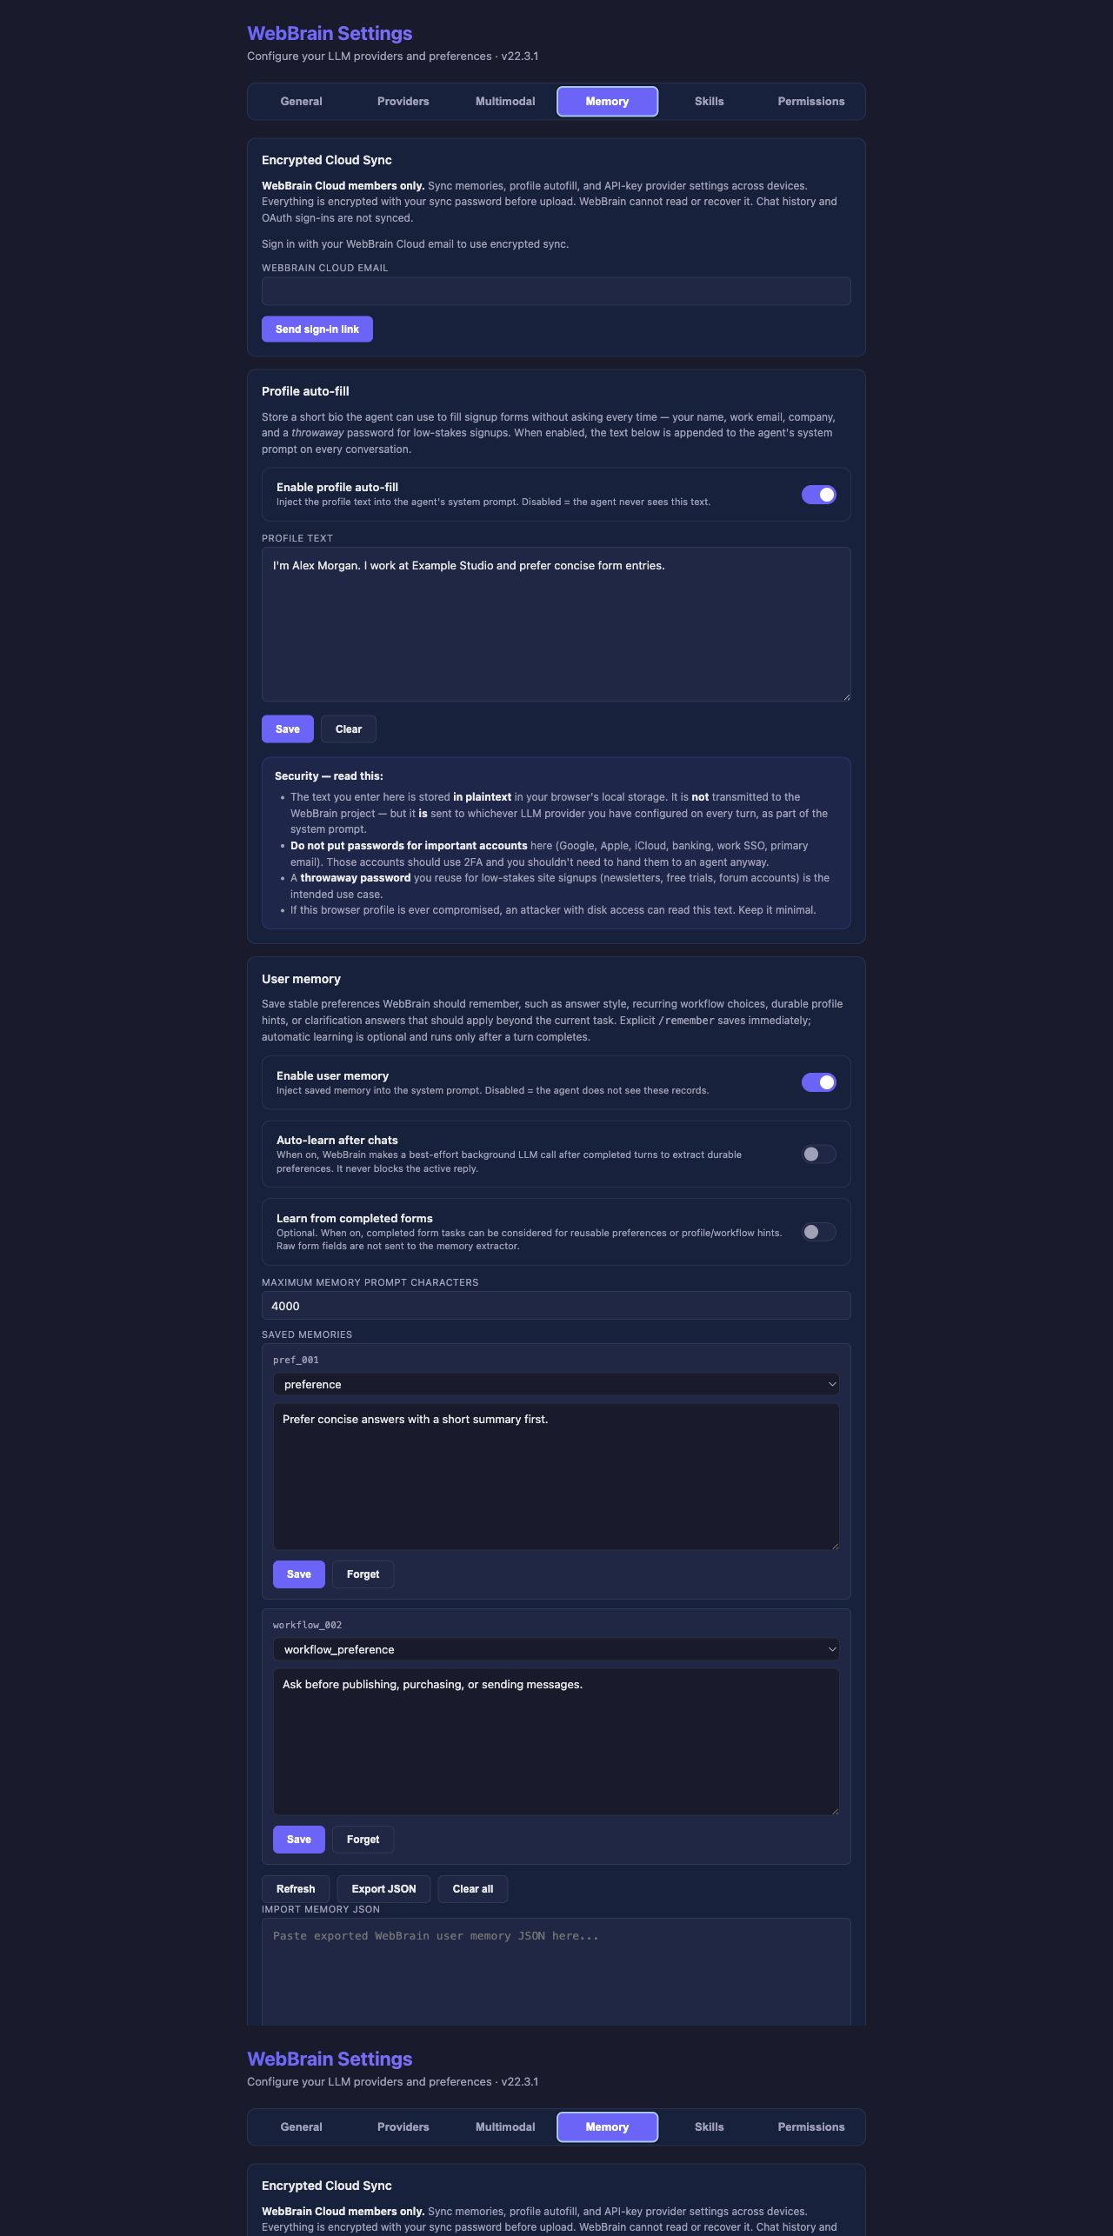
ENTRY FRAME Open Memory on encrypted sync and profile auto-fill.

Encrypted Cloud Sync
NARRATION The Memory tab contains three distinct systems: encrypted cloud sync, profile auto-fill, and user memory.
NARRATION Encrypted Cloud Sync is available to WebBrain Cloud members. It synchronizes user memory, profile auto-fill, and API-key provider settings. The data is encrypted in the browser before upload with a separate sync password.
NARRATION WebBrain cannot read the encrypted vault and cannot recover a forgotten sync password. Chat history, traces, scheduled tasks, permission records, and OAuth sign-ins are not synchronized.
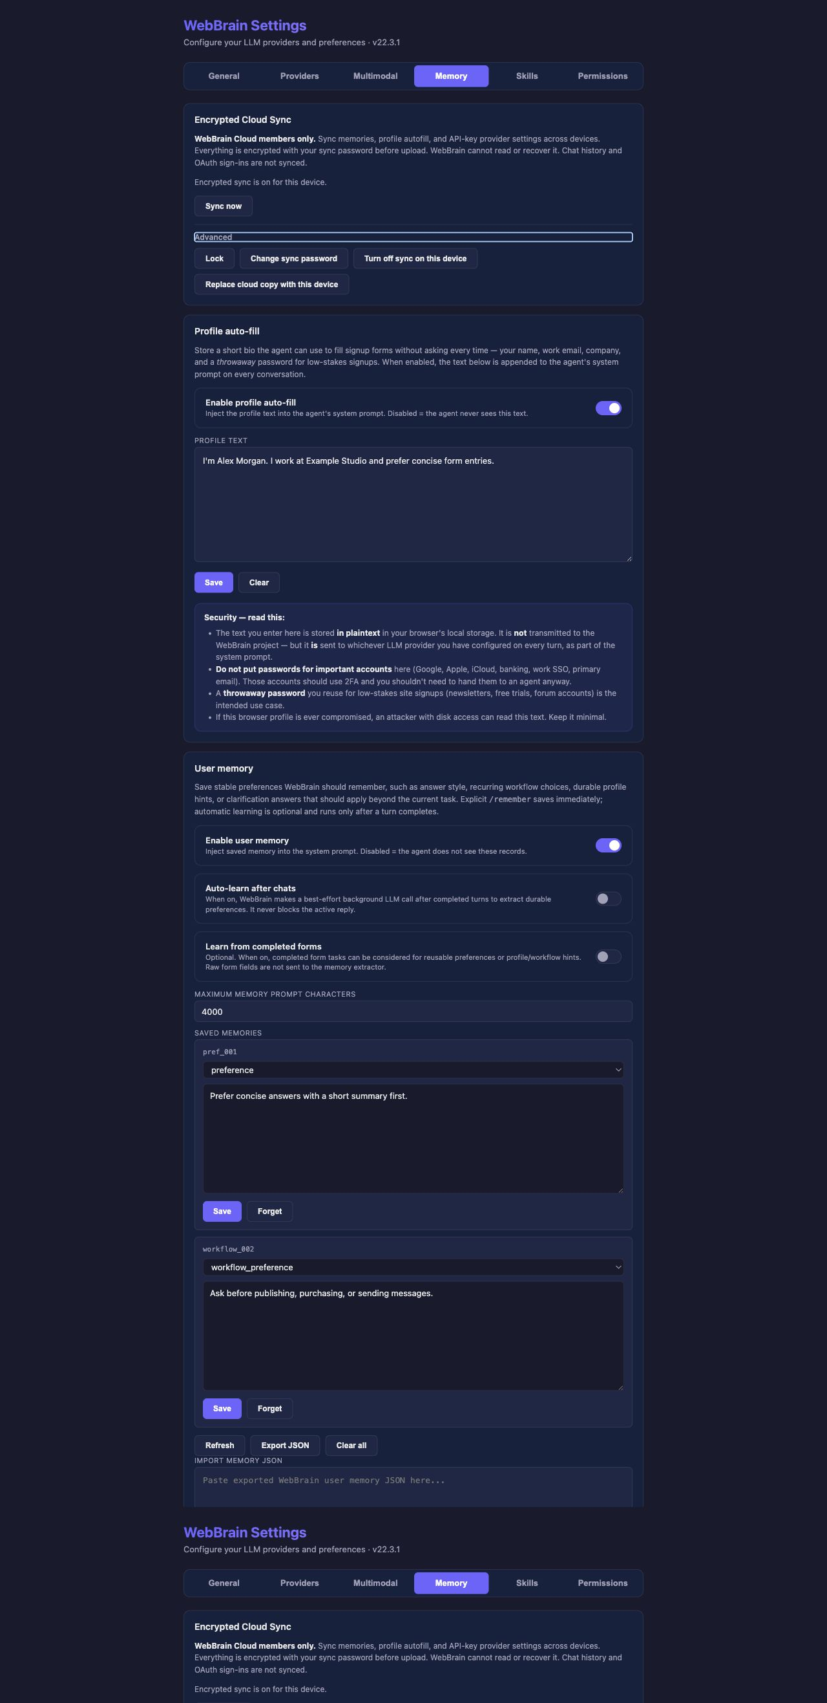
MID-CHAPTER Encrypted-sync advanced controls: lock, password change, device disable, and cloud-copy replacement.
NARRATION The normal setup is to enter the WebBrain Cloud email, request the sign-in link, and create a sync password of at least twelve characters.
NARRATION Advanced lets you lock the vault, change the password, turn off sync on the current device, or replace the cloud copy with this device. Replace cloud copy is a recovery operation, not a routine sync button.

Profile auto-fill
NARRATION Profile auto-fill is for information the agent may reuse in forms: a name, work email, company, location, or a throwaway password for low-risk signups.
NARRATION When enabled, the text is appended to the system prompt and can be received by the configured LLM provider. It is stored in plaintext in browser extension storage. Never place banking credentials, a primary email password, work SSO credentials, or recovery codes here.

User memory

MID-CHAPTER User-memory controls and harmless demo records.
NARRATION User memory stores stable preferences that should carry across conversations. Examples include Prefer concise answers, Use TypeScript for examples, or Ask before publishing anything.
NARRATION Enable user memory controls whether saved records enter the prompt. Auto-learn after chats makes a best-effort background model call after a completed turn. Learn from completed forms can contribute reusable hints without sending raw form fields to the memory extractor.
NARRATION Maximum memory prompt characters limits the amount injected into a conversation. Memories can be edited or forgotten, and the complete set can be exported, cleared, or imported as JSON.
NARRATION Memory is stored locally in plaintext and is sent to the chosen provider when enabled. Obvious credential-like memories are rejected, but memory should never be used as a password manager.

EXIT FRAME End on memory management, export, clear, and JSON import.

CHAPTER 7 / 12:00

Skills
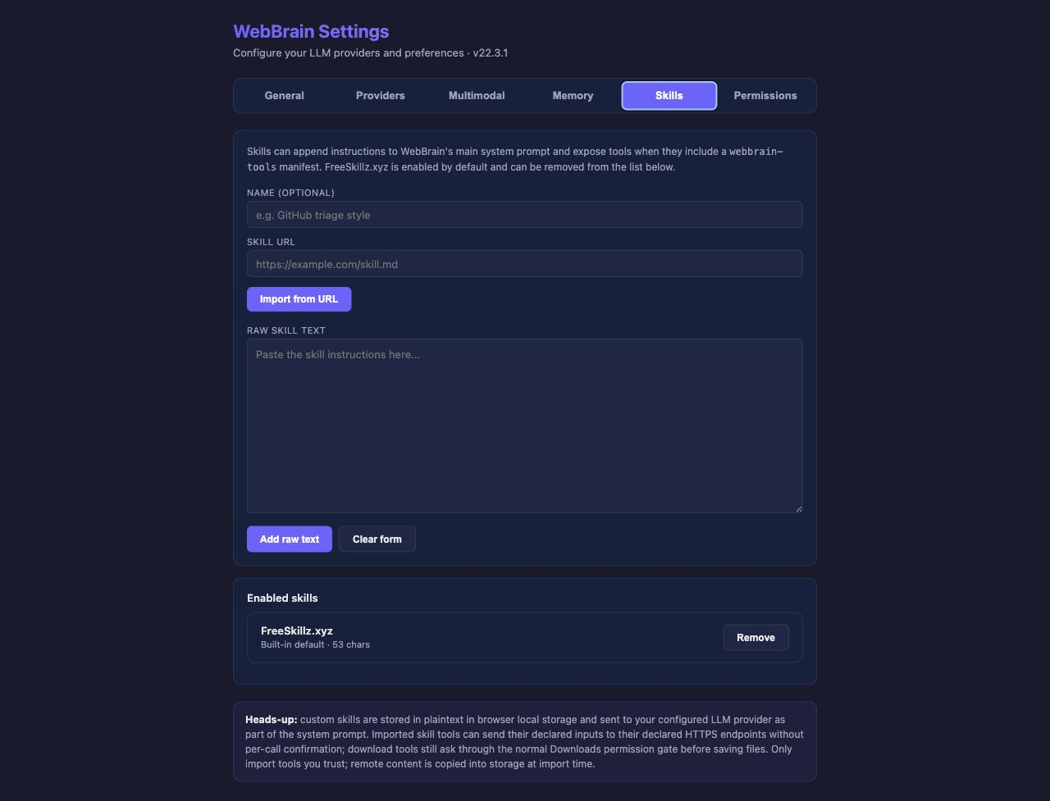
ENTRY FRAME Open Skills on the URL and raw-text import form.
NARRATION Skills customize what WebBrain knows how to do. A skill can add instructions to the main system prompt and can declare specialized tools through a WebBrain tools manifest.
NARRATION FreeSkillz.xyz is enabled by default. It provides tools for jobs such as reading YouTube transcripts and resolving or downloading public media. You can remove it if you do not want those tools available.

Importing and trusting a skill
NARRATION You can import a skill document from an HTTP or HTTPS URL, or paste raw skill text. Imported remote content is copied into local storage at import time; WebBrain does not continuously reload the source URL.
NARRATION Enabled skills show their source, size, and any tools they expose. Skill instructions are stored in plaintext and sent to the configured provider as part of the system prompt.
NARRATION A manifest may declare HTTPS endpoints. Importing the skill is the decision to trust those endpoints with the inputs declared by the skill. Read-only calls do not ask on every request. Download tools still require Act mode and the normal Downloads permission gate. Only import skills from sources you understand and trust.

EXIT FRAME End on Enabled skills and the trust-boundary warning.

CHAPTER 8 / 14:00

Permissions
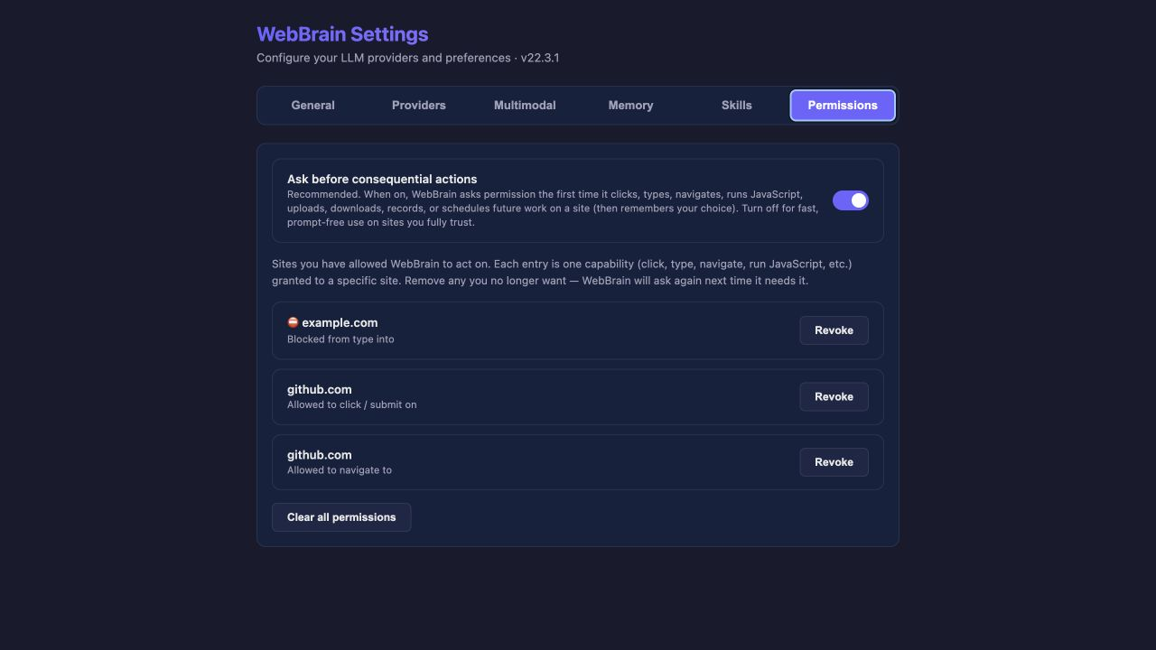
ENTRY FRAME Open Permissions with the master gate enabled and demo grants visible.
NARRATION Permissions controls consequential browser actions. Ask before consequential actions is enabled by default and is the recommended setting.
NARRATION When WebBrain first needs to click, type, navigate, run code, upload, download, record, or schedule work on a site, it asks whether to allow the action once, always allow that capability on the site, or deny it.
NARRATION Decisions are stored per capability and per website. Allowing navigation does not automatically grant typing, downloads, or every other action. Revoke removes one decision. Clear all permissions resets the complete list.
SAFETY MOMENT Turn the master switch off only in the isolated demo profile, capture the warning, then immediately switch it back on.
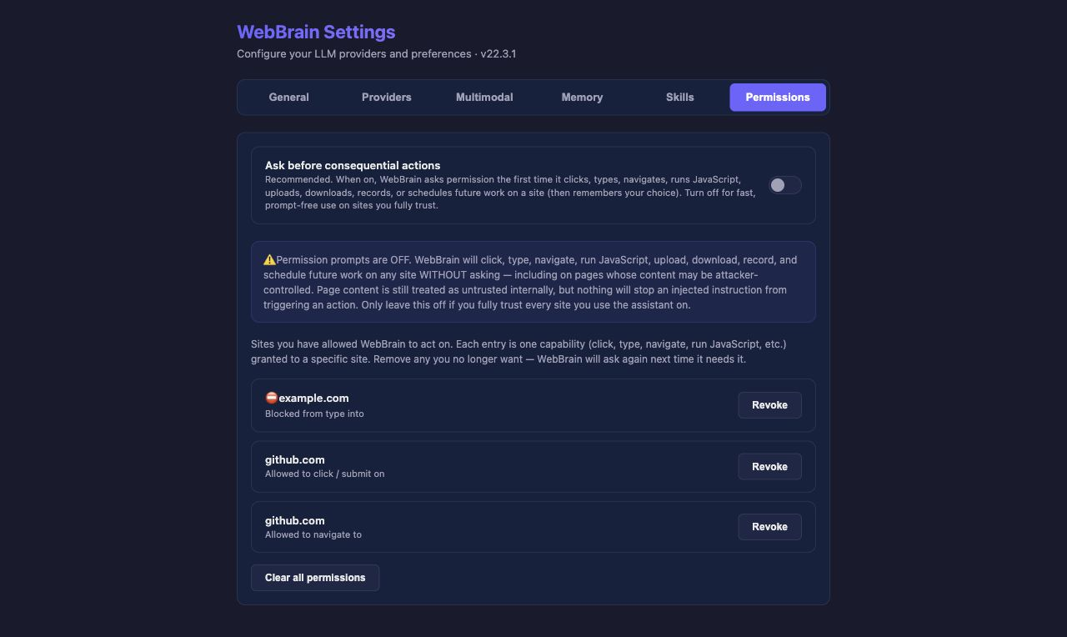
MID-CHAPTER The global off-state warning. Use this frame while explaining the security tradeoff.
NARRATION Turning the master switch off disables permission prompts globally. That is faster, but WebBrain can then perform consequential actions on any site without stopping - even when the page contains hostile or misleading instructions.
NARRATION For normal use, leave this switch on. Disable it only temporarily in a controlled environment, and turn it back on afterward.

EXIT FRAME Return the master gate to on before leaving the chapter.

CHAPTER 9 / 15:30

Every Advanced setting
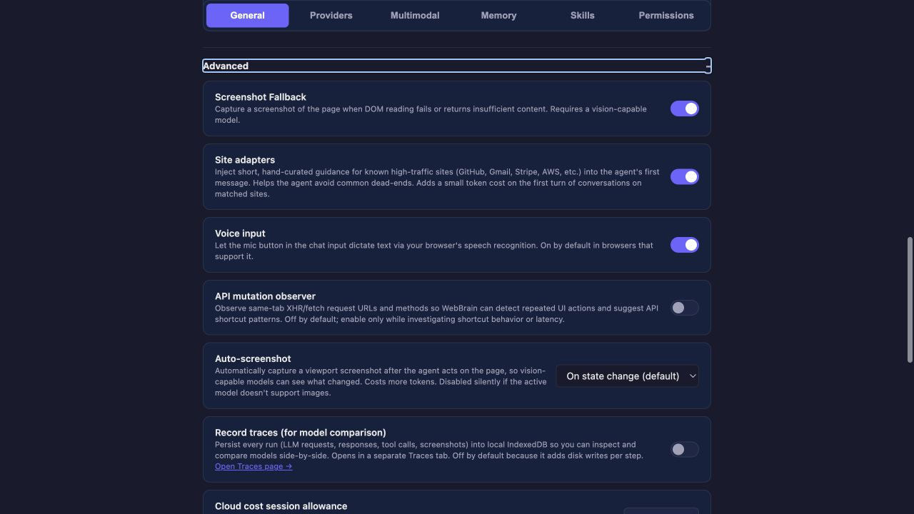
ENTRY FRAME Expand General > Advanced and begin at Screenshot Fallback.

Screenshot Fallback, site adapters, and voice
NARRATION Screenshot Fallback captures the page when normal DOM reading fails or returns too little information. It requires a vision-capable model and is enabled by default.
NARRATION Site adapters add short, hand-written guidance for known sites such as GitHub, Gmail, Stripe, and AWS. They help avoid common dead ends and add a small amount of prompt text on the first matching turn.
NARRATION Voice input enables the microphone button in browsers that support speech recognition. Browser-level microphone permission may still be required.

API observer and automatic screenshots
NARRATION The API mutation observer watches same-tab fetch and XHR URLs and HTTP methods. It helps recognize repeated interface actions and suggest a direct API pattern. It does not capture request or response bodies, and the in-memory buffer disappears when the tab closes.
NARRATION Auto-screenshot provides a fresh visual view after the agent acts. Off never captures automatically. On navigation captures after navigation. On state change is the default. Every step captures after each action. More screenshots improve visual feedback but consume more tokens.
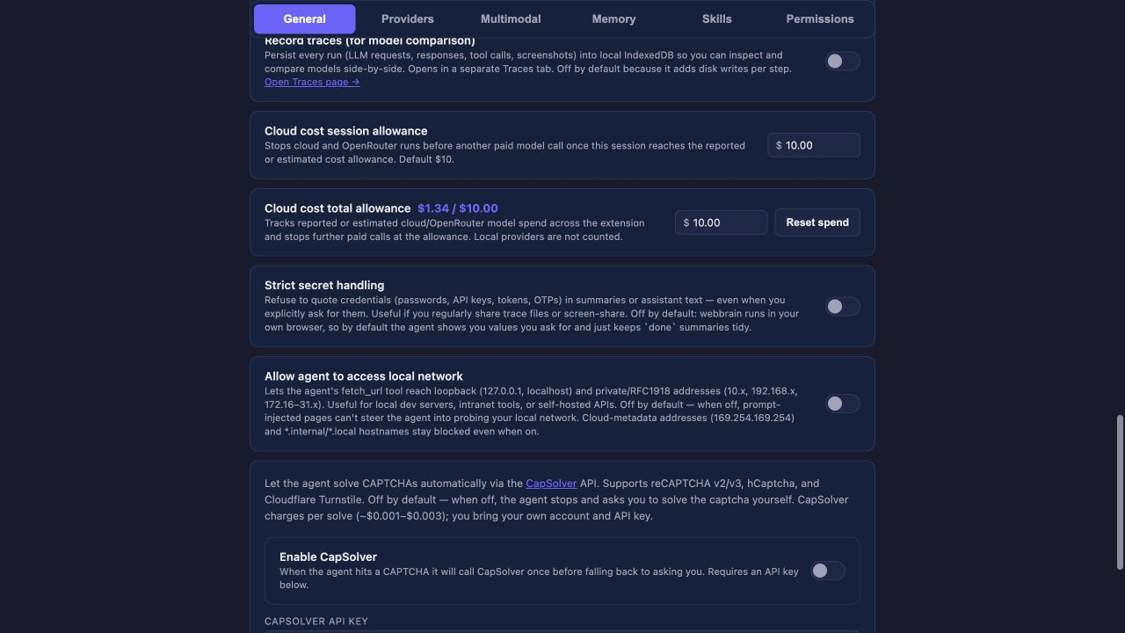
MID-CHAPTER Advanced middle: auto-screenshot, tracing, and cloud cost controls.

Tracing and cost allowances
NARRATION Record traces stores model requests, responses, tool calls, results, and screenshots in local IndexedDB. It is useful for debugging and model comparison, but adds disk writes and can capture sensitive page or conversation data.
NARRATION The session allowance stops another paid cloud or router call once the current session reaches its reported or estimated limit. The total allowance applies across the extension. Local providers are not counted.
NARRATION Reset spend clears WebBrain's accumulated counter. It does not change or refund charges recorded by the provider.

Secrets, local network access, and CAPTCHA solving
NARRATION Strict secret handling prevents WebBrain from quoting passwords, API keys, tokens, and one-time codes in assistant text, even when explicitly asked. It is useful during screen sharing or when traces may be shared.
NARRATION Allow agent to access local network lets the fetch tool reach localhost and private addresses. Enable it for local development servers, self-hosted APIs, or intranet applications. Leave it off otherwise. Cloud metadata addresses and certain internal hostnames remain blocked even when it is enabled.
NARRATION CapSolver can optionally solve reCAPTCHA, hCaptcha, and Cloudflare Turnstile. Enable it, enter an API key, save it, and use Check Balance. The service charges per solve, the key is stored in plaintext, and some sites prohibit automated CAPTCHA solving. WebBrain makes at most one attempt per encounter before falling back to the user.
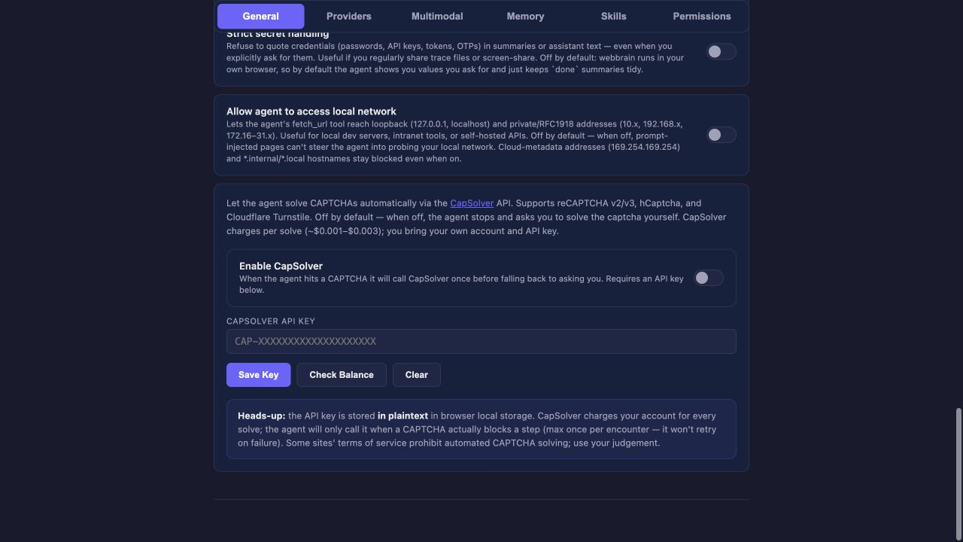
EXIT FRAME End the Advanced chapter on strict secrets, local-network access, and CapSolver.

CHAPTER 10 / 19:30

Recommended configurations and closing

ENTRY FRAME Return to the six-tab overview for the recap.

Three practical configurations
NARRATION For simple everyday use: choose a provider, keep Try planning with confidence-based review, leave the permission gate on, and keep the remaining defaults.
NARRATION For local models: verify the server URL, load the model list, confirm the context window, choose an appropriate prompt tier, and increase the request timeout if the model starts slowly.
NARRATION For advanced automation: configure scheduled-task confirmation, cost allowances, traces, memory, and skills - but review the security and privacy implications before enabling each one.

Closing narration
NARRATION The main idea is simple: Providers chooses the brain, General controls its behavior, Multimodal adds supporting models, Memory and Skills personalize it, and Permissions controls how much freedom it has inside your browser.
NARRATION Start with the defaults, change one thing at a time, and only open the advanced controls when you have a specific reason. That is the complete WebBrain Settings walkthrough.

EXIT FRAME Final frame: hold the six-section navigation for two seconds, then cut to the WebBrain side panel or end card.

