WEEK 2 TASK
SYSTEM ARCHITECTURE
& DESIGN
Proposed Unified e-Governance Service Portal
Scalable, secure and citizen-friendly blueprint for digital service delivery
Internship | Junior Software Developer - E-Governance & Digital Services
Submitted by | Anshika Sharma
Course / Institution | BCA / Institute of Technology and Management, GIDA
Internship Organization | Yuva Intern
Builds on | Week 1 - Requirement Analysis and Planning (FR-01 to FR-20, NFR-01 to NFR-15)
Submission Date | 28-10-2026

Contents
1. Executive Summary 4
1.1 How this document meets the Week 2 brief 4
2. Contextual Analysis 5
2.1 Envisioned e-Governance Services and Their Significance 5
2.2 User Groups 5
2.3 Design Drivers Taken from Week 1 5
2.4 Architecture Principles 6
3. Architecture Overview 6
3.1 Architectural Style - Decision Record 6
3.2 Logical Architecture 7
3.3 Layer Responsibilities 8
4. Architectural Breakdown 8
4.1 Front-End (Presentation Layer) 8
4.2 API Gateway 8
4.3 Core Application Services 8
4.4 Middleware and Integration 9
4.5 Data Layer 9
4.6 Infrastructure 10
5. Component Interactions 10
5.1 Communication Patterns 10
5.2 Worked Interaction: Submitting an Application 11
5.3 Application Lifecycle and Business Rules 11
5.4 Failure Handling 12
6. Data Architecture and Integrity 12
6.1 Logical Data Model 12
6.2 Data Classification and Handling 13
6.3 Integrity Mechanisms 13
6.4 Privacy and Retention 13
7. Technology Choices and Justification 14
7.1 Weighted Decision Matrix: Back-End Framework 15
8. Security Architecture 15
8.1 Defence in Depth: Network Zones 15
8.2 Authentication and Session Management 16
8.3 Authorization: Roles and Permissions 16
8.4 Encryption and Cryptography 16
8.5 Application and API Security 17
8.6 Audit, Logging and Monitoring 17
8.7 Threat Model Summary (STRIDE) 18
8.8 OWASP Top 10 (2021) Coverage 18
8.9 Incident Response and Compliance Alignment 18
9. Scalability, Availability and Performance 19
9.1 Scaling Techniques 19
9.2 Capacity Estimate (Illustrative Planning Assumptions) 19
9.3 Scaling Roadmap 20
9.4 High Availability and Disaster Recovery 20
9.5 Performance and Observability 20
10. Deployment and DevOps 21
11. Design Justification: Requirement Traceability 21
11.1 Functional Requirements to Architecture 21
11.2 Non-Functional Requirements to Architecture 22
12. Risks, Trade-offs and Assumptions 23
12.1 Architectural Risks and Mitigations 23
12.2 Key Trade-offs 23
12.3 Assumptions and Items to Confirm with the Department 23
13. Conclusion and Next Steps 24
Appendix A: Architecture Decision Log 25
Appendix B: Glossary 25
Appendix C: References 26
Document Review Checklist 26

1. Executive Summary
This document defines the system architecture for the Unified e-Governance Service Portal scoped in Week 1. It converts the 20 functional and 15 non-functional requirements into a concrete, buildable blueprint: components, interactions, data model, technology stack, security controls and scaling strategy.
- Style: API-first, layered architecture with 8 coarse-grained domain services, an API gateway, an event broker and a polyglot data layer (PostgreSQL, Redis, object storage, OpenSearch).
- Security: defence in depth - 3 network zones, OIDC + MFA, RBAC with ownership checks, TLS 1.2/1.3 in transit, AES-256 at rest, append-only audit trail, scanned uploads and secure CI/CD gates.
- Scalability: stateless containers on Kubernetes with autoscaling, cache and CDN, read replicas, asynchronous processing, multi-AZ deployment and a disaster-recovery site.
- Integrity: ACID transactions, constraints, optimistic locking, idempotent submissions, SHA-256 document hashes and a hash-chained audit log.
- Pilot-ready, growth-ready: the same design runs a 100-user Income Certificate pilot and scales to roughly 100,000 registered citizens without redesign.

Reading guide: Section 2 gives the context, 3-5 give the architecture and interactions, 6 the data design, 7 the technology justification, 8-9 security and scalability, 11 the traceability proof that every Week 1 requirement is covered.

1.1 How this document meets the Week 2 brief
Expected deliverable | What is provided | Section
Detailed DOC describing overall architecture | Layered architecture, 8 services, middleware, data and infrastructure layers | 3, 4
Architectural diagram of components and interactions | 6 figures: layered view, sequence flow, state machine, data model, security zones, CI/CD | Figures 1-6
Choice of technologies, security protocols, scalability measures | Technology table with alternatives, weighted decision matrix, security architecture, scaling plan | 7, 8, 9
Justification of design decisions vs functional and non-functional requirements | Decision records plus FR-to-component and NFR-to-design traceability matrices | 3.1, 11, App. A
Contextual analysis | Envisioned services, users, design drivers, principles | 2
Clear headings, bullets, structured sections | Numbered sections, tables, callouts, glossary, review checklist | All

2. Contextual Analysis

2.1 Envisioned e-Governance Services and Their Significance
The portal is a single digital entry point for government services. The Income Certificate service is the pilot; the architecture is service-agnostic so new services are added through configuration (FR-18), not new code.
Service | Significance to citizens and department | Release | Complexity
Income Certificate (pilot) | High-volume, document-driven, needed for scholarships and schemes; ideal end-to-end test of the workflow | Pilot | Medium
Domicile / Caste Certificate | Same workflow with different eligibility rules and documents; proves reuse of the engine | Phase 2 | Medium
Birth / Death Registration | Legal records with strict data-integrity needs | Phase 2 | High
Welfare Scheme Application | Eligibility checks, possible integration with other department APIs | Phase 3 | High
Fee / Fine Payment | Requires payment-gateway integration and reconciliation | Phase 3 | High
Complaint / Help Request | Transparency and accountability; builds trust (FR-13) | Pilot | Low
Application Tracking | Removes repeat office visits; most-used feature (FR-08) | Pilot | Low

2.2 User Groups
User group | Primary needs | Architectural implication
Citizens | Simple forms, status visibility, privacy | Responsive SPA, low-bandwidth pages, bilingual content, notifications
Citizens needing assistance | Accessibility, help centre support | WCAG 2.2 AA, assisted-service role that acts on behalf of a citizen with full audit
Case officers / supervisors | Work queue, fast review, clear rules | Role-based staff console, search index, workflow engine
Department / system admins | Configure services, manage users | Admin APIs under change control, separate admin plane
Auditors / security team | Evidence, traceability | Tamper-evident audit pipeline, read-only access

2.3 Design Drivers Taken from Week 1
Week 1 requirement | Architectural decision it drives
Pilot of ~100 users, 5-10 officers; later expansion | Start small but stateless and containerised so capacity is added by replicas, not rewrites
95% of requests within 2 s (NFR-01) | CDN, Redis cache, indexed queries, asynchronous side-effects
99.5% monthly availability = 216 min downtime (NFR-02) | Multi-AZ deployment, redundant instances, health checks, automated failover
RPO 24 h, RTO 8 h (NFR-09) | Daily encrypted backups plus continuous log archiving; DR site; tested restores
Personal data, audit, privacy (NFR-04, 05, 13) | Data classification, field encryption, RBAC, append-only audit, India-hosted data
Interoperability with SMS, e-mail, identity, payment (NFR-12) | Integration adapters behind an anti-corruption layer; fail-safe fallbacks
Accessibility and local languages (NFR-06, 14) | Accessible component library, i18n resource bundles, UTF-8 throughout
Data integrity (NFR-15) | ACID database, constraints, optimistic locking, idempotency keys, checksums

2.4 Architecture Principles
- Security by design: least privilege, deny by default, zero trust between services.
- API-first: every capability is an documented REST API (OpenAPI); UI and integrations use the same APIs.
- Stateless services: state lives in the data layer, so any instance can serve any request.
- Loose coupling: services communicate through APIs and events, never through each other's tables.
- Open standards and open source: OIDC, OAuth 2.0, REST/JSON, PostgreSQL, Kubernetes - avoids vendor lock-in and licence cost.
- Inclusive by default: accessibility, plain language and assisted channels are architectural requirements, not extras.
- Observable and auditable: every action is logged, measured and traceable.
- Evolvable: start with coarse-grained services; split further only when load or team size justifies it.

3. Architecture Overview

3.1 Architectural Style - Decision Record
Three styles were evaluated against the Week 1 constraints (small pilot team, later growth, strict security, limited operations budget).
Criterion | Single monolith | Coarse-grained domain services (chosen) | Fine-grained microservices
Pilot delivery speed | Fastest | Fast | Slow (many pipelines)
Independent scaling | No - scale whole app | Yes - per service (e.g. Document, Notification) | Yes - very fine
Fault isolation | Poor | Good | Excellent
Operational complexity | Low | Medium | High
Team size needed | Small | Small to medium | Large
Security boundaries | One large attack surface | Per-service permissions, mTLS | Per-service, but more to manage
Future growth | Rewrite likely | Split services later if needed | Already split

Decision (ADR-01): Adopt coarse-grained domain services behind an API gateway. They deliver independent scaling and fault isolation where it matters (documents, notifications, reporting) without the operational burden of dozens of microservices. Risks and mitigations are in Section 12.

3.2 Logical Architecture
Request path in one line:
Flow: Citizen / Staff -> CDN -> DDoS + WAF -> Load Balancer -> Web tier (SPA) -> API Gateway -> Domain services -> (Message Broker -> Notification / Audit / Search) and (PostgreSQL, Redis, Object Storage)
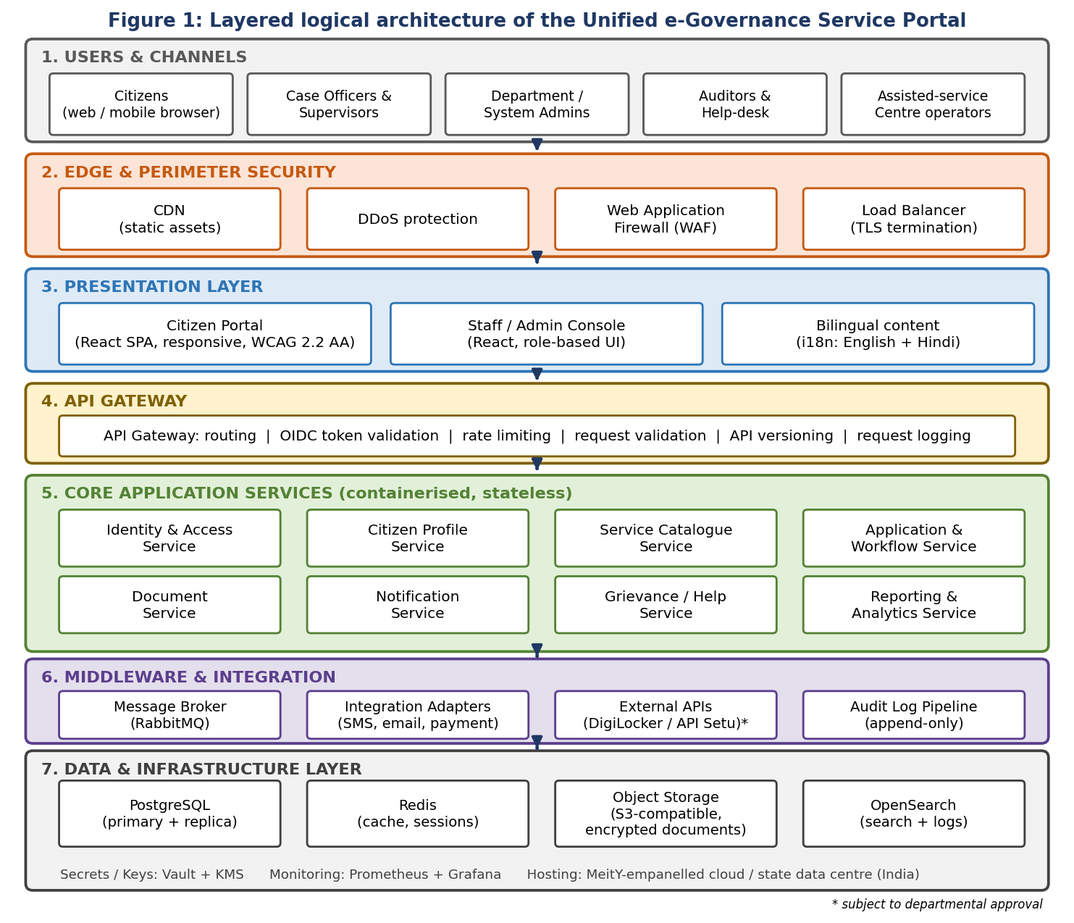

3.3 Layer Responsibilities
# | Layer | Responsibility
1 | Users and channels | Browsers on desktop and mobile; assisted-service centres use the same portal with an operator role
2 | Edge and perimeter | CDN for static assets, DDoS mitigation, WAF filtering (OWASP rules), TLS termination, load distribution
3 | Presentation | React single-page applications: Citizen Portal and Staff/Admin Console; accessibility, i18n, client-side validation (convenience only)
4 | API gateway | Single entry for all APIs: token validation, routing, rate limiting, request size limits, versioning, access logs
5 | Core services | Business logic: identity, profile, catalogue, application workflow, documents, notifications, grievances, reporting
6 | Middleware and integration | Message broker for asynchronous events, adapters for SMS/e-mail/payment/identity, audit-log pipeline
7 | Data and infrastructure | PostgreSQL, Redis, object storage, OpenSearch, secrets/key management, monitoring, hosting

4. Architectural Breakdown

4.1 Front-End (Presentation Layer)
- Citizen Portal: service catalogue, guided application form, document upload, My Applications tracker, notifications inbox, help/complaint form.
- Staff / Admin Console: work queue with filters, application review screen, request-information action, reports, user and service administration.
- Built as: React + TypeScript SPAs served from the CDN; responsive (mobile-first), semantic HTML and ARIA for WCAG 2.2 AA; English and Hindi through i18n bundles.
- Low-bandwidth design: code splitting, compressed assets, image optimisation, form progress saved server-side (FR-05).
- Security in the browser: Content-Security-Policy, secure + HttpOnly + SameSite cookies, no secrets in the client, tokens held in memory.

4.2 API Gateway
- Validates the access token (signature, expiry, audience) before any request reaches a service.
- Applies rate limits per IP and per user (e.g. 100 requests/min per user, stricter for login and OTP endpoints).
- Rejects oversized or malformed requests; adds correlation ID to every request for tracing.
- Exposes versioned routes (/api/v1/...) so mobile or partner clients can evolve safely.

4.3 Core Application Services
Service | Responsibility | Owns data | Key APIs / events
Identity & Access | Registration, login, OTP/MFA, token issue, roles (FR-01, 14, 20) | Users, credentials, roles | OIDC endpoints, /users, /roles
Citizen Profile | View/update profile and contact preferences (FR-02) | Profile, preferences | /profiles/me
Service Catalogue | Services, eligibility, required documents, fees, form schema (FR-03, 18) | Services, form schemas | /services, /services/{id}
Application & Workflow | Draft, validate, submit, assign, review, status history, queue (FR-04 to 11, 17) | Applications, status history | /applications, /submit, /queue; emits ApplicationSubmitted, StatusChanged
Document | Upload, validate, virus-scan, store, serve through signed URLs (FR-06) | Document metadata, files | /documents; emits DocumentScanned
Notification | Templates, channel choice, delivery, retry (FR-12) | Notification log | Consumes events; calls SMS/e-mail adapters
Grievance / Help | Complaint tickets and tracking reference (FR-13) | Grievance tickets | /grievances; emits GrievanceRaised
Reporting & Analytics | Volumes, status, processing time, exports (FR-16) | Aggregates (read-only) | /reports; reads replica + search index

The Audit capability (FR-15) is implemented as a pipeline in the middleware layer: every service publishes audit events that are written to an append-only store.

4.4 Middleware and Integration
Component | Purpose and design
Message broker (RabbitMQ) | Durable queues and topics for domain events; retry with dead-letter queue; decouples slow tasks (SMS, scanning, indexing) from user requests
Integration adapters | One adapter per external system (SMS gateway, e-mail, payment, identity). Maps external formats to internal models, applies timeouts, retries and circuit breakers - an anti-corruption layer (NFR-12)
External APIs (subject to approval) | Optional DigiLocker / API Setu style document and identity verification; fall back to manual upload if unavailable
Outbox pattern | Events are first written to an outbox table in the same database transaction as the business change, then published - no lost events if the broker is briefly down
Audit pipeline | Consumes audit events, writes append-only hash-chained records, forwards copies to the SIEM

4.5 Data Layer
Store | Used for | Why this store
PostgreSQL (primary + replica) | Users, applications, status history, catalogue, grievances, audit | ACID transactions, constraints, JSONB for flexible form data, open source, mature replication
Redis | Session data, catalogue cache, rate-limit counters, OTP expiry | In-memory speed; reduces database load
Object storage (S3-compatible) | Uploaded documents, generated certificates, backups | Cheap, durable, scalable, per-object encryption and versioning
OpenSearch | Staff search/filter (FR-17), centralised logs | Fast full-text and faceted search without loading the primary database

4.6 Infrastructure
- Hosting: MeitY-empanelled cloud or NIC / State Data Centre in India (final choice by department and procurement).
- Runtime: Docker containers orchestrated by Kubernetes; Helm charts and infrastructure-as-code for repeatable environments.
- Supporting services: Vault + KMS for secrets and keys; Prometheus, Grafana and OpenTelemetry for observability; ClamAV for malware scanning.

5. Component Interactions

5.1 Communication Patterns
Pattern | Used for | Rules
Synchronous REST (HTTPS/JSON) | User-facing reads and writes that need an immediate answer | Always through the gateway; timeouts 3 s; idempotency keys on writes
Asynchronous events (broker) | Notifications, audit, search indexing, reporting updates | At-least-once delivery; consumers are idempotent; failures go to dead-letter queue
Scheduled batch | Retention clean-up, report pre-aggregation, backups | Run off-peak; logged and monitored

Event | Published by | Consumed by
ApplicationSubmitted | Application Service | Notification (receipt), Audit, Search indexer, Reporting
StatusChanged | Application Service | Notification (status alert), Audit, Search indexer
InfoRequested | Application Service | Notification (action-required alert), Audit
DocumentScanned | Document Service | Application Service (unlock submission), Audit
GrievanceRaised | Grievance Service | Notification, Audit, Reporting

5.2 Worked Interaction: Submitting an Application
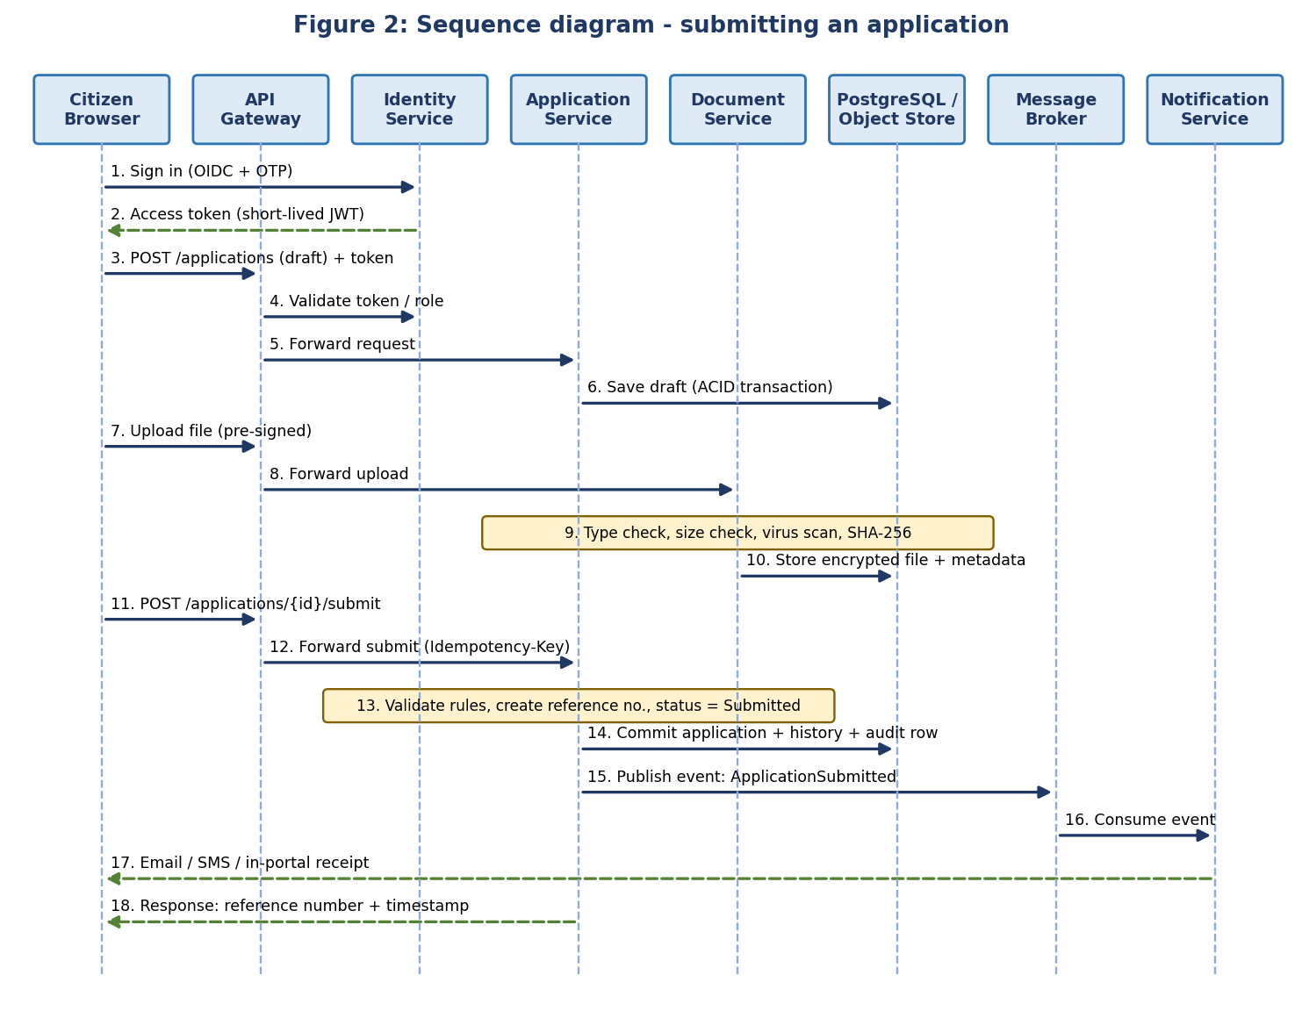
Key points:
- Token is validated at the gateway (steps 3-4) so unauthenticated calls never reach services.
- Draft and submission are separate ACID transactions; the reference number is created only after server-side validation (FR-07).
- The upload is virus-scanned and hashed before the application can be submitted (steps 9-10).
- Notification (steps 15-17) is asynchronous: if SMS is down, the citizen still receives the reference number on screen.
- The Idempotency-Key header makes a repeated click or network retry return the original result, not a duplicate application.

5.3 Application Lifecycle and Business Rules
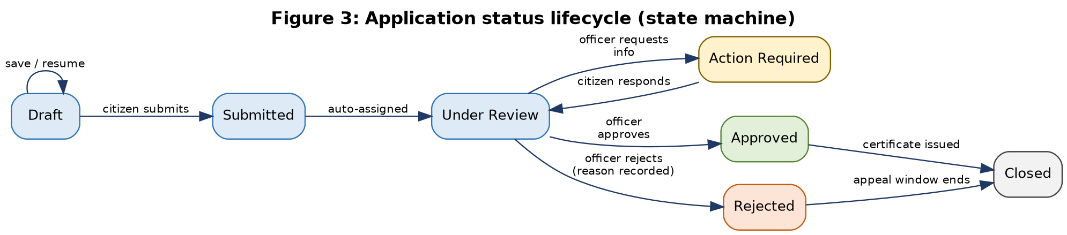
- Only the transitions shown are allowed; any other change is rejected by the workflow engine (data integrity).
- Every transition writes a status-history row and an audit event with actor, role, time and remarks (FR-08, FR-15).
- Approve/Reject require the Case Officer or Supervisor role; Rejected needs a recorded reason.
- Two officers cannot overwrite each other: updates carry a row version and a conflict returns HTTP 409.

5.4 Failure Handling
Failure scenario | Designed behaviour
SMS / e-mail provider unavailable | Message stays queued; retries with exponential back-off; dead-letter queue after limit; in-portal notification still shown
Virus-scan service unavailable | File stays in Pending-scan state; submission blocked until clean; citizen sees a clear message
Database primary fails | Automatic promotion of replica; services reconnect with retry; no confirmed submission is lost (NFR-08)
Message broker down | Outbox table keeps events; publisher resumes when broker returns
External verification API down | Circuit breaker opens; citizen can upload documents manually; officer verifies
Duplicate submit / double click | Idempotency key returns the original response
Concurrent officer edits | Optimistic locking returns 409; officer reloads latest version

6. Data Architecture and Integrity

6.1 Logical Data Model
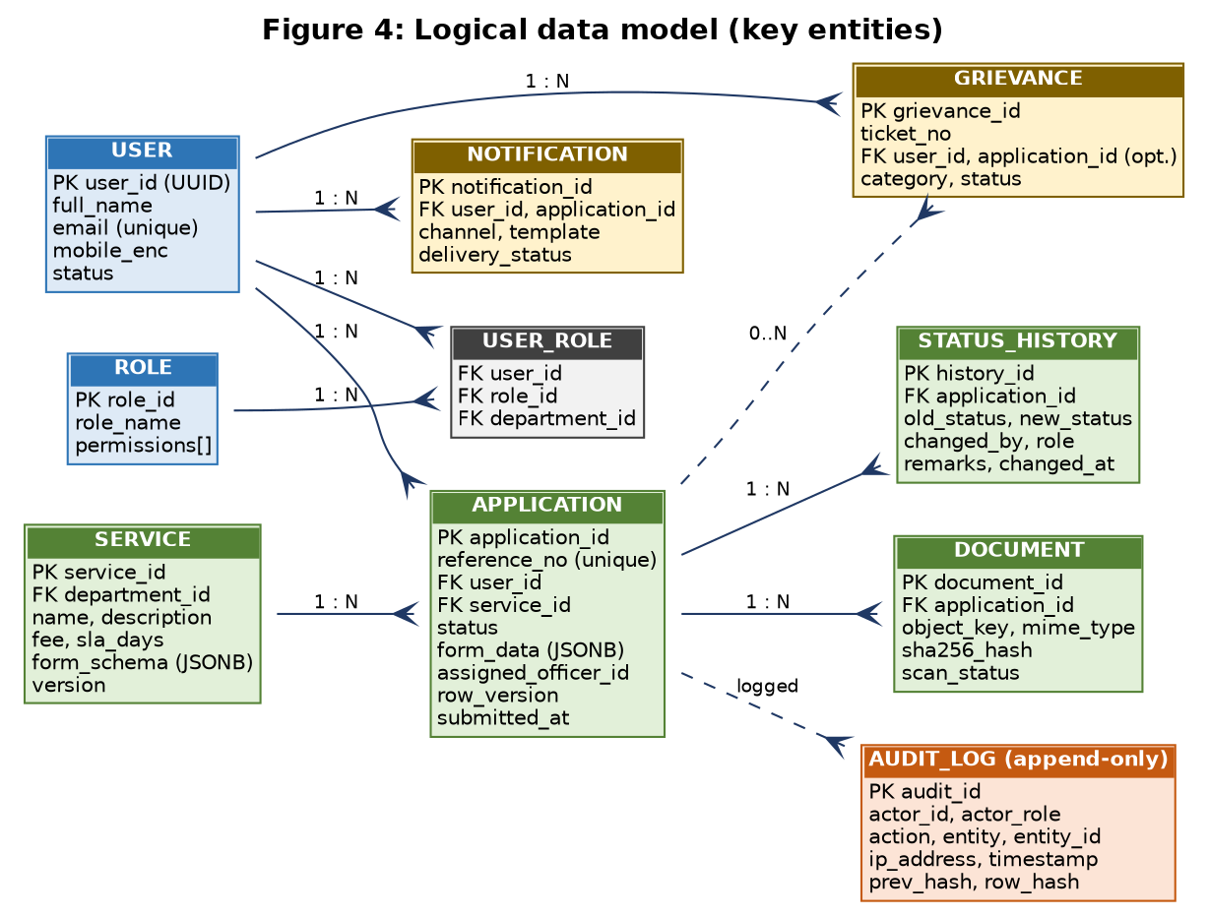
- Logical separation: each service owns its own schema; no cross-schema joins. Services exchange data through APIs or events.
- Hybrid form storage: core fields (user, service, status, dates) are strict columns; service-specific form answers are stored as JSONB validated against the service's form schema, so new services need no database migration.
- Identifiers: UUIDs for primary keys (non-guessable); a separate human-friendly reference number for citizens.

6.2 Data Classification and Handling
Class | Examples | Controls
Public | Service catalogue, fee schedule, help text | Integrity protection; cacheable on CDN
Internal | Reports without personal data, system logs (masked) | Authenticated access; masking of identifiers in logs
Confidential (personal data) | Name, address, mobile, e-mail, application answers | RBAC + ownership check, TLS, encrypted storage, access logged
Restricted | Uploaded identity/income documents, credentials, keys, audit log | Field/object encryption with KMS keys, tight access, no export without approval, tamper-evident logging

6.3 Integrity Mechanisms
Mechanism | How it protects the data
ACID transactions | Application, status history and outbox event are committed together or not at all
Constraints | Primary/foreign keys, NOT NULL, unique reference number, CHECK on allowed status values
Workflow state machine | Prevents illegal status jumps (e.g. Draft to Approved)
Optimistic locking | row_version column prevents lost updates
Idempotency keys | Prevents duplicate applications and double payments
Input validation | Server-side validation against form schema; client validation only improves usability
Document checksums | SHA-256 stored at upload; re-verified on download to detect tampering or corruption
Hash-chained audit log | Each audit row stores the hash of the previous row; any edit or deletion breaks the chain and is detected
Backups and restore tests | Verified, encrypted backups with scheduled restore drills

6.4 Privacy and Retention
- Collect only fields the service rule needs (data minimisation, NFR-05); show purpose and notice at the point of collection.
- Retention schedule per record type approved by the department; scheduled jobs archive or delete after the period.
- Development and test environments use synthetic or anonymised data only.
- Aadhaar numbers or similar national identifiers are not stored unless the law and the department explicitly require it; if required, they are masked and field-encrypted.

7. Technology Choices and Justification
Selection criteria, in priority order: security, scalability, maintainability, then ecosystem and talent, cost, and fit with government practice (open source, India hosting).
Layer | Choice | Alternatives considered | Justification
Front-end | React + TypeScript, accessible component library | Angular, Vue, server-rendered pages | Large ecosystem, component reuse across portal and console, type safety lowers defects, strong accessibility tooling (axe, ARIA patterns)
Back-end | Java 17 + Spring Boot | Django, NestJS, .NET | Mature security framework (Spring Security), proven at large scale, wide adoption in Indian government IT, strong tooling and talent pool (see 7.1)
API style | REST/JSON with OpenAPI 3 | GraphQL, SOAP | Simple, cacheable, easy to secure and document; matches Open API practice
Identity | Keycloak (OIDC / OAuth 2.0, TOTP MFA) | Custom auth, Auth0 (SaaS) | Open source, self-hosted in India, standards-based, avoids writing risky custom authentication; integrates with national identity later
Database | PostgreSQL 15+ | MySQL, Oracle, MongoDB | ACID, strong constraints, JSONB, row-level security, replication, no licence cost; relational model suits applications and audit
Cache | Redis | Memcached | Data structures for sessions, counters, TTLs; high availability options
Messaging | RabbitMQ | Apache Kafka, cloud queues | Simpler to run for pilot volumes, durable queues, dead-letter support; Kafka is the upgrade path at state scale
Documents | S3-compatible object storage (MinIO / provider) | Database BLOBs, file server | Scales cheaply, versioning, per-object encryption, keeps database small
Search / logs | OpenSearch | Elasticsearch, DB LIKE queries | Open licence, fast filtering for work queues, shared platform for logs
Gateway / edge | Kong or Spring Cloud Gateway, NGINX, WAF | Cloud-specific gateways | Portable, plugin support for auth and rate limits
Containers | Docker + Kubernetes + Helm | VMs only, Docker Compose | Autoscaling, self-healing, rolling updates; Compose acceptable for a developer machine only
CI/CD | GitHub Actions or GitLab CI, SonarQube, OWASP Dependency-Check, Trivy | Manual deployments | Automated, repeatable and secure delivery with scanning gates
Observability | Prometheus, Grafana, OpenTelemetry, OpenSearch Dashboards | Proprietary APM | Open source; covers metrics, traces and logs
Secrets / keys | HashiCorp Vault + KMS/HSM | Environment variables, config files | Central rotation, access policy and audit of secrets

7.1 Weighted Decision Matrix: Back-End Framework
Framework (score 1-5) | Security  (25%) | Scalability  (20%) | Maintainability  (20%) | Ecosystem / talent  (15%) | Cost / licensing  (10%) | Government adoption  (10%) | Weighted total
Spring Boot (Java) | 5 | 5 | 4 | 5 | 5 | 5 | 4.80 / 5
ASP.NET Core | 5 | 5 | 4 | 4 | 4 | 3 | 4.35 / 5
Django (Python) | 4 | 4 | 5 | 4 | 5 | 3 | 4.20 / 5
NestJS (Node.js) | 4 | 4 | 4 | 5 | 5 | 3 | 4.15 / 5
Scores are the author's engineering judgement for this context and should be validated with the project team. Spring Boot leads mainly on security tooling, scalability track record and government adoption. A team strong in another framework could still deliver the same architecture, because services interact only through REST and events.

8. Security Architecture

8.1 Defence in Depth: Network Zones
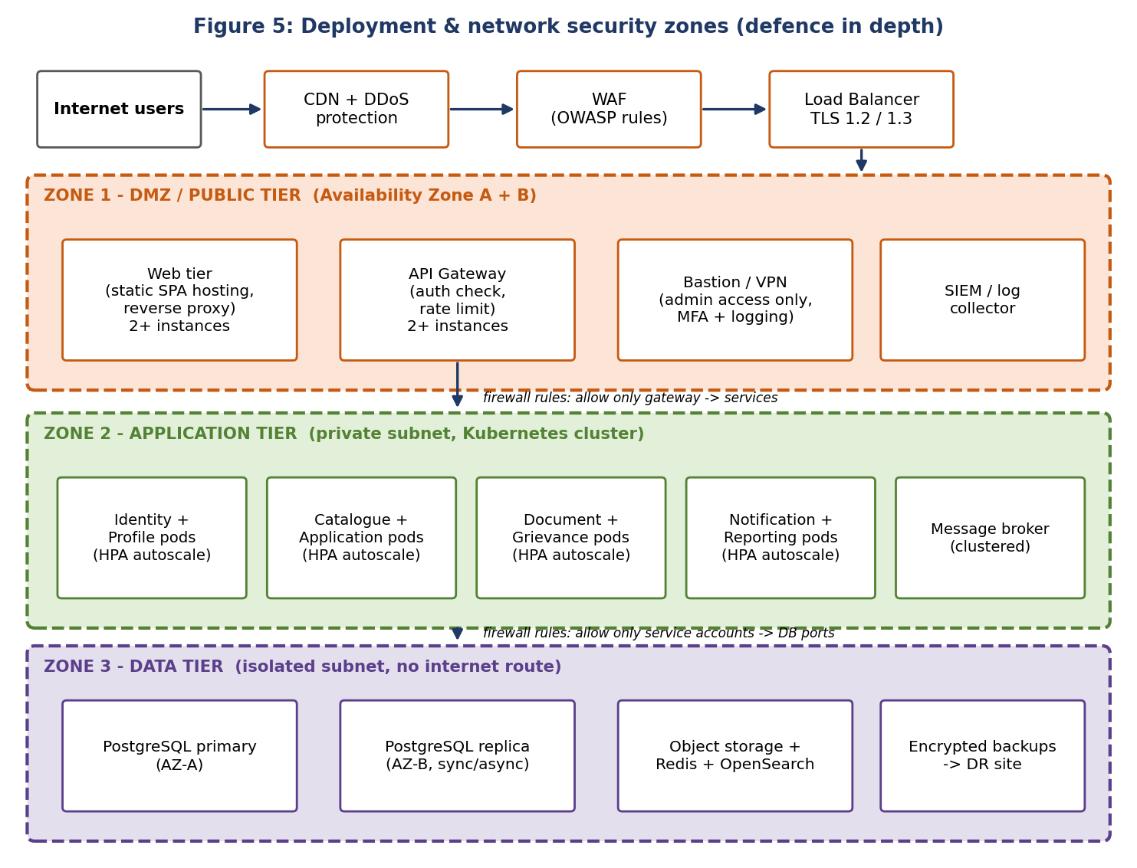
- Only the load balancer is reachable from the internet; the data tier has no internet route.
- Firewall/security-group rules allow only the minimum flows (gateway to services, service accounts to database ports).
- Administrators reach servers only through a VPN/bastion with MFA and session logging.
- Kubernetes network policies restrict pod-to-pod traffic; internal service calls use mutual TLS.

8.2 Authentication and Session Management
Control | Design
Protocol | OpenID Connect / OAuth 2.0 (authorization-code flow with PKCE for the SPA)
Citizen sign-in | E-mail/mobile + password with OTP verification; optional approved national identity or DigiLocker sign-in, subject to department approval
Staff sign-in | Mandatory MFA (TOTP or hardware token); access only from approved networks/VPN
Password policy | Minimum 8 characters (citizens) / 12 (staff), breached-password check, no forced periodic rotation (NIST SP 800-63B)
Password storage | Salted, memory-hard hashing (Argon2id preferred; bcrypt/PBKDF2 as supported by the identity provider); never plain text
Tokens | Signed JWT (RS256/ES256), access token 15 min, refresh-token rotation, revocation on logout
Session control (FR-20) | Proposed idle timeout 15 min citizens / 10 min staff, absolute limit 8 h, re-authentication before sensitive actions
Brute-force defence | Account lock-out with back-off, CAPTCHA after repeated failures, OTP rate limits

8.3 Authorization: Roles and Permissions
Role-based access control (FR-14) is enforced at the gateway and again inside every service. Citizens can only reach their own records because services check ownership on every request, so changing an ID in a URL returns nothing (Week 1 acceptance criterion).
Capability | Citizen | Case Officer | Super-visor | Dept Admin | System Admin | Auditor | Help-desk
Submit and track own applications | Own | - | - | - | - | - | -
View queue (own department) | - | Yes | Yes | Read | - | Read | Status only
Approve / reject / request info | - | Yes | Yes | - | - | - | -
Reassign cases | - | - | Yes | Yes | - | - | -
Configure services and forms | - | - | - | Yes | - | - | -
Manage users and roles | - | - | - | Dept staff | Yes | - | -
View audit logs | - | - | - | Read | Read | Yes | -
Reports and dashboards | - | Own queue | Yes | Yes | - | Read | -
Infrastructure and deployment | - | - | - | - | Yes | - | -
System Administrators manage the platform but have no routine access to citizen application data; break-glass access is time-limited, approved and fully logged.

8.4 Encryption and Cryptography
Data state | Method | Key management
In transit: user to edge | TLS 1.2 minimum, TLS 1.3 preferred, HSTS, strong cipher suites, certificates from a trusted CA | Certificate rotation, automated renewal
In transit: service to service | Mutual TLS inside the cluster; TLS to database, Redis and broker | Short-lived service certificates
At rest: database and volumes | AES-256 storage encryption | Master keys in KMS/HSM
At rest: sensitive fields | Application-level AES-256-GCM for mobile, address, identifiers (envelope encryption) | Data keys wrapped by master key; rotated periodically
At rest: documents | Server-side AES-256 per object | Separate keys from database keys
Passwords | Argon2id / bcrypt with unique salt | Handled by identity provider
Backups | AES-256 encrypted, stored off-site in India | Separate backup key, access restricted
Integrity and signing | SHA-256 checksums; digital signature on issued certificates (subject to approval) | Signing keys in HSM

8.5 Application and API Security
- Parameterised queries / ORM only - no string-built SQL; output encoding against XSS; CSRF tokens and SameSite cookies.
- Server-side validation of every input against schema; request size limits; strict CORS allow-list.
- Security headers: CSP, X-Content-Type-Options, X-Frame-Options/frame-ancestors, Referrer-Policy.
- Error messages are generic to users; details only in protected logs (no stack traces or personal data in responses).
- Outbound calls from integration adapters use an allow-list (protection against SSRF).

Secure document upload (FR-06)
- Allow-list of types (PDF, JPG, PNG) and size limit (proposed 5 MB per file, 10 files per application); check content signature, not just the extension.
- File stored in a private bucket under a random name; scanned with ClamAV; quarantined until the scan is clean.
- Served only through short-lived signed URLs (e.g. 5 minutes) after an authorisation check; never from the web root.

8.6 Audit, Logging and Monitoring
- Audit events: sign-in/out, failed logins, status changes, document access, role changes, configuration changes, report exports (FR-15, NFR-13).
- Append-only, hash-chained storage; auditors have read-only access; logs shipped to SIEM in near real time.
- Retention: minimum 180 days of logs held in India as required by CERT-In directions (2022); department may require longer.
- Alerts on: repeated failed logins, privilege changes, unusual download volume, WAF block spikes, certificate expiry.

8.7 Threat Model Summary (STRIDE)
Threat | Example | Mitigation
Spoofing | Stolen password used to impersonate a citizen or officer | OTP/MFA, short-lived tokens, lock-out, breached-password check
Tampering | Officer or attacker alters a status or document | Workflow rules, DB constraints, hash chain, checksums, TLS
Repudiation | User denies approving an application | Immutable audit trail with actor, role, time and IP
Information disclosure | Citizen reads another's application | Ownership checks, RBAC, encryption, masked logs, generic errors
Denial of service | Flood of requests during a deadline | CDN, DDoS protection, WAF, rate limits, autoscaling
Elevation of privilege | Citizen calls an admin API | Deny by default, role checks in every service, separate admin plane

8.8 OWASP Top 10 (2021) Coverage
Risk | Control in this architecture
A01 Broken Access Control | Deny by default, RBAC, ownership check per record, UUID identifiers
A02 Cryptographic Failures | TLS 1.2/1.3, AES-256, Argon2id, KMS-managed keys
A03 Injection | Parameterised queries, input validation, output encoding
A04 Insecure Design | Threat modelling, decision records, security review gates (Week 1 plan)
A05 Security Misconfiguration | Hardened images, infrastructure-as-code, CIS baselines, no default credentials
A06 Vulnerable Components | Dependency and image scanning in CI, SBOM, patch SLAs
A07 Identification and Authentication Failures | MFA, lock-out, session timeouts, token rotation
A08 Software and Data Integrity Failures | Signed images, protected pipeline, approvals, checksums
A09 Logging and Monitoring Failures | Central audit log, SIEM alerts, dashboards
A10 Server-Side Request Forgery | Outbound allow-list, URL validation in adapters

8.9 Incident Response and Compliance Alignment
Incident flow: Detect -> Triage -> Contain -> Eradicate -> Recover -> Report (to CERT-In within 6 hours of noticing, as per its 2022 directions) -> Post-incident review

Standard / law | How the architecture aligns
Digital Personal Data Protection Act, 2023 | Notice and purpose limitation, data minimisation, reasonable security safeguards, breach handling, erasure/retention jobs
Information Technology Act, 2000 and rules | Security practices, audit logs, lawful handling of electronic records
CERT-In directions (2022) | 6-hour incident reporting, 180-day log retention in India
GIGW 3.0 and WCAG 2.2 AA | Accessible, bilingual, usable portal (NFR-06, 14)
MeitY cloud empanelment / NIC hosting | Data hosted in India with approved providers
IndEA (India Enterprise Architecture) principles | Reusable services, open standards, interoperability, security by design
OWASP ASVS, NIST SP 800-63B, ISO/IEC 27001 controls | Verification checklist, authentication guidance, control framework
Third-party security audit | Audit by a CERT-In empanelled auditor before go-live (release gate from Week 1: no open critical/high findings)
As noted in Week 1, applicability and retention periods must be confirmed with the department's legal and compliance officers.

9. Scalability, Availability and Performance

9.1 Scaling Techniques
Technique | Where applied | Benefit
Horizontal scaling (HPA) | Every service pod; scale on CPU and request rate | Capacity grows by adding replicas; handles deadline peaks
Stateless services | All services; session state in Redis/tokens | Any instance can serve any request; easy rolling updates
Caching | CDN for static files; Redis for catalogue and sessions | Lower latency and database load (NFR-01)
Database read replicas | Reporting, search, status-tracking reads | Keeps the primary free for writes
Indexing and query tuning | Reference number, user ID, status, date columns | Fast lookups as tables grow
Asynchronous processing | Notifications, virus scan, indexing, report generation | User requests return quickly; spikes absorbed by queues
Connection pooling | Services to PostgreSQL (e.g. PgBouncer) | Prevents connection exhaustion
Rate limiting and back-pressure | Gateway and adapters | Protects services from overload
Partitioning (later) | Large tables by year or department | Maintains performance at state scale
Graceful degradation | Feature flags, cached catalogue, queue-based notifications | Core submit/track flow survives partial failures

9.2 Capacity Estimate (Illustrative Planning Assumptions)
- Growth target: 100,000 registered citizens; peak concurrency 5% = 5,000 users.
- If each active user makes one request every 10 s: 5,000 / 10 = 500 requests/s; with 2x headroom the design target is 1,000 requests/s.
- If one service pod handles about 100 requests/s (to be confirmed by load testing), roughly 10 pods across services cover the peak, with autoscaling above that.
- Storage: 100,000 applications/year x 3 documents x 1 MB average = 300,000 MB, about 0.3 TB per year of documents.
- Availability: 99.5% allows 216 minutes of downtime per 30-day month; multi-AZ design supports a later 99.9% goal (about 43 minutes).

9.3 Scaling Roadmap
Stage | Scale | Infrastructure
Pilot | About 100 users, 1 service, 5-10 officers | Small Kubernetes cluster (3 nodes), 2 replicas per service, PostgreSQL primary + 1 replica, single DR copy of backups
Growth | About 100,000 citizens, 5-10 services | Autoscaling 2-10 pods per service, 2 read replicas, Redis cluster, 3-node OpenSearch, warm-standby DR site
State scale | Millions of users, many departments | Multi-cluster / multi-region, table partitioning, Kafka for event streaming, data warehouse for analytics
Figures are indicative planning values and must be validated by load testing and the hosting provider, as stated in Week 1.

9.4 High Availability and Disaster Recovery
Item | Design | Target
Compute | At least 2 replicas per service across 2 availability zones; health checks; self-healing | Supports NFR-02 (99.5%)
Database | Primary + synchronous or asynchronous replica; automatic failover | Failover in minutes
Database backup | Daily full backup + continuous WAL archiving | Week 1 RPO 24 h; design allows 15 min or better
Document backup | Versioned buckets, replicated to DR site | RPO 24 h
Disaster recovery site | Warm standby in a different seismic/geographic zone within India; infrastructure-as-code rebuild | Week 1 RTO 8 h
Restore testing | Before launch and then quarterly | Evidence recorded (NFR-09)

9.5 Performance and Observability
Signal | What is measured | Alert threshold (proposed)
Latency | p50 / p95 response time per API | p95 above 2 s for 5 min
Errors | 5xx rate, failed logins, dead-letter queue depth | Error rate above 2%
Saturation | CPU, memory, DB connections, disk | Above 80%
Replication | Database replication lag | Above 60 s
Availability | Synthetic checks of login, search and submit flow | Any failure twice in a row
Security | WAF blocks, privilege changes, abnormal downloads | Spike versus baseline
Design target is p95 of 2 s (Week 1 performance bullet); the 3 s value in NFR-01 is treated as the maximum acceptance limit for pilot testing.

10. Deployment and DevOps
Environment | Purpose | Data
Development | Developer integration and feature work | Synthetic only
Test / QA | Automated and manual testing | Synthetic only
Staging | Production-like rehearsal, performance and security tests, UAT | Anonymised
Production | Live service (3 network zones) | Real citizen data, fully protected
Disaster recovery | Warm standby | Replicated, encrypted
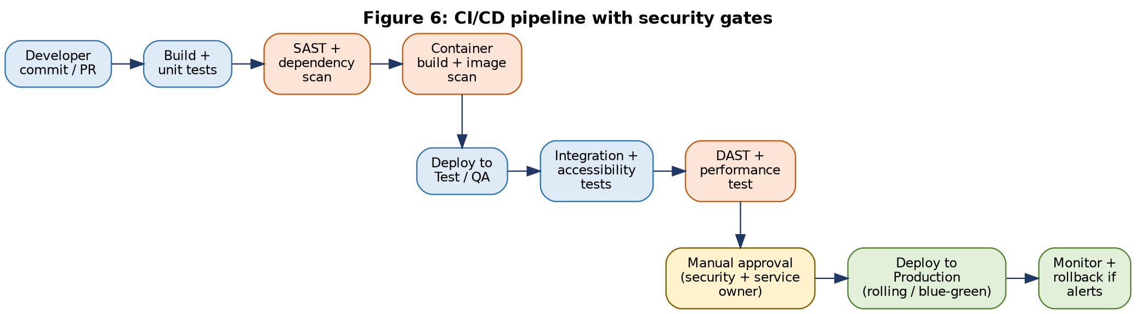
- Protected main branch, mandatory code review, signed commits; infrastructure and Helm charts stored in Git (infrastructure-as-code).
- Security gates fail the build on critical findings; production release needs security and service-owner approval.
- Rolling or blue-green deployments with automated rollback; database migrations versioned and backward compatible.
- OpenAPI contracts are published for every service (NFR-10); unit-test coverage target of at least 70% (proposed).

11. Design Justification: Requirement Traceability
Every Week 1 requirement maps to an architectural element, which shows that the design meets both functional and non-functional needs.

11.1 Functional Requirements to Architecture
ID | Requirement | Priority | Architectural element that satisfies it
FR-01 | Register and sign in | Must | Identity Service (Keycloak, OIDC, OTP); Citizen Portal
FR-02 | Profile management | Should | Citizen Profile Service
FR-03 | Service catalogue | Must | Service Catalogue Service; Redis/CDN cache
FR-04 | Application form with validation | Must | Form schema from Catalogue; client and server validation in Application Service
FR-05 | Save draft | Should | Draft status in Application Service; state saved server-side
FR-06 | Safe document upload | Must | Document Service: type/size checks, ClamAV, SHA-256, private storage
FR-07 | Unique reference and timestamp | Must | Application Service: DB sequence-based reference, committed in transaction
FR-08 | Status tracking and history | Must | Status-history table, My Applications API, Notification events
FR-09 | Staff work queue | Must | Queue API with role and department filters; OpenSearch
FR-10 | Review, decide, request information | Must | Workflow engine, Staff Console, Document Service
FR-11 | Citizen response to requests | Must | Action Required to Under Review transition; document re-upload
FR-12 | Notifications | Should | Message broker, Notification Service, SMS/e-mail adapters
FR-13 | Complaint / help request | Should | Grievance Service with tracking reference
FR-14 | Role management | Must | Keycloak roles, RBAC matrix, admin APIs
FR-15 | Audit trail | Must | Audit pipeline, append-only hash-chained log
FR-16 | Reports | Should | Reporting Service on read replica / search index
FR-17 | Search and filtering | Should | OpenSearch index fed by events
FR-18 | Service configuration | Could | Catalogue admin APIs under change control and audit
FR-19 | Accessibility support | Must | Accessible component library, axe tests in CI, manual screen-reader tests
FR-20 | Session control | Must | Token expiry, idle timeout, re-authentication in Identity Service and gateway

11.2 Non-Functional Requirements to Architecture
ID | Attribute | Design decision | Verification
NFR-01 | Performance | CDN, Redis cache, indexes, async side-effects, connection pools | Load test, p95 report
NFR-02 | Availability | Multi-AZ, 2+ replicas, health checks, DB failover, rolling deploys | Uptime monitoring
NFR-03 | Scalability | Stateless containers, HPA, read replicas, broker, object storage | Load test, capacity review
NFR-04 | Security | Section 8: zones, OIDC/MFA, RBAC, encryption, scanning, secrets vault | Security review, audit
NFR-05 | Privacy | Data minimisation, classification, field encryption, retention jobs, synthetic test data | Privacy impact review
NFR-06 | Accessibility | WCAG 2.2 AA components, keyboard navigation, ARIA | Automated + manual tests
NFR-07 | Usability | Guided forms, drafts, status tracker, plain language, assisted channel | Moderated usability tests
NFR-08 | Reliability | Idempotency, retries, circuit breakers, outbox, dead-letter queue | Failure-path tests
NFR-09 | Backup / recovery | Daily backup, WAL archive, DR site, restore drills | Restore test evidence
NFR-10 | Maintainability | Modular services, OpenAPI, CI, code review, tests | Code review, documentation
NFR-11 | Compatibility | Responsive design, browser matrix, progressive enhancement | Browser/device matrix
NFR-12 | Interoperability | REST/OpenAPI, adapters with fallback behaviour | Integration tests
NFR-13 | Auditability | Hash-chained audit store, restricted access, SIEM | Audit-log inspection
NFR-14 | Localization | i18n bundles, UTF-8, English + Hindi, Unicode fonts | Language review
NFR-15 | Data integrity | ACID, constraints, state machine, optimistic locking, checksums | Data validation tests

12. Risks, Trade-offs and Assumptions

12.1 Architectural Risks and Mitigations
Risk | Impact | Mitigation
Over-engineering for a small pilot | Delay, cost | Coarse-grained services; start with minimum replicas; add components only when needed
Kubernetes operational complexity | Outages, skill gap | Managed Kubernetes where available; runbooks; training; Compose only for local development
Dependence on external APIs | Feature failures | Adapters, circuit breakers, manual fallback, contracts and test environments
Vendor lock-in | Cost, flexibility | Open-source stack, S3-compatible storage, containers, infrastructure-as-code
Data-residency or hosting rules change | Re-hosting effort | Portable design; confirm hosting policy early
Flexible JSONB form data hard to query | Slow reports | Index key fields, copy reporting fields into columns, use search index
Security misconfiguration | Breach | Infrastructure-as-code, hardening baselines, pre-go-live third-party audit

12.2 Key Trade-offs
Decision | Chosen | Trade-off accepted
Service granularity | 8 coarse-grained services | Less independent than microservices, but far simpler to operate
Authentication | Keycloak (buy/reuse) | Less custom control, much lower security risk than custom code
Messaging | RabbitMQ | Lower peak throughput than Kafka, simpler for pilot; upgrade path defined
Form storage | Hybrid columns + JSONB | Some query complexity in exchange for configurable services
Consistency | Strong in core workflow, eventual for notifications/search | Search and alerts may lag by seconds

12.3 Assumptions and Items to Confirm with the Department
- Hosting provider, network zones and procurement route; availability of a DR site in India.
- Identity options (OTP only, DigiLocker, other) and whether any national ID data may be handled.
- SMS/e-mail gateway and payment gateway providers, with test environments.
- Data-retention periods, languages beyond English and Hindi, and expected volumes beyond the pilot.
- Final choice of technology stack with the development team; the architecture remains valid if a different back-end framework is selected.

13. Conclusion and Next Steps
The proposed architecture gives the e-Governance portal a secure, scalable and maintainable foundation: a layered design with domain services, event-driven integration, strong data-integrity controls and a defence-in-depth security model. Each decision is traceable to a Week 1 requirement and justified against security, scalability and maintainability.
Next steps:
- Review this blueprint with the supervisor and service owner; resolve the open items in 12.3.
- Produce detailed API specifications (OpenAPI) and the physical database schema.
- Build wireframes and a clickable prototype of the citizen journey and staff console.
- Set up the CI/CD pipeline and a development environment, then implement the Identity and Application services first.
- Plan performance, security and accessibility test cases using the targets in Sections 8 and 9.

Appendix A: Architecture Decision Log
ID | Decision | Main reason | Requirement link
ADR-01 | Coarse-grained domain services behind an API gateway | Balance of scalability and simplicity | NFR-03, NFR-10
ADR-02 | React SPA with accessible component library | Reuse, accessibility, responsive UI | FR-19, NFR-06, NFR-11
ADR-03 | Spring Boot back-end | Security tooling, scale, government adoption | NFR-04, NFR-10
ADR-04 | Keycloak for identity (OIDC, MFA) | Avoid custom authentication risk | FR-01, FR-14, FR-20
ADR-05 | PostgreSQL as system of record | ACID, constraints, JSONB | NFR-15
ADR-06 | Event-driven side effects with outbox | Reliability and fast responses | NFR-08, FR-12
ADR-07 | Object storage for documents, encrypted | Scalability and security | FR-06, NFR-04
ADR-08 | Hash-chained audit log | Tamper evidence | FR-15, NFR-13
ADR-09 | Three-zone network with WAF and mTLS | Defence in depth | NFR-04
ADR-10 | Kubernetes with autoscaling and multi-AZ | Availability and elasticity | NFR-02, NFR-03

Appendix B: Glossary
Term | Meaning
ACID | Atomicity, Consistency, Isolation, Durability - reliable database transaction properties
API Gateway | Single entry point that authenticates, routes and limits API traffic
CDN | Content Delivery Network that serves static files from locations near users
HPA | Horizontal Pod Autoscaler - Kubernetes feature that adds or removes replicas
Idempotency | Repeating a request gives the same result and no duplicate effect
JWT | JSON Web Token used to carry signed identity claims
KMS / HSM | Key Management Service / Hardware Security Module for protecting encryption keys
mTLS | Mutual TLS - both client and server authenticate each other
OIDC / OAuth 2.0 | Open standards for authentication and delegated authorisation
Outbox pattern | Writing events to a database table in the same transaction, then publishing them
RBAC | Role-Based Access Control
RPO / RTO | Recovery Point Objective (data loss tolerance) / Recovery Time Objective (downtime tolerance)
SIEM | Security Information and Event Management system
WAF | Web Application Firewall that blocks common web attacks

Appendix C: References
- Week 1 - Requirement Analysis and Planning, Unified e-Governance Service Portal (FR-01 to FR-20, NFR-01 to NFR-15).
- OWASP Top 10 (2021) and OWASP Application Security Verification Standard (ASVS).
- NIST SP 800-63B, Digital Identity Guidelines: Authentication and Lifecycle Management.
- Digital Personal Data Protection Act, 2023; Information Technology Act, 2000; CERT-In Directions of 28 April 2022.
- Guidelines for Indian Government Websites and Apps (GIGW 3.0); W3C WCAG 2.2.
- MeitY: India Enterprise Architecture (IndEA); MeghRaj cloud empanelment; Policy on Adoption of Open Source Software for Government of India.

Document Review Checklist
Check | Status | Section
System architecture described with components, modules and interactions | Complete | 3-5
Diagrams included (layered, sequence, state, data, security zones, CI/CD) | Complete | Figs 1-6
Technology choices justified with alternatives | Complete | 7
Security protocols and encryption methods covered | Complete | 8
Scalable infrastructure and availability design | Complete | 9
Design decisions traced to functional and non-functional requirements | Complete | 11
Risks, assumptions and open items stated | Complete | 12
Consistent with Week 1 IDs and targets | Complete | 2.3, 11

