WEEK 3 TASK
IMPLEMENTATION &
CODING STANDARDS
Developer Guidelines Manual - Unified e-Governance Service Portal
Clean code, version control, modularity and collaborative practices for junior developers
Internship | Junior Software Developer - E-Governance & Digital Services
Submitted by | Anshika Sharma
Course / Institution | BCA / Institute of Technology and Management, GIDA
Internship Organization | Yuva Intern
Builds on | Week 1 (Requirements) and Week 2 (System Architecture & Design)
Document version | 1.0
Submission Date | 31-10-2026

Contents
1. Executive Summary 4
1.1 How this document meets the Week 3 brief 4
2. Purpose, Scope and Guiding Principles 4
2.1 Purpose and Audience 4
2.2 Scope 5
2.3 Rule Strength 5
2.4 Guiding Principles 5
2.5 Precedence of Rules 5
3. Importance of Clean Code, Documentation and Version Control 6
3.1 Why Standards Matter in e-Governance 6
3.2 Importance of Clean Code 6
3.3 Importance of Documentation 6
3.4 Importance of Version Control 6
4. Coding Standards Framework 7
4.1 Naming Conventions 7
4.2 Formatting 7
4.3 File and Project Organisation 8
4.4 Commenting Practices 8
4.5 Clean Code Rules 9
4.6 Language-Specific Standards 10
4.7 Configuration and Secrets 11
5. Modularity and Code Structure 12
5.1 Layered Structure 12
5.2 Designing Functions, Classes and Modules 12
5.3 SOLID Principles Applied 13
5.4 Rules for Scalable, Maintainable Structure 13
6. Error Handling and Logging 14
6.1 Principles 14
6.2 Exception Hierarchy 14
6.3 Standard Error Response 15
6.4 Input Validation 15
6.5 Logging Standards 16
6.6 Resilience in Code 16
7. Secure Coding Standards 16
7.1 Accessibility and Localisation in Code 17
7.2 Data Protection in Code 17
8. Version Control with Git 18
8.1 Repository Rules 18
8.2 Branching Strategy 18
8.3 Commit Message Standard 19
8.4 Pull Requests and Merging 20
8.5 Resolving Conflicts 20
8.6 Releases, Tags and Versions 20
8.7 Everyday Git Commands 20
9. Documentation Practices 21
9.1 README Template 21
9.2 Documentation Rules 21
10. Testing Standards 22
10.1 Test Strategy 22
10.2 Rules for Writing Tests 22
11. Tools and Framework Recommendations 23
11.1 Local Developer Checks (pre-commit) 24
11.2 CI Pipeline Definition (excerpt) 24
12. Quality Assurance and Enforcement 25
12.1 Code Review Process 25
12.2 Reviewer and Author Etiquette 26
12.3 Continuous Integration and Automated Enforcement 26
12.4 Quality Gate Thresholds 26
12.5 Definition of Done 27
12.6 Quality Metrics Reviewed Monthly 27
13. Collaborative Development Practices 27
13.1 Day-to-Day Workflow 27
13.2 Team Practices 28
13.3 Onboarding Path for Junior Developers 28
13.4 Handling Exceptions to the Standards 28
13.5 Maintaining This Manual 28
14. Conclusion 29
Appendix A: One-Page Cheat Sheet 30
Appendix B: Pull Request Template 30
Appendix C: Code Review Checklist 31
Appendix D: Glossary 31
Appendix E: References 32
Document Review Checklist 32

1. Executive Summary
This manual defines how the development team writes, stores, reviews and ships code for the Unified e-Governance Service Portal. It is a working reference for junior developers: every rule is short, justified, and shown with an example. The standards follow the architecture approved in Week 2 (Java 17 + Spring Boot services, React + TypeScript front-end, PostgreSQL, Git-based CI/CD).
- Clean code: readable names, small functions, one responsibility per class, no magic values.
- Structure: package-by-feature, strict layers (controller, service, repository, domain), dependencies point downwards only.
- Errors and logs: one exception hierarchy, standard error response, no personal data in logs, correlation IDs everywhere.
- Secure coding: OWASP-based checklist built into every review (government data is high-risk data).
- Version control: Git with protected main, short-lived branches, Conventional Commits, squash merges, semantic version tags.
- Quality gates: automated lint, tests, scans and a SonarQube gate on every pull request, plus mandatory human review.

How to use this document: New joiners read Sections 2-4 and Appendix A (one-page cheat sheet) on day one. Use the other sections as a lookup reference during development and review.

1.1 How this document meets the Week 3 brief
Expected deliverable | What is provided | Section
Detailed coding standards for the project | Naming, formatting, file organisation, language-specific rules, API and SQL conventions | 4, 5, 6, 7
Importance of clean code, documentation, version control | Why-it-matters section with e-governance reasons; documentation standards | 3, 9
Code structuring, commenting, error handling | Layering rules, comment standards with good/bad examples, exception and logging standards | 4.4, 5, 6
Tools and frameworks for code quality | Tool table by category, configuration snippets, pre-commit hooks | 11
Version control: branching, merging, commit messages | Branching model diagram, commit convention, PR and merge rules, release tagging | 8
Quality assurance: code reviews, CI enforcement | Review workflow, checklists, CI pipeline, quality-gate thresholds, Definition of Done | 12, App. B-C
Practicality as a team reference | Cheat sheet, PR template, review checklist, glossary | Appendices

2. Purpose, Scope and Guiding Principles

2.1 Purpose and Audience
- Give every developer one shared definition of "good code" so that any team member can read, review and maintain any module.
- Reduce defects and security vulnerabilities in a system that handles citizens' personal data.
- Speed up onboarding of junior developers and interns.
- Provide objective, checkable rules that reviewers and CI tools can enforce, so reviews focus on design and logic rather than style.

2.2 Scope
Area | Covered
Languages | Java 17 (back-end), TypeScript / JavaScript (React front-end), SQL (PostgreSQL), YAML / Dockerfiles (configuration)
Artefacts | Source code, database migrations, API contracts (OpenAPI), configuration, tests, documentation, pipeline definitions
People | Developers, reviewers, QA engineers, DevOps and interns working on the portal
Out of scope | Project management methods and detailed UI design (covered in other weeks)

2.3 Rule Strength
Each rule uses one of three words so developers know what is negotiable.
Word | Meaning | Enforcement
MUST / MUST NOT | Mandatory; exceptions need written approval from the tech lead | Blocked automatically by CI where possible, otherwise by reviewer
SHOULD | Strong recommendation; deviate only with a documented reason | Reviewer judgement
MAY | Optional good practice | None

2.4 Guiding Principles
- Readability first: code is read far more often than it is written; optimise for the next reader.
- Simplicity: choose the simplest solution that meets the requirement (KISS); avoid building for imagined future needs (YAGNI).
- Security by default: validate input, check permissions, protect data - in every change, not only in security tickets.
- Consistency over personal taste: follow the standard even if you prefer another style; automate formatting to end debates.
- Automate what can be automated: formatters, linters, tests and scanners do the repetitive checking.
- Leave the code better than you found it (boy-scout rule), in small, safe steps.

2.5 Precedence of Rules
Order of precedence: 1) Law and government policy (e.g. data protection, accessibility, CERT-In directions) > 2) Project security requirements from Week 2 > 3) This manual > 4) Official language style guides (Google Java Style, Airbnb/TypeScript conventions) > 5) Personal preference.

3. Importance of Clean Code, Documentation and Version Control

3.1 Why Standards Matter in e-Governance
A government portal differs from a typical commercial app: it is used by the public, holds sensitive records, must be auditable and often lives for ten years or more, passing between different teams and vendors.
E-governance reality | Consequence for coding practice
Sensitive personal data of citizens | A single injection or access-control bug can be a legal and reputational incident; secure coding rules are mandatory
Public accountability and audits | Code, changes and approvals must be traceable: who changed what, why and who approved it
Long system life, staff turnover | Code must be understandable by people who did not write it; documentation must survive handover
Citizens depend on the service | Defects mean denied or delayed certificates and benefits; testing and review must be rigorous
Public money, multiple vendors | Open standards, readable code and clear documentation prevent lock-in and rework costs
Diverse users and devices | Accessibility and localisation must be built into code from the start

3.2 Importance of Clean Code
- Fewer bugs: simple, small units are easier to reason about and test.
- Lower cost of change: most effort in a system's life is maintenance; clean code makes new services and rule changes cheap (supports FR-18 and NFR-10).
- Faster reviews and onboarding: reviewers understand the change quickly and find real problems.
- Safer security fixes: vulnerabilities are easier to locate and patch in well-structured code.
- Team scalability: many developers can work in parallel without conflicts when code is modular.

3.3 Importance of Documentation
- Explains the why behind decisions that code cannot show (legal rules, department policies, trade-offs).
- Allows operations, auditors and new vendors to run and verify the system without the original authors.
- Documents APIs so front-end, partner and test teams can work independently.
- Serves as evidence for security and quality audits before go-live.

3.4 Importance of Version Control
- Traceability: every line links to an author, a date, a reason (commit message) and a ticket.
- Safe collaboration: branches isolate work; pull requests add review before code reaches main.
- Recoverability: any bad change can be reverted; any past release can be rebuilt from its tag.
- Auditability: protected branches, signed commits and review history show that approved process was followed.
Key message: Clean code, clear documentation and disciplined version control are not extras for a government system - they are the controls that make the system secure, auditable and maintainable.

4. Coding Standards Framework

4.1 Naming Conventions
Names MUST be meaningful, pronounceable and in English. Avoid abbreviations except well-known ones (id, url, otp, dto).
Item | Convention | Good example / avoid
Java class, interface, enum | PascalCase, noun | ApplicationService, CertificateRepository / avoid: AppMgr, Data1
Java method | camelCase, verb | submitApplication(), findByReferenceNo() / avoid: doIt(), process()
Java variable, parameter | camelCase, descriptive | applicantEmail, retryCount / avoid: x, tmp, a1
Java constant | UPPER_SNAKE_CASE | MAX_UPLOAD_SIZE_BYTES, OTP_VALIDITY_SECONDS
Java package | lowercase, no underscores | in.gov.egov.portal.application.service
Boolean | Reads as a question | isEligible, hasPendingDocuments / avoid: flag, status1
TypeScript variable, function | camelCase | applicationList, fetchApplicationStatus()
React component, TS type | PascalCase | ApplicationForm, StatusBadge, ApplicationDto
React hook | camelCase starting with use | useApplicationStatus()
Front-end files | Component: PascalCase.tsx; others: kebab-case.ts | ApplicationForm.tsx, date-utils.ts
SQL tables, columns | snake_case, plural tables | applications, status_history, submitted_at
SQL constraints, indexes | Prefix by type | pk_applications, fk_documents_application, idx_applications_status
REST paths | Lowercase, plural nouns, hyphens | /api/v1/applications/{id}/documents (not /getDocs)
JSON fields | camelCase | referenceNo, submittedAt
Environment variables | UPPER_SNAKE_CASE, prefixed | EGOV_DB_URL, EGOV_SMS_API_KEY
Git branches | type/ticket-short-description | feature/EGOV-12-draft-save

4.2 Formatting
- Formatting is automated: Spotless (Google Java Format) for Java, Prettier for TypeScript, .editorconfig for all editors. Never format by hand or argue about style in reviews.
- UTF-8 encoding and LF line endings; no trailing spaces; one blank line at end of file.
- Indentation: 4 spaces for Java, 2 spaces for TypeScript, JSON, YAML and SQL. No tabs.
- Maximum line length 120 characters; wrap long method calls and chains one call per line.
- One top-level class per file; one statement per line; always use braces for if / for / while.
- Import order: standard library, third-party, project; no wildcard imports; remove unused imports.

4.3 File and Project Organisation
Organise by feature (what the code is for), then by layer inside the feature. This keeps related code together and makes it easy to split a feature into its own service later.
Recommended layout (back-end service and front-end)
application-service/
pom.xml (or build.gradle)
README.md (purpose, run, test, config)
src/main/java/in/gov/egov/application/
api/ controllers + request/response DTOs
service/ business rules, transactions
domain/ entities, enums, value objects
repository/ database access
integration/ adapters (events, other services)
config/ Spring configuration, security
exception/ custom exceptions + handler
src/main/resources/
application.yml default config (no secrets)
db/migration/ V1__create_applications.sql ...
src/test/java/... mirrors main package structure

portal-web/ (React + TypeScript)
src/features/applications/ components, hooks, api, types, tests
src/shared/ reusable UI, utils, i18n bundles
src/app/ routing, providers, layout

- File names MUST describe contents; a file that needs the word "misc" or "util2" needs to be split.
- Keep files short: a class SHOULD be under 300 lines and a React component under 200 lines; larger files are split.
- Generated files, build output, local config and secrets MUST NOT be committed.

4.4 Commenting Practices
Good code explains what it does through names and structure. Comments explain why, and document public contracts.
Write a comment when... | Do not write a comment when...
A business or legal rule is not obvious (cite the rule or circular) | It repeats the code ("increment i")
A workaround exists for a known bug or external-system quirk (add ticket link) | A better name or smaller function would remove the need
A public class, method or API needs a contract: inputs, outputs, errors | It is old commented-out code (delete it; Git keeps history)
A performance or security decision looks unusual | It is a personal note or joke
A TODO is unavoidable: format TODO(EGOV-123): reason | It could become wrong when code changes - keep comments close to code

Example: comments that explain why
// BAD: restates the code
// check if age is above 18
if (age > 18) { ... }

// GOOD: explains the rule and its source
// Applicants below 18 need a guardian declaration (Dept. Order 12/2026, cl. 4).
if (applicant.getAge() < ADULT_AGE_YEARS) {
requireGuardianDeclaration(applicant);
}

Example: Javadoc for a public method (use TSDoc in TypeScript)
/**
* Submits a draft application and generates its reference number.
*
* @param applicationId id of an existing draft owned by the caller
* @param idempotencyKey client key; repeating it returns the first result
* @return the submitted application with reference number and timestamp
* @throws ValidationException if mandatory fields or documents are missing
* @throws AccessDeniedException if the caller does not own the draft
*/
public ApplicationDto submit(UUID applicationId, String idempotencyKey) { ... }

4.5 Clean Code Rules
Rule | Standard (MUST unless marked)
Function size | Do one thing; SHOULD be under 30 lines; extract helper methods instead of adding comments
Parameters | SHOULD be 4 or fewer; group related values in an object (e.g. SearchCriteria)
Complexity | Cyclomatic complexity 10 or less and cognitive complexity 15 or less per method (checked by SonarQube)
Nesting | Maximum 3 levels; use early returns / guard clauses
Magic values | No unexplained numbers or strings; use named constants, enums or configuration
Duplication (DRY) | Same logic in 3 places MUST be extracted; duplicated lines on new code under 3%
Single responsibility | A class has one reason to change; names with "And", "Manager" or "Helper" are warning signs
Immutability | Prefer final fields, records and immutable DTOs; avoid shared mutable state
Null safety | Do not return null for collections (return empty); use Optional for single absent results; validate arguments
Dead code | Delete unused code, imports and commented-out blocks
Boolean parameters | SHOULD be avoided; use two methods or an enum
Side effects | Functions that query MUST NOT change state; name state-changing functions with verbs

Example: before and after
// BAD: deep nesting, magic numbers, unclear names
public boolean chk(User u, Doc d) {
if (u != null) {
if (d != null) {
if (d.getSize() < 5242880) { return true; }
}
}
return false;
}

// GOOD: guard clauses, named constant, clear intent
private static final long MAX_UPLOAD_SIZE_BYTES = 5L * 1024 * 1024;

public boolean canAcceptDocument(User uploader, Document document) {
if (uploader == null || document == null) {
return false;
}
return document.getSizeBytes() <= MAX_UPLOAD_SIZE_BYTES;
}

4.6 Language-Specific Standards

Java (Spring Boot)
- Follow Google Java Style as enforced by Spotless and Checkstyle; target Java 17 features (records for DTOs, switch expressions, text blocks).
- Use constructor injection (not field injection with @Autowired); keep beans stateless.
- Use @Transactional on service methods only, with the narrowest scope; never on controllers.
- Never expose entities in APIs; map to DTOs. Validate DTOs with Bean Validation annotations (@NotBlank, @Size, @Pattern).
- Use Optional, streams and lambdas where they improve clarity - not for cleverness.
- Use SLF4J for logging, never System.out.println or printStackTrace().
- Close resources with try-with-resources; use java.time for dates and store timestamps in UTC.

TypeScript / React
- Enable strict mode; any is not allowed without a comment explaining why.
- Function components with hooks; one component per file; keep components small and presentational where possible.
- Never put business rules or secrets in the browser - the server is the source of truth for validation and permissions.
- Never use dangerouslySetInnerHTML with user-provided content; sanitise any rich text.
- All user-visible text goes through the i18n bundle (English and Hindi), never hard-coded in components.
- Accessibility is part of the code: semantic elements, labels for every input, keyboard focus order, alt text, ARIA only when native HTML is not enough.
- Handle loading, empty and error states for every data-driven screen.

SQL and database migrations
- Schema changes only through versioned Flyway migrations (V12__add_status_history.sql); never edit an applied migration.
- Migrations MUST be backward compatible with the previous release (add before remove) to allow rolling deployments.
- Always use parameterised queries or the ORM; no string-built SQL.
- Name every constraint; add indexes for foreign keys and filter columns; no SELECT * in application code.
- Keep personal data columns identified in a data dictionary so encryption and retention rules can be applied.

REST API conventions
Topic | Standard
URLs and verbs | Nouns not verbs; GET read, POST create, PUT/PATCH update, DELETE remove; version in path (/api/v1)
Status codes | 200 OK, 201 Created, 204 No Content, 400 validation, 401 not authenticated, 403 not allowed, 404 not found, 409 conflict, 422 business-rule failure, 429 rate limited, 500 unexpected
Pagination | page, size and sort parameters; default size 20, maximum 100
Contracts | Every endpoint documented in OpenAPI; changes that break clients need a new version
Idempotency | POST operations that create records accept an Idempotency-Key header
Dates and IDs | ISO-8601 UTC timestamps; UUIDs for identifiers

4.7 Configuration and Secrets
- Configuration MUST be separate from code (application.yml profiles, environment variables); the same build runs in every environment.
- Passwords, API keys, tokens and certificates MUST NOT be in source code, config files in Git, logs or chat. Use Vault / the platform secret store.
- Provide application-example.yml with placeholder values so new developers know what to set.
- If a secret is committed by mistake, treat it as leaked: rotate it immediately and report to the tech lead - deleting the commit is not enough.

5. Modularity and Code Structure

5.1 Layered Structure
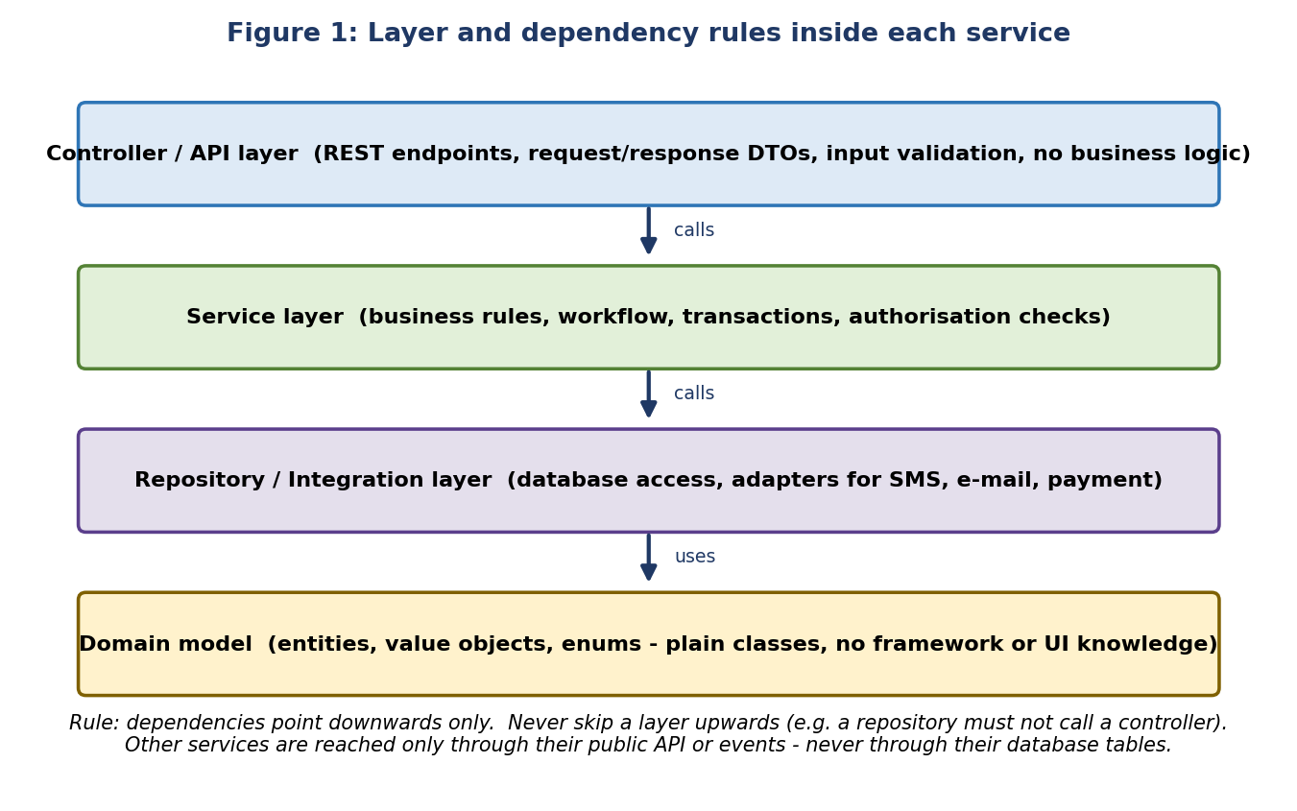
Layer | Allowed | Not allowed
Controller | Map HTTP to DTOs, validate input, call one service method, return response | Business rules, database access, transaction handling
Service | Business rules, workflow transitions, authorisation checks, transactions, publish events | HTTP types (request/response objects), SQL
Repository | Queries, persistence, mapping to entities | Business decisions, calling other services
Domain | Entities, enums, value objects, invariants | Framework, database or UI dependencies
Integration adapter | Wrap SMS, e-mail, payment, external APIs with timeout, retry and mapping | Leaking external data formats into the domain

5.2 Designing Functions, Classes and Modules
Unit | Design standard
Function | Small, single purpose, no hidden side effects, descriptive verb name, validate inputs at boundaries, return early on invalid input
Class | High cohesion (members belong together), low coupling (few dependencies; max 5 constructor parameters), depend on interfaces not concrete classes
Package / module | One feature or business capability per package; expose a small public API; keep internals package-private
Service (deployable) | Owns its data; communicates by REST or events; no shared database tables with other services
Shared library | Only for genuinely generic code (error format, logging, validation utils); versioned; never contains business rules of one service

5.3 SOLID Principles Applied
Principle | Meaning | Portal example
Single responsibility | One reason to change | Separate NotificationService from ApplicationService
Open / closed | Extend without editing tested code | Add a new SmsProvider adapter without changing the notification logic
Liskov substitution | Implementations behave like their interface | Any DocumentScanner implementation returns CLEAN or INFECTED consistently
Interface segregation | Small, focused interfaces | Separate ReadableRepository and WritableRepository where needed
Dependency inversion | Depend on abstractions | Service depends on the PaymentGateway interface, not a vendor class

Example: dependency inversion and constructor injection
public interface SmsGateway { // abstraction
DeliveryResult send(MobileNumber to, String message);
}

@Service
public class NotificationService {
private final SmsGateway smsGateway; // depends on interface

public NotificationService(SmsGateway smsGateway) { // constructor injection
this.smsGateway = smsGateway;
}

public void sendReceipt(Application app) {
smsGateway.send(app.getApplicantMobile(), receiptText(app));
}
}

5.4 Rules for Scalable, Maintainable Structure
- Stateless code: no session or user data in static or instance fields; state goes to the database, cache or token (supports horizontal scaling).
- Configuration-driven services: service rules, fees and form fields come from the catalogue, not hard-coded if chains (FR-18).
- Feature flags for incomplete or risky features; remove flags once the feature is stable.
- Avoid circular dependencies between packages; the build tool (ArchUnit test) fails if layers are violated.
- Backward compatibility: do not change a public API or event format without versioning and a migration plan.
- Performance by design: paginate list endpoints, avoid N+1 queries, index filter columns, move slow work to asynchronous events.
- Reuse before writing: search the shared library and existing modules first; extend instead of copying.
Example: ArchUnit test that enforces the layer rule automatically
@AnalyzeClasses(packages = "in.gov.egov.application")
class ArchitectureTest {
@ArchTest
static final ArchRule controllers_do_not_access_repositories =
noClasses().that().resideInAPackage("..api..")
.should().dependOnClassesThat().resideInAPackage("..repository..");
}

6. Error Handling and Logging

6.1 Principles
- Fail fast, fail safely: validate inputs at the boundary and reject bad data early with a clear message.
- Never swallow exceptions: an empty catch block is not allowed; handle, translate or rethrow with context.
- Use specific exceptions: do not catch Exception or Throwable except in the single global handler.
- Separate users from developers: users get a short, safe message; the log gets full technical detail.
- Never leak internals: no stack traces, SQL, file paths or personal data in API responses (OWASP A05, A09).
- Leave data consistent: a failure inside a transaction rolls back everything; external calls use timeouts, retries and circuit breakers.

6.2 Exception Hierarchy
Standard exception types shared by all services
PortalException (abstract, unchecked, carries errorCode)
|-- ValidationException -> HTTP 400 invalid input
|-- AuthenticationException -> HTTP 401 not signed in / token invalid
|-- AccessDeniedException -> HTTP 403 signed in but not allowed
|-- ResourceNotFoundException -> HTTP 404 (also used when user does not own the record)
|-- ConflictException -> HTTP 409 duplicate or version conflict
|-- BusinessRuleException -> HTTP 422 rule violated (e.g. illegal status change)
|-- ExternalServiceException -> HTTP 502/503 SMS, payment or identity provider failed
`-- (anything else) -> HTTP 500 unexpected; logged with correlation ID

6.3 Standard Error Response
All services return the same JSON structure (based on RFC 7807 Problem Details) so the front-end can handle errors uniformly.
Example error body (no stack trace, no personal data)
{
"timestamp": "2026-10-28T09:41:12Z",
"status": 422,
"errorCode": "APP-STATUS-ILLEGAL-TRANSITION",
"message": "This application cannot be approved from its current status.",
"details": [ { "field": "status", "issue": "Draft cannot move to Approved" } ],
"correlationId": "c7a1f0e2-5d4b-4b8e-9a31-2f0d6a1b7c44"
}

Example: one global handler per service
@RestControllerAdvice
public class GlobalExceptionHandler {
private static final Logger log = LoggerFactory.getLogger(GlobalExceptionHandler.class);

@ExceptionHandler(BusinessRuleException.class)
public ResponseEntity<ErrorResponse> handleBusinessRule(BusinessRuleException ex) {
log.warn("Business rule violated: code={}", ex.getErrorCode());
return ResponseEntity.unprocessableEntity().body(ErrorResponse.of(ex));
}

@ExceptionHandler(Exception.class) // last resort only
public ResponseEntity<ErrorResponse> handleUnexpected(Exception ex) {
log.error("Unexpected error", ex); // full detail in log only
return ResponseEntity.internalServerError().body(ErrorResponse.generic());
}
}

Example: handling exceptions
// BAD: swallowed exception, lost context, returns misleading value
try { scanner.scan(file); } catch (Exception e) { }

// GOOD: specific, logged with context, translated to a domain exception
try {
scanner.scan(file);
} catch (ScannerUnavailableException e) {
log.error("Virus scan unavailable for document {}", documentId, e);
throw new ExternalServiceException("DOC-SCAN-UNAVAILABLE", e);
}

6.4 Input Validation
- Validate on the server always; browser validation is only for user convenience.
- Use an allow-list approach: define what is valid (type, length, range, format) instead of trying to block bad values.
- Validate at three points: request DTO (format), service (business rules), database (constraints).
- Return all field errors together so citizens can fix a form in one attempt.

6.5 Logging Standards
Level | Use for | Example
ERROR | Operation failed and needs attention | Database unavailable; unexpected exception
WARN | Unexpected but handled situation | SMS retry 2 of 3; business rule violation
INFO | Important business events (low volume) | Application submitted: id and status only
DEBUG | Developer diagnostics; off in production | Query timing, intermediate values (no personal data)

- Logs MUST be structured (JSON) and include timestamp, level, service name, correlation ID and user ID (not name).
- Logs MUST NOT contain passwords, OTPs, tokens, full mobile numbers, addresses, ID numbers or document contents; mask values (e.g. 98XXXXXX21).
- Use parameterised messages (log.info("id={}", id)), not string concatenation; never log inside tight loops.
- Business-critical actions (login, status change, document access, role change) also write an audit event - audit is separate from debugging logs (FR-15).
- Correlation ID is created at the gateway and passed to every downstream call and message so one request can be traced end to end.

6.6 Resilience in Code
Technique | Standard
Timeouts | Every outbound call has a connect and read timeout (default 3 s); no unlimited waits
Retries | Only for idempotent operations; exponential back-off, maximum 3 attempts
Circuit breaker | Use Resilience4j for external providers so failures do not cascade
Idempotency | Create/submit operations accept an Idempotency-Key and return the original result on repeat
Graceful degradation | If notifications fail, the application still succeeds and the message is queued
Front-end errors | Show friendly messages with a next step and the reference/correlation ID for help-desk

7. Secure Coding Standards
Security is a coding responsibility. Every pull request is reviewed against this checklist (aligned with OWASP Top 10 and the Week 2 security architecture).
Risk | Coding rule (MUST) | Check by
Injection (SQL, command, LDAP) | Parameterised queries / ORM only; never concatenate user input into queries or shell commands | SAST, review
Broken access control | Check role AND ownership in the service layer for every record access; deny by default; do not trust IDs from the client | Tests, review
Cryptographic failures | Use approved libraries and algorithms (AES-256-GCM, SHA-256, Argon2id); never write your own crypto; no hard-coded keys | SAST, review
XSS and CSRF | Output encoding; React default escaping; no raw HTML from users; CSRF tokens / SameSite cookies | ESLint, DAST
Insecure file upload | Allow-list type and size, check content signature, scan with ClamAV, random file name, private storage, signed URL download | Tests, review
Sensitive data exposure | Return only fields the caller needs (DTOs); mask data in logs; encrypt sensitive fields | Review
Vulnerable components | Add dependencies only after approval; keep versions pinned; fix critical/high findings before merge | SCA scan
Hard-coded secrets | No secrets in code or Git history; secret scanning on commit and in CI | Gitleaks
Authentication weakness | Use the identity service (OIDC); never build custom login or token logic in a feature service | Review
SSRF and open redirect | Allow-list outbound hosts and redirect targets | Review
Excessive logging / errors | No stack traces to users; no personal data in logs | Review

Example: safe data access
// BAD: SQL injection and no ownership check
String sql = "SELECT * FROM applications WHERE id = '" + id + "'";

// GOOD: parameter binding + ownership enforced in the query
@Query("select a from Application a where a.id = :id and a.applicantId = :userId")
Optional<Application> findOwnedById(@Param("id") UUID id, @Param("userId") UUID userId);

7.1 Accessibility and Localisation in Code
- Meet WCAG 2.2 AA: semantic HTML, label every field, visible focus, sufficient colour contrast, error messages linked to fields, no information by colour alone.
- Run axe-core in unit/UI tests and in CI; accessibility failures block the merge for Must-priority screens (FR-19).
- Use i18n keys and UTF-8 everywhere; support Hindi and English; format dates, numbers and currency using locale libraries.

7.2 Data Protection in Code
- Collect and store only the fields the service rule requires (data minimisation).
- Mark personal-data fields in the entity (annotation or data dictionary) so encryption, masking and retention are applied consistently.
- Use synthetic data in development and test; never copy production data to a laptop or test system.
- Open-source libraries MUST have a licence compatible with government use and be recorded in the software bill of materials.

8. Version Control with Git

8.1 Repository Rules
- All source, configuration templates, migrations, infrastructure-as-code and documentation live in Git on the approved platform (GitHub Enterprise / GitLab hosted in India as decided with the department).
- One repository per deployable service plus one for the front-end, shared libraries and infrastructure; each has a README, LICENCE/ownership note, .gitignore and .editorconfig.
- Never commit: secrets, .env files with real values, build output, IDE settings, large binaries, production or personal data.
- The main branch is protected: no direct pushes, no force pushes, pull request with at least 1 approval (2 for security-sensitive code), all CI checks green, up-to-date with target.
- Developers sign commits (GPG or SSH) and use their official identity (name and organisation e-mail).

8.2 Branching Strategy
The team uses a simple, short-lived branch model. Work is small, merged often and always through a pull request.
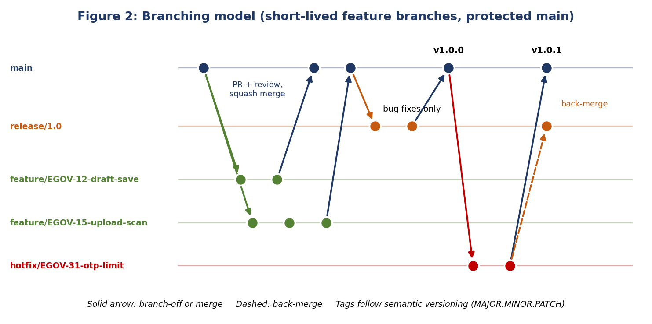
Branch | Created from | Rules
main | - | Always releasable; deployed to Test automatically; only changed by approved pull requests
feature/EGOV-nn-short-name | main | One ticket per branch; lives no longer than 3 days where possible; deleted after merge
bugfix/EGOV-nn-short-name | main | Non-urgent defect fix; same rules as feature
release/x.y | main | Created for stabilisation and UAT; only bug fixes allowed; tagged when released
hotfix/EGOV-nn-short-name | release tag or main | Urgent production fix; merged to main and back-merged to the release branch

Keep it small: Large, long-running branches cause painful merges and risky releases. Break work into slices that can be merged within 1-3 days. Incomplete features are hidden behind feature flags.

8.3 Commit Message Standard
Commit messages follow Conventional Commits: they make history readable, support automatic changelogs and tie every change to a ticket.
Format
<type>(<scope>): <short summary in imperative mood, max 72 chars>

<body: what and why, wrapped at 80 chars - optional>

Refs: EGOV-12
BREAKING CHANGE: <description - only when applicable>

Type | Use for
feat | New feature or user-visible behaviour
fix | Bug fix
docs | Documentation only
style | Formatting, no logic change
refactor | Code restructuring without behaviour change
test | Adding or correcting tests
perf | Performance improvement
build / ci | Build system, dependencies, pipeline
chore | Maintenance that does not fit above
security | Security fix or hardening

Examples
GOOD
feat(application): save draft automatically every 60 seconds
fix(document): reject files whose content type does not match extension
security(auth): limit OTP requests to 5 per hour per mobile number
refactor(notification): extract SmsGateway interface from provider class

BAD
update
fixed bug
changes for sprint 3 + more stuff

- One logical change per commit; do not mix formatting, refactoring and features.
- Commit early and often on your branch; the squash merge produces one clean message on main.
- Reference the ticket in every commit or in the PR title.

8.4 Pull Requests and Merging
- Open a pull request early (as Draft) for visibility; mark Ready when self-review and local tests are complete.
- A PR SHOULD be under 400 changed lines; larger changes are split. The title follows commit convention; the description uses the PR template (Appendix B).
- Merge method: squash merge into main for a linear, readable history; rebase your branch on main before merging to resolve conflicts locally.
- Never rewrite shared history (no force push to shared branches). Force-push is allowed only on your own feature branch before review starts.
- After merge: delete the branch, close the ticket, verify the pipeline on main.

8.5 Resolving Conflicts
Step | Action
1 | Update main locally: git fetch origin then git rebase origin/main on your branch
2 | Open each conflicted file; understand both changes; keep the intended combination (talk to the other author if unsure)
3 | Mark resolved with git add, continue with git rebase --continue
4 | Run the full tests and linters again before pushing
5 | Push with git push --force-with-lease (own branch only)

8.6 Releases, Tags and Versions
- Releases are tagged on the release commit with semantic versioning: MAJOR (breaking), MINOR (new compatible feature), PATCH (bug fix), e.g. v1.2.3.
- A release produces: signed tag, changelog generated from commits, container image tagged with the same version, SBOM, and release notes.
- Production deployments only use tagged, scanned images; the tag and ticket list form the audit trail for each release.

8.7 Everyday Git Commands
git clone <repo-url> # get the code
git switch -c feature/EGOV-12-draft-save # new branch from updated main
git status ; git diff # see what changed
git add -p # stage changes selectively
git commit -m "feat(application): save draft automatically"
git fetch origin && git rebase origin/main # stay up to date
git push -u origin feature/EGOV-12-draft-save
# open a pull request on the platform, address review comments, then squash merge
git switch main && git pull --ff-only # after merge
git branch -d feature/EGOV-12-draft-save # clean up

9. Documentation Practices
Documentation is treated as code: stored in Git, reviewed in pull requests, and updated in the same change as the code it describes.
Document | Content | Owner / location
README.md | What the service does, how to run, test and configure it, dependencies, contacts | Each repository root
API documentation | OpenAPI 3 specification generated from code and reviewed; examples for requests and errors | Service repository, published to API portal
Architecture Decision Records | Context, decision, alternatives and consequences for significant choices | /docs/adr in Git
Code comments / Javadoc / TSDoc | Public contracts and non-obvious reasoning (Section 4.4) | In source
Database data dictionary | Tables, columns, personal-data flag, retention period | /docs/data in Git
Runbook | How to deploy, monitor, back up, restore and handle common incidents | /docs/runbook
CHANGELOG / release notes | User-visible and technical changes per version | Generated at release
Test documentation | Test plan, test cases, coverage reports, accessibility results | QA folder / CI artifacts
User and admin guides | How citizens and staff use the portal (plain language) | Product documentation

9.1 README Template
# Application Service
One-paragraph purpose and the business capability it owns.

## Quick start (prerequisites, build, run locally, run tests)
## Configuration (environment variables table; no real secrets)
## API (link to OpenAPI file / Swagger UI)
## Architecture (diagram or link, dependencies, events published/consumed)
## Operations (health endpoint, logs, metrics, runbook link)
## Contributing (branching, commit and PR rules - link to this manual)
## Contacts (service owner, on-call, security contact)

9.2 Documentation Rules
- A pull request that changes behaviour, an API, configuration or a database table MUST update the related documentation (checked in the review checklist).
- Write in plain English, short sentences, active voice; define abbreviations on first use.
- Prefer diagrams for flows and structures (text-based such as Mermaid or PlantUML so they can be versioned).
- Do not document secrets or personal data; link to the vault entry or data dictionary instead.
- Review documentation at every release and delete or correct outdated pages; wrong documentation is worse than none.

10. Testing Standards

10.1 Test Strategy
Level | Share | Scope and tools
Unit tests | About 70% | One class or function in isolation; fast (milliseconds); JUnit 5, Mockito, AssertJ; Jest + React Testing Library
Integration tests | About 20% | Service with real database and broker in containers (Testcontainers); REST layer with Spring Boot Test; WireMock for external APIs
End-to-end / UI tests | About 10% | Critical journeys only (register, apply, upload, track, review, approve); Playwright or Cypress
Non-functional tests | Per release | Accessibility (axe-core + manual screen reader), performance (k6 / JMeter), security (DAST), failover and restore drills

10.2 Rules for Writing Tests
- Every new feature and every bug fix MUST include tests; a bug fix starts with a failing test that reproduces the bug (regression test).
- Follow Arrange - Act - Assert; one behaviour per test; test names state behaviour: submit_whenDocumentMissing_throwsValidationException.
- Tests MUST be independent, repeatable and order-free; no sharing of mutable state; no dependency on current date, random values or network (inject a Clock, fix seeds).
- Use synthetic test data builders; never use real citizen data.
- Test business rules and failure paths (invalid input, access denied, external service down), not only the happy path.
- Coverage targets: overall at least 70% (Week 2 target), at least 80% on new and changed code; business-rule and security classes aim for 90%. Coverage is a signal, not the goal - assertions must be meaningful.
- Flaky tests are defects: fix or quarantine within one day; do not re-run until green.
Example unit test
@Test
void submit_whenRequiredDocumentMissing_throwsValidationException() {
// Arrange
Application draft = ApplicationTestData.draftWithoutDocuments();
when(repository.findOwnedById(draft.getId(), USER_ID)).thenReturn(Optional.of(draft));

// Act + Assert
assertThatThrownBy(() -> service.submit(draft.getId(), USER_ID, "key-1"))
.isInstanceOf(ValidationException.class)
.hasMessageContaining("required document");
verify(repository, never()).save(any()); // nothing was persisted
}

11. Tools and Framework Recommendations
Tools are chosen to be open source or widely available, to run in a standard CI pipeline, and to support the Week 2 architecture. The tech lead approves additions.
Purpose | Recommended tools | Why / how used
IDE and editor | IntelliJ IDEA, VS Code, EditorConfig | Shared settings; inspections and refactoring support
Build and dependencies | Maven (or Gradle), npm with lock file, Dependabot / Renovate | Reproducible builds; automated dependency update PRs
Formatting | Spotless (Google Java Format), Prettier | Automatic, consistent style; no style debates
Linting / style checks | Checkstyle, PMD, ESLint (+ jsx-a11y plugin), TypeScript strict | Catches style, bug patterns and accessibility issues early
Static code analysis | SonarQube, SpotBugs, ArchUnit | Bugs, code smells, complexity, duplication, layer rules, quality gate
Security analysis (SAST/SCA) | SonarQube security rules or Semgrep, OWASP Dependency-Check, npm audit, Trivy | Detect vulnerable code and libraries before merge
Secret detection | Gitleaks, pre-commit hook | Stops keys and passwords entering Git
Unit and integration testing | JUnit 5, Mockito, AssertJ, Testcontainers, WireMock, Jest, React Testing Library | Fast, isolated tests plus realistic database and broker tests
End-to-end and accessibility | Playwright or Cypress, axe-core, Lighthouse, NVDA (manual) | Critical journey checks and WCAG 2.2 AA verification
Performance testing | k6 or Apache JMeter | Validate p95 latency and capacity targets
Coverage | JaCoCo, Istanbul / c8 | Coverage reports feeding the quality gate
Debugging and diagnosis | IDE debugger, Spring Boot Actuator, browser DevTools, React DevTools, OpenTelemetry + Jaeger, centralised logs (OpenSearch) | Local debugging; traces and logs by correlation ID in test environments. Remote debug ports MUST be closed in production
API design and testing | OpenAPI + Swagger UI, Postman or Bruno, contract tests | Single source of truth for APIs; shared collections in Git
Database | Flyway, DBeaver / pgAdmin (read-only on shared environments) | Versioned schema; safe inspection
CI/CD and containers | GitHub Actions or GitLab CI, Docker, Hadolint, Trivy image scan, Helm | Automated build, scan, deploy
Git automation | pre-commit or Husky + lint-staged, commitlint | Local checks before code leaves the laptop
Collaboration | Jira / GitHub Issues, wiki, team chat, CODEOWNERS | Ticket traceability, knowledge base, review routing

11.1 Local Developer Checks (pre-commit)
# .pre-commit-config.yaml (excerpt)
repos:
- repo: https://github.com/gitleaks/gitleaks
hooks: [ { id: gitleaks } ] # block secrets
- repo: local
hooks:
- id: spotless
name: Format Java
entry: mvn -q spotless:apply
language: system
- id: eslint
name: Lint TypeScript
entry: npx eslint --max-warnings 0
language: system
- repo: https://github.com/conventional-changelog/commitlint
hooks: [ { id: commitlint, stages: [commit-msg] } ] # enforce commit format

11.2 CI Pipeline Definition (excerpt)
# .github/workflows/ci.yml (excerpt)
on: { pull_request: { branches: [main] } }
jobs:
verify:
runs-on: ubuntu-latest
steps:
- uses: actions/checkout@v4
- uses: actions/setup-java@v4
with: { distribution: temurin, java-version: 17 }
- run: mvn -B verify # compile, unit + integration tests, JaCoCo
- run: mvn -B spotless:check checkstyle:check spotbugs:check
- run: mvn -B org.owasp:dependency-check-maven:check
- run: gitleaks detect --no-banner
- run: mvn -B sonar:sonar # quality gate must pass
- run: docker build -t app:${{ github.sha }} . && trivy image --exit-code 1 --severity CRITICAL,HIGH app:${{ github.sha }}

12. Quality Assurance and Enforcement

12.1 Code Review Process
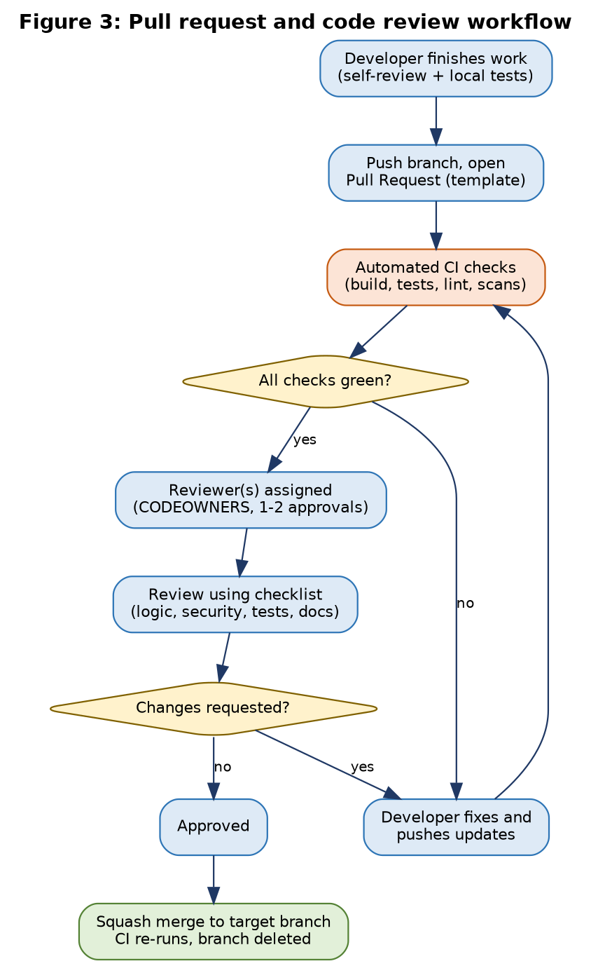
Item | Standard
Who reviews | At least one developer other than the author; two for security-sensitive code (authentication, authorisation, encryption, file upload, audit); CODEOWNERS routes reviews automatically
When | Only after CI is green; reviewers respond within 1 working day; authors reply to comments within 1 working day
Size | PRs under 400 changed lines are reviewed in one sitting (about 60 minutes at most); larger PRs are split
Comment labels | blocker (must fix), suggestion (should consider), nit (minor, optional), question (clarification)
Approval | Approve only when all blockers are resolved and the checklist (Appendix C) is satisfied; the author never approves own PR
Disagreements | Discuss in the PR or a short call; if unresolved the tech lead decides and, for design questions, records an ADR

12.2 Reviewer and Author Etiquette
- Review the code, not the person: ask questions ("What happens if the list is empty?") instead of issuing orders.
- Explain the reason behind a request and link to this manual or official documentation.
- Praise good solutions - reviews are also a learning tool for juniors.
- Authors: keep PRs focused, explain context and test evidence, accept feedback professionally, do not take comments personally.

12.3 Continuous Integration and Automated Enforcement
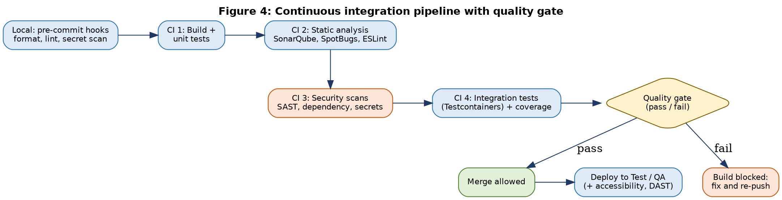
Rules that a tool can check are enforced by tools; reviewers concentrate on design, correctness and security that tools cannot judge.
Rule | Automated by | Human review adds
Formatting and style | Spotless, Prettier, Checkstyle, ESLint | Nothing - do not comment on style
Commit message format | commitlint hook and PR title check | Meaningful description
Bugs, smells, complexity, duplication | SonarQube, SpotBugs, PMD | Whether design is sensible
Vulnerable dependencies, secrets, images | Dependency-Check, npm audit, Gitleaks, Trivy | Whether a new dependency is justified
Test pass and coverage | JUnit/Jest, JaCoCo, quality gate | Whether tests are meaningful
Layer and structure rules | ArchUnit tests | Cohesion and naming
Accessibility basics | axe-core, jsx-a11y | Keyboard and screen-reader usability
Business correctness, security logic | - | Required: logic, ownership checks, error paths

12.4 Quality Gate Thresholds
Metric | Threshold (new code) | Overall target
Unit + integration test coverage | 80% or higher | 70% or higher
New critical or blocker issues | 0 | 0
New vulnerabilities (SAST/SCA, high or critical) | 0 | 0 open at release
Duplicated lines | 3% or lower | 5% or lower
Maintainability / reliability / security rating | A | A or B
Cyclomatic complexity per method | 10 or lower | -
Open security hotspots | All reviewed | All reviewed
Build must pass on | Every pull request and on main | -

12.5 Definition of Done
A ticket is Done only when all of the following are true:
- Code implemented to the acceptance criteria and follows this manual; no TODOs without a ticket.
- Unit and integration tests added and passing; coverage and quality gate satisfied.
- Peer review approved; all blockers resolved; pull request squash-merged.
- Security checklist applied; no new high/critical findings; no secrets or personal data in code or logs.
- Accessibility and localisation checked for any UI change.
- Documentation updated (README, OpenAPI, ADR, data dictionary, changelog as relevant).
- Deployed to Test, smoke-tested, and accepted by the product owner or QA.

12.6 Quality Metrics Reviewed Monthly
Metric | Target | Purpose
PR review turnaround | 1 working day or less | Keeps work flowing
PR size (median) | Under 400 lines | Reviewability
Build success on main | 95% or higher | Pipeline health
Defects found after release | Trend downward | Effectiveness of testing and review
Mean time to fix critical vulnerability | Within agreed SLA (e.g. 7 days) | Security responsiveness
Flaky test count | 0 unresolved over 1 day | Test reliability

13. Collaborative Development Practices

13.1 Day-to-Day Workflow
Step | Practice
1 | Pick a ticket from the sprint board; confirm acceptance criteria and ask questions before starting (Definition of Ready)
2 | Create a branch named after the ticket; write a failing test or sketch the design
3 | Implement in small commits; run formatter, tests and linters locally
4 | Open a Draft PR early; request feedback on design if unsure
5 | Complete self-review using the checklist; mark Ready; respond to review comments
6 | Squash merge; verify pipeline and Test deployment; update the ticket and documentation

13.2 Team Practices
- Daily stand-up (15 minutes): what I finished, what I will do, what blocks me. Raise blockers early.
- Pair programming for complex or security-sensitive work and for onboarding junior developers; rotate pairs.
- Code ownership: CODEOWNERS file names the owners of each module; owners guard design consistency but do not block others unnecessarily.
- Shared knowledge: weekly short tech talks, wiki updates after solving a hard problem, recorded demos of new features.
- Retrospective each sprint: pick one process improvement and update this manual if a rule needs to change.
- Communication: discuss design and problems in the ticket or PR so decisions are recorded; use chat for quick questions only.
- Respectful, inclusive working culture: clear, kind language; ask for help without hesitation; no blame for honest mistakes - fix the process.

13.3 Onboarding Path for Junior Developers
Period | Goals
Day 1 | Access to repositories and tools; read Sections 2-4 and Appendix A; clone, build and run the service locally
Week 1 | Complete a small starter ticket (documentation or minor bug) with a mentor; first pull request through full review
Weeks 2-4 | Implement a small feature with tests; practise code review on others' PRs; learn security checklist and logging rules
Month 2 | Own a small module; present a short tech talk; propose one improvement to this manual

13.4 Handling Exceptions to the Standards
If a rule blocks a legitimate need, raise it in the PR with the reason, the risk and an alternative. The tech lead may approve a documented exception (comment with ticket, e.g. a suppression annotation with justification). Repeated exceptions signal that the rule itself should be revisited.

13.5 Maintaining This Manual
- The manual lives in Git (/docs/coding-standards.md or this document) and changes by pull request; the tech lead approves.
- Reviewed every quarter and after major incidents or audit findings; version number and change log kept at the front.
- Any developer may propose a change; accepted changes are announced to the team.

14. Conclusion
These standards give the e-governance project a shared, practical definition of quality: clean and secure code, a modular structure that supports growth, disciplined Git workflow, and automated plus human checks that every change must pass. Following them reduces defects and security risk, speeds up onboarding, and keeps the portal maintainable and auditable for years - which is what citizens and the department expect from a public digital service.
Next steps:
- Set up repositories with templates (README, PR template, CODEOWNERS, .editorconfig, branch protection).
- Configure the CI pipeline and SonarQube quality gate with the thresholds in Section 12.4.
- Run a short walkthrough of this manual with the team and collect feedback for version 1.1.
- Start implementation with the Identity and Application services, applying the standards from the first commit.

Appendix A: One-Page Cheat Sheet
Topic | Remember
Names | Meaningful English; classes PascalCase, methods/variables camelCase, constants UPPER_SNAKE, tables snake_case
Functions | Do one thing, under 30 lines, up to 4 parameters, early return, no magic numbers
Layers | Controller -> Service -> Repository -> Domain; never skip or go upwards; entities never leave the service
Comments | Explain WHY and public contracts; delete commented-out code; TODO(EGOV-nn)
Errors | Specific exceptions, no empty catch, one global handler, standard JSON error, no internals to users
Logs | Structured, correlation ID, no personal data or secrets, right level
Security | Validate input, parameterised queries, check role AND ownership, no secrets in Git, scan uploads
Git | Branch from main, feature/EGOV-nn-name, small commits, Conventional Commits, rebase, PR, squash merge
Tests | Test every feature and bug fix, AAA, 80% on new code, synthetic data only
Review | CI green first, checklist, label comments (blocker / suggestion / nit), reply within 1 day
Docs | README, OpenAPI, ADR, data dictionary updated in the same PR
Never | Commit secrets, push to main, force-push shared branches, log personal data, merge with red CI

Appendix B: Pull Request Template
## Summary
What does this change do and why? Link ticket: EGOV-___

## Type of change
[ ] feat [ ] fix [ ] refactor [ ] docs [ ] security [ ] build/ci

## How was it tested?
Unit / integration / manual steps and results (screenshots for UI changes)

## Checklist
[ ] Follows coding standards; formatter and linters pass
[ ] Tests added or updated; coverage on new code is 80% or higher
[ ] No secrets, personal data or sensitive values in code, logs or test data
[ ] Input validation, role and ownership checks reviewed
[ ] Accessibility and i18n checked (UI changes)
[ ] Documentation updated (README / OpenAPI / ADR / data dictionary)
[ ] Database migration is backward compatible (if applicable)

## Notes for reviewers
Areas of risk, design choices, follow-up tickets

Appendix C: Code Review Checklist
Area | Questions the reviewer asks
Correctness | Does it meet the acceptance criteria? Are edge cases (empty, null, maximum, duplicate, concurrent) handled?
Design | Is the code in the right layer and module? Any duplication or unnecessary complexity? Can it be simpler?
Readability | Are names clear? Are functions small? Do comments explain why? Any dead code or magic values?
Security | Input validated? Parameterised queries? Role and ownership checked? Secrets safe? Upload rules followed? Logs free of personal data?
Error handling | Specific exceptions? Failures handled gracefully? Standard error response? Timeouts and retries on external calls?
Tests | Do tests cover success and failure paths? Are they readable and independent? Would they fail if the code broke?
Performance | N+1 queries? Missing pagination or index? Heavy work on the request thread?
Data and migrations | Backward-compatible migration? Personal-data fields identified? Constraints named?
Accessibility and i18n | Labels, keyboard use, contrast, text from i18n bundle?
Documentation | README, OpenAPI, ADR and changelog updated? Commit and PR title follow the convention?

Appendix D: Glossary
Term | Meaning
ADR | Architecture Decision Record - short note explaining a significant design decision
CI / CD | Continuous Integration / Continuous Delivery - automated build, test and deployment pipeline
Conventional Commits | Commit message format with type, scope and summary
DTO | Data Transfer Object - simple object used to carry data across API boundaries
DRY / KISS / YAGNI | Do not repeat yourself / keep it simple / you are not going to need it
Idempotency | Repeating an operation gives the same result without duplicate effect
Linter | Tool that checks code for style problems and likely bugs
OWASP | Open Worldwide Application Security Project - publisher of the Top 10 web risks
PR / MR | Pull Request / Merge Request - proposal to merge a branch, with review
SAST / SCA / DAST | Static code scanning / dependency scanning / running-application scanning
SBOM | Software Bill of Materials - list of components and versions in a release
Semantic versioning | MAJOR.MINOR.PATCH version numbering
Squash merge | Combines all branch commits into one commit on the target branch
Technical debt | Extra future work created by shortcuts in code or design

Appendix E: References
- Week 1 - Requirement Analysis and Planning, and Week 2 - System Architecture and Design (this project).
- Robert C. Martin, Clean Code; Martin Fowler, Refactoring; Steve McConnell, Code Complete.
- Google Java Style Guide; Conventional Commits specification; Semantic Versioning 2.0.0.
- OWASP Top 10 (2021), OWASP ASVS, OWASP Cheat Sheet Series; RFC 7807 Problem Details for HTTP APIs.
- W3C WCAG 2.2; Guidelines for Indian Government Websites and Apps (GIGW 3.0).
- Digital Personal Data Protection Act, 2023; CERT-In Directions (April 2022).
- Official documentation for Spring Boot, React, PostgreSQL, Git, SonarQube and the tools listed in Section 11.

Document Review Checklist
Check | Status | Section
Coding standards: naming, formatting, file organisation, commenting | Complete | 4
Importance of clean code, documentation, version control | Complete | 3, 9
Modularity, code structure, error handling | Complete | 5, 6
Secure coding and e-governance specific rules | Complete | 7
Git branching, merging, commit messages | Complete | 8
Testing, tools and framework recommendations | Complete | 10, 11
Code review and CI-based enforcement | Complete | 12
Collaboration practices and onboarding | Complete | 13
Practical templates and cheat sheet | Complete | Appendices A-C

