**BIS 698 - INFORMATION SYSTEMS PROJECT**

Classroom code: 22448438

Professor: Shankari Ghosh

Group Project Proposal Document for

**HOTEL MANAGEMENT SYSTEM**

**Group 05**

Rama Surya Sai Kiran, Gundu

Likitha Kannemadugureddivari

Manikanta Reddy Ailuri

Thirupathi Rao Bojedla

Anusha Yarlagadda

Submission Date: 01/29/2023

**Objective:**

The objective of this project is to develop a centralized system to manage various operations of a hotel, including booking, check-in, check-out, room management, billing, and reporting for hotel staff, keeping it user-friendly and accessible.

**Company Background:**

Organization Name: Chippewa Hotel

A hotel in Mount Pleasant that provides accommodations for both locals and tourists. They only use pen and paper for their booking, check-in, and check-out registers, and all their operations are manual. Businesses must adopt intelligent information technology to become cognitive, as it is difficult to maintain a business using conventional ways. For information security and privacy as well as to gather business insights, a centralized information system is intended to take the place of the pen and paper system.

Building a centralized information system for booking, check-in, check-out, room management, billing, and reporting is the goal of the project. Moreover, to view business data analytically to extract insights that support business decision-making.

**Description:**

A GUI is created using the Python programming language and its tkinter package, to communicate with the SQLite3 database, which contains all the information regarding booking details, customers, employees, rooms, and other information. To establish how the database will be, an entity relationship diagram using Lucid Chart is created. Additionally, a data flow diagram is developed to demonstrate the data flow in the information system. Lastly, a connection will be made between the database and the tableau software to enable data visualization and analytics for the purpose of gaining business insights.

**Scope:**

The system will be GUI based and accessible from a computer with an internet connection. The following functionalities will be included:

Room booking: Employees can book rooms for customers, view availability and make payments.

Room management: The system will keep track of room status (available, occupied, maintenance), assign rooms, and update room information.

Check-in/Check-out: The system will handle check-in and check-out processes and generate bills.

Billing: The system will generate bills for room charges, additional services, and taxes.

Reporting: The system will generate reports on room occupancy, revenue, and guest details.

**Technologies:**

The following technologies will be used for the development of the system:

Front-end development: PyCharm, Python language, GUI development library (Tkinter)

Database management system: SQLite3

Design tool: Lucid chart

Design techniques: ERD, DFD.

**Expected Outcomes:**

* Improved operational efficiency by automating manual processes.
* Increased guest satisfaction through a convenient and streamlined booking process.
* Improved decision-making through real-time access to occupancy, revenue, and guest data by analytical viewpoint.

**Deliverables:**

* A fully functional GUI based hotel management information system.
* User manual and documentation.
* Training for the hotel staff to use the system.

**Pre-visualization of screens:**

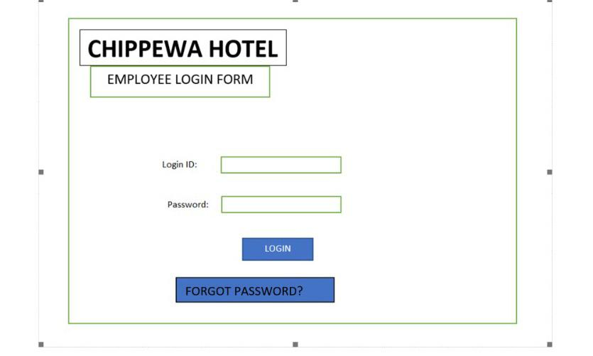

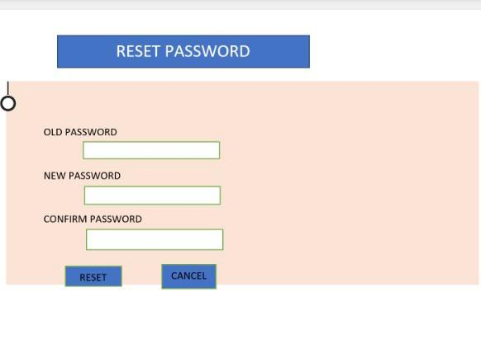

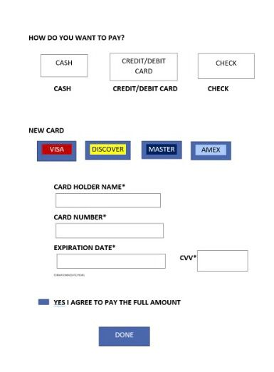

*This document is the first draft of group 5’s project discussion and their proposal. There may be changes in future, with approval of project guide (Professor Shankari Ghosh).*