1. DataSet is as given below:

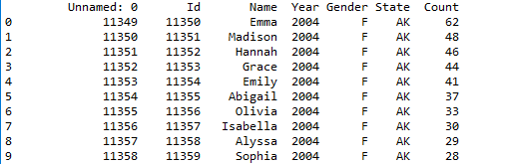

1. Delete unnamed column

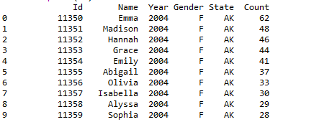

1. Show the distribution of male and female

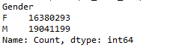

1. Show the top 5 most preferred names

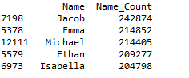

1. What is the median name occurrence in the dataset



1. Distribution of male and female born count by states

