- Getting Started
  - Typescript
Static Typing – Interfaces – Class Properties – Public/Private Accessibility
  - Conceptual Overview
App Module - Routes - Component Hierarchy - Parent and Child components
Angular Modules – Services
  - Angular-cli
Angular.json, package.json
  - Bootstrap
Webpack loads main.ts via angular.json -> app.module.ts -> index.html –> app.component.ts
  - AppModule
@NgModule – declarations – imports – providers – bootstrap
  - angular.js file – pull static assets - scripts and styles section

- Create and communicate between Angular Components
  - Templates and Data Binding
Inline Templates – Javascript String Literals – template property - Interpolation using {{expr}} - External Templates (templateUrl)
  - Communicate parent to child component - @Input decorator and binding with [property]=”property” – from parent to child.
  - Communicate child to parent component - @Output decorator and raising EventEmitter.emit(<value>) to parent – (onEvent)=”handleOnEvent($event)” in parent.
  - Access a child component with Template Variables - #childName – use (click)=”childName.foo()” - <h3>{{childName.someProperty}}</h3>
  - Styling components – styles[] – styleUrls[] – CSS Encapsulation - styles localized by default in angular – scoped to the component – mix global styles also – deep selector to change the child styles from the parent style.

- Angular Template Syntax
  - Interpolation and expressions
Interpolation – {{<expr>}} –
Property Binding - [<prop>] – Expression Restrictions – not Allowed(Assignments, new keyword, expr chaining, global ns) – Expression Recommendation – No Side Effects, Fast, Simple, Idempotent (same result every time)
  - Event Bindings with (eventname)=”<func>()”
  - ngFor – structural directive like <div *ngFor=”let event of events”/>
  - Handling null values – with ? operator (safe navigation operator) – like event?.name
  - *ngIf directive – like <div *ngIf=”event?.location”> - removed from DOM
  - [hidden]=”!event?.isMobileOnly” – present but hidden in the DOM – can bind to any DOM property with [<prop>] syntax
  - ngSwitch – like [ngSwitch]="event?.time" with *ngSwitchCase="'8:00 am'" with *ngSwitchDefault
  - ngClass directive like [class.lightred]="event?.time=='8:00 am'" – multiple classes like [ngClass]="{lightgreen: event?.time=='9:00 am', fontitalic: event?.time=='9:00 am'}" – can also call a method like [ngClass]=”getElementClass()” – getElementClass() can return as return ‘lightgreen fontitalic’ or return [‘lightgreen’, ‘fontitalic’] based on a condition - can also combine normal class with ngClass like <div class=”well” [ngClass]=”getElementClass()”>
  - ngStyle class works similarly – [style.color]=”event?.time == 8:00 pm ? ‘blue’:’green’” - or [ngStyle] = “{‘color’: event?.time=='9:00 am' ? ’green’ : ’blue’ }” – or a method like getElementStyle() - but must return an object like return {color: 'blue', 'font-weight': 'bold'}; - ngStyle also works side by side with the normal style attribute of an element.

- Creating Reusable Angular Services
  - Dependency Injection – create a normal class – decorate with @Injectable() – specify the provider in the component/module – inject in constructor(private eventService: EventService).
  - Services can encapsulate third party plugins – like toastr – for this update angular.js and provide wrapper methods around the service – inject into the component as usual.

- Routing and Navigating Pages
  - Server side page loads and Single Page application page loads
  - Adding the first route - <router-outlet> element – appRoutes definition as { path: 'events/:id', component: EventsListComponent } – pathMatch (full or pre (starts-with)) – RouterModule.forRoot(appRoutes) inside imports property of ng-module – telling angular what its routes are relative to with <base href=”/”/> - specify route parameter as ‘events/:id’
  - Access Route Params - First inject in constructor as route: ActivatedRoute – then access as this.route.snapshot.params[‘id’]
  - Linking to routes – specify as [routerLink]="['/events',event.id]" for a <div>, <a> element etc.
  - Navigating from code – Import the Router from “@angular/Router”, inject it in the constructor and call this.router.navigate(['events']);
  - Route Guards – To Prevent a user from navigating to a page unless validated using certain criteria – for this - Create simple 404 component – create a new service (or a function also will do) (with @Injectable()) that implements CanActivate Interface (from @angular/router) – the method canActivate() is injected with ActivatedRouteSnapshot object – here based on condition we can navigate to 404 and return a Boolean (indicating true or false for canActivate) – plugin to the ngModule under [providers] - finally specify in routes as:
{ path: 'events/:id', component: EventDetailsComponent, canActivate: [EventRouteActivatorService] },
  - Route Deactivation Guards – To prevent a user from navigating away from a route (like without saving data the user navigates away) - We can use a service similar to above – but we can also use a function with a long handle notation – we can provide this in the ngModule [providers] as - {provide: 'canDeactivateCreateEventService',useValue: checkDirtyState} - and specify the route definition as { path: 'events/new', component: CreateEventComponent, canDeactivate: ['canDeactivateCreateEventService']} – note that checkDirtyState() can automatically take as parameter the component on whom the route is defined here CreateEventComponent.
  - Resolver Guards: We can gracefully retrieve data (especially AJAX call data) with resolvers – for this – specify the resolve property in route definition as - { path: 'events', component: EventsListComponent, resolve: {events: EventDataResolver} } – (what this line tells is ‘before you do the routing to this path ensure that you resolve the data with the help of the EventDataResolver and then only route to the EventsListComponent’; the resolved data is available in the activatedRoute’s data property) -
now create a new injectable() service EventDataResolver (implements Resolve<any> ) and pipe the xhr data as
resolve() {return this.eventDataService.getEvents().pipe(map(events => events));} - wire it up in the ng-module and access the resolved data through the activatedRoute snapshot (on ngOnInit) as this.events = this.activatedRoute.snapshot.data['events'];
  - Styling active links – Use routerLinkActive="active" and [routerLinkActiveOptions]="{exact:true}" to the element (a, div etc) to which [routeLink] directive is attached.
  - LazyLoading modules – create module with imports as CommonModule instead of BrowserModule and use RouterModule.forChild(userProfileRoutes) in the imports – In the main appRoutes use { path: 'user', loadChildren: './user/user.module#UserModule' } or
{ path: 'jobs', loadChildren: () => import('./modules/jobs/jobs.module').then(m => m.JobsModule) } in Angular 8

- Collecting data with forms and validation
  - Models for type safety – strongly type models as interfaces – use prop?:type (like age?:number) for nullable fields.
  - Template based forms – all the form logic is in the html template – advantage – it is simple for simple use cases – disadvantage – as use case gets complex more logic gets added and you cannot unit test the validation logic in a template based form.

Appendix
Completed Practice Exercises
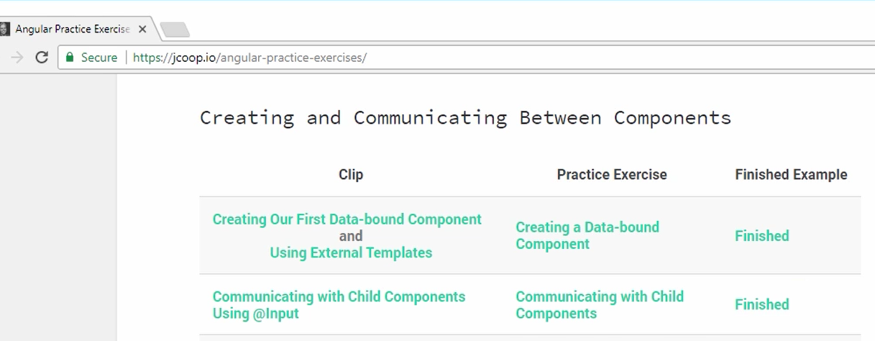
Support files
