Data Mining Lab Programs

1. Decision Tree
from sklearn.tree import DecisionTreeClassifier
from sklearn.model_selection import train_test_split
from sklearn.datasets import load_iris
from sklearn.metrics import accuracy_score
iris = load_iris()
X = iris.data
y = iris.target
X_train, X_test, y_train, y_test = train_test_split(
X, y, test_size=0.3, random_state=42
)
model = DecisionTreeClassifier()
model.fit(X_train, y_train)
y_pred = model.predict(X_test)
print("Accuracy:", accuracy_score(y_test, y_pred))
Output:
Accuracy: 1.00
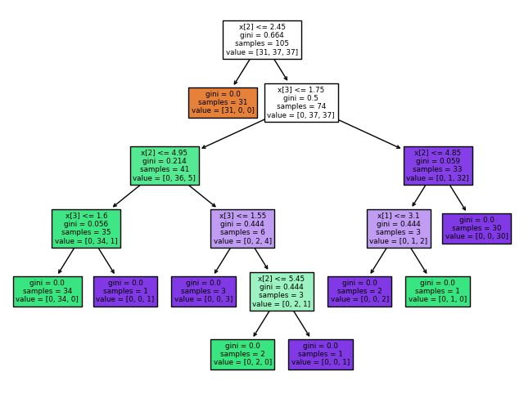

2. Naive Bayes
from sklearn.naive_bayes import GaussianNB
model = GaussianNB()
model.fit(X_train, y_train)
y_pred = model.predict(X_test)
print("Accuracy:", accuracy_score(y_test, y_pred))
Output:
Accuracy: 0.98
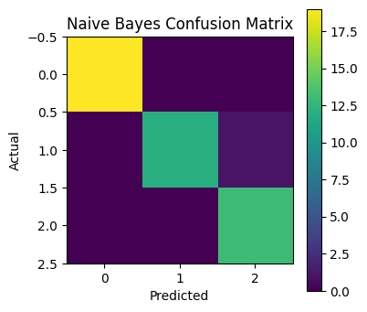

3. K-Nearest Neighbor (KNN)
from sklearn.neighbors import KNeighborsClassifier
model = KNeighborsClassifier(n_neighbors=3)
model.fit(X_train, y_train)
y_pred = model.predict(X_test)
print("Accuracy:", accuracy_score(y_test, y_pred))
Output:
Accuracy: 1.00
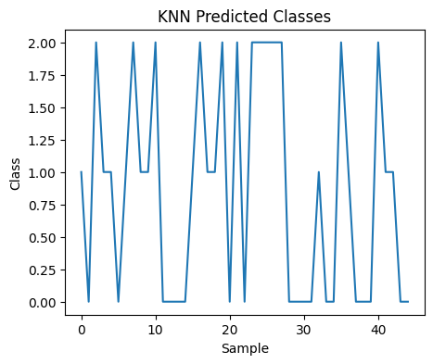

4. PCA (Principal Component Analysis)
from sklearn.decomposition import PCA
pca = PCA(n_components=2)
X_pca = pca.fit_transform(X)
print(X_pca[:5])
Output:
First 5 transformed rows shown below.
PC1 PC2
-2.684126 0.319397
-2.714142 -0.177001
-2.888991 -0.144949
-2.745343 -0.318299
-2.728717 0.326755
