2026 2nd International Conference on Ambient Intelligence, Knowledge Informatics and Industrial Electronics (AIKIIE)

TOMATOCARE: AN INTELLIGENT DEEP LEARNING–BASED SYSTEM FOR TOMATO MATURITY CLASSIFICATION

Tejaswini Raj B
Department of CSE (AIML) Vidyavardhaka College of Engineering Mysuru, India vvce22cseaiml0049@vvce.ac.in

Sinchana S
Department of CSE (AIML) Vidyavardhaka College of Engineering Mysuru, India vvce22cseaiml0050@vvce.ac.in

Vidhul S
Department of CSE (AIML) Vidyavardhaka College of Engineering Mysuru, India vvce22cseaiml0129@vvce.ac.in

Lakshmishree A G
Department of CSE (AIML) Vidyavardhaka College of Engineering Mysuru, India vvce22cseaiml0138@vvce.ac.in

Prof. Vijay C.P
Department of CSE (AIML) Vidyavardhaka College of Engineering Mysuru, India
vijay.cp@vvce.ac.in

Abstract—TomatoCare is a deep learning–based intelligent sys-tem designed for the automatic classification of tomato maturity stages using computer vision and transfer learning techniques. Traditional tomato maturity assessment relies heavily on man-ual visual inspection, which is subjective, labor-intensive, and highly inconsistent under varying illumination and environmental conditions. These limitations become more severe in large-scale farming, post-harvest processing units, and supply-chain envi-ronments. To overcome these challenges, TomatoCare employs multiple pre-trained convolutional neural network (CNN) archi-tectures to analyze tomato images and classify them into distinct maturity stages. In this study, four transfer learning models
- MobileNetV2, ResNet50, EfficientNetB0, and DenseNet121 - were comparatively evaluated to understand their suitability for tomato maturity classification. The system assigns each tomato image to one of five ripening stages - Green, Breaker, Turning, Pink, or Red - based on visible changes in color distribution and surface texture. To improve generalization and reduce overfitting, data augmentation techniques were incorpo-rated during training. The experimental results indicate that ResNet50 achieved the highest classification accuracy of 93.63%, outperforming DenseNet121 (89.48%), EfficientNetB0 (79.41%), and MobileNetV2 (58.52%). The experimental results indicate that TomatoCare provides a reliable and scalable approach that can be effectively applied in practical agricultural and post-harvest grading environments.
Index Terms—Tomato ripeness detection, transfer learning, deep neural networks, CNNs.

  - Introduction
Tomatoes rank among the most extensively grown and economically vital horticultural crops globally. The harvest maturity level directly influences fruit quality, storage dura-tion, shipping suitability, and commercial worth. Thus, pre-cise ripeness evaluation proves vital for farming, post-harvest processing, and distribution networks. Conventional methods rely on human visual checks of skin color and texture. Yet,
these suffer from subjectivity, lengthy processes, and errors stemming from individual differences and factors like illu-mination or surroundings [2]. Progress in image processing and neural networks has spurred automated tools for produce evaluation. CNNs excel at extracting key visual traits from raw images. Prior research has used deep learning for tomato ripeness identification [1]–[4], but most treat it as broad categories—immature, partially ripe, or fully ripe. Such sim-plifications ease computation but overlook nuanced ripening phases like Breaker, Turning, and Pink, which share similar appearances.
Many studies emphasize detection models like YOLO for spotting fruits amid cluttered fields [1], [5]–[7], [10], [11], [15], [18]. While suited for localization, they add processing demands and design intricacy, hindering use on limited devices such as smartphones or edge agriculture setups [4], [8]. To overcome these issues, we introduce TomatoCare, a smart CNN framework for detailed tomato ripeness categorization. Unlike conventional approaches, the proposed system focuses on distinguishing five biologically meaningful ripening stages: Green, Breaker, Turning, Pink, and Red. The system is de-signed as a simplified classification pipeline that avoids unnec-essary detection complexity while maintaining high predictive performance. Additionally, a systematic comparative analysis of multiple pre-trained CNN architectures, including Mo-bileNetV2, ResNet50, EfficientNetB0, and DenseNet121, is conducted under uniform experimental conditions to evaluate their effectiveness in capturing subtle visual variations across maturity stages.
A. Contributions
The main contributions of this work are summarized as follows:

979-8-3195-4167-3/26/$31.00 ©2026 IEEE

- A Specialized Low-Complexity Framework: We in-troduce a streamlined, single-task classification pipeline that bypasses the computational overhead and localized bounding-box regressions typical of multi-stage object detection models (e.g., YOLO variants). This design choice minimizes processing latency and memory foot-prints, making it highly optimal for edge-device deploy-ment without sacrificing predictive fidelity.
- Granular Intermediate Stage Discrimination: Unlike conventional systems that rely on coarse-grained group-ings, this framework isolates five biologically distinct ripening phases (Green, Breaker, Turning, Pink, and Red). It specifically optimizes the feature space to resolve high-interclass similarity among transitional stages like Breaker, Turning, and Pink.
- Systematic Deep Learning Benchmarking: We present a unified, highly controlled experimental framework that directly isolates and evaluates architectural impacts. By maintaining uniform preprocessing pipelines and a standardized classification head across MobileNetV2, ResNet50, EfficientNetB0, and DenseNet121, we provide empirical clarity on the trade-offs between gradient-propagation depth and real-time edge viability.
  - Related Work
M. Lumoring, S. K. David, and R. R. Kumar [9] proposed a tomato maturity classification approach combining YOLOv4 for fruit detection with a statistical color model for ripeness estimation. N. Begum and M. K. Hazarika [2] investigated tomato maturity detection using transfer learning and evalu-ated pre-trained CNN architectures. H. S. Mputu, A. Abdel-Mawgoud, A. Shimada, and M. S. Sayed [3] proposed a tomato quality classification framework based on transfer learning fea-ture extraction and traditional machine learning classifiers. M. Waseem, M. M. Sajjad, L. H. Naqvi, Y. Majeed, T. U. Rehman, and T. Nadeem [4] developed a deep learning model for pre-cise and rapid tomato maturity prediction using an optimized ResNet-18 architecture with pruning and quantization. H. Wei and H. Li [7] enhanced YOLOv8s by integrating a Squeeze-and-Excitation (SE) attention mechanism for improved tomato maturity detection.
M. Hossain, M. M. Pritom, and A. A. S. Khan [10] presented a YOLOv5-based decision-fusion framework for au-tomated tomato harvesting, integrating maturity detection and peduncle localization. Two specialized models, YOLOv5mu and YOLOv5su, were employed for maturity classification and peduncle detection respectively. H. Wei and H. Li [11] developed an improved tomato maturity detection system by enhancing the YOLOv8s model with an SE attention Mechanism. L. Luo, H. Zhang, and Y. Chen [12] proposed an integrated tomato harvesting system combining maturity detection and shelf-life prediction. Faster RCNN was used for maturity identification, while AlexNet predicted remaining shelf life from post-harvest images.
C.-A. Pai and H.-Y. Lin [13] introduced a tomato maturity and yield estimation system combining RGB and multispectral
imaging. YOLOv8 with OSNet was used for detection, while StrongSORT enabled fruit tracking across frames. P. Arya, K.
Y. Anand, S. Ram, and V. Singh [14] developed a computer vision-based tomato quality evaluation system using VGG16 with transfer learning to classify maturity stages and detect diseases. G. J. Angeles, V. A. N. Buenventura, D. J. Oguing, L.
A. Canada, and A. Rosales [15] implemented a YOLO-based automated tomato sorting system integrated with a robotic arm.
A. Bhardwaj, D. Gupta, and P. Kumari [1] proposed a CNN-based tomato maturity grading system trained on RGB images classified into green, yellow, and red stages.
A. Widiyanto, D. P. U. Wicaksono, and H. Widodo [16] ap-plied Faster R-CNN for tomato maturity detection using RGB images in greenhouse environments. S. Baar, Y. Kobayashi, T. Horie, K. Sato, and S. Watanabe [17] monitored 286 tomatoes in a 4-Hectare commercial greenhouse over 40 days, acquiring RGB images every three days, with manual measurements of ripeness and diameter. X. Qian and H. Seong [18] developed YOLO-ASFF, an improved YOLOv5s variant for detecting tomatoes with variable maturity stages in complicated orchard environments.
A. Recent Advances in Advanced Sensing, Transformers, and XAI
The technological frontier in smart agriculture has recently moved beyond standard spatial convolutions. Vision Trans-formers (ViTs) and shifted-window self-attention mechanisms are increasingly utilized to establish long-range contextual associations across the fruit epidermis, resolving localized color limits in basic CNN designs. Concurrently, multimodal structures and hyperspectral platforms have expanded beyond visible skin spectra. By capturing narrow band arrays across the near-infrared spectrum, these systems isolate internal physicochemical properties—such as soluble solids content (SSC) and chlorophyll breakdown indices—allowing classi-fication when surface colors are visually indistinguishable.
However, deep neural architectures present an inner com-plexity that functions as an opaque black box. To bridge this, Explainable AI (XAI) models like Gradient-weighted Class Activation Mapping (Grad-CAM) are being incorporated into agricultural vision tasks. These modules map specific decision drivers to spatial coordinates, verifying that the network is analyzing true pigment distributions rather than background artifacts.
  - Research Gaps
Despite significant advancements in tomato maturity de-tection using deep learning and computer vision techniques, several critical limitations persist in existing studies, particu-larly when transitioning from controlled experimental setups to practical agricultural environments.
- Existing research largely employs coarse ripeness cate-gories (e.g., immature, partial, mature), ignoring detailed progression in transitional phases like Breaker, Turning, and Pink. These subtle, overlapping visual traits demand

accurate detection for harvesting timing, shelf-life fore-casting, and supply grading.
- Many approaches use detection models such as YOLO variants, built for fruit spotting in field clutter. While effective there, they add unneeded computational load and complexity for classification-only tasks, limiting edge devices and mobile farm applications.
- Few studies offer standardized comparisons of neural architectures. Isolated optimizations hinder insights into trade-offs in accuracy, efficiency, and robustness, neces-sitating a unified evaluation framework.
- High-quality datasets for fine-grained classification are scarce, often skimping on intermediate stages or using controlled setups that weaken real-field performance. Datasets capturing all subtle variations are thus essential.
  - Proposed System
The TomatoCare framework targets tomato maturity clas-sification exclusively, excluding unrelated tasks such as fruit detection or yield prediction. This single-task focus preserves architectural simplicity and delivers reliable results in practical farming settings. It employs a clear workflow: image prepro-cessing first, then feature extraction via pre-trained models, and finally classification with output predictions. Every step supports robust training and steady performance.
- System Overview
The workflow of the TomatoCare maturity detection system consists of the following major stages:
  - Image Acquisition
  - Dataset Preparation and Organization
  - Image Preprocessing
  - Deep Learning–Based Tomato Maturity Classification
  - Prediction and Visualization Interface
- Dataset Description
- Tomato Maturity Dataset: The TomatoCare system uti-lizes a custom-curated tomato maturity dataset designed for fine-grained classification of ripening stages. The dataset consists of RGB images categorized into five maturity classes—Green, Breaker, Turning, Pink, and Red. Fig. 1(a–e) illustrates the five tomato maturity stages, where (a) Green,
- Breaker, (c) Turning, (d) Pink, and (e) Red.
The dataset came together from various sources to guarantee variety and practical value. We collected a total of 683 images with a DSLR camera for top-quality resolution, plus some from HD smartphone cameras and reliable online sources. We filtered internet images strictly to fit the set maturity stages. This blend of origins brings in differences in light, clarity, and angles, which builds the model’s strength and wide ap-plicability. Our team manually sorted all images into maturity stages by checking surface color spread, using standard farm guidelines. Images from our collection got labeled right away, and outside ones went through careful review. We focused extra on stages like Breaker, Turning, and Pink for steady labeling. The dataset shows picked tomatoes alone, without
leaves or stems around. This lets the model zero in on the fruit’s own traits like color and feel, cutting out background noise. The approach fits our goal of straight classification, not detection, which simplifies training and sharpens key features. While this setup lifts performance, we plan to adapt it later for tougher field settings with real backgrounds.
The dataset is categorized into five classes with the follow-ing distribution:
  - Green: 170 images
  - Breaker: 140 images
  - Turning: 181 images
  - Pink: 180 images
  - Red: 263 images
This results in a total of 934 original images. The dataset ex-hibits class imbalance, with fewer samples in the Breaker class and a higher representation in the Red class. To address this imbalance and improve model performance, data augmentation techniques were applied during training. After augmentation, each class was expanded to 900 images, resulting in a balanced dataset of 4500 images. Class balancing through augmentation ensures that the model does not become biased toward majority classes. The dataset was split into 70% training, 15% valida-tion, and 15% testing sets. The training set is used for learning model parameters, the validation set supports hyperparameter tuning and overfitting detection, and the test set is reserved for final performance assessment. Although the dataset cap-tures diverse conditions, further expansion with additional geographical variations, tomato varieties, and environmental conditions can enhance generalization and scalability.
- Data Augmentation: With a moderately sized dataset, augmentation methods were used in training to boost general-ization and curb overfitting. Techniques like random rotations, horizontal flips and zooming mimic diverse field settings. They train the model to prioritize essential visual cues over rote image memorization. For rigorous assessment, the dataset splits into training, validation, and test portions. Training tunes the model weights, validation tracks progress mid-training, and testing gauges final results. Class-balanced folders structure each subset for seamless loading via deep learning tools.

- Preprocessing Pipeline and Hyperparameter Tuning
Prior to tensor ingestion, raw matrices are normalized and scaled using fixed hyperparameters to guarantee reproducibil-ity. Every input image is resized using a bilinear interpolation algorithm to a uniform spatial dimension of 224 × 224 pixels to match model input requirements. Channel-wise global pixel normalization scales initial intensity bounds to stable floats based on ImageNet channel configurations.
Let I_{raw} be the incoming original image state matrix. The spatial resolution resizing mapping function is mathematically defined as:

$I_{\text{resized }}=T_{\text{bilinear }}\left(I_{\text{raw }},224×224\right)$ (1)

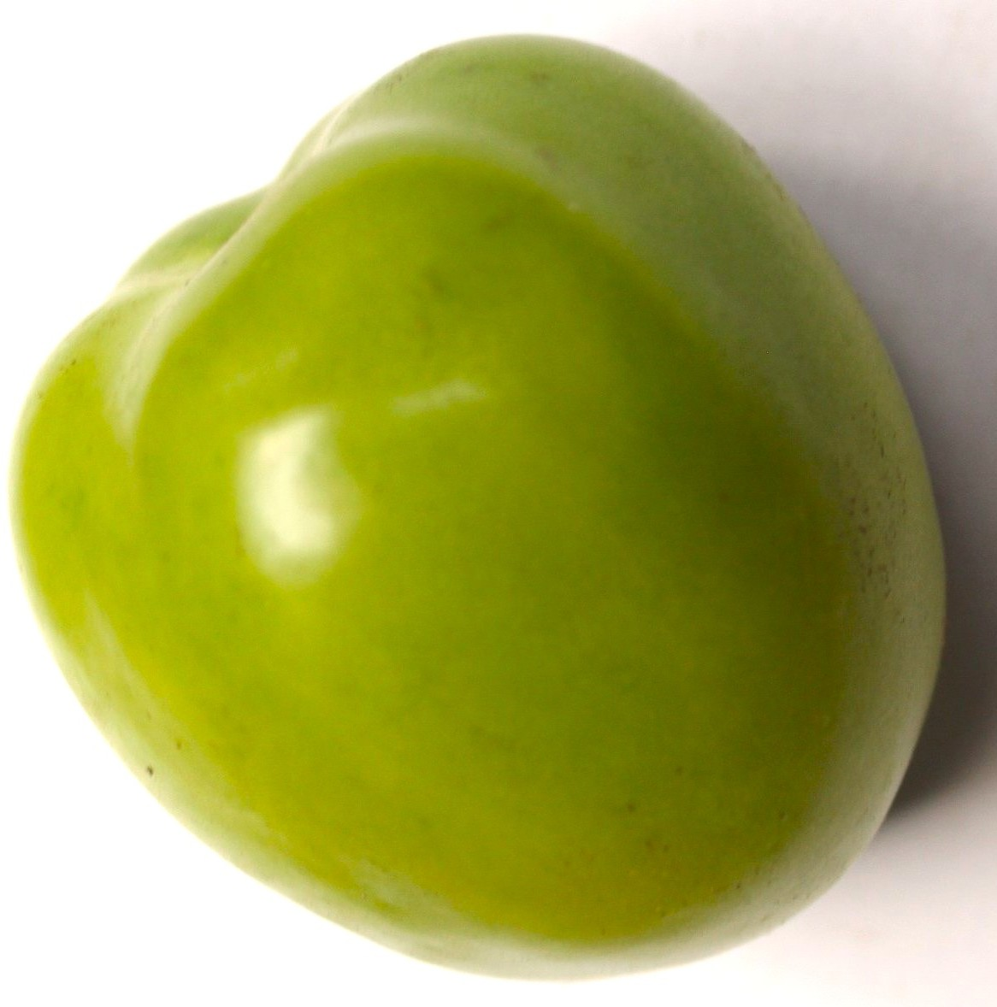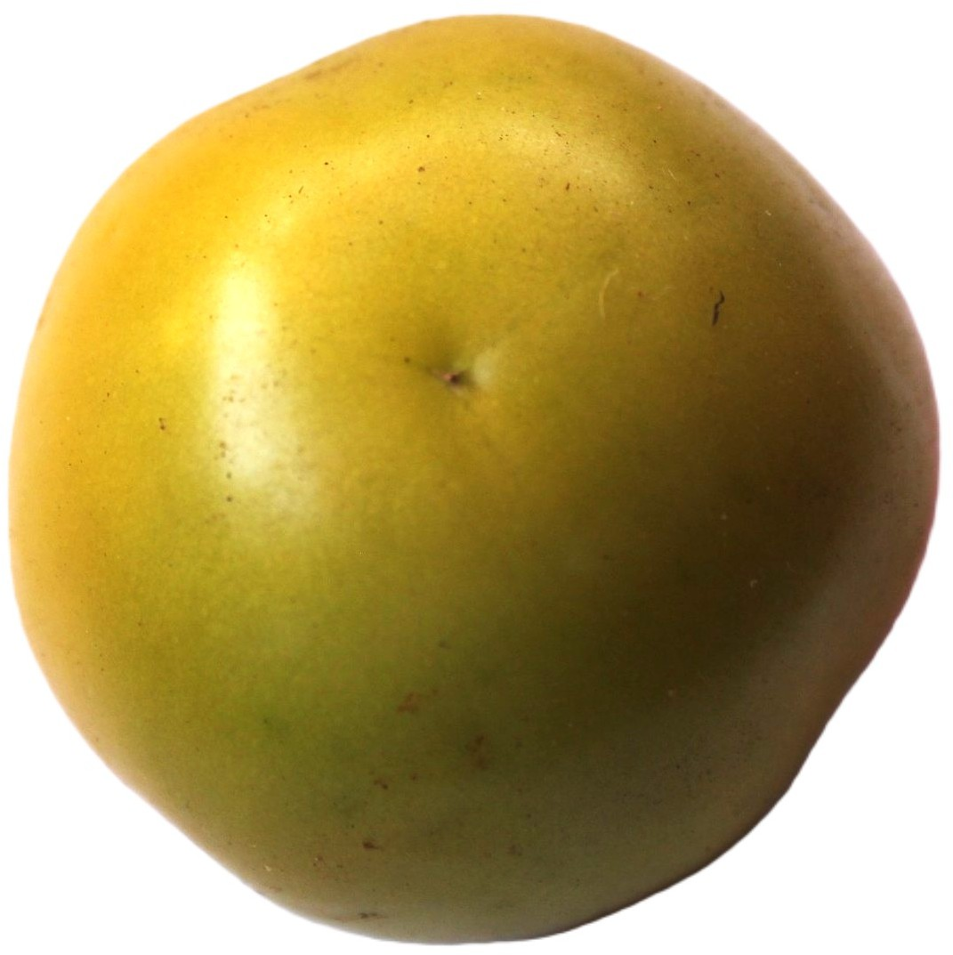
(a) Green (b) Breaker
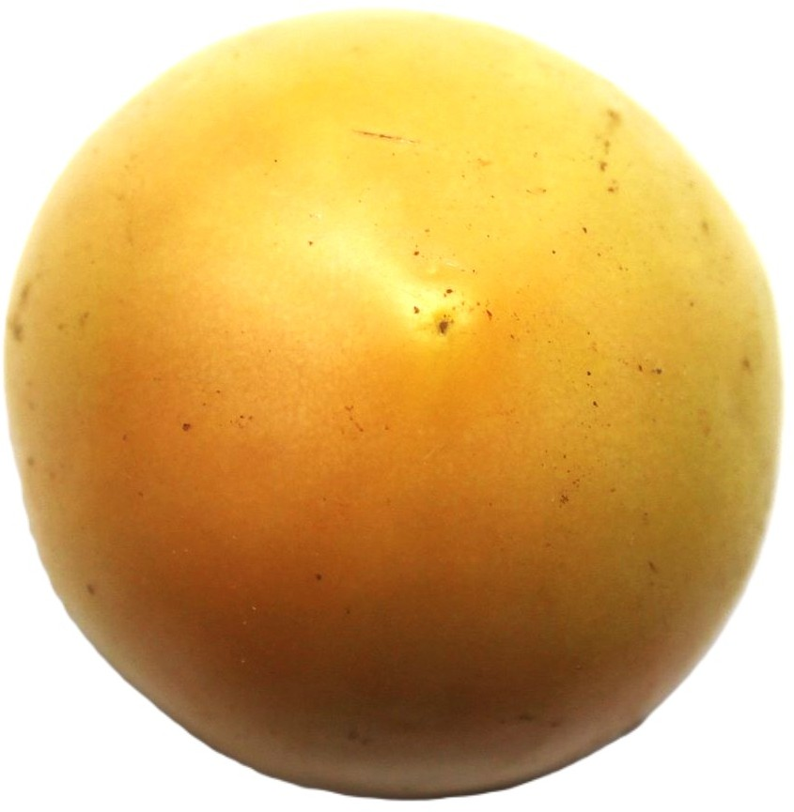
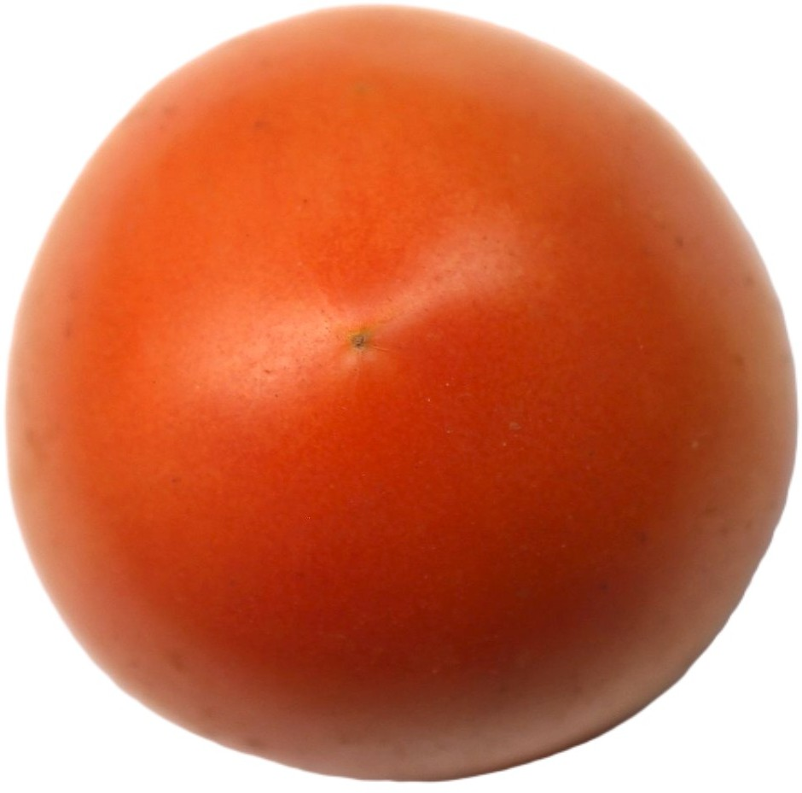
- Turning (d) Pink
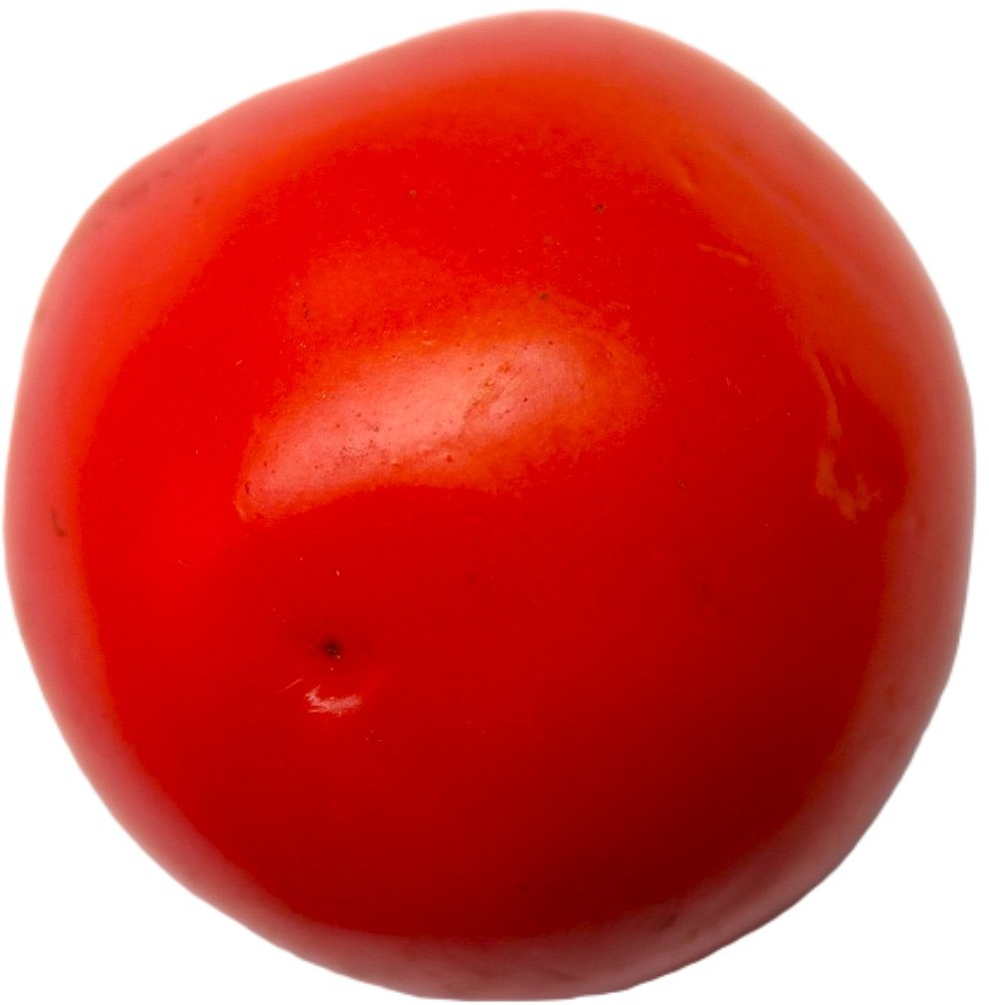
(e) Red
Fig. 1: (a–e) illustrates the five tomato maturity stages: Green, Breaker, Turning, Pink, and Red.

The vector feature input tensor x fed into the network architec-ture is regularized by channel parameters µ and σ as follows:

TABLE I: Maturity Description

Stage Images Description

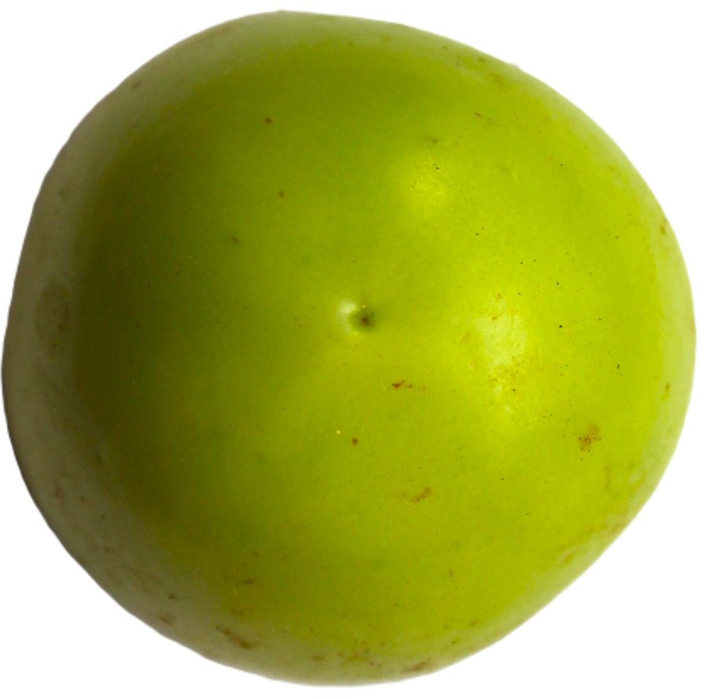
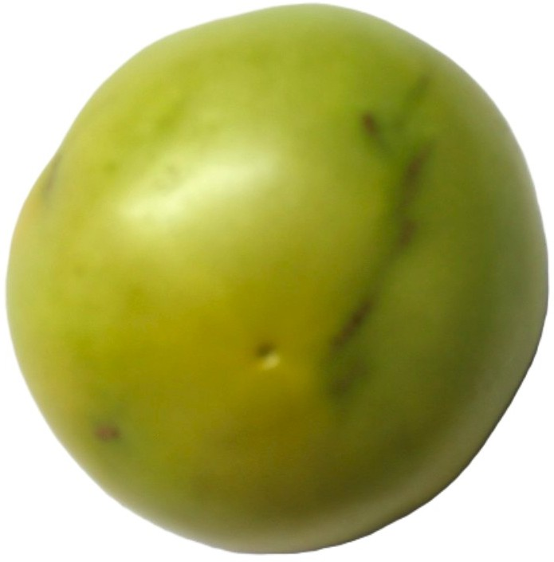
Green Fruit surface is
completely green.
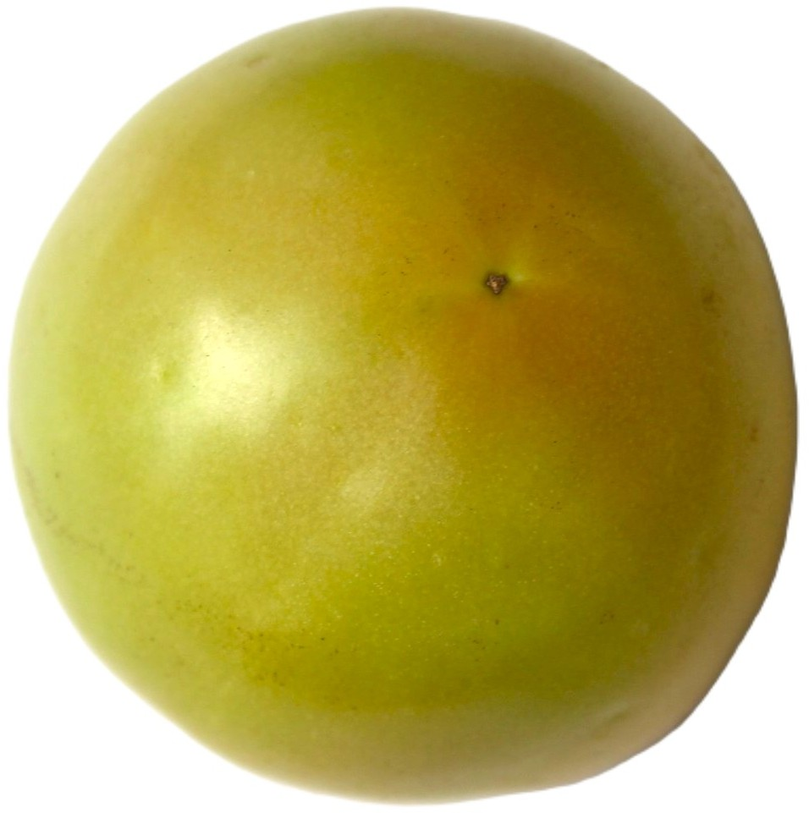
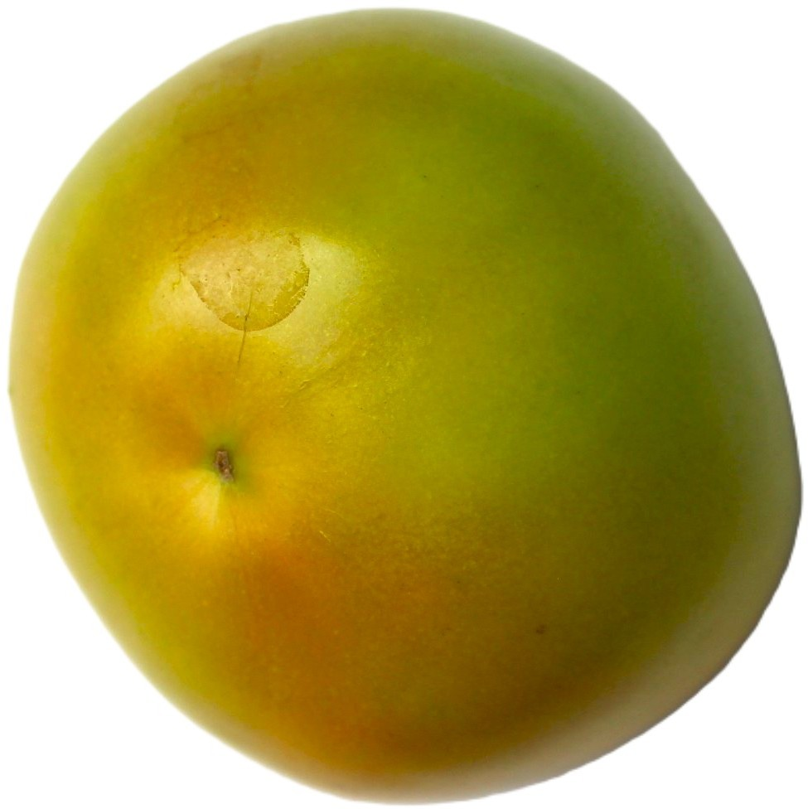
Breaker Clear color shift from green to tannish-yellow, pink, or red covers no more than 10% of the
surface.
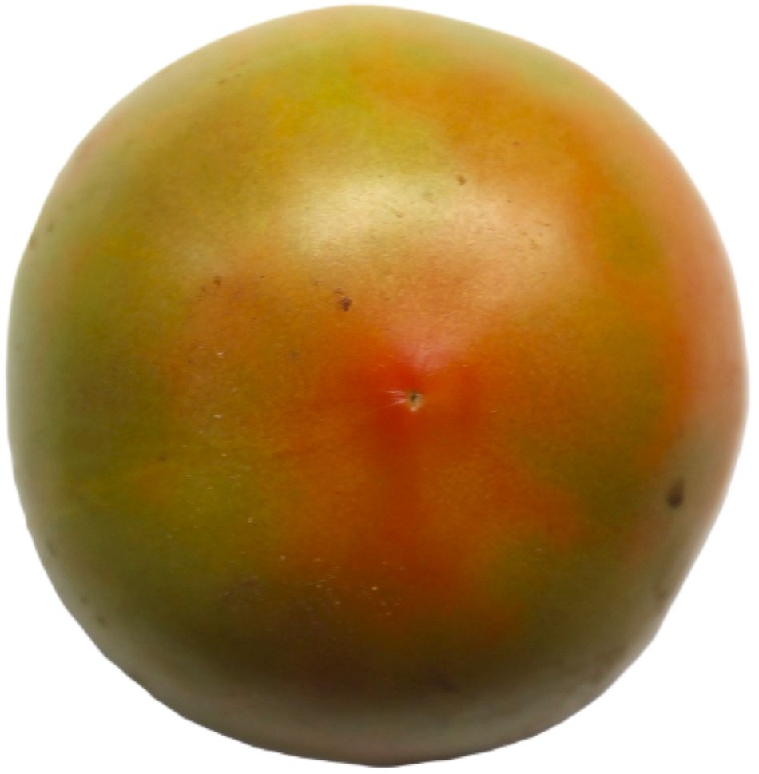
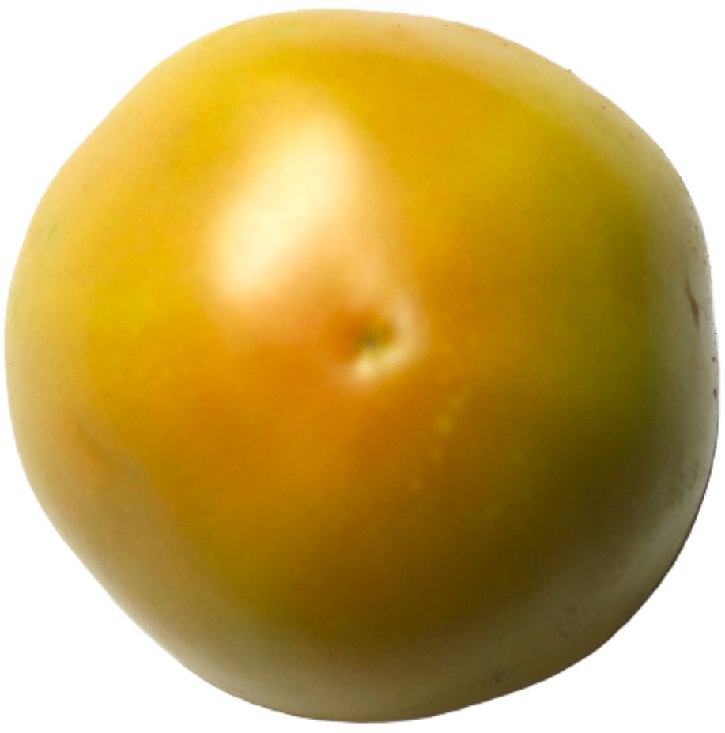
Turning 10% to 30% of the
surface shows non-green
color.
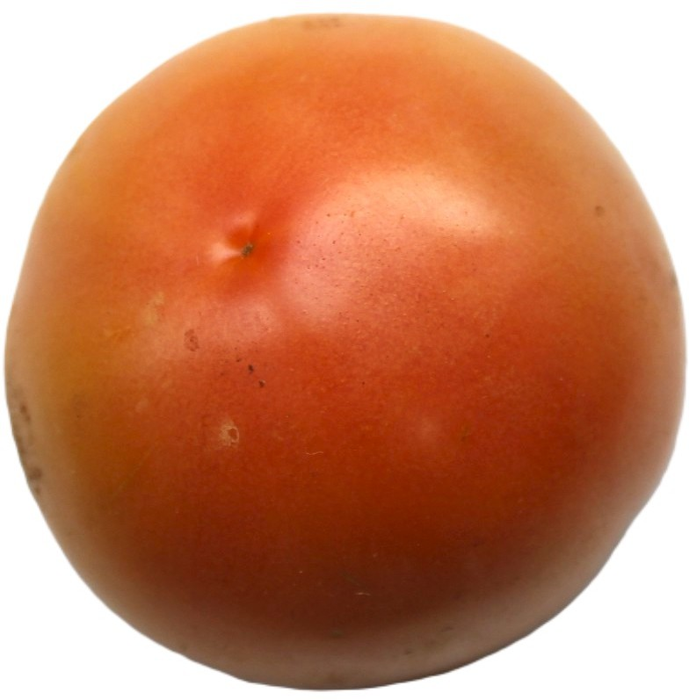
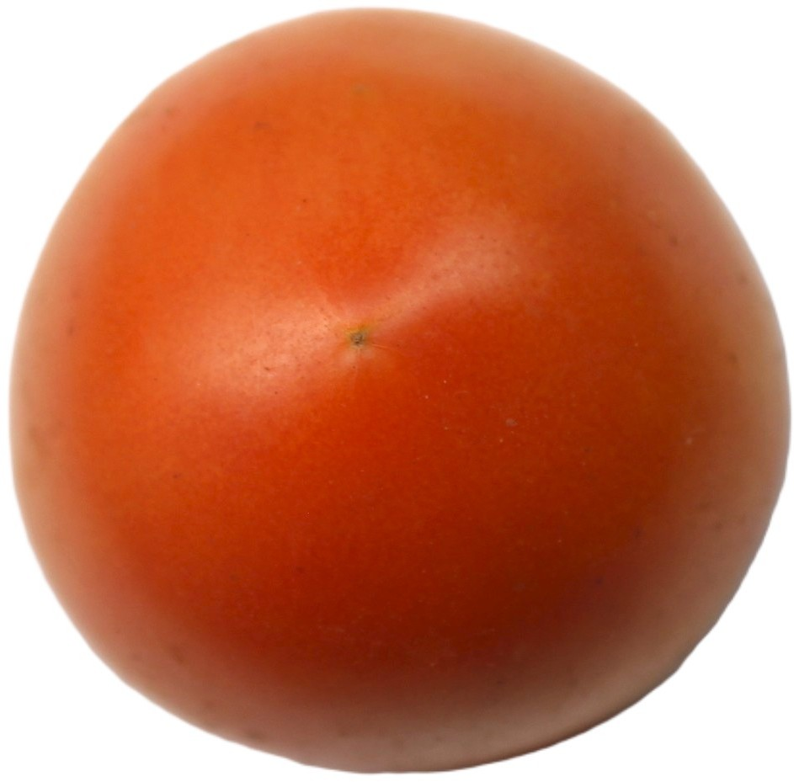
Pink 30% to 60% of the
surface appears non-green.

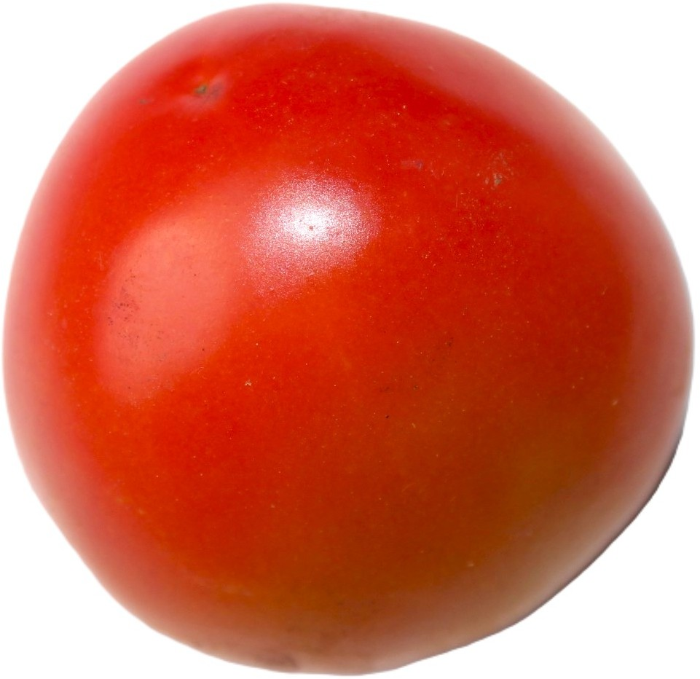
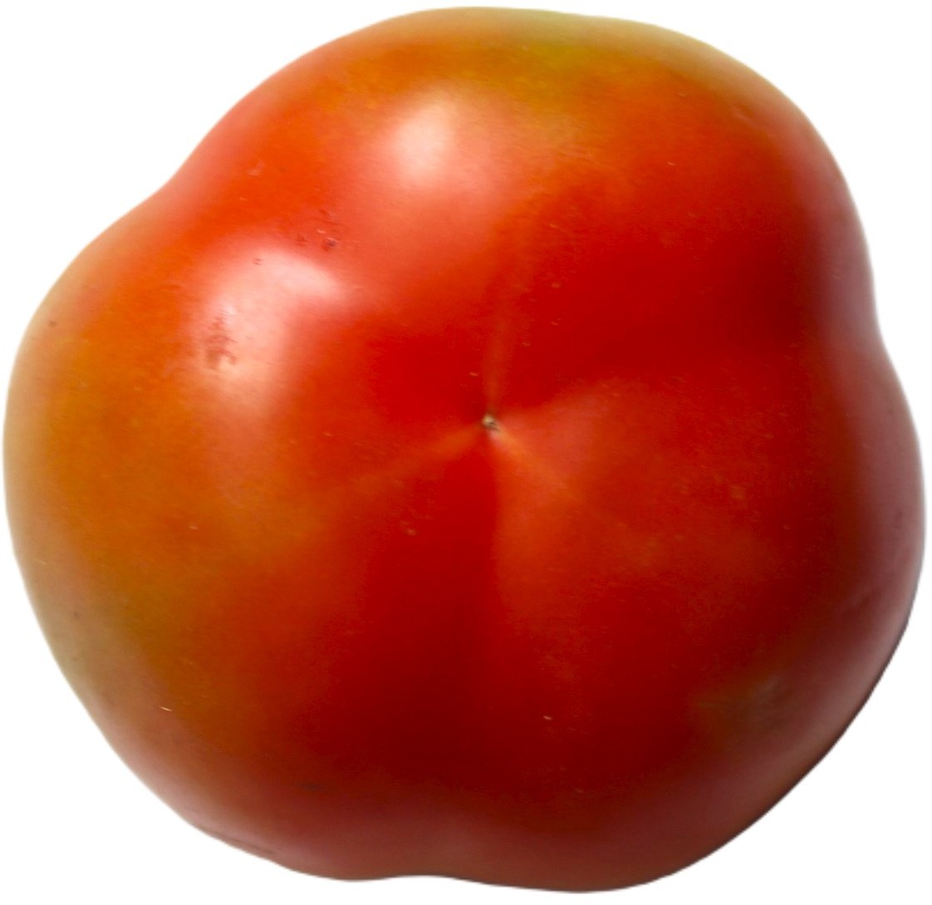
Red Over 80% of the surface
displays non-green
coloration.

- Methodology
The system processes an input image through multiple computational stages to predict the corresponding maturity level. Table I shows the maturity description of each class.
The maturity classification pipeline is the core processing unit of the TomatoCare system, responsible for transform-ing raw tomato images into accurate maturity stage predic-tions. The pipeline is designed as a sequential and mod-ular framework that ensures robustness, generalization, and computational efficiency. Each stage of the pipeline plays a specific role in extracting discriminative visual features asso-ciated with tomato ripening. To assess architecture impacts,

$x=\frac{\left(\frac{I_{\text{resized }}}{255}\right)-μ_{\text{ImageNet }}}{σ_{\text{ImageNet }}}$
(2)
four established pre-trained CNNs were tested: MobileNetV2, ResNet50, EfficientNetB0, and DenseNet121. Selection re-

The custom dense classification head links a Global Average Pooling (GAP) layer directly to a fully connected dense layer containing 256 internal units equipped with Rectified Linear Unit (ReLU) activation functions. To enforce spatial parameter regularization and minimize over-parameterization, a Dropout block is set at a constant rate of 0.4. The operational conditional target probabilities for fine-grained multi-class label output assignments are computed via a 5-way Softmax transformation layer:

$P\left(y=c∣x\right)=\frac{e^{w_{c}^{T}x+b_{c}}}{\sum_{j=1}^{5}{e^{w_{i}^{T}x+b_{j}}}}$ (3)
flects their varied balances of depth, efficiency, and feature power. All models used uniform conditions and the same classification head for fair, direct comparisons.
- Prediction and Visualization Interface
Post-training, the system outputs a tomato image’s maturity stage plus confidence. A user-friendly interface supports image uploads or path inputs for instant evaluation. Lightweight designs allow real-time predictions, supporting on-site use in farms, markets, and grading stations.

  - E
XPERIMENTS AND
Results

The experimental evaluation was conducted to assess the

Optimization parameters are optimized with a standard Adam optimizer routine configured against a categorical cross-entropy loss tracking objective function L across N elements:
accuracy, consistency, and overall robustness of the proposed deep learning-based maturity classification framework. Mul-tiple architectures were tested under identical conditions to ensure a fair and meaningful comparison of their performance.

$L=-\sum_{i=1}^{N}{\sum_{c=1}^{5}{y_{i,c}}}\log\left(P\left(y=c∣x_{i}\right)\right)$ (4)

- Experimental Setup
The experimental study was carried out using an augmented tomato maturity dataset covering five ripening stages: Green,

Breaker, Turning, Pink, and Red. For fair and robust eval-uation, the dataset divides into training, validation, and test sets. Training optimizes model parameters, validation detects overfitting and refines hyperparameters, and testing delivers unbiased final metrics.

- Evaluation Metrics
TomatoCare performance draws on diverse metrics for full insight. In multi-class settings, accuracy alone falls short, so class-specific measures supplement it.
  - Class-Wise Performance Evaluation: Table II and Fig. 2 provide deeper insights into per-class prediction confidence across the five maturity stages: Green, Breaker, Turning, Pink, and Red.
TABLE II: Class-wise confidence (%) of different models

Images | 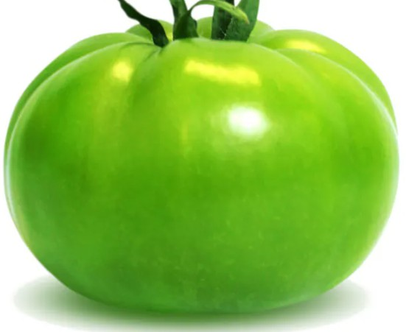 | 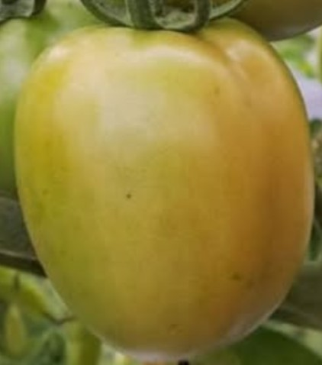 | 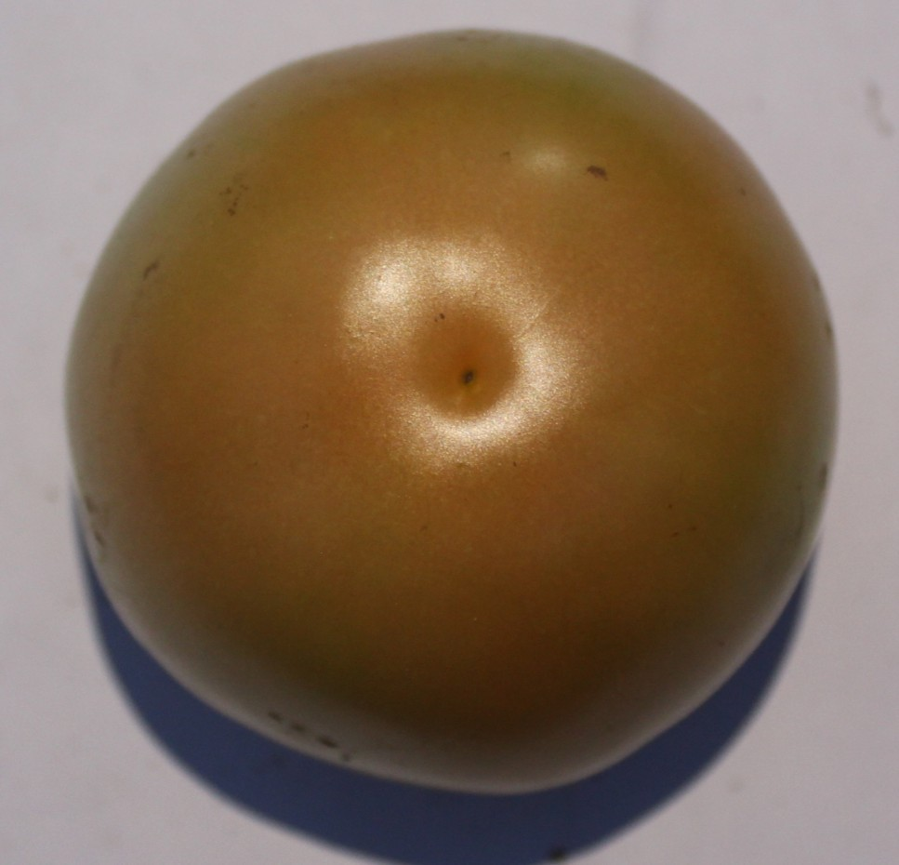 | 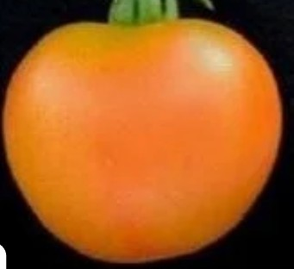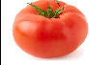
Actual Class | Green | Breaker | Turning | Pink | Red
MobileNetV2 | Green (99.95%) | Breaker (93.73%) | Pink (59.15%) | Turning (59.69%) | Red (97.66%)
DenseNet121 | Green (99.3%) | Breaker (49.74%) | Turning (69.3%) | Turning (59.69%) | Red (87.37%)
EfficientNetB0 | Green (99.3%) | Breaker (49.74%) | Turning (69.3%) | Breaker (46.27%) | Red (87.37%)
ResNet50 | Green (100.00%) | Breaker (83.01%) | Turning (99.84%) | Pink (74.14%) | Red (97.99%)

A detailed examination of class-wise confidence reveals important observations for each individual maturity stage:
    - Green Stage: All models showed very high confidence when classifying the Green stage, often exceeding 99%. High performance across models is anticipated, given the uniform green hue and negligible red pigmentation in unripe tomatoes.
    - Breaker Stage: Ripening begins here with initial yellow or orange patches emerging amid dominant green. Mod-els generally succeeded, though with modestly reduced confidence, reflecting potential overlap with Green and Turning phases that can cause minor misclassifications.
    - Turning Stage: Green, yellow, and pale orange colors spread more broadly, creating smoother transitions than in Breaker. The lack of sharp boundaries with Pink ele-vates difficulty, especially for compact models, however, demonstrated superior confidence by adeptly modeling these fine color gradients.
    - Pink Stage: Pink hues prevail as green recedes, signaling late ripening, yet proximity to Turning and Red creates ongoing transitional ambiguity. This demands nuanced color discernment, where ResNet50 sustained top con-fidence through effective capture of progressive shifts.
    - Red Stage: Every model, led by near-flawless ResNet50, exhibited peak confidence for fully ripe, vividly uniform red tomatoes. Their stark distinction from prior stages streamlines recognition, bolstering the system’s overall accuracy.
The confidence comparison graph (Fig. 2) clearly demon-strates that ResNet50 consistently produces the highest con-fidence values across all maturity stages, suggesting strong internal feature representation and robust class separation.

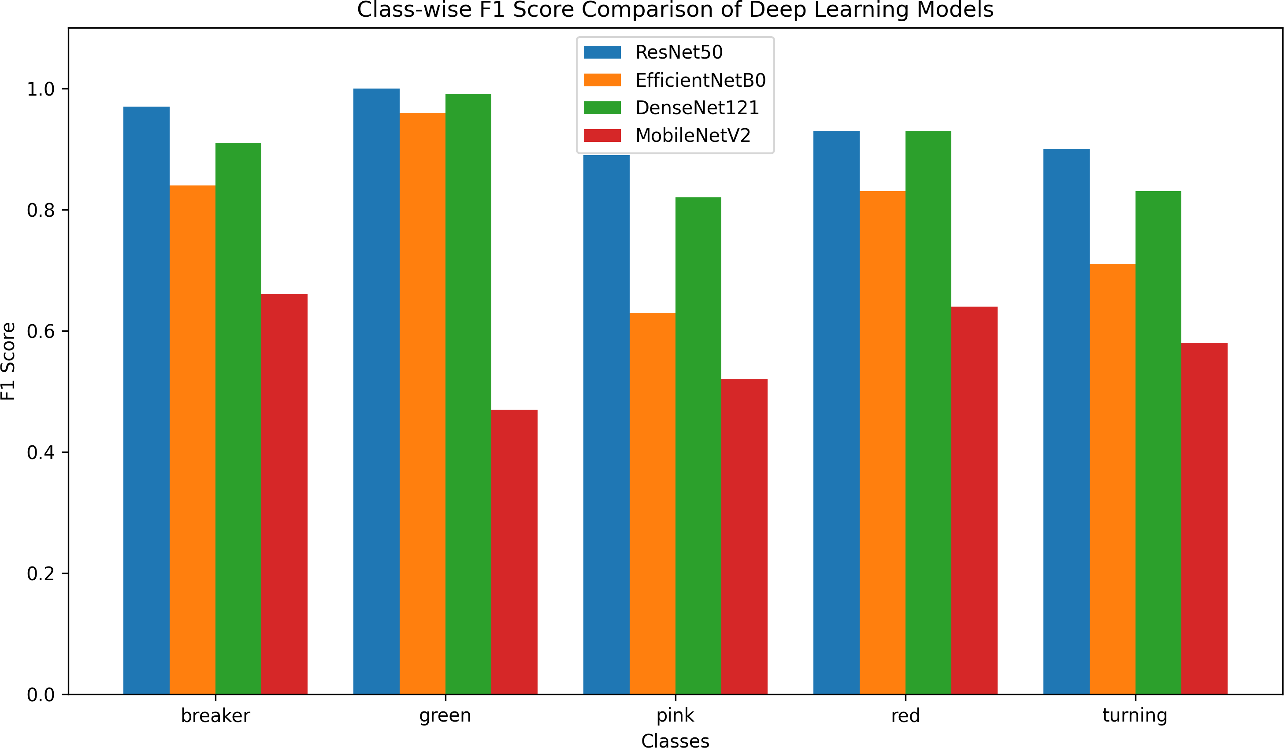

Fig. 2: Comparison of class-wise F1-scores for MobileNetV2, EfficientNetB0, DenseNet121, and ResNet50 across the five tomato maturity stages.
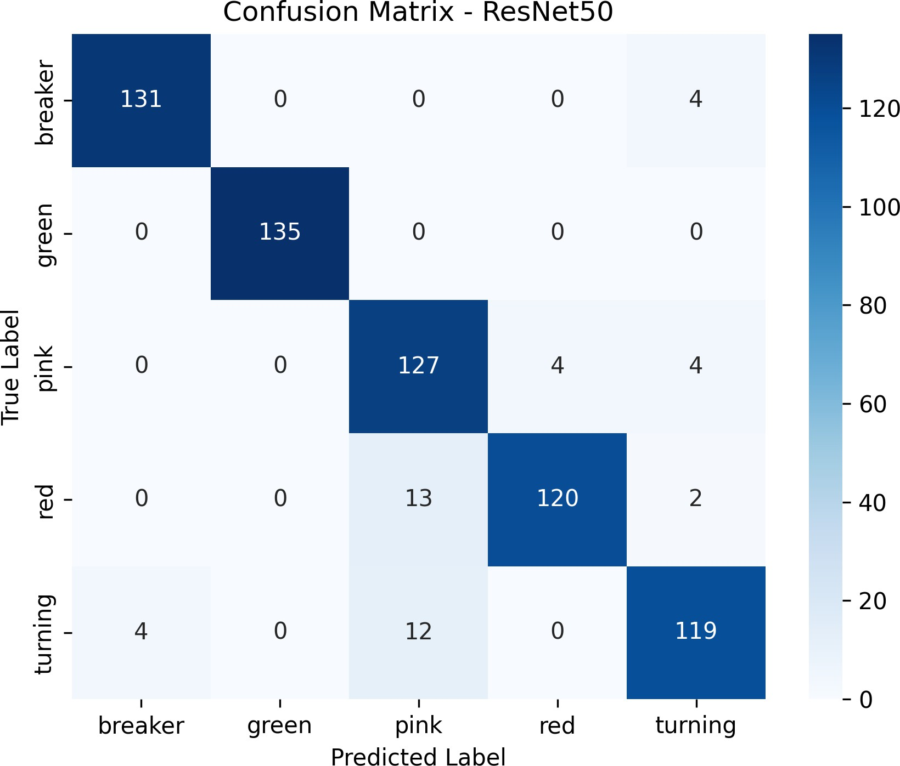
Fig. 3: Confusion matrix analysis of the ResNet50 model for tomato maturity classification across the five maturity stages.

  - Confusion Matrix Analysis: The confusion matrix pro-vides a detailed evaluation of the classification performance of the ResNet50 model across the five tomato maturity stages: Breaker, Green, Pink, Red, and Turning. Table III shows the confusion matrix analysis for the ResNet50 Model, and its visual distribution layout is displayed in Fig. 3.
TABLE III: Confusion Matrix for ResNet50 Model

True / Predicted | Breaker | Green | Pink | Red | Turning
Breaker | 131 | 0 | 0 | 0 | 4
Green | 0 | 135 | 0 | 0 | 0
Pink | 0 | 0 | 127 | 4 | 4
Red | 0 | 0 | 13 | 120 | 2
Turning | 4 | 0 | 12 | 0 | 119

The confusion matrix confirms that most samples are correctly classified, with the Green class achieving perfect separation. Minor misclassifications are restricted to adjacent ripening stages (Breaker/Turning and Pink/Red) due to the continuous biological color transitions between neighboring classes.
  - Grad-CAM Based Interpretability Analysis: To under-stand the decision-making process of the model, Grad-CAM is used to visualize the regions of the input image that contribute

most to the classification. Fig. 4 shows the original images (top row) and corresponding Grad-CAM visualizations (bottom row) for different tomato maturity stages. The highlighted regions indicate that the model primarily focuses on the tomato surface, particularly areas exhibiting color variations, which are essential for distinguishing ripening stages.
For intermediate stages such as Breaker, Turning, and Pink, the model attention is often localized due to subtle and overlapping visual differences between classes. Although the model focuses on relevant regions, the overall accuracy is 93.63%, as these fine-grained stages are inherently difficult to separate. Overall, the Grad-CAM results confirm that the model learns meaningful features while highlighting the chal-lenges of fine-grained maturity classification.
  - Training Time Comparison of Models: The training time comparison graph illustrates the computational efficiency of different deep learning architectures used in the tomato maturity classification system. The models evaluated include ResNet50, EfficientNetB0, DenseNet121, and MobileNetV2. Table IV shows the training time in seconds of each model.
TABLE IV: Training Time Comparison of Deep Learning Models

Model | Training Time (seconds)
ResNet50 | 12034
EfficientNetB0 | 5223
DenseNet121 | 18388
MobileNetV2 | 3558

Among the models, DenseNet121 required the highest training time, indicating greater computational complexity. MobileNetV2 recorded the lowest training time, reflecting its lightweight design optimized for faster training and deploy-ment. Fig. 5 shows the training time comparison between models.
This comparison highlights a critical trade-off between model complexity and computational efficiency. Lightweight architectures such as MobileNetV2 offer faster training and lower computational cost, making them suitable for real-time and edge-based applications. In contrast, deeper architectures such as ResNet50 and DenseNet121 require higher compu-tational resources but deliver superior classification perfor-mance.
  - Overall Model Performance Analysis: The classification reports presented in Tables V, VI, VII, and VIII provide a detailed evaluation of the performance of each deep learn-ing model across the five tomato maturity classes: Breaker, Green, Pink, Red, and Turning. The evaluation metrics include precision, recall, and F1-score, which collectively assess the reliability and consistency of classification for each class.
As shown in Table IX, ResNet50 achieves the highest classification performance across all evaluation metrics with an accuracy of 93.63%, followed by DenseNet121 (89.48%) and EfficientNetB0 (79.41%), while MobileNetV2 records the lowest accuracy baseline at 58.52%. The bar graph in Fig. 6 further illustrates the comparative performance of the models,
clearly highlighting the gap between ResNet50 and the other architectures.
TABLE V: Classification Report for ResNet50

Class | Precision | Recall | F1-Score
Breaker | 0.97 | 0.97 | 0.97
Green | 1.00 | 1.00 | 1.00
Pink | 0.84 | 0.94 | 0.89
Red | 0.97 | 0.89 | 0.93
Turning | 0.92 | 0.88 | 0.90

TABLE VI: Classification Report for EfficientNetB0

Class | Precision | Recall | F1-Score
Breaker | 0.84 | 0.84 | 0.84
Green | 0.98 | 0.94 | 0.96
Pink | 0.69 | 0.59 | 0.63
Red | 0.90 | 0.78 | 0.83
Turning | 0.62 | 0.82 | 0.71

TABLE VII: Classification Report for DenseNet121

Class | Precision | Recall | F1-Score
Breaker | 0.94 | 0.87 | 0.91
Green | 0.98 | 0.99 | 0.99
Pink | 0.85 | 0.79 | 0.82
Red | 0.91 | 0.96 | 0.93
Turning | 0.79 | 0.87 | 0.83

TABLE VIII: Classification Report for MobileNetV2

Class | Precision | Recall | F1-Score
Breaker | 0.52 | 0.90 | 0.66
Green | 1.00 | 0.30 | 0.47
Pink | 0.62 | 0.44 | 0.52
Red | 0.94 | 0.49 | 0.64
Turning | 0.46 | 0.79 | 0.58

The bar graph representation (Fig. 6) visually reinforces these findings by clearly illustrating the performance gap between ResNet50 and the other three models. The graphical comparison further emphasizes the impact of architectural design on classification performance, highlighting that deeper networks with residual learning mechanisms are more effective in modeling complex visual patterns required for fine-grained classification tasks.
  - Interpretation of Performance Trends: The experimental results indicate that network architecture plays a critical role in fine-grained tomato maturity classification. Differences in model design—like how deep they are, how layers connect, and their overall size—really matter for spotting small visual changes during tomato ripening. Lightweight models (e.g., MobileNetV2) work great for classes that look very different, but they struggle with in-between stages because they can’t capture enough detail. In our case, Breaker, Turning, and Pink stages have slow, overlapping color changes that need stronger feature detection than simple models provide.
ResNet50 performs best thanks to its deeper structure and residual (skip) links. These help gradients flow smoothly and let it learn complex, layered patterns—perfect for transitional stages where we need to catch gradual color shifts and texture

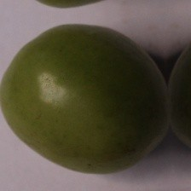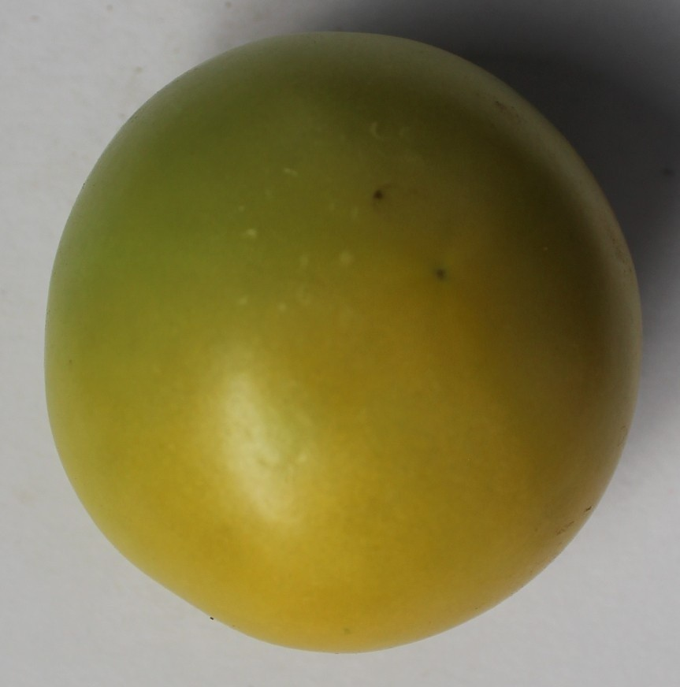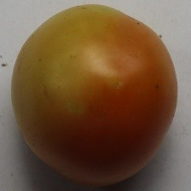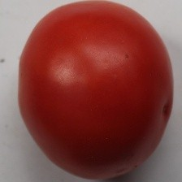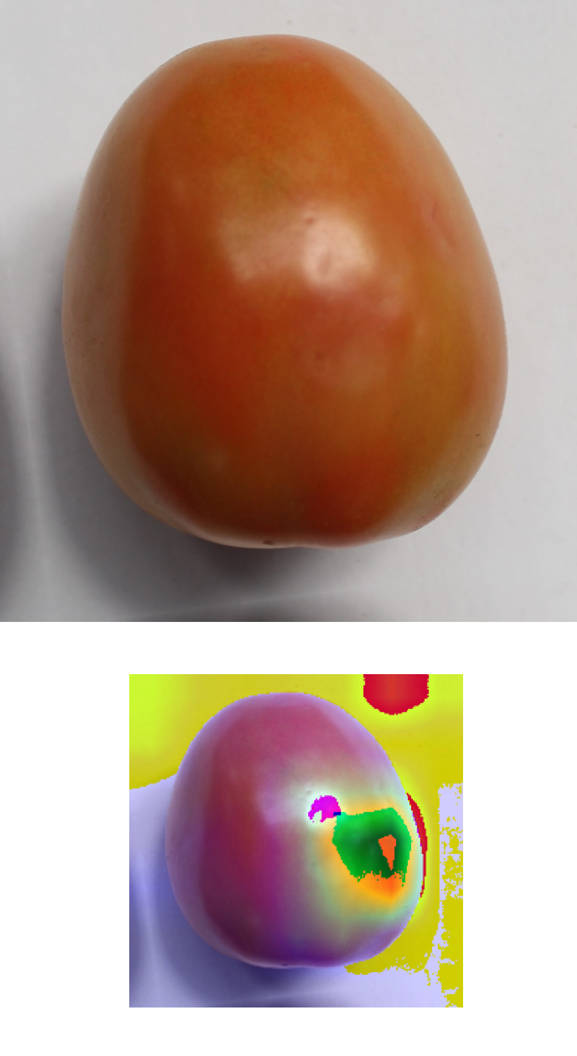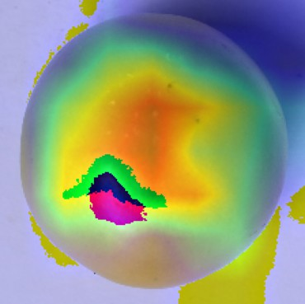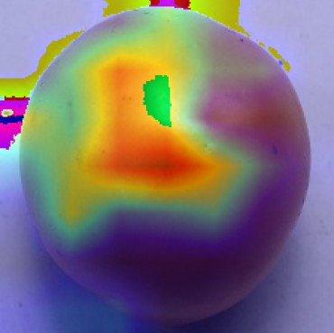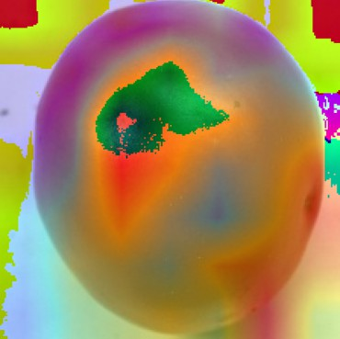
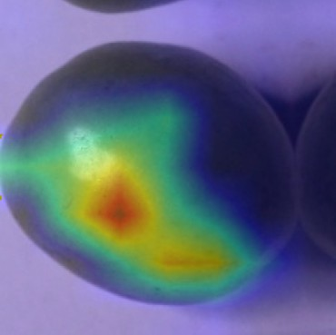
Fig. 4: Comparison of original tomato images (top row) and corresponding Grad-CAM visualizations (bottom row) across different maturity stages: (a) Green, (b) Breaker, (c) Turning, (d) Pink, and (e) Red. The heatmaps highlight regions that contribute most significantly to the model’s classification decisions.

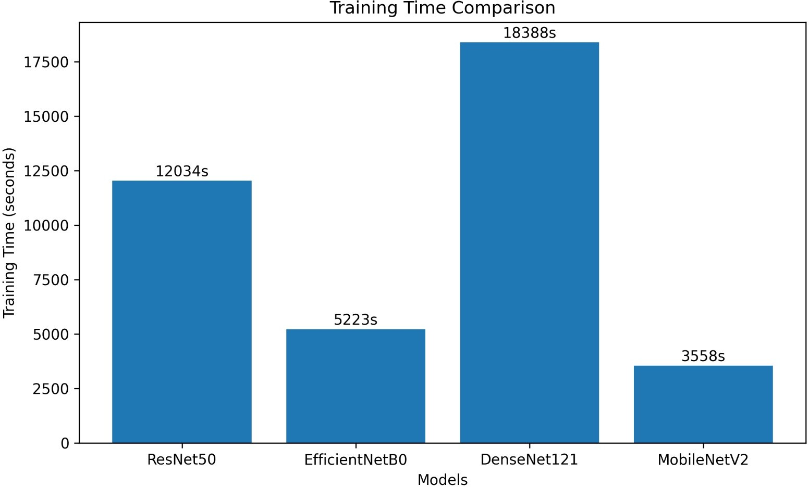
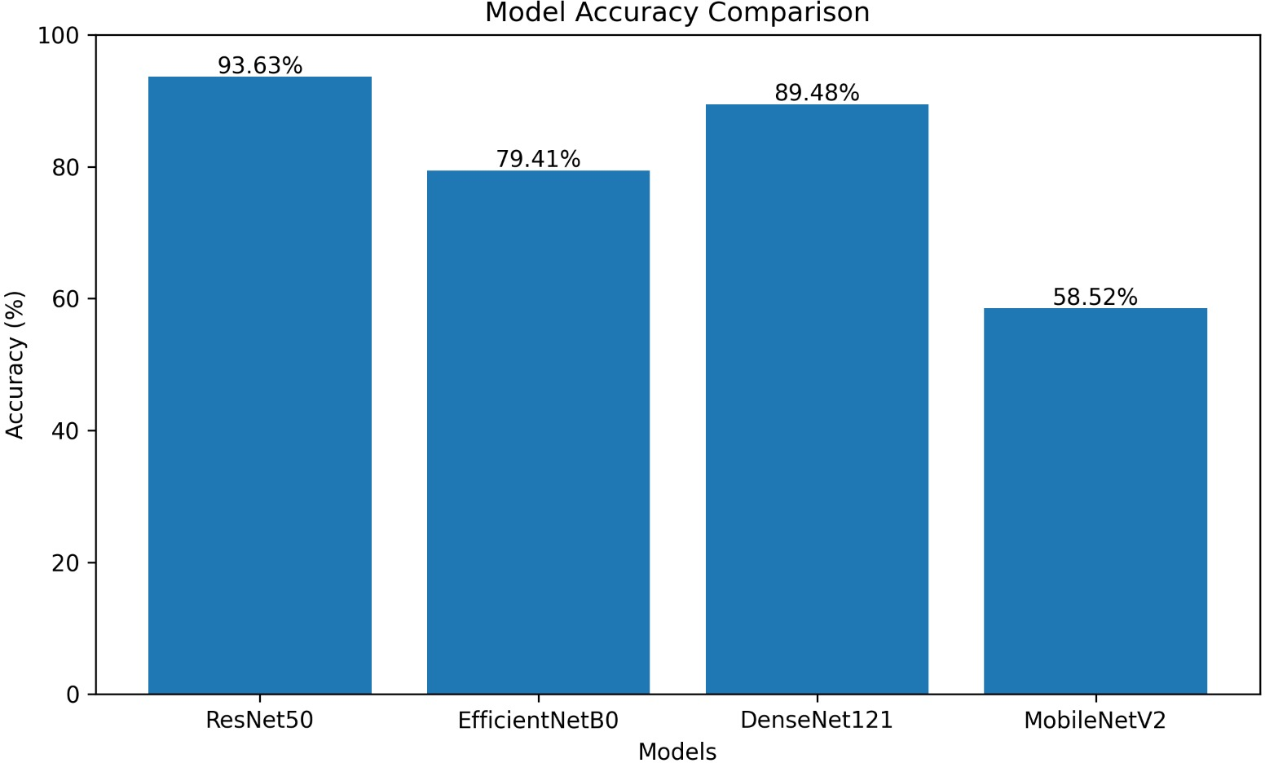

Fig. 5: Comparative analysis of training time required by the evaluated deep learning models.
TABLE IX: Performance Comparison of Deep Learning Mod-els

Model Name | Accuracy (%) | Precision (%) | Recall (%) | F1 Score (%)
MobileNetV2 | 58.52 | 70.75 | 58.52 | 57.29
EfficientNetB0 | 79.41 | 80.58 | 79.41 | 79.54
ResNet50 | 93.63 | 93.92 | 93.63 | 93.67
DenseNet121 | 89.48 | 89.65 | 89.48 | 89.46

changes on the tomato skin. Since our images show just plucked tomatoes (no leaves or stems), models focus only on surface color and texture—no background distractions. This clean setup lets deeper models shine. Fine-tuning the final layers also helps them adapt to our specific ripening patterns, avoiding overfitting despite our small dataset.
Since our dataset contains exclusively plucked tomato im-ages captured without leaves, stems, or field occlusions, it explicitly focuses the network’s optimization path onto skin color metrics and surface textures. While this design constraint effectively simplifies the classification task and isolates the parameters driving maturity profiling, it creates an idealized setup. Consequently, the performance trends documented in
Fig. 6: Comparative accuracy across architectures, highlight-ing ResNet50’s superiority attributable to enhanced residual learning depth.

this study reflect optimal post-harvest sorting environments rather than highly cluttered, live-field conditions.
  - Practical Implications: For real-world deployment, architecture selection aligns with application demands: ResNet50 excels where peak accuracy is vital, such as robotic sorting or premium export chains; MobileNetV2 suits resource-limited field operations with its fast inference and low memory footprint; EfficientNetB0 balances performance and efficiency for scalable farming; and DenseNet121 provides reliable baseline results in moderate-compute environments. This flexibility enables TomatoCare to adapt across diverse settings, from smallholder farms to industrial processors, while minimizing operational costs through optimized resource use. Moreover, the system’s edge-deployable nature supports integration with IoT sensors for continuous monitoring. Over-all, these findings affirm that TomatoCare bridges identified research gaps through a streamlined ripeness classification system, achieving strong predictive power without added de-tection complexity for practical agricultural integration. These

findings demonstrate the practical applicability of TomatoCare in real-world agricultural scenarios, particularly in precision harvesting, automated grading systems, and post-harvest qual-ity assessment, where accurate maturity classification is criti-cal.
  - Conclusion
This study introduces TomatoCare, a deep learning frame-work designed for detailed classification of tomato ripeness across five stages: Green, Breaker, Turning, Pink, and Red. Unlike typical broad-category methods, our approach tar-gets the subtle color shifts in intermediate phases that drive key farming choices. We systematically compared pre-trained CNN models—MobileNetV2, EfficientNetB0, DenseNet121, and ResNet50—using identical training setups. ResNet50 de-livered the best results at 93.63% accuracy, thanks to its skill in capturing complex visual patterns needed for precise sorting. Lighter models like MobileNetV2 run faster with less computing power but struggle to separate similar stages.
While Green and Red stages separate easily due to clear colors, Breaker, Turning, and Pink challenge models with their gradual overlaps—yet our system maintains strong per-formance overall. For practical use, TomatoCare supports accurate harvest timing, automatic grading, and post-pick quality checks, with a simple design suited for phones or edge devices. Future plans include field tests with real backgrounds/lighting/occlusions, adding attention features and Grad-CAM explanations, dataset growth, and real-time opti-mization. These findings show deep learning offers a reliable, expandable tool for smart crop monitoring.
A. Future Scope
Although TomatoCare delivers promising performance, sev-eral avenues remain to strengthen its practical deployment. Future research will expand the dataset to encompass var-ied tomato cultivars, cultivation environments, and illumi-nation conditions, thereby improving model generalization for authentic field use. Incorporating time-series modeling could track ripening progression, enabling predictions of ideal harvest times and aiding planning. Real-time video analysis offers another avenue, supporting deployment in automated sorting systems and robotic harvesters for ongoing evaluation. Lastly, the framework’s design lends itself to adaptation for other fruits and vegetables; with new datasets and fine-tuning through targeted retraining, it could become a versatile plat-form for maturity grading in smart agriculture.
References
- A. Bhardwaj, D. Gupta, and P. Kumari, “Automated Tomato Maturity Grading System Using CNN,” in Proceedings of the International Conference on Computing, Communication and Intelligent Systems,
IEEE, 2022. doi:10.1109/ICCCIS56430.2022.10074158
- N. Begum and M. K. Hazarika, “Maturity detection of tomatoes using transfer learning,” Measurement: Food, vol. 7, p. 100038, Elsevier, 2022.doi:10.1016/j.measfoo.2022.100038
- H. S. Mputu, A. Abdel-Mawgoud, A. Shimada, and M. S. Sayed, “Tomato quality classification based on transfer learning feature extrac-tion and machine learning algorithm classifiers,” IEEE Access, vol. 12, 2024. doi:10.1109/ACCESS.2024.3354112
- M. Waseem, M. M. Sajjad, L. H. Naqvi, Y. Majeed, T. U. Rehman, and T. Nadeem, “Deep learning model for precise and rapid prediction of tomato maturity based on image recognition,” Food Physics, vol. 2, 2025. doi:10.1016/j.foodp.2025.100042
- X. Qian and H. Seong, “YOLO-ASFF: An Enhanced YOLOv5s Model for Tomato Maturity Detection in Complex Orchard En-vironments,” in Proceedings of the International Conference on Agriculture Robotics and Intelligent Vision Systems, IEEE, 2022. doi:10.1109/ICARIVS56488.2022.10043512
- Y. P. Huang, L. Liu, H. Zhang, and Y. Chen, “Tomato Maturity Detection Method Based on YOLOv4 and Statistical Color Model,” in Proceedings of the 11th International Conference on Cyber Technology in Automation, Control, and Intelligent Systems (CYBER), IEEE, 2021. doi:10.1109/CYBER53097.2021.9651742
- H. Wei and H. Li, “Research on Tomato Maturity Detection Based on YOLOv8s and Attention Mechanism,” in Proceedings of the Interna-tional Conference on Agricultural Intelligence and Automation (AIA), 2024. doi:10.1109/AIA61442.2024.10555312
- L. Liu, H. Zhang, and Y. Chen, “Multi-task Tomato Fruit and Bunch Maturity Detection Approach Based on an Improved YOLOv7 Model,” in Proceedings of the International Conference on Agri-cultural Robotics and Intelligent Harvesting Systems (ARIHS), 2023. doi:10.1109/ARIHS59844.2023.10399411
- M. Lumoring, S. K. David, and R. R. Kumar, “Classification of Tomato Maturity Using Transfer Learning EfficientNetB0 Algorithm,” in Proceedings of the International Conference on Computer Vi-sion and Smart Agriculture Systems (CVSAS), 2023, pp. 310–316. doi:10.1109/CVSAS58322.2023.10166214
- M. Hossain, M. M. Pritom, and A. A. S. Khan, “YOLOv5-Driven Decision Fusion Approach for Aiding Automated Tomato Harvesting,” in Proceedings of the International Conference on In-novations in Science, Engineering and Technology (ICISET), 2024. doi:10.1109/ICISET61343.2024.10544122
- H. Wei and J. Li, “Research on Tomato Maturity Detection Based on YOLOv8s and Attention Mechanism,” in Proceedings of the Inter-national Conference on Robotics, Automation and Intelligent Control (ICRAIC), 2024. doi:10.1109/ICRAIC61532.2024.10522134
- L. Luo, Y. Chen, Z. Wang, and X. Liu, “Facility Tomato Picking System Based on Shelf Life Prediction and Fruit Maturity Discrimination,” in Proceedings of the IEEE International Power Electronics Conference (IPEC), 2022. doi:10.23919/IPEC-Himeji2022-E43042.2022.9807115
- C.-A. Pai and H.-Y. Lin, “Maturity and Yield Estimation of Toma-toes Using RGB and Multispectral Images,” in Proceedings of the IEEE International Conference on Industrial Technology (ICIT), 2026. doi:10.1109/ICIT56133.2026.10844215
- P. Arya, K. Y. Anand, S. Ram, and V. Singh, “A Novel Approach for Tomato Quality Evaluation: Computer Vision in Maturity Assessment and Disease Detection,” in Proceedings of the International Conference on Intelligent Trends in Engineering and Technology (INCET), 2024. doi:10.1109/INCET61123.2024.10577148
- G. J. Angeles, V. A. N. Buenventura, D. J. Oguing, L. A. Canada, and A. Rosales, “Automated Tomato Maturity Classification Integrating Computer Vision System and Robotic Manipulation,” in Proceedings of the IEEE Conference on Intelligent Automation and Agro-Technology, 2022.doi:10.1109/AgroTech56114.2022.10099415
- A. Widiyanto, D. P. U. Wicaksono, and H. Widodo, “Image-Based Tomato Maturity Classification and Detection Using Faster R-CNN Method,” in Proceedings of the IEEE Global Conference on Consumer Electronics (GCCE), 2022. doi:10.1109/GCCE56422.2022.10013145
- S. Baar, Y. Kobayashi, T. Horie, K. Sato, and S. Watanabe, “Tomato Fruit Maturity Estimation from RGB Images,” in Proceedings of the IEEE Global Conference on Consumer Electronics (GCCE), 2022. doi:10.1109/GCCE56422.2022.10013201
- X. Qian and H. Seong, “YOLO-ASFF: A Model for De-tecting Tomatoes of Different Maturities Based on Improved YOLOv5s,” in Proceedings of the International Conference on Agricultural Machine Vision and Intelligent Sensing, IEEE, 2023. doi:10.1109/AMVIS59431.2023.10255416

