Jenkins
-Jenkins is an open source server used for the continuous integration and continuous delivery. It helps automate the building ,testing and deployment with 1400 plugins.

Continuous Integration:
-It refers to continuously integrating the code changes done to the code by the developer and automate build and tests.
-A continuous integration service automatically builds and runs unit tests on the new code changes to immediately surface any errors.
-The key goals of continuous integration are to find and address bugs quicker, improve software quality, and reduce the time it takes to validate and release new software updates.
-It includes stages such as build and test

Continuous deployment:
-Continuous deployment is a strategy in software development where code changes to an application are released automatically into the production environment. This automation is driven by a series of predefined tests. Once new updates pass those tests, the system pushes the updates directly to the software's users.
-It includes the stages such as building the docker image, push the image to repository, orchestrate and deploy.

Continuous delivery:

Installation
-Create an ec2 instance with port 8080 open
-Once the instance is launched connect to it and follow the below mentioned steps.
https://www.jenkins.io/doc/tutorials/tutorial-for-installing-jenkins-on-AWS/ or https://www.jenkins.io/doc/book/installing/linux/
-Once java and jenkins is installed, we can access jenkins using <publicIP of the instance>:8080 (as jenkins runs defaultly on 8080 port)
-It will display the home page of jenkins and the path of the password will be shown.
-Go to the mentioned path and get the password to login to jenkins.
-Install the recommended plugins
-After the installation of plugins, create the first admin user and start jenkins.

Change default port of jenkins
-Default port of jenkins is 8080. There is a need to change this default port as it might also be in use with other applications like tomcat.
-Connect to the instance in which jenkins is installed and start jenkins.
-cd to the path /usr/lib/systemd/system . In this path if we do ls -lrt, multiple services will be running. Can filter using ls -l *jenkin*
-We will find a jenkins.service file. vi to the file and in the Envirnment section, port number will be mentioned. Change the port to required port. This port should be open in the instance too.
-Use sudo systemctl restart jenkins to restart and can check the status of jenkins using sudo systemctl status jenkins. It the status is active, conncet using <publicIP of the instance>:new port no

Types of items in jenkins
1. Freestyle project
2. Pipeine
3. Multi-configuration project
4. Folder
5. Github organizer
6. Multibranch pipeline

Here,
-V1.1 is the source code in the local workstations which will be pushed to source control tools such as github
-Once the code is available in the source control, the build stage is triggered where the code is build to generate artifacts and unit tests are run.
-Next is staging in which the generated artifacts are deployed in the target environments which can be dev, staging, test, QA, pre prod and prod.
-After the artifacts are deployed in the staging env, regression and performance tests are conducted.

Jenkins Master slave configuration
a.Master is in which the jenkins is configured
b.Slave is used to distribute the load of the master but jenkins is not configured. Java(same version as in the master) has to be installed in the slave.

Declarative pipeline
1.All the stages and the steps of the pipeline will be defined in the YAML file within the pipeline block. The pipeline is defined with {}
2.They are designed to create the pipeline much easier, less error proof and more accessible for the users.
3.Agent: It will be specifies without any brackets
-It is the section in which it is specified where to run the entire pipeline or a perticular stage of the pipeline
-There are two types of agents, top level agents and stage agents. Top level agents are defined after the pipeline and is responsible for all the activities
-Stage agents are declared within the stage which specifies which agent is to be used for the stage.
-Agent any specifies that the stage can run in any of the available agents.
-Agent none is specifies at the top level which sppecifies that the agent will be specifies at each stage
4.Stages: It is specified with {}
-It atleast should contain one stage within it.
-It is where most of the work is discribed within the pipeline.
5.Stage: It is specified with ('') when ever used.
6.Steps: It is specified with {}. It consists of the steps which will be executed.

Java project workflow example
1.The source code will be committed to the github by the developers
2.Jenkins is used for the continuous integration to build the code. Once the code is build, it generates artifacts.

Pipeline bestpractices
1.Use of shellscript in the pipeline: This smiplifies the build by combining multiple steps in a single stage. Modification of the shell script is simpler
than that of the stage or steps.
2.Using shared library to avoid repitative work.(Share library is a collection of Groovy scripts shared between different Jenkins jobs. To run the scripts,
they are pulled into a Jenkinsfile.)
3.Cleanup old jenkins builds
4.Reduce repeting similar steps

Integrate jira with jenkins
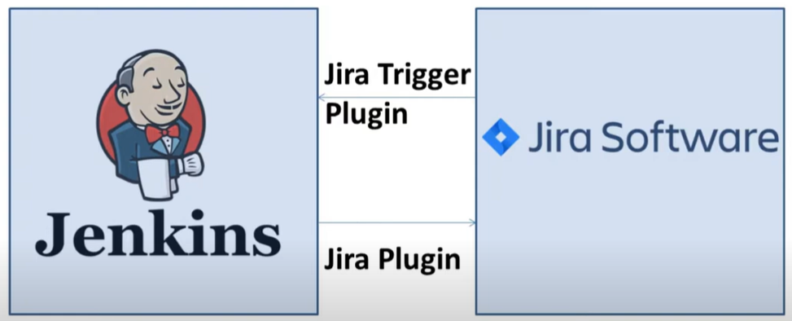

- Jira pipeline steps is the plugin to be installed in jenkins
-Manage jenkins – configure systems – JIRA steps – name – URL of the jira – login type as OAuth
https://developer.atlassian.com/cloud/jira/platform/jira-rest-api-oauth-authentication/ following the steps will give consumer, private, secret and token key. Fill these keys and test connection if success,

Jenkins pipeline script from SCM
The Jenkins file can be stored in the SCM i.e, github.
- In Jenkins – pipeline definition – Pipeline script from SCM
- In the SCM section, give git, specify the repository and the branch.

