**DAILY ONLINE ACTIVITIES SUMMARY**

|  |  |  |  |  |  |  |  |  |
| --- | --- | --- | --- | --- | --- | --- | --- | --- |
| **Date:** | **27-06-20** | | | | | **Name:** | **Sinchana .** | |
| **Sem & Sec** | **6th Sem ‘B’ Sec** | | | | | **USN:** | **4AL17CS117** | |
| **Online Test Summary** | | | | | | | | |
| **Subject** | | **DBMS and JDBC** | | | | | | |
| **Max. Marks** | | **--** | | **Score** | | |  | |
| **Certification Course Summary** | | | | | | | | |
| **Course** | **Placement Training** | | | | | | | |
| **Certificate Provider** | | | **Mr. Hemanth K**  **Mr. Sayeesh** | | **Duration** | | | **4 Hours** |
| **Coding Challenges** | | | | | | | | |
| **Problem Statement: 1 program** | | | | | | | | |
| **Status: Executed** | | | | | | | | |
| **Uploaded the report in GitHub** | | | | | **yes** | | | |
| **If yes Repository name** | | | | | <https://github.com/sinchana514/coding> | | | |
| **Uploaded the report in slack** | | | | | **yes** | | | |

**DBMS Session 1:**

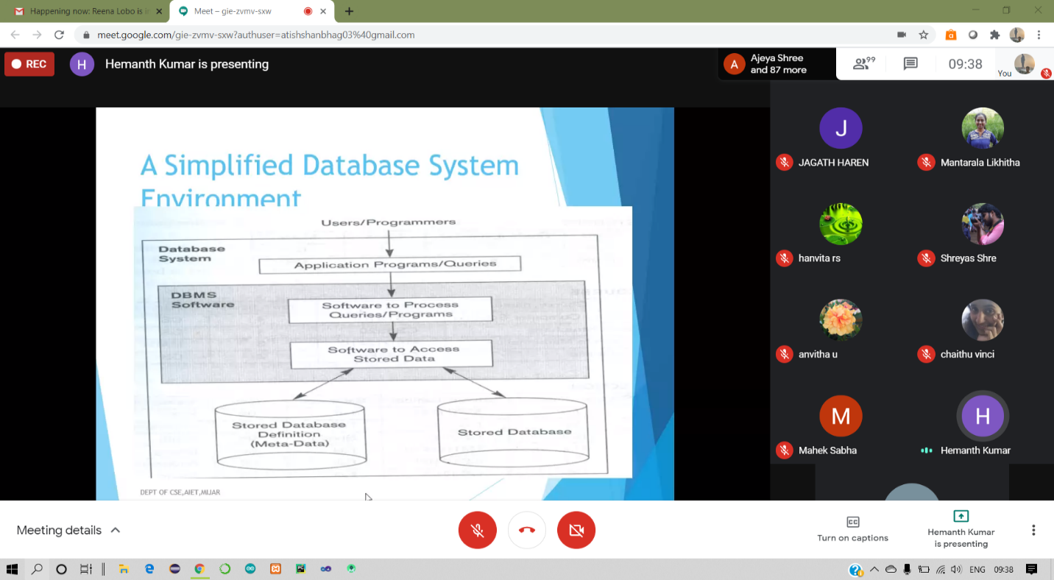

**In today’s placement training session I have studied important topics in Data base management system such as various queries and architechture related stuffs.**

**JDBC Session 2**

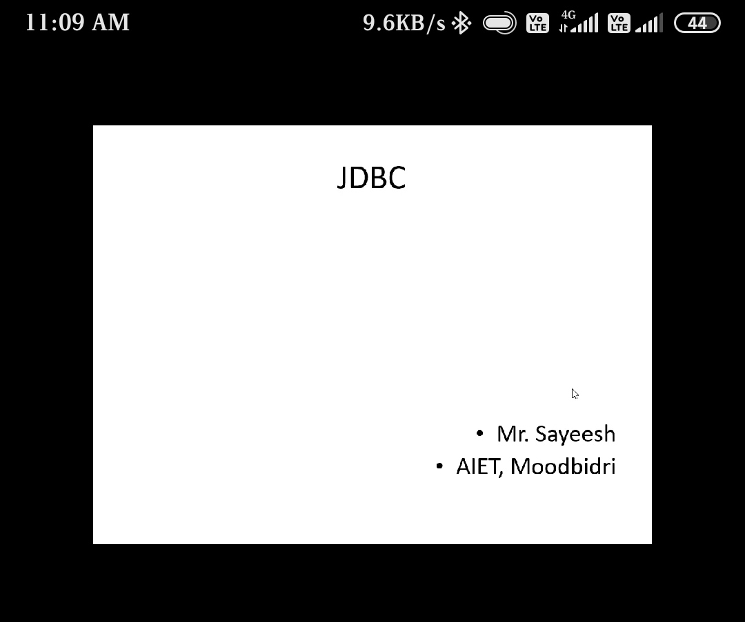

**In today’s session of JDBC I have studied stuffs such as components of jdbc with its types and also transaction and rollback function implemented programming examples.**

**Coding Challenges Details:**

27June – Code:

**Program 1 -Queue and dequeue operation**

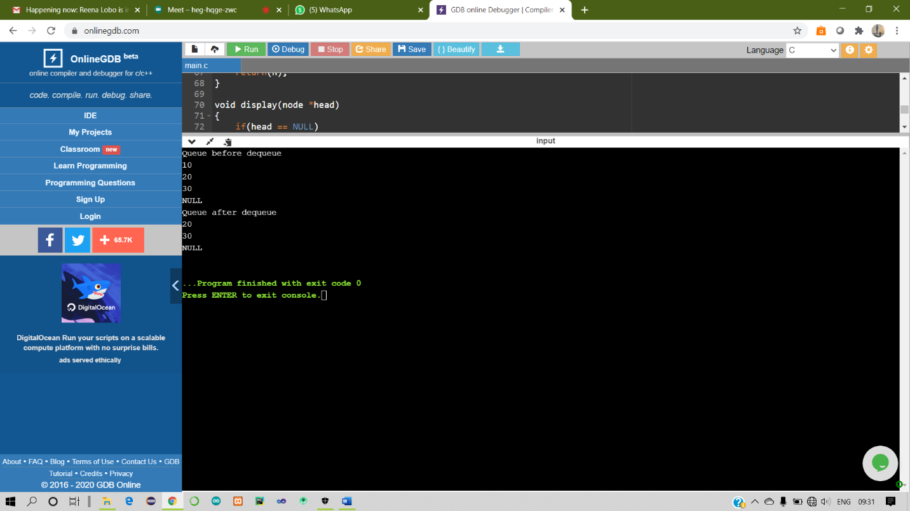

**1-For Report and daily coding challenges** 🡪

<https://github.com/sinchana514/coding>

**2-For Exercises of DBMS**

<https://github.com/sinchana514/coding/blob/master/27thjune/schema%20and%20er1.pdf>