UART Command System using ESP32 Bluetooth
Wireless FPGA-Based Command and Sensor Monitoring System
Internship Project Documentation

Submitted by

Sinchana

Table of Contents

- PROJECT OVERVIEW
- PROJECT OBJECTIVES
- PROBLEM STATEMENT
- EXISTING SYSTEM
- PROPOSED SYSTEM
- DESIGN AND ARCHITECTURE
- HARDWARE COMPONENTS
- SOFTWARE REQUIREMENTS
- WORKING PRINCIPLE
- SYSTEM FLOW
- MODULE DESCRIPTION
- BUILD INSTRUCTIONS
- RUN INSTRUCTIONS
- TESTING PROCEDURE
- TEST RESULT
- CONCLUSION
- REFERENCES

1. Project Overview
This project implements a wireless command and monitoring system built around an Artix-7 FPGA development board , using an onboard ESP32 module as a Bluetooth Low Energy (BLE) to UART bridge. Single ASCII commands sent from a smartphone are received over BLE, forwarded by the ESP32 to the FPGA over a UART serial link, and decoded entirely in hardware to drive a set of onboard peripherals: LEDs, a buzzer, a relay (switching an external load), and a 16x2 LCD.
Beyond simple remote control, the system is bidirectional. A dedicated sensor-read command triggers an SPI-based read of an onboard MCP3202 analog-to-digital converter, sampling an onboard potentiometer, and returns the live reading as decimal text back to the phone over the same BLE link. Every byte received, recognized or not, is also echoed back and displayed as its decimal ASCII value on a MAX7219-driven seven-segment display, providing continuous visual feedback of UART activity.
The design is implemented as a set of independent, concurrently operating Verilog modules rather than a single sequential program, reflecting a hardware-centric digital design approach.

2. Project Objectives
- Design a wireless command system using Bluetooth-to-UART communication with an FPGA as the hardware controller.
- Decode received commands entirely in digital logic, without a software command-interpreter loop.
- Drive multiple onboard peripherals (LEDs, buzzer, relay, LCD) independently and concurrently from decoded commands.
- Implement a return communication path so the FPGA can report data back to the phone, not only receive commands.
- Read a live analog sensor value (potentiometer via MCP3202 ADC) and report it as text over Bluetooth.
- Provide continuous visual feedback of all received UART traffic via a seven-segment display.
- Demonstrate safe control of an external load (bulb) via an onboard relay.

3. Problem Statement
Many simple embedded control demonstrations are one-directional: a phone or remote sends a command, and a microcontroller executes it. Such systems cannot report sensor data back, and typically implement command parsing in software running on a single processor core, which does not demonstrate the benefits of true hardware-level concurrency. This project addresses both limitations by implementing the entire command-and-response pipeline as parallel, independent Verilog hardware modules and adding a genuine sensor-reporting path, making the system bidirectional rather than purely receive-only.

4. Existing System
Conventional Bluetooth remote-control projects are typically built entirely around a microcontroller an Arduino or ESP32 ), executing command parsing and peripheral control as sequential software instructions. These systems generally lack a return communication channel for sensor data, do not demonstrate hardware-level concurrent execution, and tie all timing-sensitive operations (UART, SPI, display refresh) to a single CPU's instruction loop, introducing scheduling overhead and limiting true parallelism between peripherals.

5. Proposed System
The proposed system separates the wireless communication role (handled by the ESP32, acting purely as a BLE-to-UART bridge) from the command decoding and peripheral control role (handled entirely by the FPGA in hardware). The ESP32 forwards raw bytes in both directions without interpreting them. The FPGA receives each byte through a hardware UART receiver, decodes it through a dedicated command-decoder module, and dispatches control signals to independent, concurrently running peripheral controllers. A separate response-arbiter module manages the single shared return path, allowing the system to send back either a simple echo or a live sensor reading, depending on the command received.

6. Design and Architecture
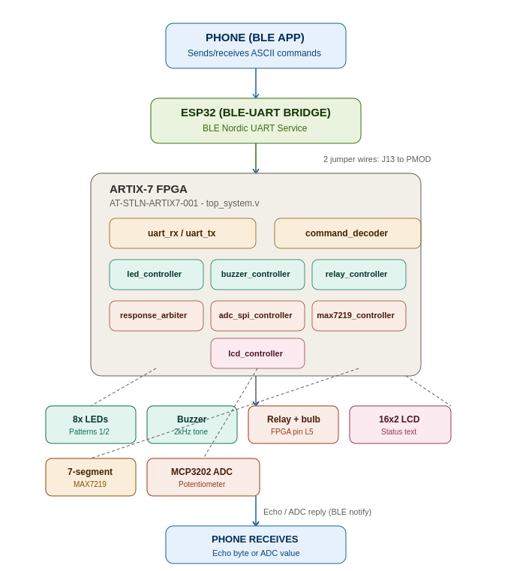
The phone communicates with the ESP32 over Bluetooth Low Energy using the UART. The ESP32 forwards bytes transparently over a UART link to the FPGA, requiring two jumper wires between the ESP32's J13 header and the FPGA's PMOD header, since these pins are not pre-wired on the board. Inside the FPGA, uart_rx deserializes incoming bytes, which command_decoder interprets to drive led_controller, buzzer_controller, and relay_controller. In parallel, response_arbiter decides whether to echo the received byte back or trigger an ADC read via adc_spi_controller, then sends the result back out through uart_tx. The seven-segment display (via max7219_controller) and the LCD (via lcd_controller) react independently to every received byte, the former unconditionally and the latter only for the LED pattern commands.

7. Hardware Components
- AT-STLN-ARTIX7-001 Artix-7 FPGA Development Board
- Onboard ESP32 module (Bluetooth Low Energy)
- Onboard 8x user LEDs
- Onboard piezo buzzer
- Onboard relay (SANYOU SRD Form-C, K1) and screw terminal (J17) for external load
- Onboard MCP3202 12-bit SPI analog-to-digital converter
- Onboard potentiometer (analog input to the ADC)
- Onboard MAX7219-driven seven-segment display
- 16x2 character LCD (HD44780-compatible, 8-bit parallel interface)
- External bulb (switched via the relay's NO/COM/NC screw terminal)

8. Software Requirements
- Xilinx Vivado Design Suite (synthesis, implementation, bitstream generation, simulation)
- Verilog HDL (RTL design)
- Arduino IDE (ESP32 BLE firmware)
- A BLE UART terminal application (e.g. Bluefruit LE Connect) on the phone

9. Working Principle
The user sends a single ASCII character from a phone-based BLE terminal application. The ESP32 receives it over its BLE UART RX characteristic and forwards the raw byte over a hardware UART link to the FPGA at 9600 baud. The FPGA's uart_rx module deserializes the byte and pulses rx_done with the received value on rx_data.command_decoder examines the byte and, for recognized commands, produces a one-cycle pulse or persistent code for the relevant peripheral: '0', '1', or '2' update led_code (driving led_controller's off, blinking, or chase pattern); 'B'/'b' pulses buzz_pulse (driving a timed, tone-generated beep); 'R'/'r' and 'X'/'x' pulse relay_on_pulse/relay_off_pulse (latched by relay_controller into a persistent on/off state).
Independently, response_arbiter inspects every received byte: for 'S'/'s' it triggers adc_spi_controller to perform an SPI conversion on the onboard MCP3202 and, once complete, transmits the 12-bit result as four decimal digits plus a carriage return and line feed; for every other byte, it simply echoes the same byte back. uart_tx serializes whatever response_arbiter provides and drives it out to the ESP32, which relays it to the phone over a BLE notification.
In parallel with all of the above, max7219_controller reacts to every received byte unconditionally, splitting it into three decimal digits and displaying its ASCII value on the seven-segment display. lcd_controller reacts only to '1' and '2', updating the second line of the LCD to indicate which LED pattern is active.

10. System Flow
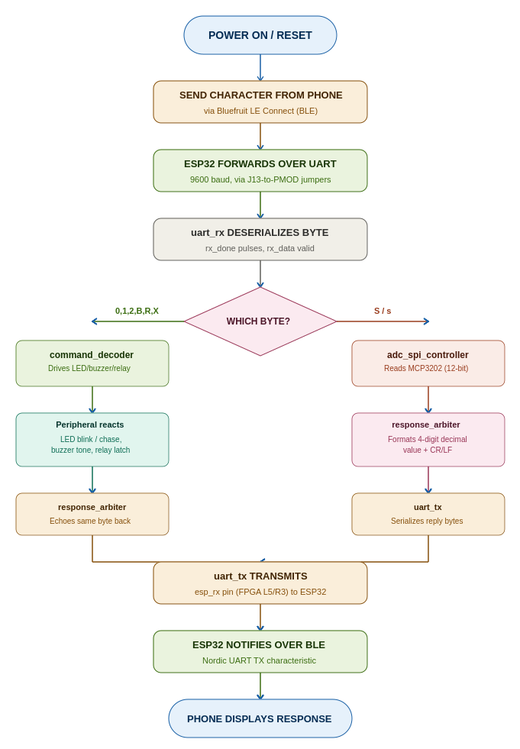

11. Module Description
uart_rx.v
8N1 UART receiver uses a 2-stage input synchronizer and a CLKS_PER_BIT parameter (clock frequency divided by baud rate) to sample each bit at its midpoint, producing rx_data and a one-cycle rx_done pulse per received byte.
uart_tx.v
8N1 UART transmitter,on a one-cycle tx_start pulse, serializes tx_data onto the output line and pulses tx_done when complete.
command_decoder.v
Translates a received byte into LED, buzzer, and relay control signals. Uses a default-clear-then-case-override pattern so buzz_pulse, relay_on_pulse, and relay_off_pulse remain clean one-cycle pulses.
led_controller.v
Drives the eight onboard LEDs. Pattern 1 alternates between 0x55 and 0xAA at approximately 2 Hz; pattern 2 produces a single-bit chase pattern; any other code turns all LEDs off.
buzzer_controller.v
Generates a timed beep on buzz_pulse. An outer counter times the overall beep duration (approximately 500 ms); an inner counter toggles the output at an audible frequency (tunable via a TONE_FREQ_HZ parameter, default 2 kHz) to produce an actual oscillating tone rather than a flat DC level.
relay_controller.v
A persistent level latch, not a timed pulse. relay_on_pulse sets the relay output high; relay_off_pulse clears it; the output otherwise holds its last value. Defaults to off on reset.
response_arbiter.v
Arbitrates the single shared UART return path. On 'S'/'s', triggers an ADC conversion and, once complete, transmits the result as decimal digits plus CR/LF; for any other byte, echoes it back unchanged.
adc_spi_controller.v
SPI master for the onboard MCP3202 ADC, fixed to the potentiometer's channel. Shifts out a configuration word, then clocks in 12 data bits, returning a 0-4095 value and an adc_done pulse.
max7219_controller.v
Drives the seven-segment display via the MAX7219 controller chip. Splits the most recently received byte into three decimal digits and shifts each digit out as a 16-bit SPI word; relies on the MAX7219's built-in Code B decode mode rather than computing segment patterns directly.

lcd_controller.v
Writes a fixed title string to the LCD's first line once at startup, then updates the second line only when the received byte is '1' or '2', displaying "LED PATTERN 1" or "LED PATTERN 2" accordingly.
top_system.v
Top-level module instantiating and interconnecting all of the above, exposing the physical FPGA pins defined in the board's constraints file.

12. Build Instructions
- Open Xilinx Vivado and create a new RTL project.
- Add all Verilog source files: top_system.v, uart_rx.v, uart_tx.v, command_decoder.v, led_controller.v, buzzer_controller.v, relay_controller.v, response_arbiter.v, adc_spi_controller.v, max7219_controller.v, lcd_controller.v.
- Add top_system_tb.v as a simulation source.
- Add constraints.xdc as the constraints source.
- Set top_system as the synthesis top module.
- Run Synthesis, then Implementation, then Generate Bitstream.
- Program the FPGA with the generated bitstream.
- Upload the BLE-UART bridge firmware to the onboard ESP32 via the Arduino IDE.

13. Run Instructions
- Power the FPGA board.
- Connect the two jumper wires between the ESP32's J13 header and the FPGA's PMOD header (UART TX/RX bridge).
- Confirm the reset switch is in the released (inactive) position, since rst is active-high.
- Pair a phone with the ESP32 over Bluetooth Low Energy using a BLE UART terminal app.
- Send a single ASCII character (e.g. '1', 'B', 'R', 'S') and observe the corresponding peripheral response.
- For the relay, connect the external bulb to the relay's screw terminal (J17, NO/COM/NC) following appropriate load-voltage safety practice.

14. Testing Procedure
The following test cases were executed to verify correct operation of each command path, including the bidirectional UART return path and the ADC-based sensor reading feature.
Test Case | Description | Expected Result | Actual Result | Status
TC-01 | LED Pattern 1 ('1') | LEDs blink alternating 0x55/0xAA at ~2Hz; LCD line 2 shows "LED PATTERN 1"; 7-segment shows 049; byte '1' echoed to phone. | System operated as expected except LCD  (as it is not connected) | Pass
TC-02 | LED Pattern 2 ('2') | LEDs show chase pattern (single bit walking); LCD line 2 shows "LED PATTERN 2"; 7-segment shows 050; byte '2' echoed. | System operated as expected.(except LCD) | Pass
TC-03 | LEDs Off ('0') | All LEDs turn off; 7-segment shows 048; byte '0' echoed. | System operated as expected. | Pass
TC-04 | Buzzer ('B'/'b') | Buzzer produces an audible ~500ms, 2kHz tone; unaffected peripherals remain unchanged; byte echoed. | System operated as expected after tone-generation fix. | Pass
TC-05 | Relay ON ('R'/'r') | Relay (FPGA pin L5) energizes, switching external bulb on; state persists until 'X'/'x'; byte echoed. | System operated as expected. | Pass
TC-06 | Relay OFF ('X'/'x') | Relay de-energizes, switching bulb off; byte echoed. | System operated as expected. | Pass
TC-07 | Sensor Read ('S'/'s') | FPGA performs SPI read of MCP3202 (potentiometer), returns a 4-digit decimal value (0-4095) + CR/LF instead of an echo; value changes when the potentiometer is turned. | System operated as expected once UART return-path jumper was corrected. | Pass
TC-08 | Arbitrary byte echo | Any unrecognized byte is echoed back unchanged and its decimal ASCII value is shown on the 7-segment display. | System operated as expected. | Pass
TC-09 | UART return path | Verified FPGA-to-ESP32 jumper wire on pin R3 (not T3); confirmed echo/ADC replies reach the phone over BLE notify. | Initial miswiring (T3 instead of R3) identified and corrected; communication confirmed bidirectional. | Pass
TC-10 | Reset behavior | Asserting rst (active-high) holds entire design in reset; LEDs off, relay off, buzzer silent; design resumes correctly on release. | System operated as expected. | Pass

15. Test Result
The FPGA successfully decoded every defined command and correctly drove the corresponding peripheral. LED patterns, buzzer tone, and relay switching all operated as designed. The bidirectional path was verified by confirming that the seven-segment display reacts to every received byte, that recognized commands are echoed back to the phone, and that the 'S'/'s' command returns a live, changing potentiometer reading rather than an echo. An initial hardware fault, in which the FPGA-to-ESP32 return jumper was connected to the wrong physical pin, was identified through systematic testing and corrected, after which the full bidirectional command and sensor-reporting pipeline was confirmed functional.

16. Conclusion
This project successfully demonstrates a wireless, FPGA-controlled command and monitoring system, combining Bluetooth communication, hardware-level UART and SPI protocol implementation, and concurrent digital peripheral control. By extending beyond simple one-directional remote control to include a live sensor-reporting path, the system illustrates a representative architecture for Bluetooth-controlled home automation and basic IoT sensor-reporting applications, while the modular Verilog design demonstrates the benefits of parallel, hardware-based execution over a sequential software control loop.

17. References
- Xilinx Vivado Design Suite Documentation
- AT-STLN-ARTIX7-001 Artix-7 FPGA Board Manual
- Microchip MCP3202 12-Bit ADC Datasheet
- Maxim Integrated MAX7219 Datasheet
- Espressif ESP32 Bluetooth Low Energy (BLE) Documentation

