Day 1
Number Systems- Assignment
Q1. Complete the table with equivalents in Binary, Octal, and Hexa for: 143.75 (decimal), 11011.101 (binary), 453 (octal), 1F.C (hex).
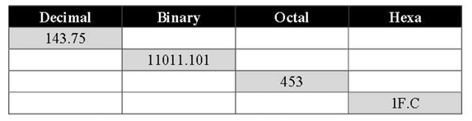
Q2. Find equivalents:
a) 324₅ = ?₁₀
b) 32.23₄ = ?₁₀
c) 231₁₀ = ?₇
d) 189₁₀ = ?₆

Q3. Find the radix r:
a) (312/20)ᵣ = (13.1)ᵣ
b) 264ᵣ + 136ᵣ = 433ᵣ
c) 221505₈ = 12345ᵣ

Q4. Addition:
a) 1101₂ + 11011111₂
b) 77652₈ + 76543₈
c) 578A₁₆ + ABDE₁₆
d) 234₆ + 315₆

Q5. Binary → Gray code:
a) 10101₂
b) 01110₂

Q6. Gray code → Binary:
a) 01101 (gray)
b) 10101 (gray)

Day 2

Day 3

Day 4

Day 5

