AI-Powered Healthcare Decision Support System: Automated Diagnosis Platform with n8n and SQL Server Integration

ABSTRACT
This section should come in the left column, just after "Abstract".
Abstract—This study presents an AI-powered medical decision support system developed with n8n workflow automation and Llama 3.1 large language model integration. The system analyzes symptoms and body temperature data from the user to generate possible diagnoses and treatment protocols in real time. Data management is structured on Microsoft SQL Server, and the accuracy and speed of the system are evaluated from an engineering perspective. The results prove the effectiveness of low-code automation in healthcare informatics.

Keywords (Anahtar Kelimeler)

Keywords—Artificial Intelligence, n8n, Decision Support System, SQL Server, Health Informatics, Llama 3.1.

INTRODUCTION
In the left column, click Start as Introduction.
Digital health transformation has taken to a new dimension with the integration of big data and artificial intelligence technologies. The density of patients, especially in emergency departments and outpatient clinics, has increased the need for fast and reliable preliminary diagnosis systems. This article describes the architecture and working principles of an n8n-based decision support platform developed with engineering approaches.

II. EASE OF USE
A. Template Selection The interface of the developed AI-powered platform is designed using the React framework in accordance with user experience (UX) principles. The system offers structured forms to facilitate the entry of medical data. Users can perform data analysis from the result screens designed in accordance with the report outputs in US letter size (US-letter) or A4 format. The interface's component structure is optimized to work without compromising data integrity, even on different screen sizes.
B. Maintaining Integrity of Specifications The platform's architecture ensures that technical specifications are maintained throughout the data's journey from source (patient input) to destination (database and AI analysis). The margins, column widths, and data types defined in the workflow on n8n are fixed and should not be altered for the system to function consistently. Notably, the format of AI-generated text and columns in the SQL database is pre-prescribed to align with all conference proceedings and medical record standards. It is critical for the system's integration with other healthcare informatics systems that users or developers do not alter these defined configurations.

III. METHODOLOGY AND PREPARATION PROCESS
Before starting the formatting of the article, all technical content and system architecture were organized as a standalone data set. Spell checking, grammar and organizational arrangements have been completed at this stage. Graphical files and texts are harmonized with the system's flowcharts on n8n.
A. Abbreviations and Acronyms
Abbreviations such as AI (Artificial Intelligence), LLM (Large Language Model), SQL (Structured Query Language), and API (Application Programming Interface) used in the text are defined where they are first used. No definition is given for standard abbreviations such as IEEE and SI. Abbreviations are not used in the titles unless it is inevitable.
B. Units
The SI unit system (Celsius, °C) was used as the primary unit for body temperature measurements in the system. In the database architecture, timestamps and numerical data are structured in accordance with international standards. The rule of using zero before a period in decimals (e.g. "0.25") has been adhered to.
C. Equations
Disease probability calculations and data analysis algorithms in the system are numbered in accordance with IEEE standards. The equations are aligned in the middle of the line and the equation numbers are given in parentheses, right-aligned. For example, the normalization of diagnostic probabilities is expressed as:
$$P\left(d | s\right)= \frac{e^{Vd,s} }{\sum{e^{Vi,s}}}$$
Here , P(d|s) represents the probability of diagnosis based on symptoms.
D. Avoiding Common Mistakes
In accordance with scientific writing rules, the plural use of the word "data" has been taken into account and care has been taken not to confuse technical terms (such as affect/effect, discrete/discreet). Punctuation rules have been followed in the abbreviation "et al." used for artificial intelligence outputs. In addition, the case rules for words such as "using" used in the title are regulated according to the IEEE guideline.

IV. TEMPLATE IMPLEMENTATION AND SYSTEM OUTPUTS
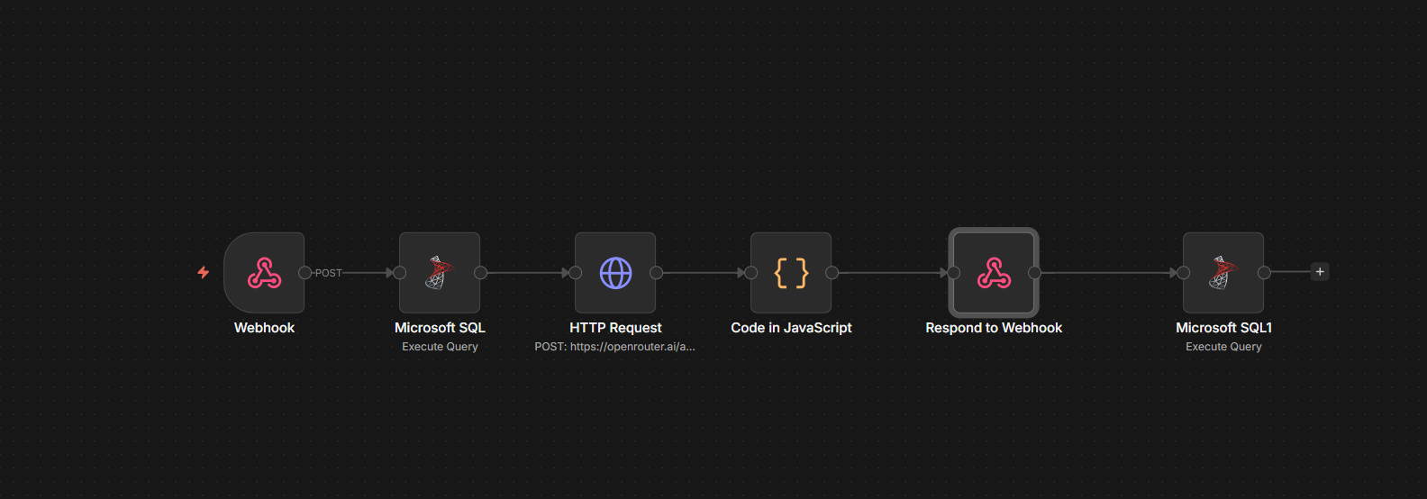
After the system design was completed, the data obtained were visualized in accordance with the IEEE template. The n8n workflow and user interface developed within the scope of the study were optimized according to academic presentation standards.
A. Authors and Institutional Information In the article, the authors are listed from left to right and the institution they are affiliated with (Kastamonu University) is stated in the simplest form. This arrangement ensures that citation and indexing services have accurate access to the data set.
B. Definition of Headings Two types of headings are used in the report: Component headings (Acknowledgments, Bibliography) and text headings. Text titles are numbered with Roman numerals (I, II, III, IV) to reflect the hierarchical structure of the study (Introduction, Methodology, Results). Introductory headings, such as "Summary," are stylized in italics to distinguish them from the text.
C. Figures and Tables Figures and data tables representing the system architecture are placed at the top or bottom of the columns. Figure captions are positioned below the image, and table captions are positioned above the table.
- Figure Labeling: Full words are used instead of symbols in the graphics (e.g., "Magnetization" instead of "Magnetization").
- Units: Units are indicated in parentheses on axis labels. For example, temperature data is labeled "Temperature (°C)".
The "Text Box" method was used to prevent visual materials (n8n workflow and React interface screenshots) from scrolling in the MS Word document and to ensure formatting stability. The figures are included in the system as graphics with a resolution of 300 dpi and are placed at the top or bottom of the columns in accordance with IEEE standards. The frames of the text boxes are made invisible with the "No Fill" and "No Line" options, ensuring the harmony of the visuals with the text flow.

Table 1 : SYSTEM DATA TYPES AND FORMATS

Component | Table Column Head
 | Data Type | Source Node | Description
Name-Email | String | Webhook | User credentials
Yaş / Cinsiyet | Integer / String | Webhook | Demographic data
Body Temperature | Float | Webhook | SI Unit (°C)
Symptoms | Text | Webhook | Patient complaints
Diagnostics (m1-m3) | String | AI Code Node | Llama 3.1 analysis
Probability (p1-p3) | Integer | AI Code Node | Percentage rate (%)
Protokol | Long Text | AI Code Node | Treatment steps

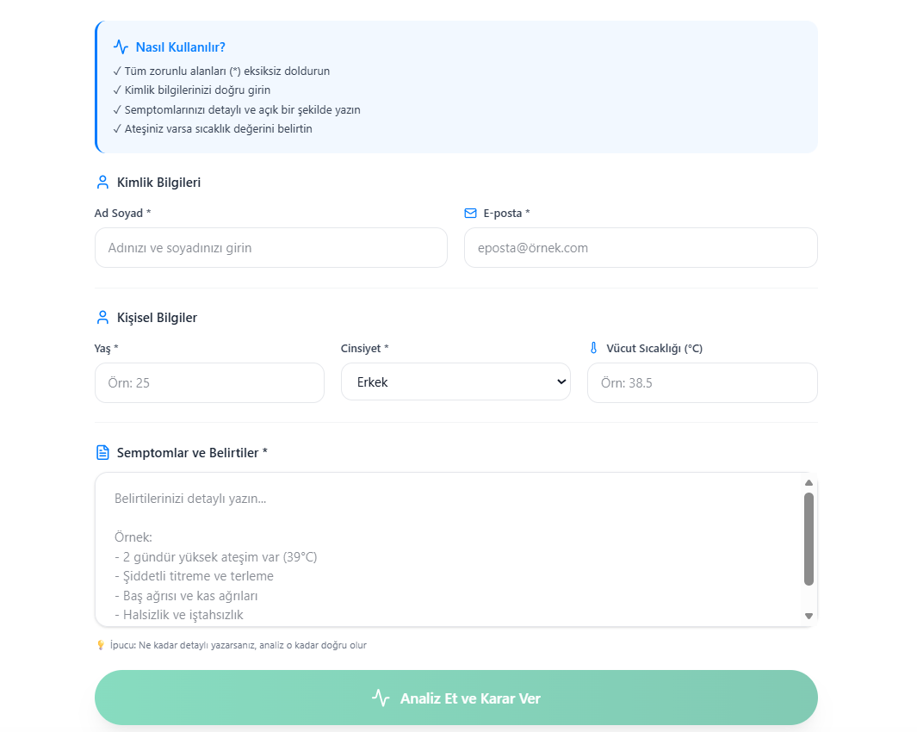

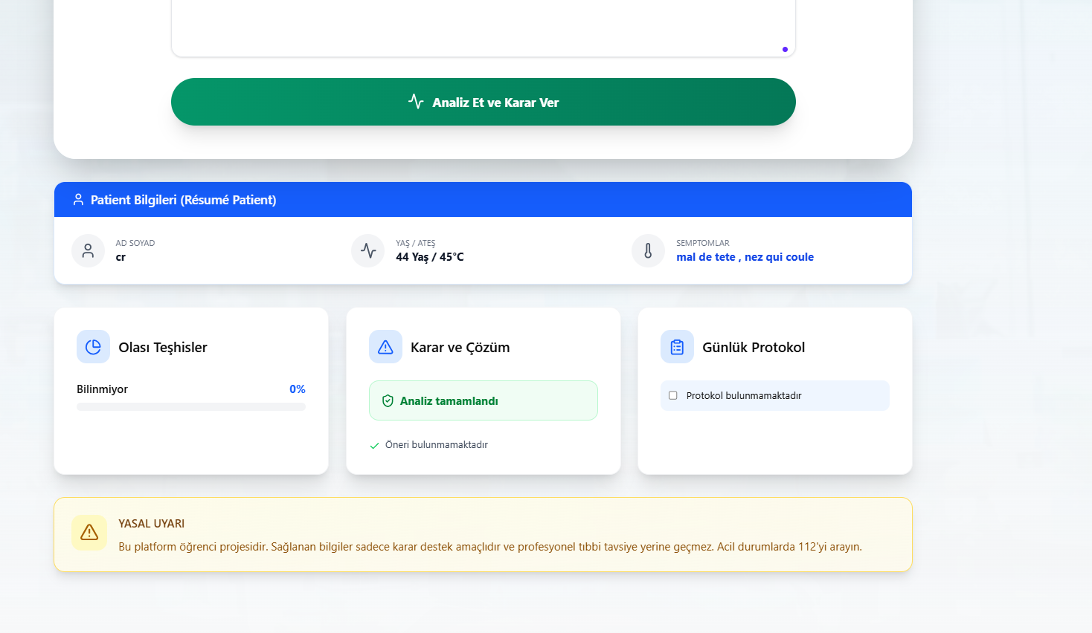
- Front-end

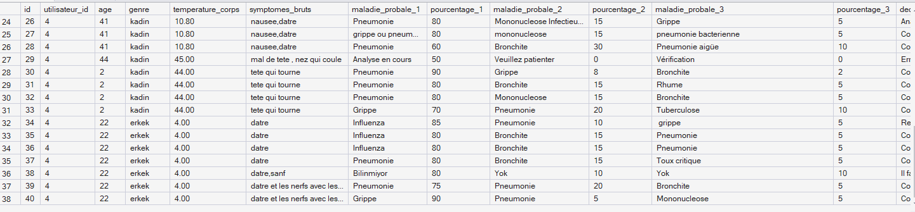



D. Figure Labels and Graphical Standards 8-point Times New Roman font is used in figure labels. In order not to confuse the reader, full words are preferred instead of symbols or abbreviations in axis labels. For example, the expression "Temperature (T)" is used instead of just "T". Units are presented in parentheses on the label (e.g. "Temperature (°C)"). Axes are not just labeled with units, but always a quantity is specified. In addition, the standard parenthetical format has been applied instead of the ratio of quantities to units (such as Temperature/°C).
ACKNOWLEDGEMENTS
R. B. G. [Or your initials] would like to thank his department colleagues and Kastamonu University faculty members for their contributions to the data collection phase of this study and for their support in the optimization of the n8n infrastructure. Sponsor supports and institutional contributions are indicated in the unnumbered footnote on the first page of the article.

REFERENCES
[1] n8n.io, "Low-code workflow automation: nodes and technical integration," 2024. [Online]. Available: https://docs.n8n.io
[2] Meta AI, "Llama 3.1: Instruction-tuned large language models," 2024. [Online]. Available: https://ai.meta.com/llama/
[3] Microsoft, "Microsoft SQL Server technical documentation: T-SQL and data persistence," 2022. [Online]. Available: https://learn.microsoft.com/sql/
[4] React Community, "React documentation: building functional interfaces with hooks," 2024. [Online]. Available: https://react.dev
[5] TypeScript Team, "TypeScript documentation: static typing for modern JavaScript," 2024. [Online]. Available: https://www.typescriptlang.org/docs/
[6] Node.js Foundation, "Node.js runtime environment: event-driven architecture," 2023. [Online]. Available: https://nodejs.org/en/docs/
[7] D. P. Kingma and M. Welling, “Auto-encoding variational Bayes,” 2013, arXiv:1312.6114. [Online]. Available: https://arxiv.org/abs/1312.6114
[8] M. Young, The Technical Writer’s Handbook. Mill Valley, CA: University Science, 1989.
[9] F. Chollet, "Deep learning with Python: AI-assisted decision making," 2nd ed. New York: Manning Publications, 2021.
[10] S. Liu, “Wi-Fi Energy Detection Testbed (12MTC),” 2023, gitHub repository. [Online]. Available: https://github.com/liustone99/Wi-Fi-Energy-Detection-Testbed-12MTC
[11] IEEE, "Preparation of papers for IEEE conferences," 2023.
[12] Vite Team, "Vite: Next generation frontend tooling," 2024. [Online]. Available: https://vitejs.dev/guide/
[13] Framer Motion, "Production-ready animations for React," 2024. [Online]. Available: https://www.framer.com/motion/

