Page-53

// BPF with rp=3dB , rs=45dB , passband [4,8]kHz,stopband [2,12]kHz,sampling frequency 25Khz

**#include**<stdio.h>

**#include**<math.h>

**void** **main**()

{

**int** N,i,k;

**double** rp=3.0,rs=45.0,fp1=4000.0,fp2=8000.0,fs1=2000.0,fs2=12000.0,Fs=25000.0;

**double** hd[25],wn[25],h[45],pi=3.1415926,fc1,fc2,TW;

fc1=(fp1-fs1)/(2*Fs);

fc2=(fs2-fp2)/(2*Fs);

TW=**fabs**((fp2-fp1))/Fs;

N=**ceil**(4/TW);

**if**(N%2==0)

N=N+1;

k=(N-1)/2;

**for**(i=0;i<k;i++)

{

wn[i]=0.54-0.46\***cos**((2*pi*(**double**)i)/(N-1)); // Hamming window

hd[i]=((**sin**(2*pi*fc2*(**double**)(i-k)))/(pi*(i-k)))-((**sin**(2*pi*fc1*(**double**)(i-k)))/(pi*(i-k))); // BPF

h[i]=hd[i]*wn[i];

h[N-i-1]=h[i];

}

h[i]=2*(fc2-fc1)*(0.54-0.46\***cos**((2*pi*(**double**)i)/(N-1)));

}

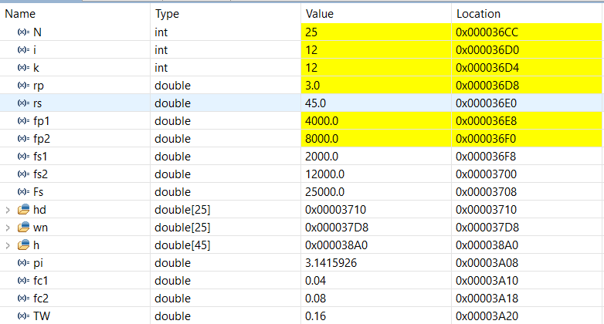

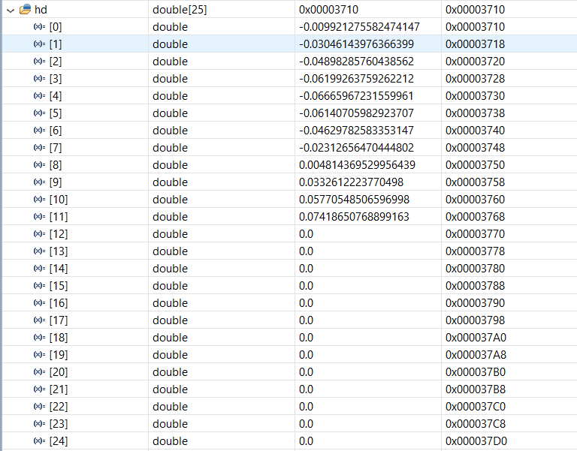

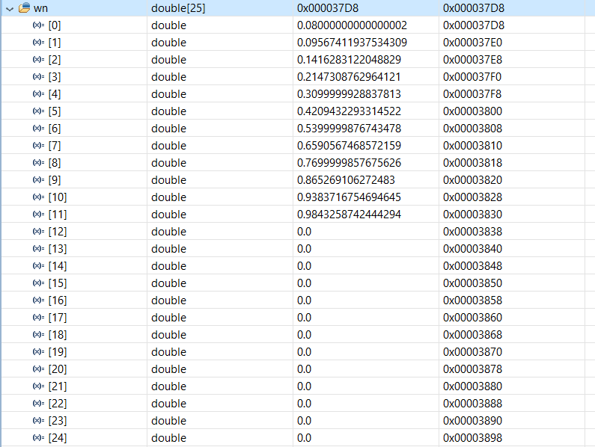

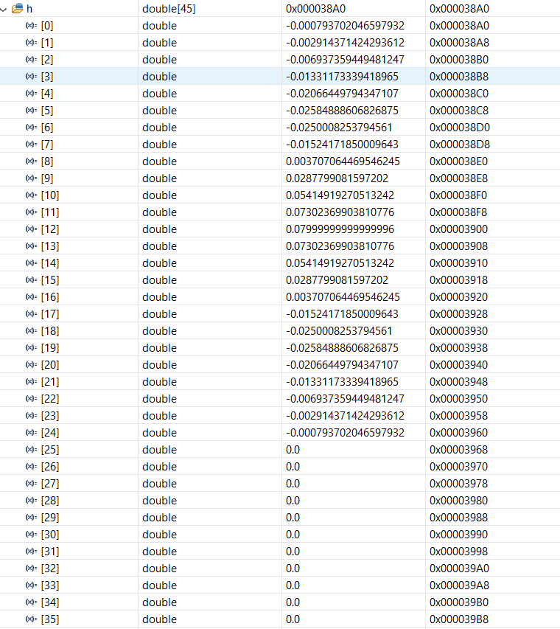

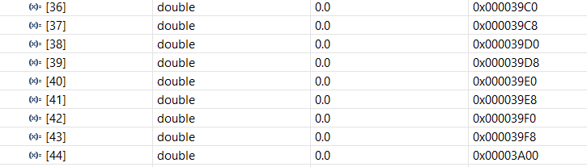

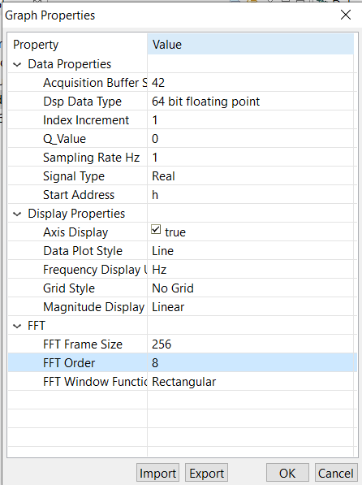

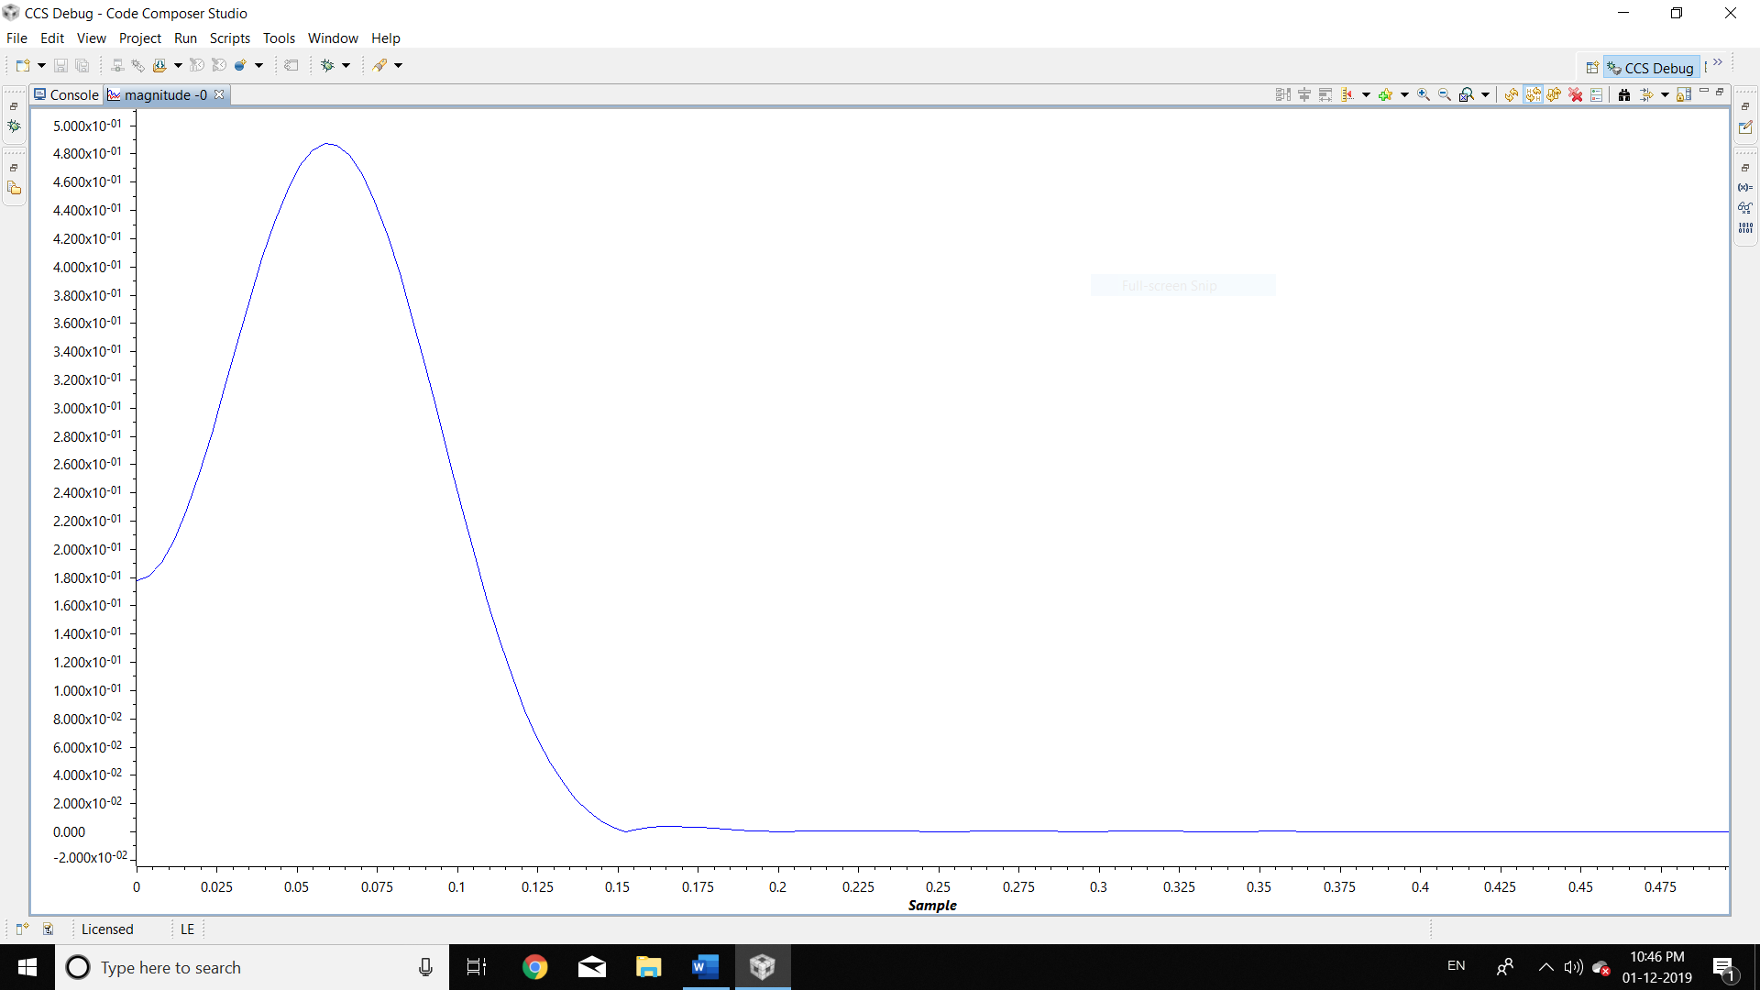

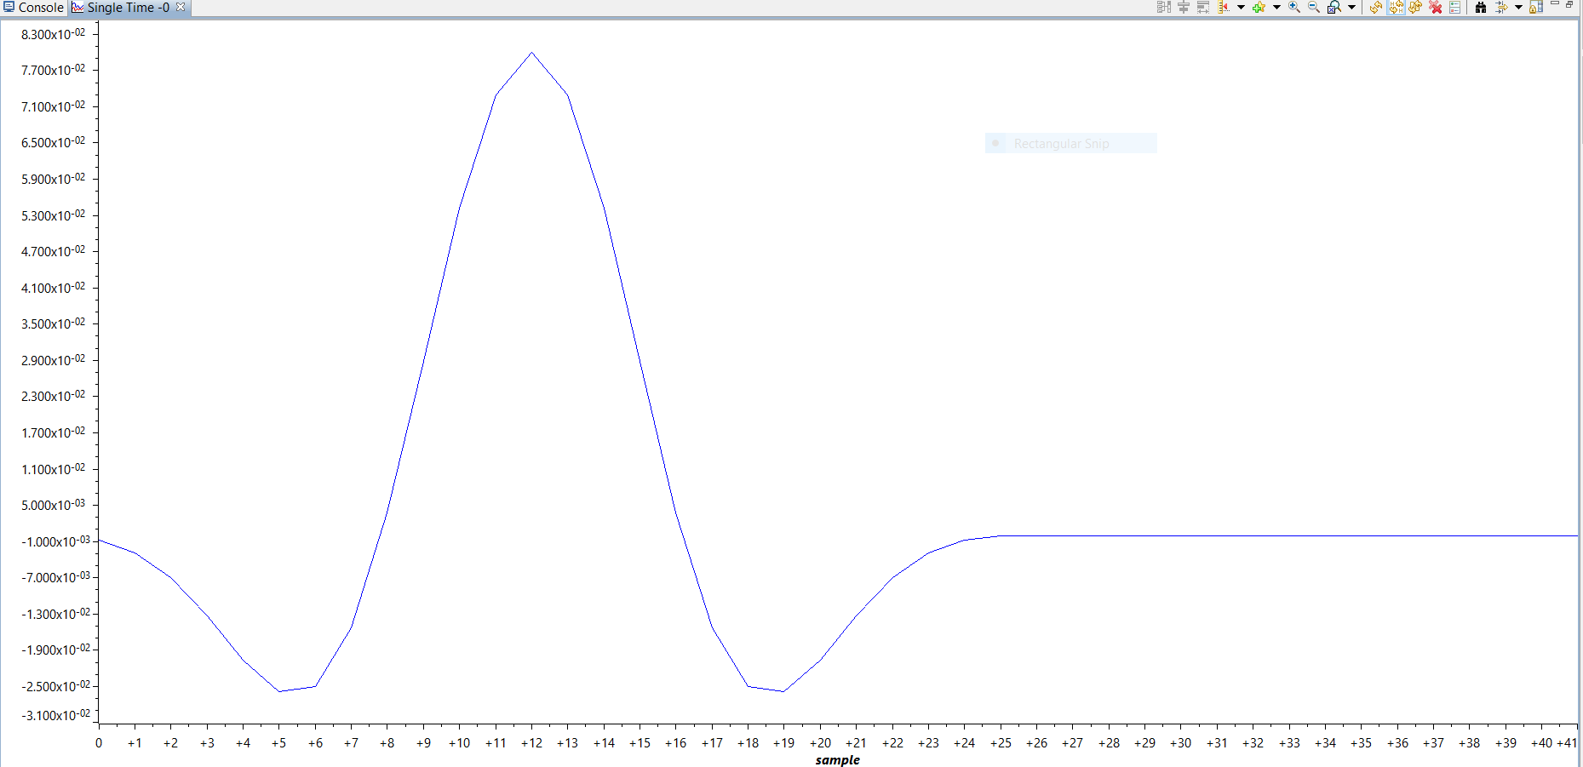

Page – 53

// HPF with rs=45dB , transition region between 2 and 3 khz,sampling frequency 10Khz

**#include**<stdio.h>

**#include**<math.h>

**void** **main**()

{

**int** N,i,k;

**double** rs=45.0,fs=2000.0,fp=3000.0,Fs=10000.0;

**double** hd[25],wn[25],h[45],pi=3.1415926,fc,TW;

fc=(fp+fs)/(2*Fs);

TW=**fabs**((fs-fp))/Fs;

N=**ceil**(4/TW);

**if**(N%2==0)

N=N+1;

k=(N-1)/2;

**for**(i=0;i<k;i++)

{

wn[i]=0.54-0.46\***cos**((2*pi*(**double**)i)/(N-1)); // Hamming window

hd[i]=-((**sin**(2*pi*fc*(**double**)(i-k)))/(pi*(i-k))); // HPF

h[i]=hd[i]*wn[i];

h[N-i-1]=h[i];

}

h[i]=(1-2*fc)*(0.54-0.46\***cos**((2*pi*(**double**)i)/(N-1)));

}

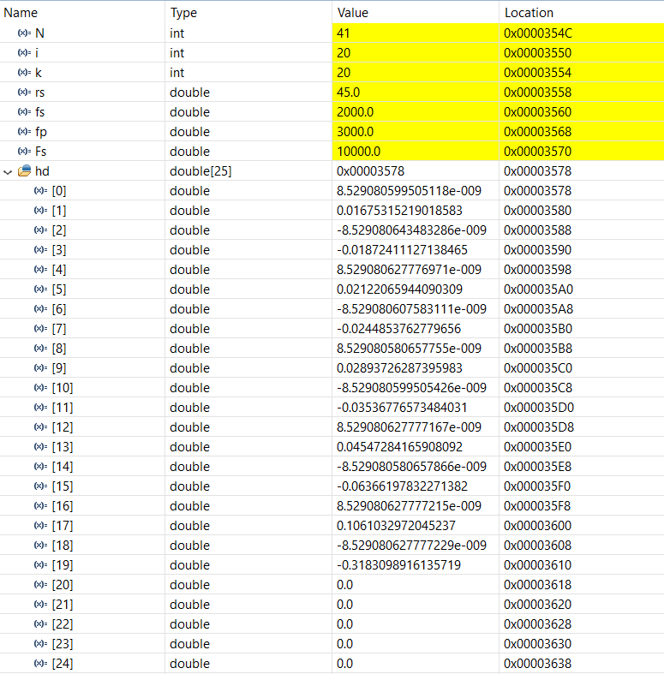

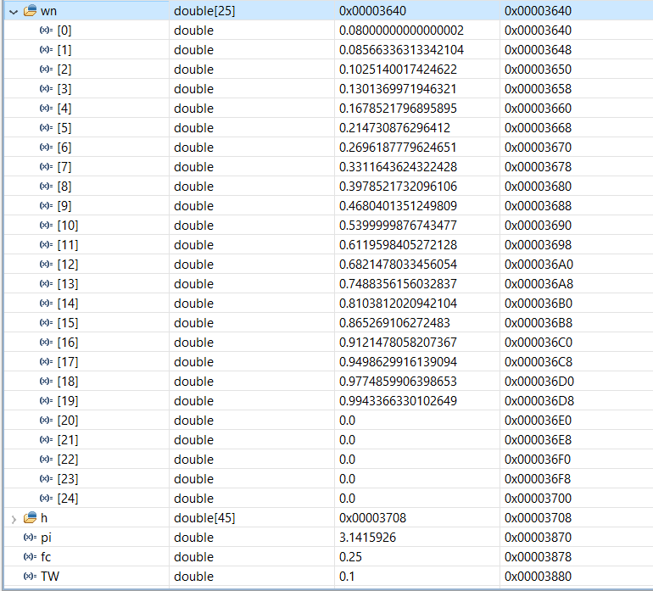

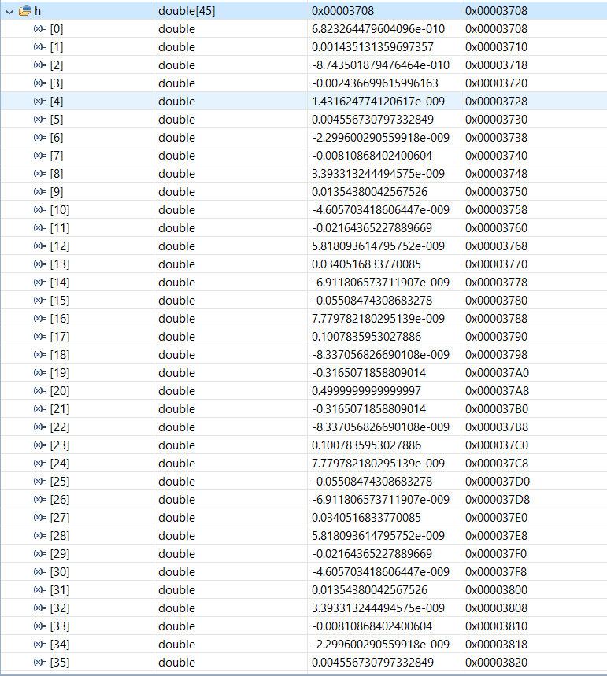

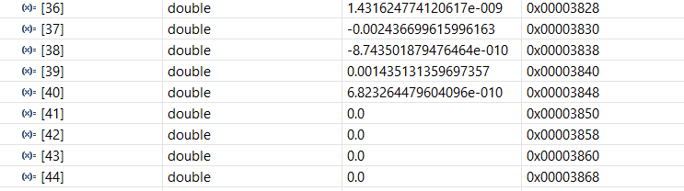

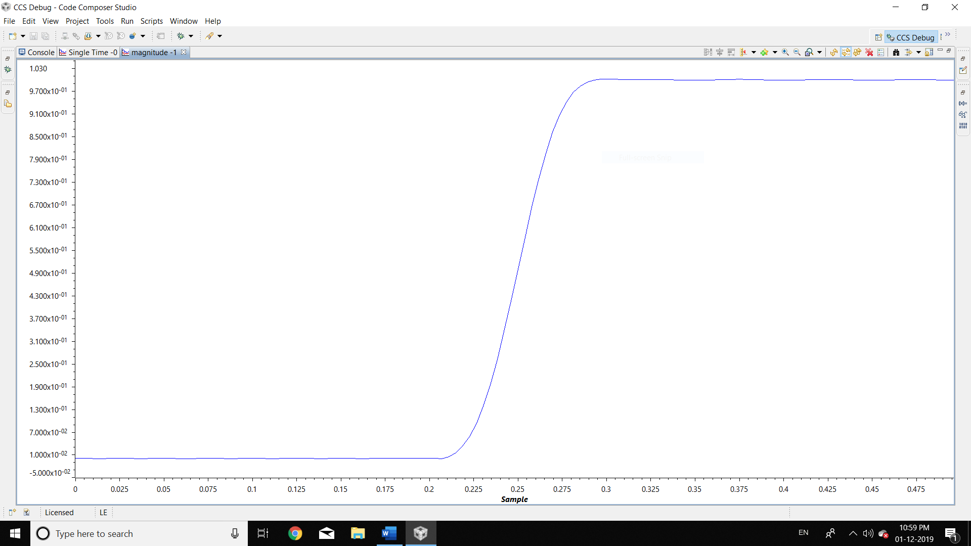

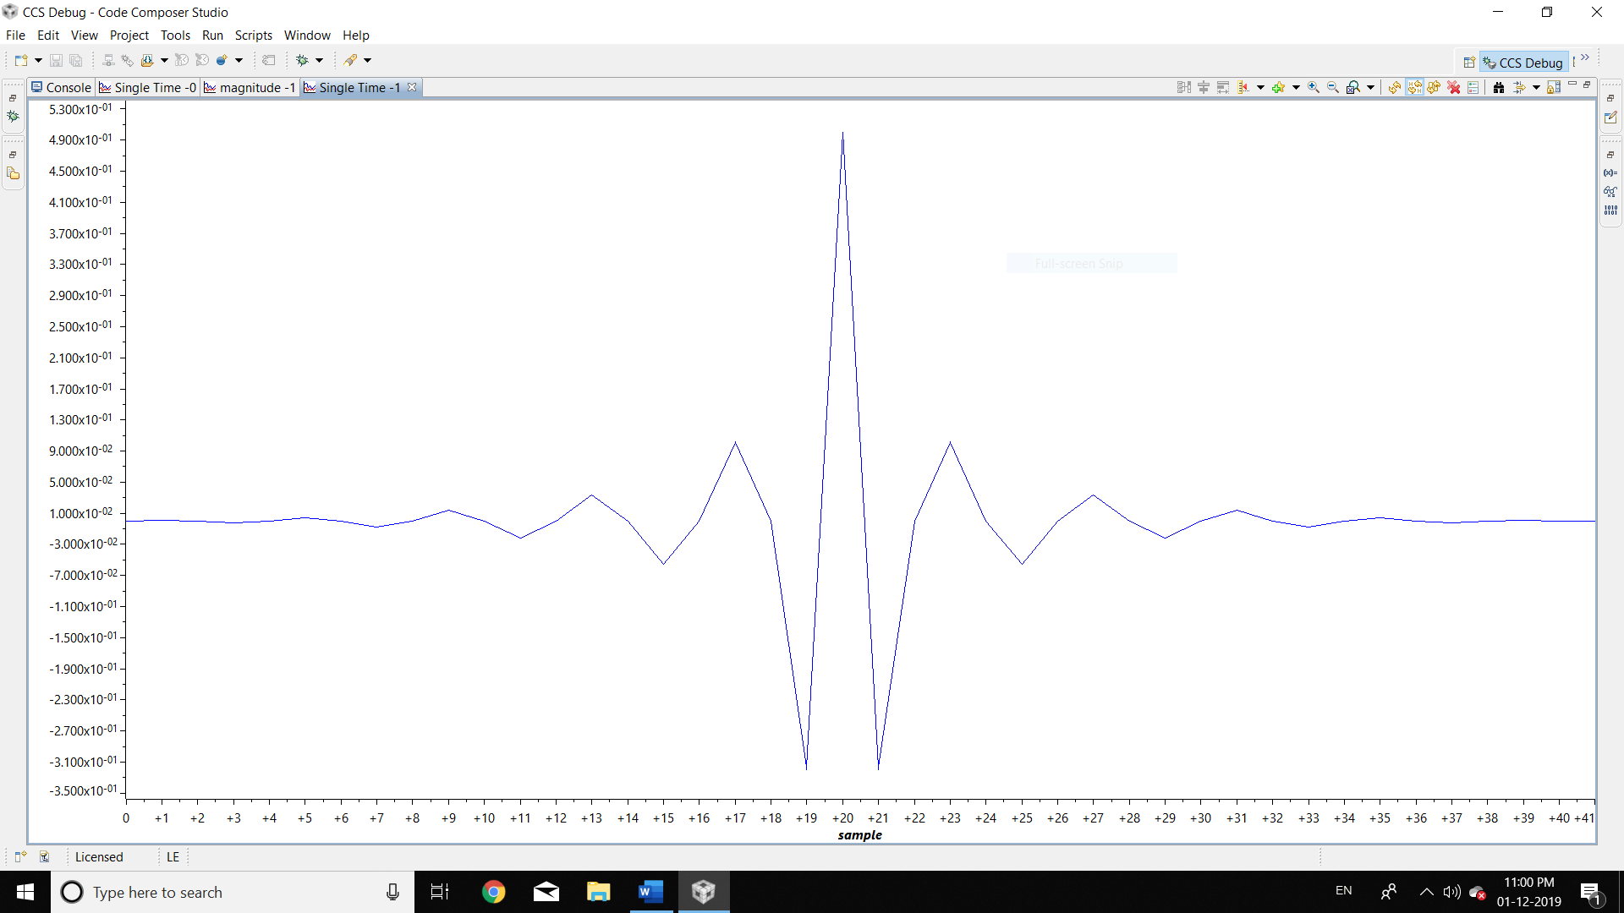

Generation of noise in matlab

n=15;

x=[];

for i=1:n+1

number=rand();

x(i)=sin(2*pi*10/100*i)+0.00001*number;

end

disp(x)