**First program**

**y[n]**

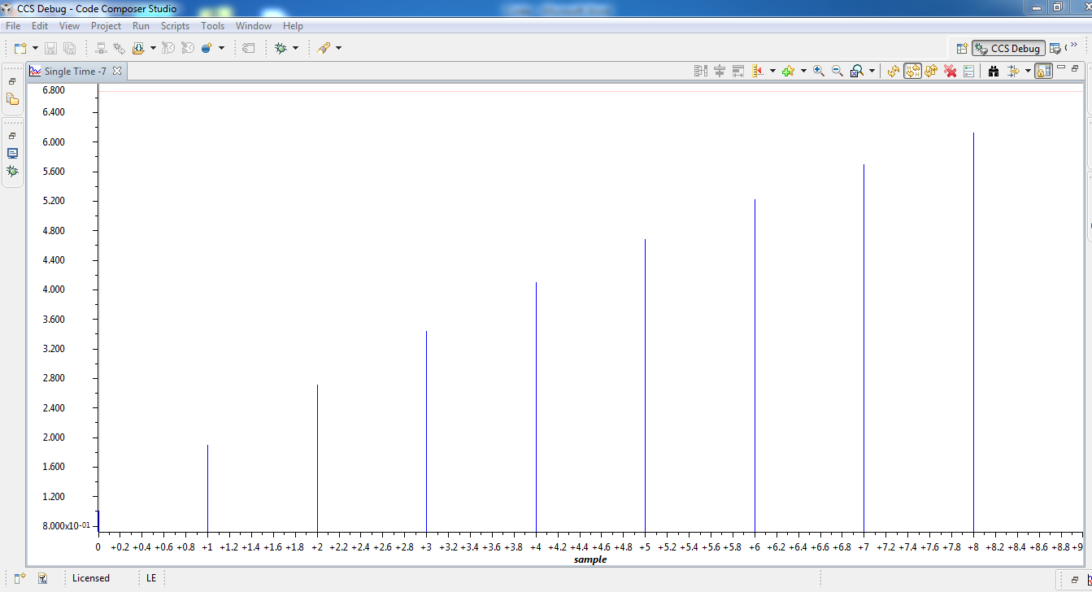

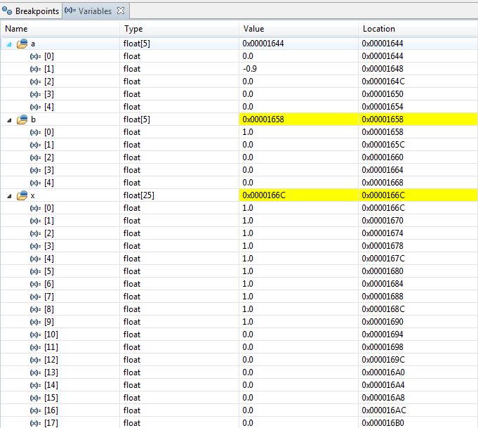

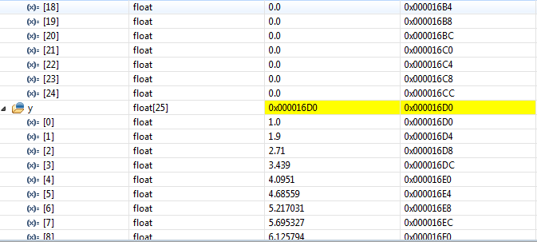

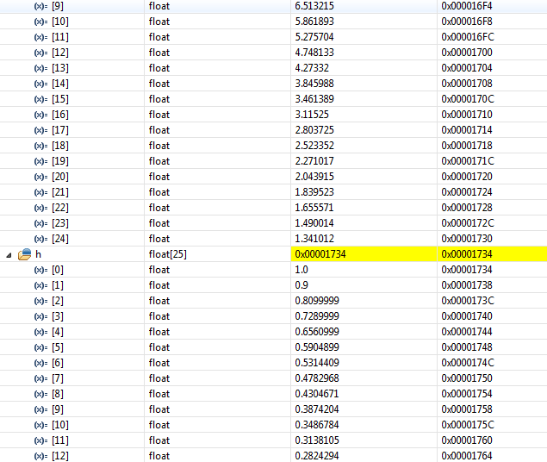

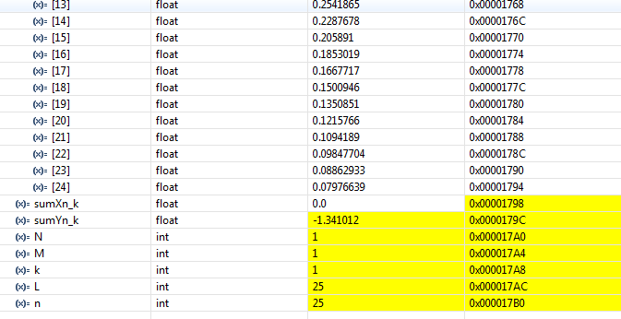

**h[n]**

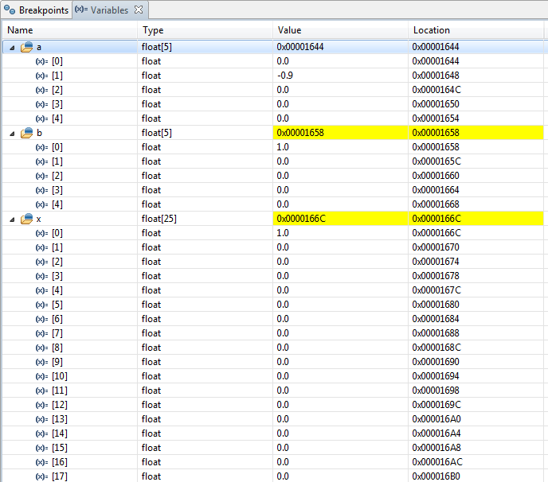

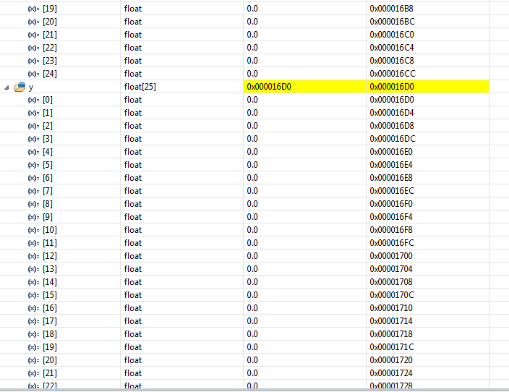

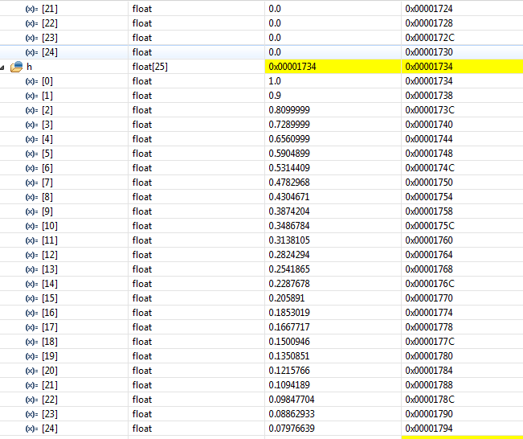

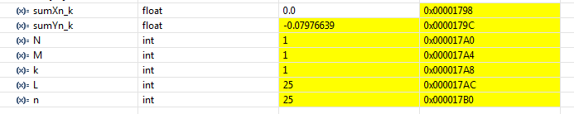

**h[n]**

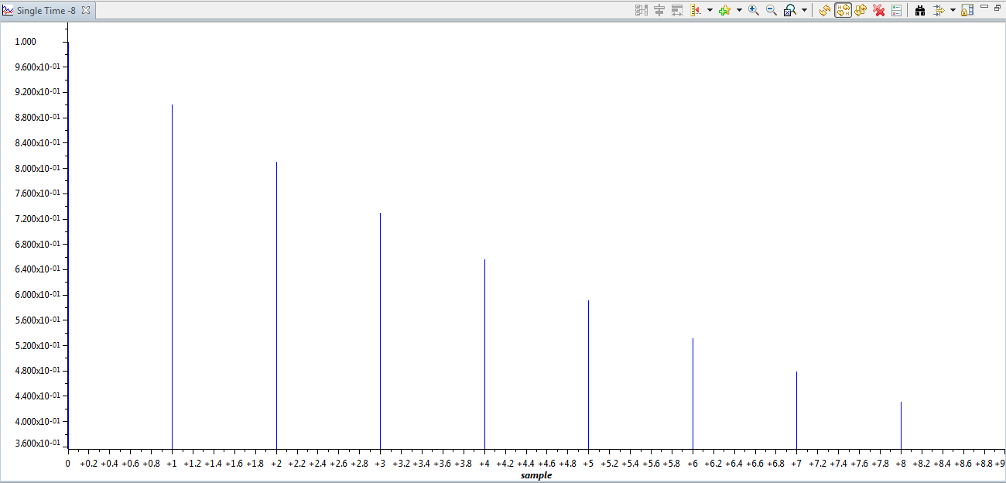

**Dual time graphs**

**h[n]**

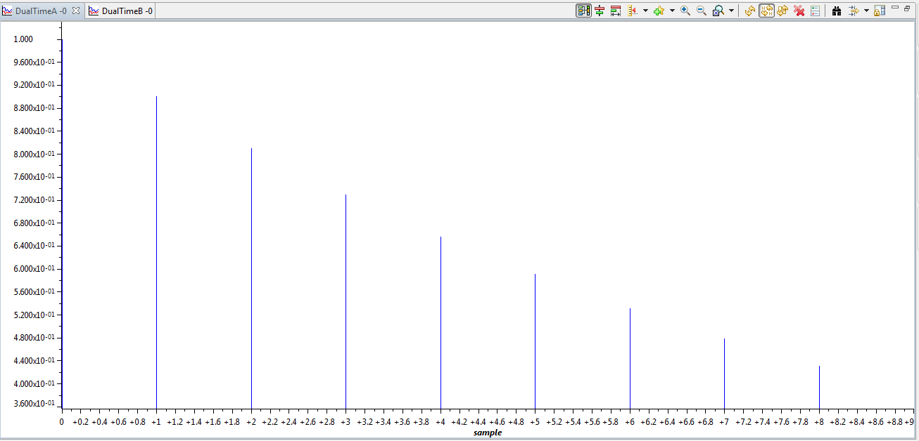

**y[n]**

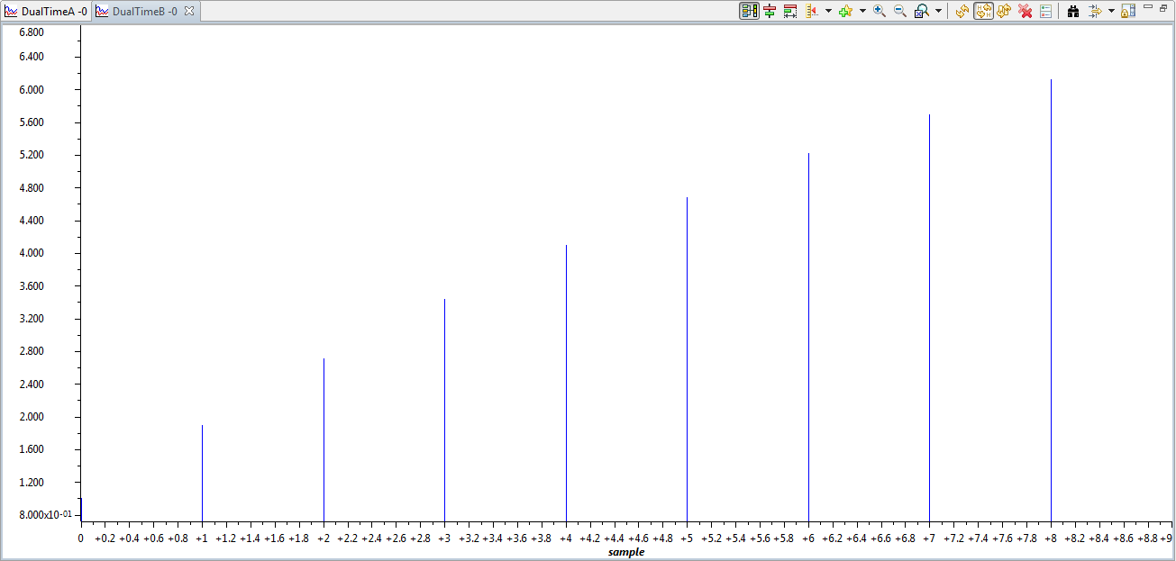

**Second program**

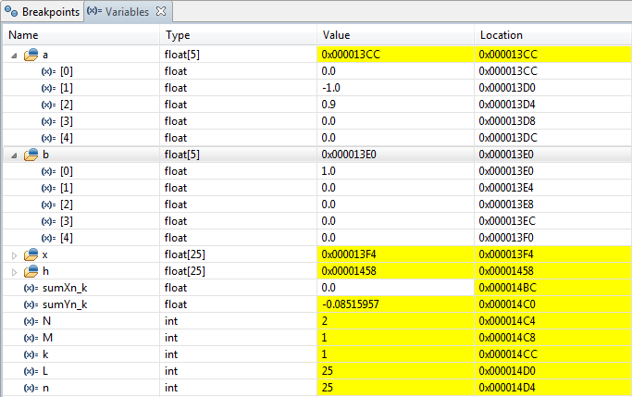

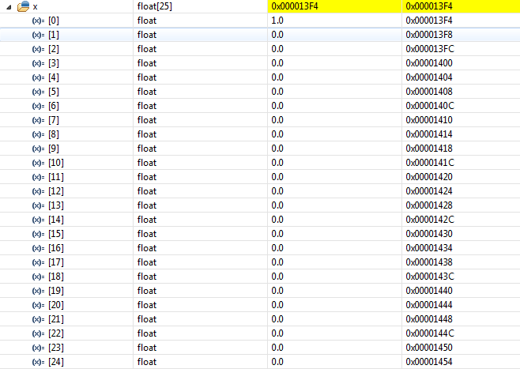

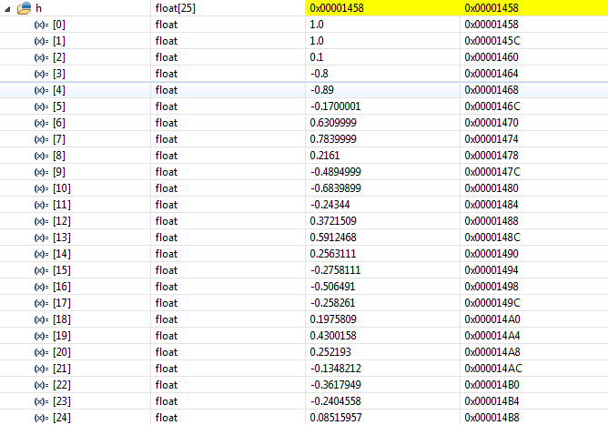

**h[n]**

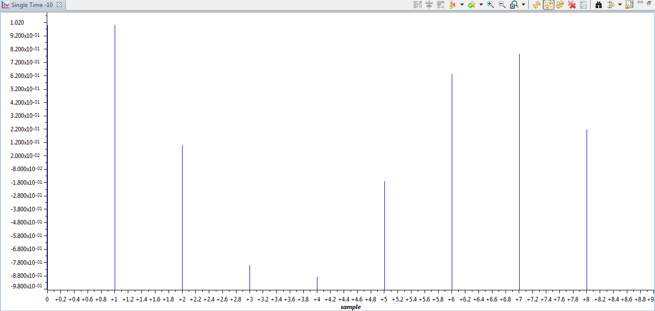

**Assignment**

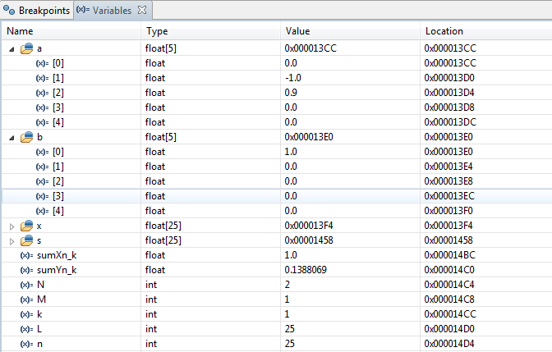

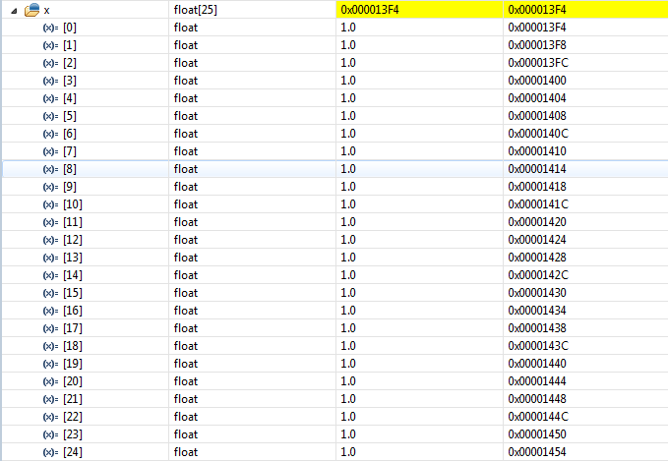

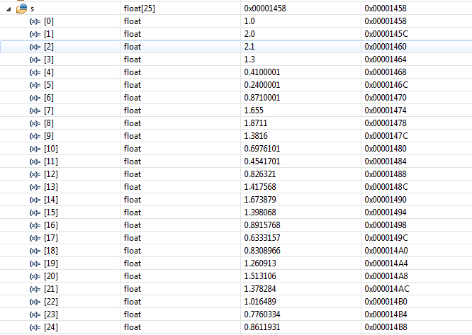

**Step response s[n]**

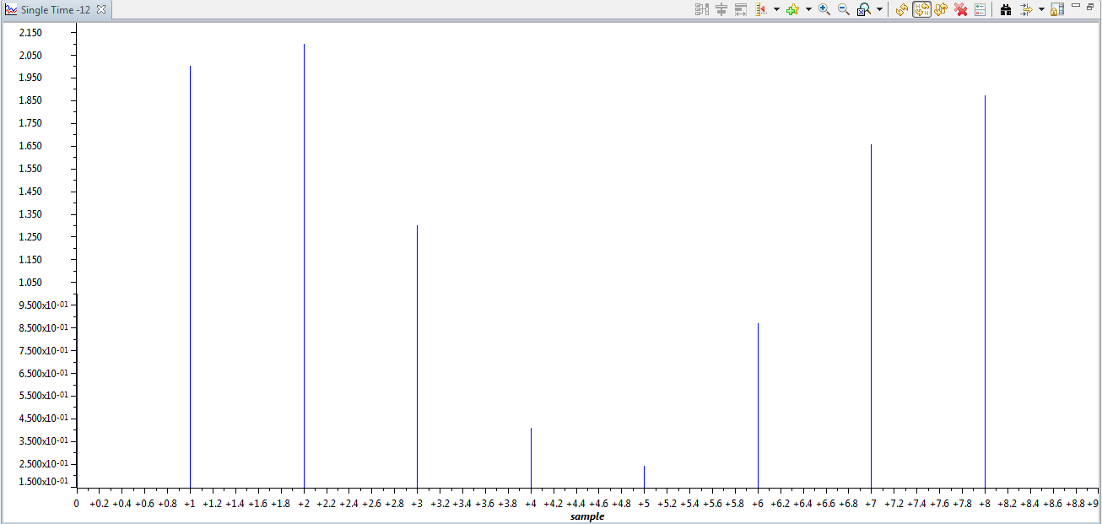

**Assignment code**

**#include**<stdio.h>

**#include**<math.h>

**void** **main**()

{

**float** a[5],b[5],x[25],s[25],sumXn_k,sumYn_k;

**int** N,M,k,L,n;

// Number of denominator coefficients and ak (a subscript k)

N=2;

a[1]=-1.0;

a[2]=0.9;

// Number of numerator coefficients and bk (b subscript k)

M=1;

b[0]=1;

// Number of input samples and the input sequences

L=25;

// step sequence from n=0 to n=25

**for**(k=0;k<L;k++)

{

x[k]=1.0;

}

// Computation of s(n) that is the step response

**for**(n=0;n<L;n++)

{

sumYn_k=0;

sumXn_k=0;

// computation of a1*y(n-1)+a2*y(n-2)+a3*y(n-3)+....

**for**(k=1;(k<=n)&&(k<=N);k++)

{

sumYn_k+=a[k]*s[n-k];

}

// computation of b0*x(n)+b1*x(n-1)+b2*x(n-2)+.....

**for**(k=0;(k<=n)&&(k<M);k++)

{

sumXn_k+=b[k]*x[n-k];

}

s[n]=-sumYn_k+sumXn_k;

}

}