CONTROL SYSTEM RESPONSE

(i)MATLAB program to find step,impulse and other inputs

num=26;

den=[1 2 26];

sys=tf(num,den)

roots(den)

t=0:0.01:10

step(sys,t);

grid on;

figure;

impulse(sys,t);

grid on;

stepinfo(sys)

[u,t1]=gensig('square',6);

figure;

lsimplot(sys,u,t1)

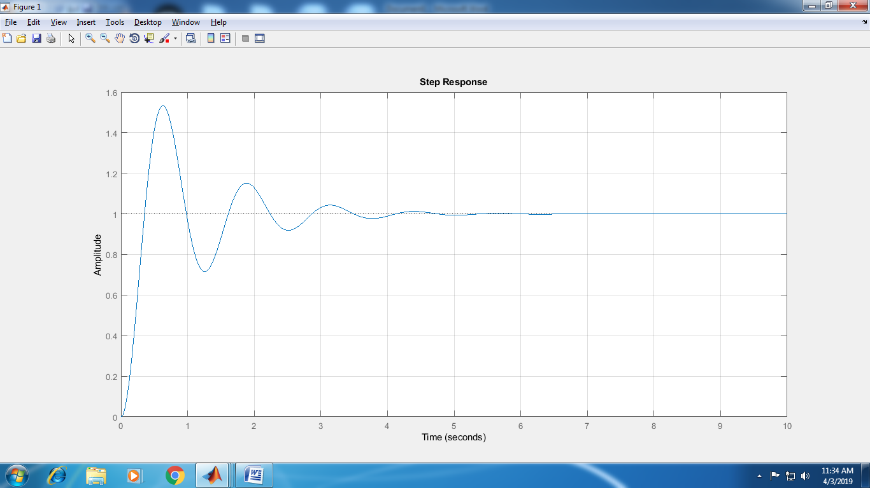

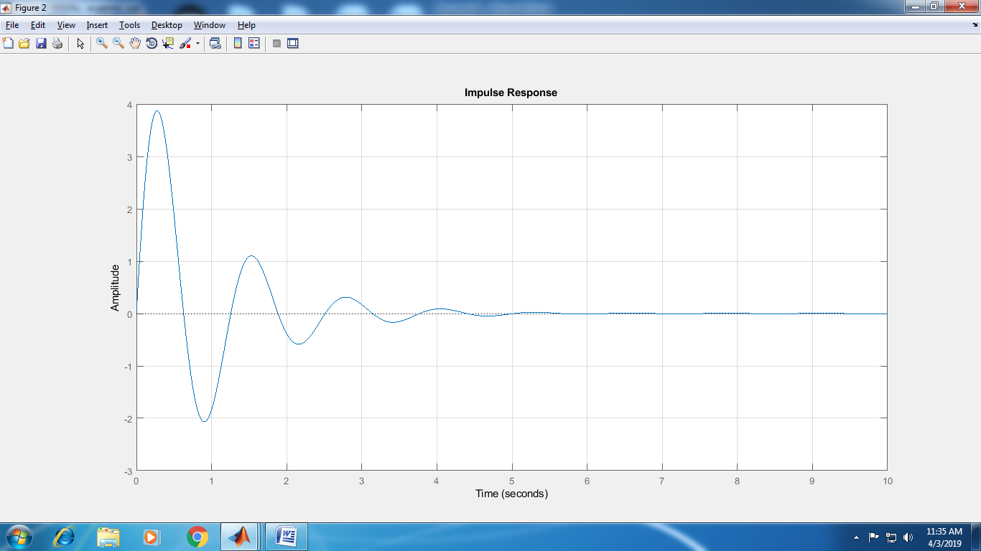

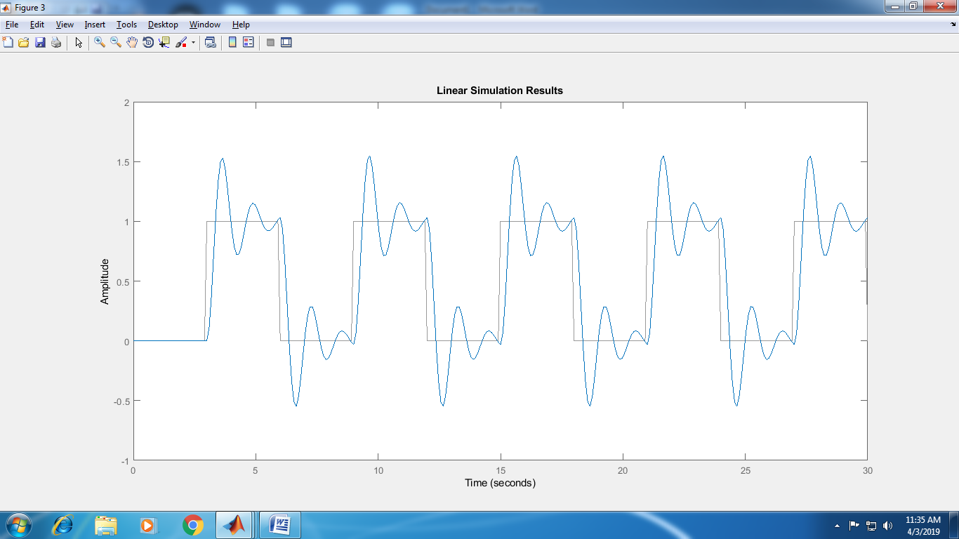

(ii)Use of Graphical user interface “ltiview”

num=26;

den=[1 2 26];

sys=tf(num,den)

roots(den)

ltiview(sys)

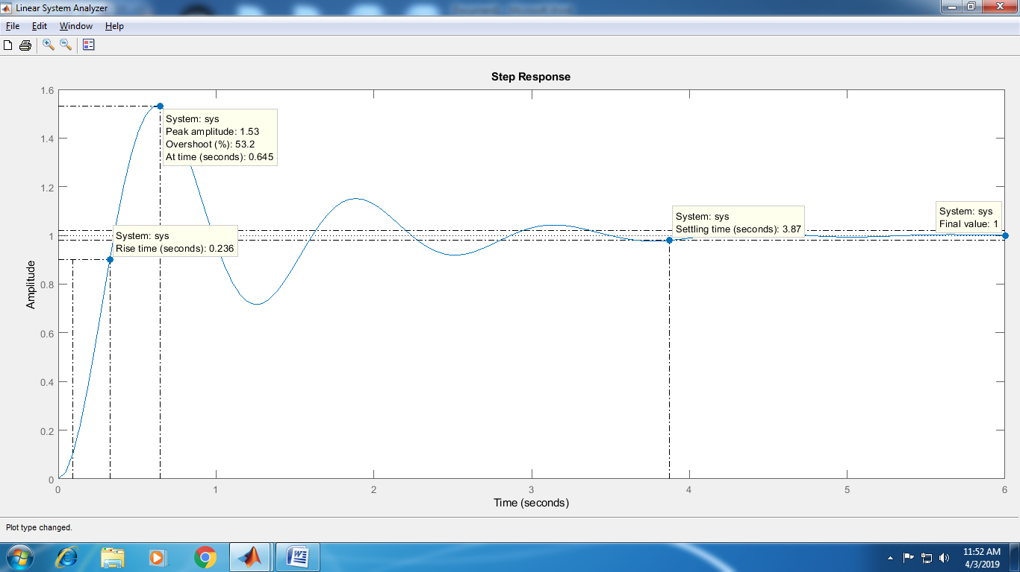

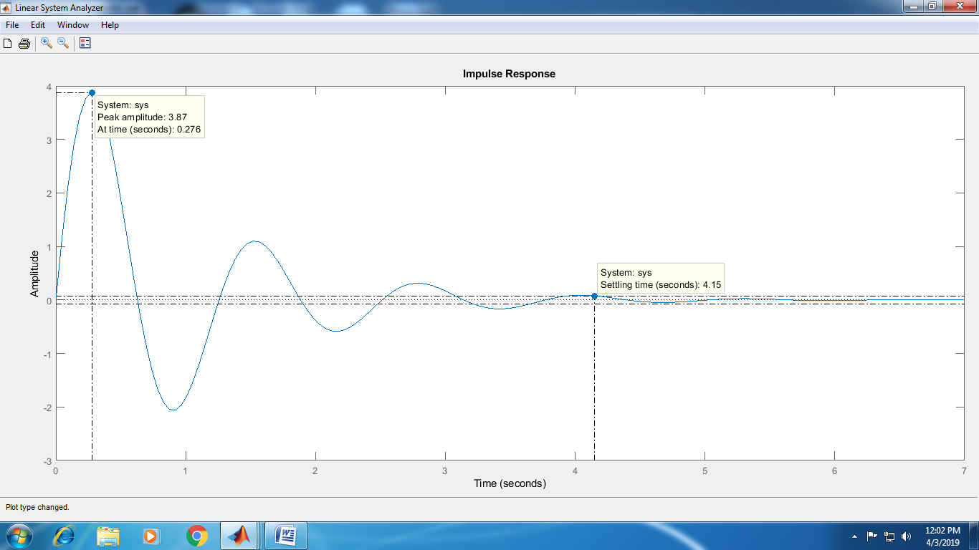

(iii)Ramp/parabolic response of the unity feedback control system having forward transfer function

n1=25;

d1=[1 5 25];

[n2,d2]=feedback(n1,d1,1,1);

sys=tf(n2,d2)

t=0:0.001:5;

u1=t;

plot(t,u1)

hold on;

lsimplot(sys,u1,t);

grid on;

title('ramp Response')

figure;

u2=t.\*t;

plot(t,u2)

hold on;

lsimplot(sys,u2,t);

grid on;

title('parabolic response')

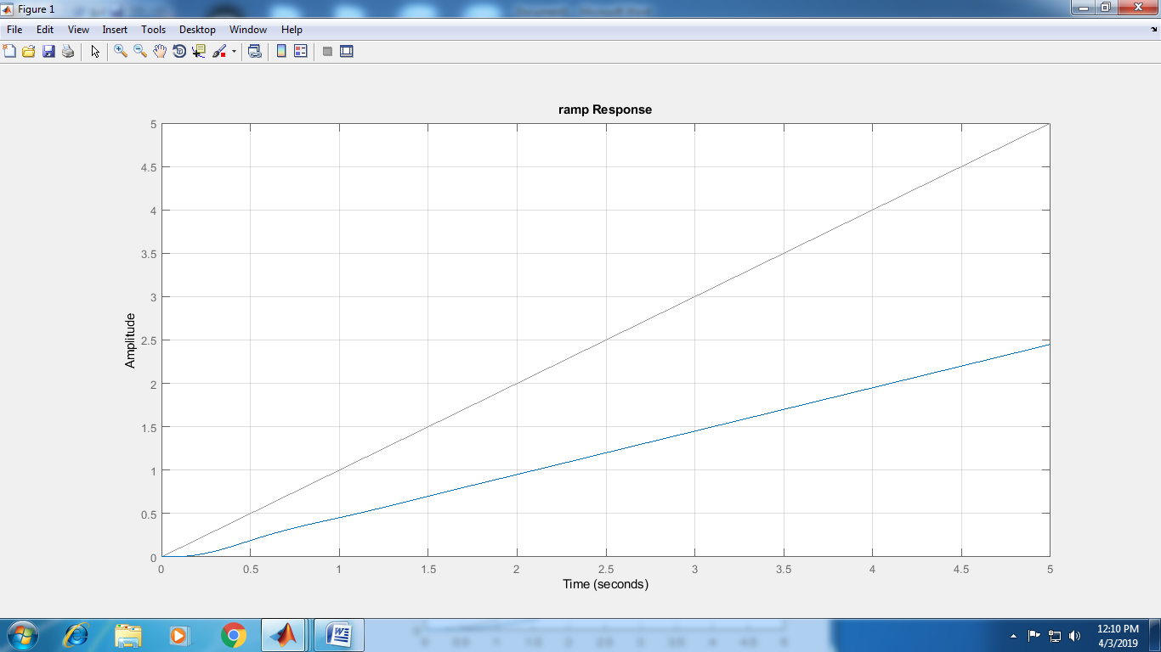

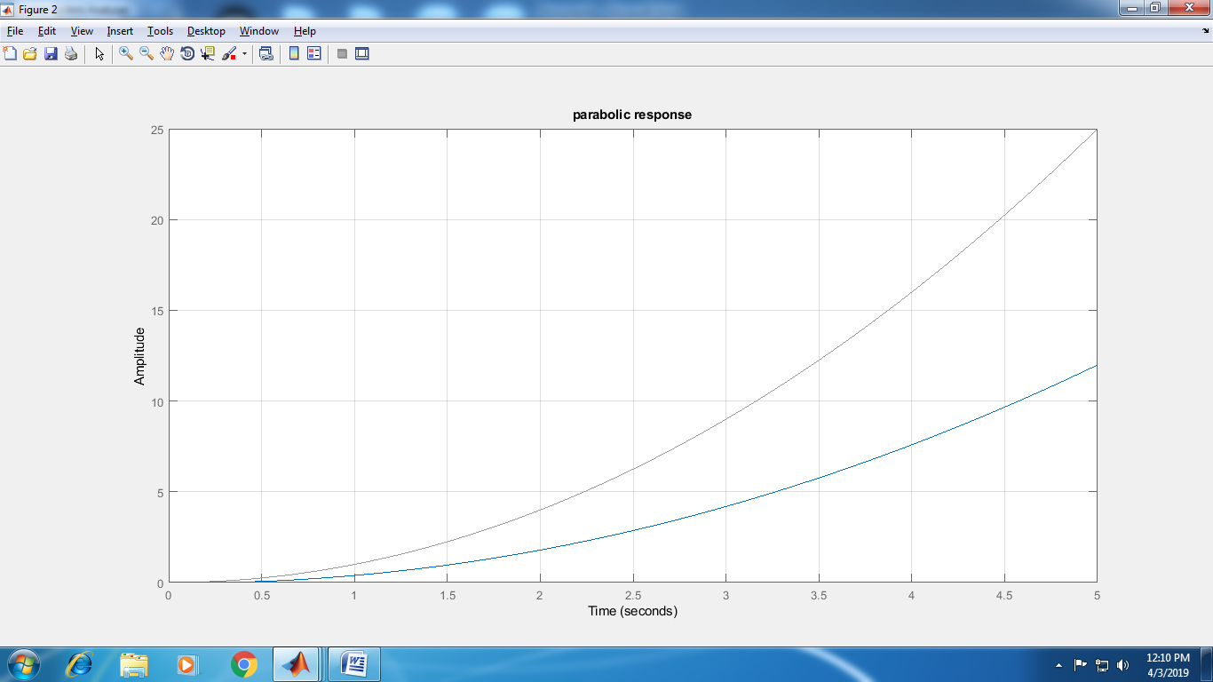

(v)Unity feedback control system with Time derivative

Program without PID function

nwd=25;

dwd=[1 2.5 0];

[n1,d1]=feedback(nwd,dwd,1,1);

disp('Transfer Function without derivative control is:');

sys1=tf(n1,d1)

Td=0.18;

nd=[Td 1];

dd=[0 1]

[ns,ds]=series(nd,dd,nwd,dwd);

[n2,d2]=feedback(ns,ds,1,1);

disp('Transfer function with derivative control is:');

sys2=tf(n2,d2)

step(sys1);

grid;

hold on;

step(sys2);

legend('without PD','with PD')

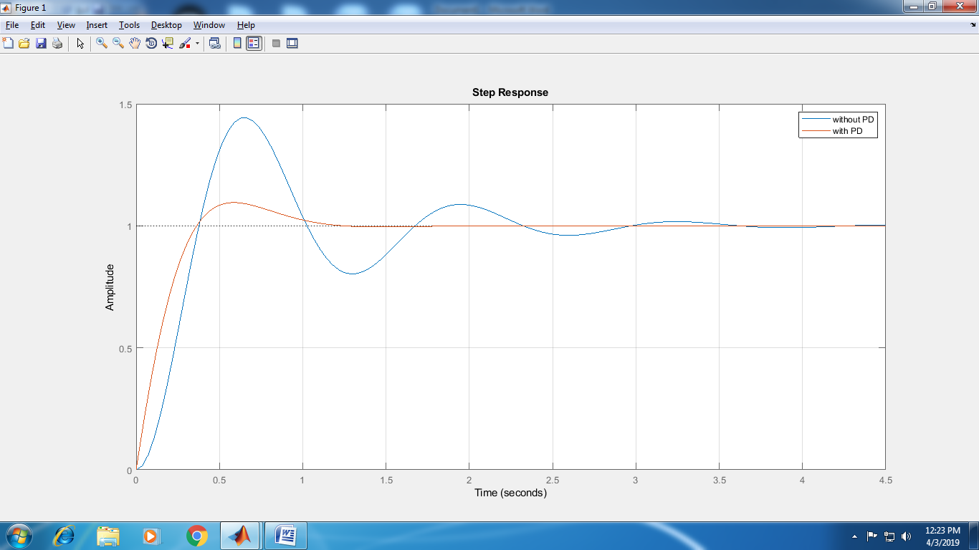

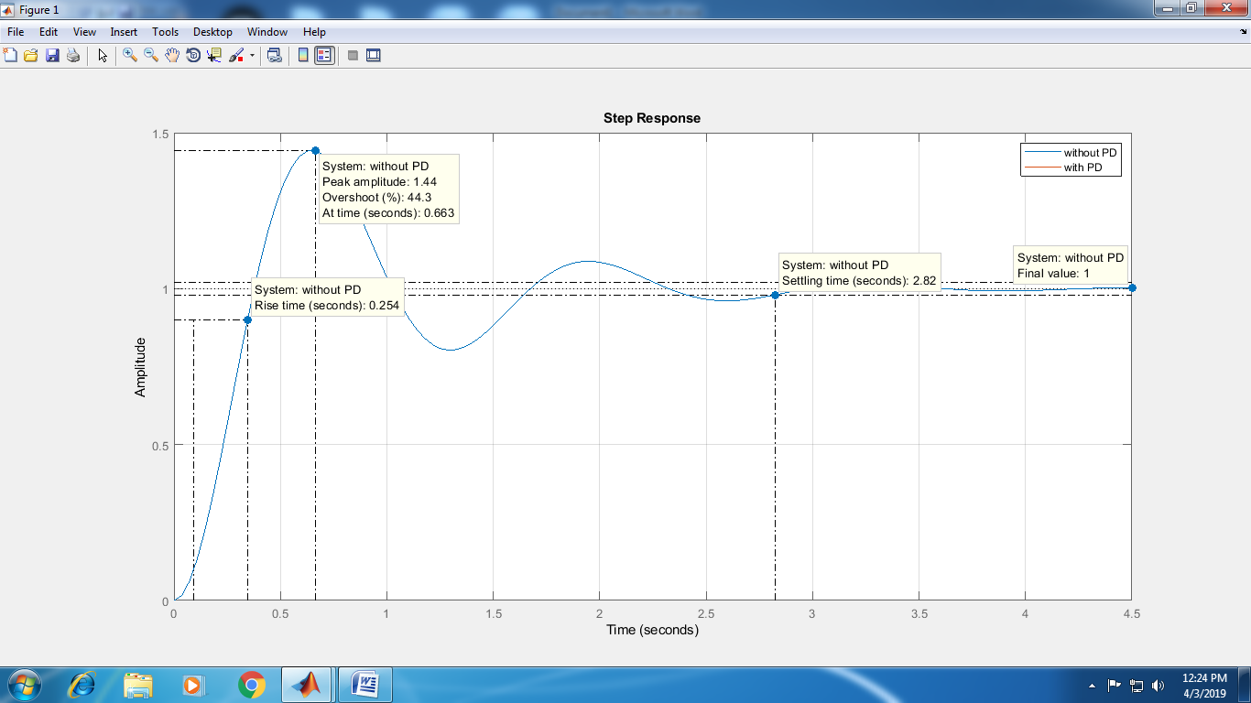

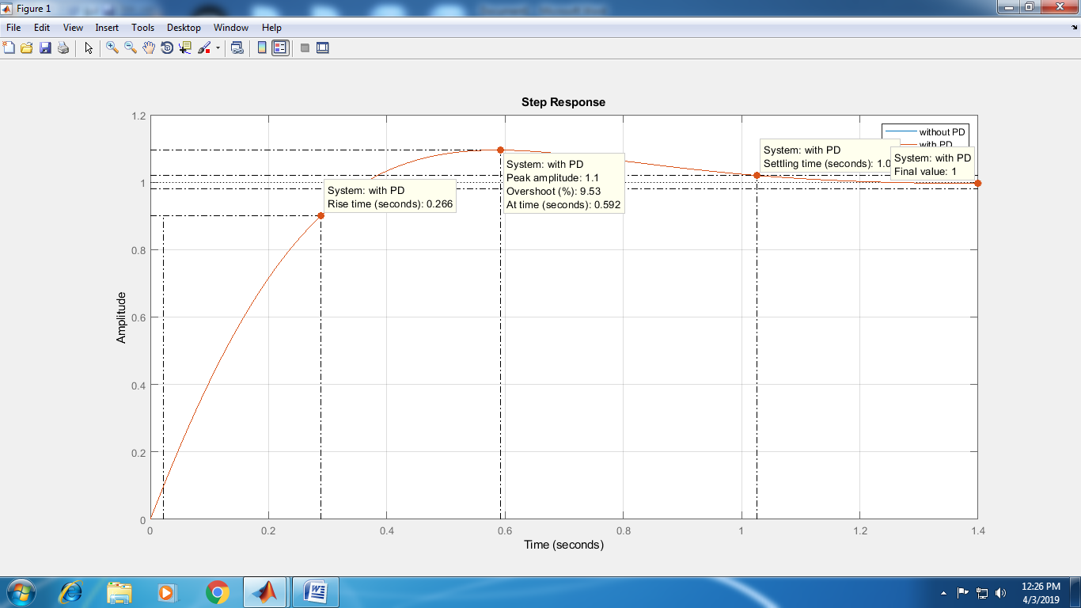

Program using PID function

nwd=25;

dwd=[1 2.5 0];

sys=tf(nwd,dwd);

[n1,d1]=feedback(nwd,dwd,1,1);

disp('Transfer function without derivative control is');

sys1=tf(n1,d1)

step(sys1);

grid;

hold on;

Kp=1;

Ki=0;

Kd=0.18;

C1=pid(Kp,Ki,Kd)

step(feedback(C1\*sys,1));

legend('without PD','with PD')

Program using PID Tuning function to get best response

nwd=25;dwd=[1 2.5 0];

sys=tf(nwd,dwd);

[n1,d1]=feedback(nwd,dwd,1,1);

disp('Transfer function without derivative control is');

sys1=tf(n1,d1)

step(sys1);grid;

hold on;

Kp=1;Ki=0;Kd=0.18;

C1=pid(Kp,Ki,Kd)

step(feedback(C1\*sys,1));

hold on;

Kp=0.8;Ki=0.6;Kd=0.18;

C2=pid(Kp,Ki,Kd)

step(feedback(C2\*sys,1));

legend('without PD','with PD')

[C3,Info]=pidtune(sys,'pid')

figure;step(feedback(C3\*sys,1));grid;

