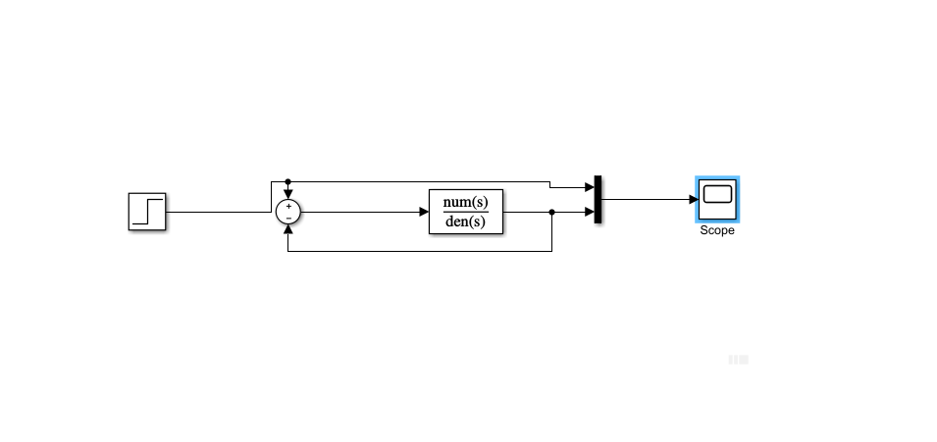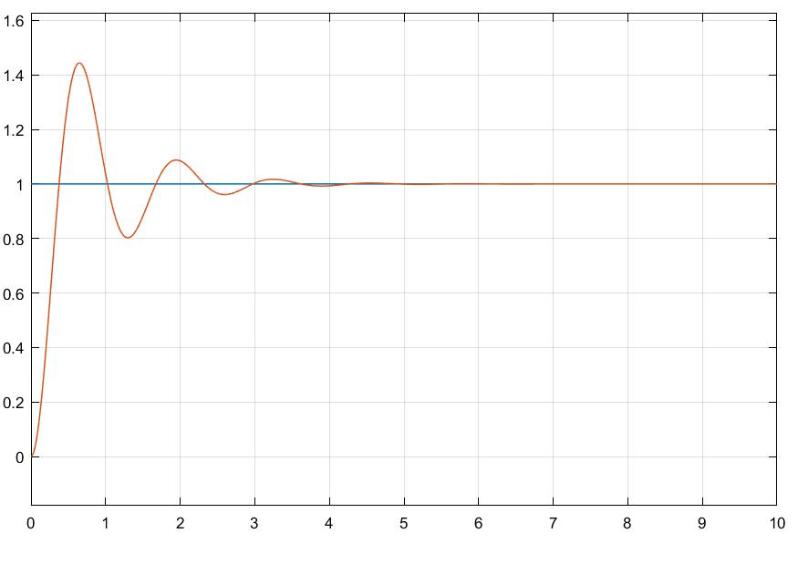Exp-7

Peak Time = 653.626 ms

Peak Overshoot = 0.444e

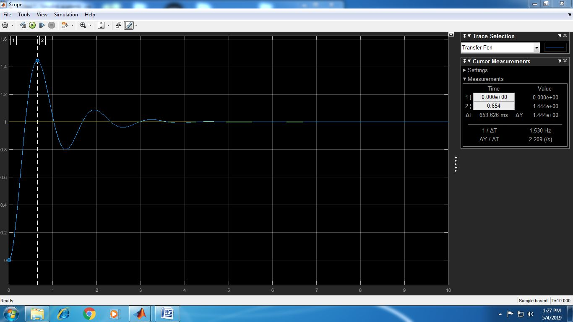

Rise Time = 376.908 ms

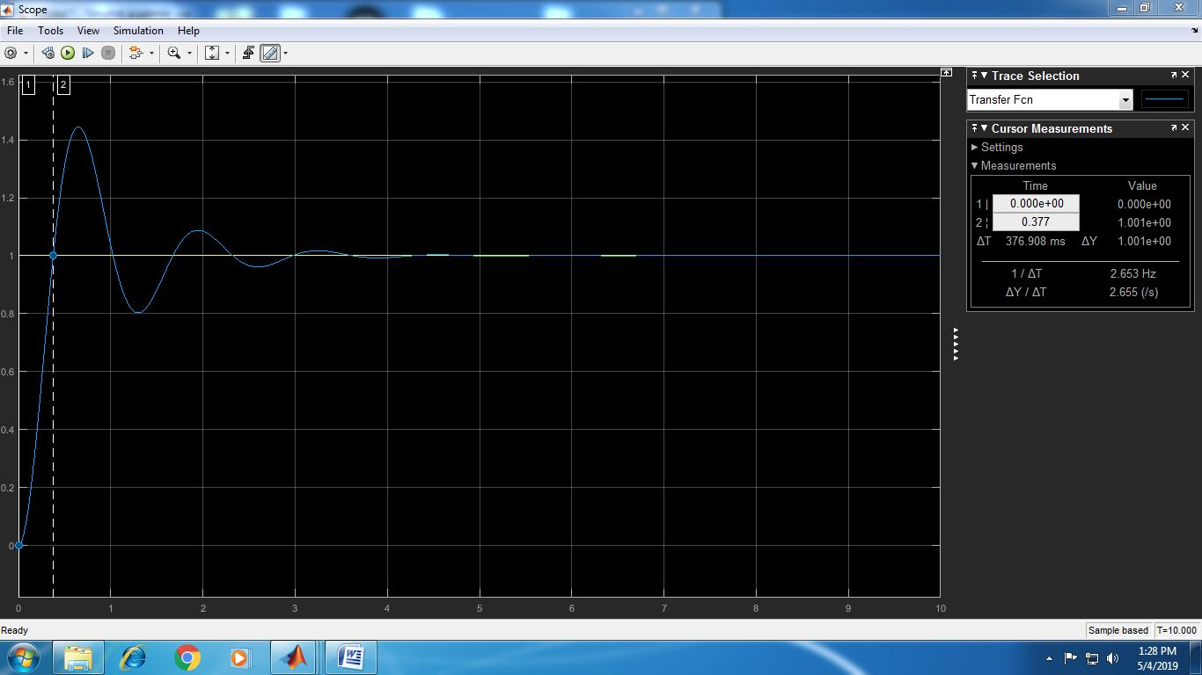

Exp-8

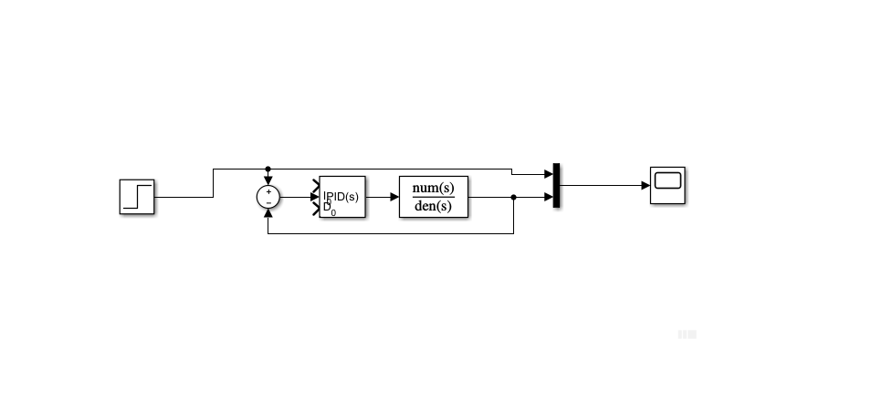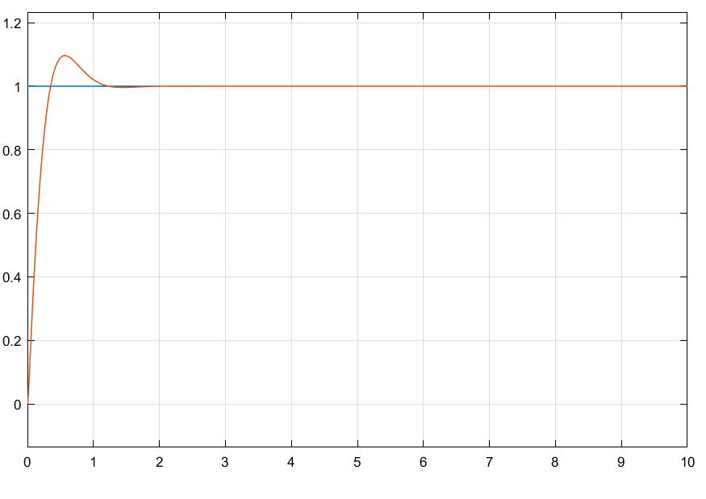

Rise Time = 367.366 ms

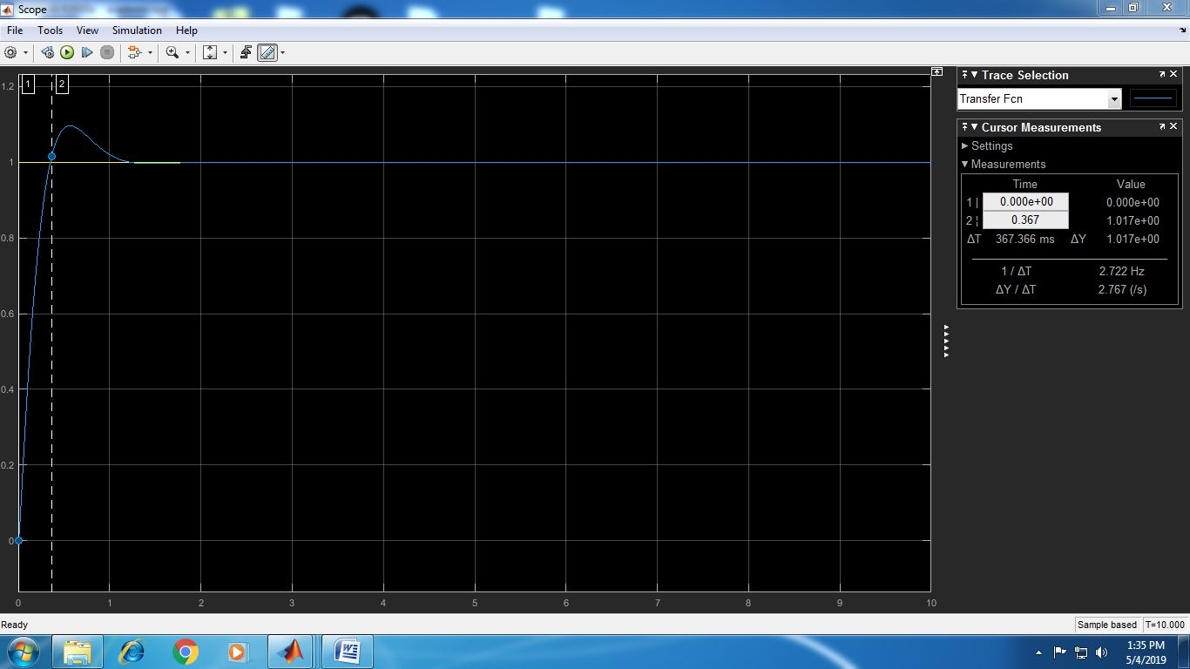

Peak Time = 558.206 ms

Peak Overshoot = 0.096e

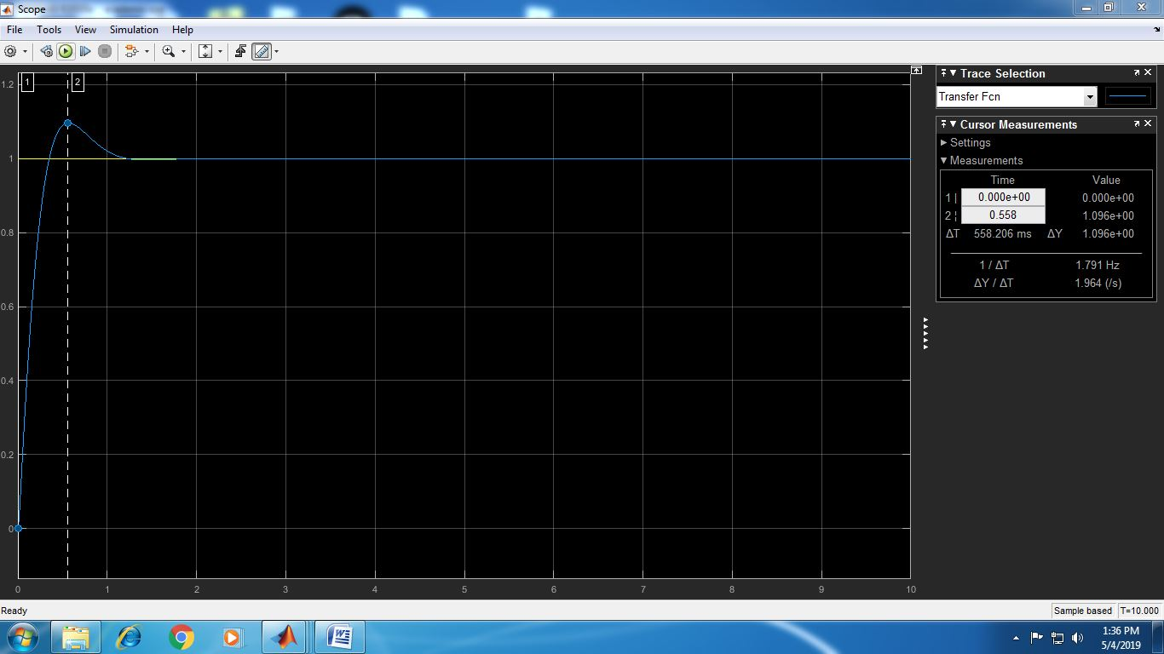

Exp-9

1.



2.





3.



4.



5.



6.

Assignment 1:





Exp-10

3.

Frequency Response





Assignment 2:

