MATLAB program to find step,impulse,square wave
clc; clear all; close all;
num=26;
den=[1 2 26];
sys=tf(num,den)
roots(den)
t=0:0.01:10;
step(sys,t);
grid on;
figure;
impulse(sys,t);
grid on;
stepinfo(sys)
[u,t1]=gensig('square',6);
figure;
lsimplot(sys,u,t1)

output
>> response1

sys =

26
--------------
s^2 + 2 s + 26

Continuous-time transfer function.

ans =

-1.0000 + 5.0000i
-1.0000 - 5.0000i

ans =

struct with fields:

RiseTime: 0.2356
SettlingTime: 3.8748
SettlingMin: 0.7160
SettlingMax: 1.5316
Overshoot: 53.1643
Undershoot: 0
Peak: 1.5316
PeakTime: 0.6447
Graphs

(ii)Use of Graphical user interface “ltiview”
num=26;
den=[1 2 26];
sys=tf(num,den)
roots(den)
ltiview(sys)

output
response2

sys =

26
--------------
s^2 + 2 s + 26

Continuous-time transfer function.

ans =

-1.0000 + 5.0000i
-1.0000 - 5.0000i

>> response2

sys =

26
--------------
s^2 + 2 s + 26

Continuous-time transfer function.

ans =

-1.0000 + 5.0000i
-1.0000 - 5.0000i
Graph:
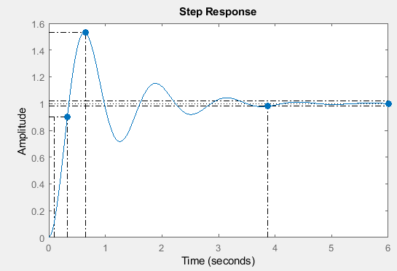
(iii)Ramp/parabolic response of the unity feedback control system having forward transfer function
n1=25;
d1=[1 5 25];
[n2,d2]=feedback(n1,d1,1,1);
sys=tf(n2,d2)
t=0:0.001:5;
u1=t;
plot(t,u1)
hold on;
lsimplot(sys,u1,t);
grid on;
title('ramp Response')
figure;
u2=t.*t;
plot(t,u2)
hold on;
lsimplot(sys,u2,t);
grid on;
title('parabolic response')
output:
sys =

25
--------------
s^2 + 5 s + 50
graphs:

(iv)Unity feedback control system with Time derivative
Program without PID function
nwd=25;
dwd=[1 2.5 0];
[n1,d1]=feedback(nwd,dwd,1,1);
disp('Transfer Function without derivative control is:');
sys1=tf(n1,d1)
Td=0.18;
nd=[Td 1];
dd=[0 1]
[ns,ds]=series(nd,dd,nwd,dwd);
[n2,d2]=feedback(ns,ds,1,1);
disp('Transfer function with derivative control is:');
sys2=tf(n2,d2)
step(sys1);
grid;
hold on;
step(sys2);
legend('without PD','with PD')

output:

>> response5
Transfer Function without derivative control is:

sys1 =

25
----------------
s^2 + 2.5 s + 25

Continuous-time transfer function.

dd =

0 1

Transfer function with derivative control is:

sys2 =

4.5 s + 25
--------------
s^2 + 7 s + 25

Continuous-time transfer function.
Graphs:
Program using PID function
nwd=25;
dwd=[1 2.5 0];
sys=tf(nwd,dwd);
[n1,d1]=feedback(nwd,dwd,1,1);
disp('Transfer function without derivative control is');
sys1=tf(n1,d1)
step(sys1);
grid;
hold on;
Kp=1;
Ki=0;
Kd=0.18;
C1=pid(Kp,Ki,Kd)
step(feedback(C1*sys,1));
legend('without PD','with PD')

Output:

>> response6
Transfer function without derivative control is

sys1 =

25
----------------
s^2 + 2.5 s + 25

Continuous-time transfer function.

C1 =

Kp + Kd * s

with Kp = 1, Kd = 0.18

Continuous-time PD controller in parallel form.

>> response6
Transfer function without derivative control is

sys1 =

25
----------------
s^2 + 2.5 s + 25

Continuous-time transfer function.

C1 =

Kp + Kd * s

with Kp = 1, Kd = 0.18

Continuous-time PD controller in parallel form.
Graph :
Program using PID Tuning function to get best response
nwd=25;dwd=[1 2.5 0];
sys=tf(nwd,dwd);
[n1,d1]=feedback(nwd,dwd,1,1);
disp('Transfer function without derivative control is');
sys1=tf(n1,d1)
step(sys1);grid;
hold on;
Kp=1;Ki=0;Kd=0.18;
C1=pid(Kp,Ki,Kd)
step(feedback(C1*sys,1));
hold on;
Kp=0.8;Ki=0.6;Kd=0.18;
C2=pid(Kp,Ki,Kd)
step(feedback(C2*sys,1));
legend('without PD','with PD')
[C3,Info]=pidtune(sys,'pid')
figure;step(feedback(C3*sys,1));grid;
output:
Transfer function without derivative control is

sys1 =

25
----------------
s^2 + 2.5 s + 25

Continuous-time transfer function.

C1 =

Kp + Kd * s

with Kp = 1, Kd = 0.18

Continuous-time PD controller in parallel form.

C2 =

1
Kp + Ki * --- + Kd * s
s

with Kp = 0.8, Ki = 0.6, Kd = 0.18

Continuous-time PID controller in parallel form.

C3 =

1
Kp + Ki * --- + Kd * s
s

with Kp = 0.527, Ki = 0.337, Kd = 0.183

Continuous-time PID controller in parallel form.

Info =

struct with fields:

Stable: 1
CrossoverFrequency: 4.4525
PhaseMargin: 83.8783

Graphs:

