1.
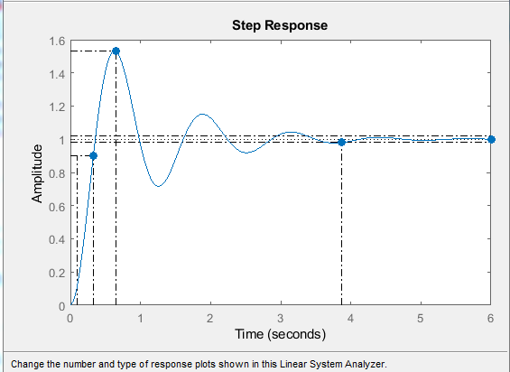
2.

3.

4.

Assignment:

