StepImpulseSquareWaveResponse.m

clc;
clear all;
close all;
num=26;
den=[1 2 26];
sys=tf(num,den)
roots(den) % poles of the system
t=0:0.01:10; % response time vector
step(sys,t); % step response of the system with plot
grid on;
figure;
impulse(sys,t); % impulse response of the system with plot
grid on;
stepinfo(sys) % step response information
[u,t1]=gensig('square',6); % generate square wave
figure;
lsimplot(sys,u,t1) % plot the response of LTI system for the specified input % u

sys =

26
--------------
s^2 + 2 s + 26

Continuous-time transfer function.

ans =

-1.0000 + 5.0000i
-1.0000 - 5.0000i

Warning: MATLAB has disabled some advanced graphics rendering features by switching to software OpenGL. For more information,
click here.

ans =

struct with fields:

RiseTime: 0.2356
SettlingTime: 3.8748
SettlingMin: 0.7160
SettlingMax: 1.5316
Overshoot: 53.1643
Undershoot: 0
Peak: 1.5316
PeakTime: 0.6447

>>

----------------------------------------------------------------
guiCSResponse.m

clc;
clear all;
close all;
num=26;
den=[1 2 26];
sys=tf(num,den)
roots(den) % poles of the system
ltiview(sys) % graphical user interface

sys =

26
--------------
s^2 + 2 s + 26

Continuous-time transfer function.

ans =

-1.0000 + 5.0000i
-1.0000 - 5.0000i

>>

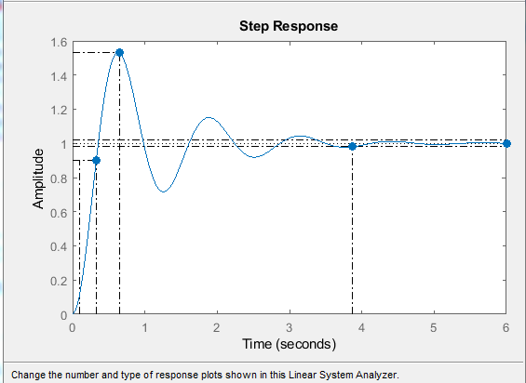

----------------------------------------------------------------

RampParabolicResponse.m
clc;
clear all;
close all;
n1=25;
d1=[1 5 25];
[n2,d2]=feedback(n1,d1,1,1);
sys=tf(n2,d2)
t=0:0.001:5;
u1=t; % ramp input
plot(t,u1)
hold on;
lsimplot(sys,u1,t);
grid on;
title(' Ramp Response ')
figure;
u2=t.*t; % parabolic input
plot(t,u2)
hold on;
lsimplot(sys,u2,t);
grid on;
title(' Parabolic Response ')

sys =

25
--------------
s^2 + 5 s + 50

Continuous-time transfer function.

>>

------------------------------------------------------------------------------------------------------------------------------------------
4th
Csr4.m
% program without PID function
clc;
close all;
clear all;
% transfer function without derivative control
nwd=25;
dwd=[1 2.5 0];
[n1,d1]=feedback(nwd,dwd,1,1); % unity feedback
disp(' Transfer Function without derivative control is : ');
sys1=tf(n1,d1)
Td=0.18;
nd=[Td 1];
dd=[0 1];
% Transfer Function of derivative control
[ns,ds]=series(nd,dd,nwd,dwd);
[n2,d2]=feedback(ns,ds,1,1);
disp(' Transfer Function with derivative control is : ');
sys2=tf(n2,d2)
step(sys1);
grid;
hold on;
step(sys2);
legend('without','with PD')

Transfer Function without derivative control is :

sys1 =

25
----------------
s^2 + 2.5 s + 25

Continuous-time transfer function.

Transfer Function with derivative control is :

sys2 =

4.5 s + 25
--------------
s^2 + 7 s + 25

Continuous-time transfer function.

>

------------------------------------------------------------------------------------------------------------------------------------------
Csr5.m
% program using PID function
clc;
close all;
clear all;
% Transfer function without derivative control
nwd=25;
dwd=[1 2.5 0];
sys=tf(nwd,dwd);
[n1,d1]=feedback(nwd,dwd,1,1);
disp(' Transfer Function without derivative control is : ');
sys1=tf(n1,d1)
%% Step response without PD controller
step(sys1);
grid;
hold on;
%% Define as a PID object
Kp=1;
Ki=0;
Kd=0.18;
C1=pid(Kp,Ki,Kd)
% Add derivative term to increase stability
step(feedback(C1*sys,1)); % step response with PD controller
legend('without','with PD')

Transfer Function without derivative control is :

sys1 =

25
----------------
s^2 + 2.5 s + 25

Continuous-time transfer function.

C1 =

Kp + Kd * s

with Kp = 1, Kd = 0.18

Continuous-time PD controller in parallel form.

>>

----------------------------------------------------------------

BestResponseUsingPIDfunction.m

clc;
close all;
clear all;
% Transfer function without derivative control
nwd=25;
dwd=[1 2.5 0];
sys=tf(nwd,dwd);
[n1,d1]=feedback(nwd,dwd,1,1);
disp('Transfer Function without derivative control is: ');
sys1=tf(n1,d1)
% STep response without PD controller
step(sys1);
grid;
hold on;
% Define as a PID object
Kp=1;
Ki=0;
Kd=0.18;
C1=pid(Kp,Ki,Kd)
% Add derivative term to increase stability
step(feedback(C1*sys,1)); % step response with PD controller
hold on;
% Define as a PID object
Kp=0.8;
Ki=0.6;
Kd=0.18;
C2=pid(Kp,Ki,Kd)
% Add derivative term to increase stability and integral term to reduce
% steady state error
% step response with PID controller
step(feedback(C2*sys,1));
legend('without','with PD','with PID')
% Design from command line
[C3,Info]=pidtune(sys,'pid')
% look at controller , C3, info
figure;
step(feedback(C3*sys,1));
grid;

Transfer Function without derivative control is:

sys1 =

25
----------------
s^2 + 2.5 s + 25

Continuous-time transfer function.

C1 =

Kp + Kd * s

with Kp = 1, Kd = 0.18

Continuous-time PD controller in parallel form.

C2 =

1
Kp + Ki * --- + Kd * s
s

with Kp = 0.8, Ki = 0.6, Kd = 0.18

Continuous-time PID controller in parallel form.

C3 =

1
Kp + Ki * --- + Kd * s
s

with Kp = 0.527, Ki = 0.337, Kd = 0.183

Continuous-time PID controller in parallel form.

Info =

struct with fields:

Stable: 1
CrossoverFrequency: 4.4525
PhaseMargin: 83.8783

>>

------------------------------------------------------------------------------------------------------------------------------------------
Exp7ass.m
clc;
clear all;
close all;
num=[1 1];
den=[1 2 0];
[n1,d1]=feedback(num,den,1,1);
sys=tf(n1,d1)
roots(den) % poles of the system
t=0:0.01:10; % response time vector
step(sys,t); % step response of the system with plot
grid on;
figure;
impulse(sys,t); % impulse response of the system with plot
grid on;
stepinfo(sys) % step response information
[u,t1]=gensig('square',6); % generate square wave
figure;
lsimplot(sys,u,t1) % plot the response of LTI system for the specified input % u

sys =

s + 1
-------------
s^2 + 3 s + 1

Continuous-time transfer function.

ans =

0
-2

ans =

struct with fields:

RiseTime: 5.0699
SettlingTime: 9.3949
SettlingMin: 0.9010
SettlingMax: 0.9992
Overshoot: 0
Undershoot: 0
Peak: 0.9992
PeakTime: 17.9068

>>

