Question 1

<?php
// Reject invalid page numbers before they reach the query.
$page = filter_input(
INPUT_GET,
'page',
FILTER_VALIDATE_INT,
['options' => ['min_range' => 1]]
);
$page = $page ?: 1;

// Treat a missing search term as an empty search.
$search=trim((string)($_GET['s'] ?? ''));

// WP_Query is a class, so use "new" to create its query object.
$q = new WP_Query([
'posts_per_page' => 10,
// WP_Query uses "paged" to select a search-results page.
'paged' => $page,
's' => $search,
]);

$pages = (int) $q->max_num_pages;
?>

<?php if ($search !== '') : ?>
<h1>
Page <?= esc_html((string) $page) ?>
of <?= esc_html((string) $pages) ?>:
Search for <?= esc_html($search) ?>
</h1>
<?php endif; ?>

<?php if ($q->have_posts()) : ?>

<?php while ($q->have_posts()) : $q->the_post(); ?>

<?php
// Apply the standard WordPress formatting before replacing placeholders.
$content = apply_filters('the_content', get_the_content());

// Escape the brackets so the pattern matches the literal [ad] marker.
$content = preg_replace_callback(
'/
$ad$
/',
static function ($matches) {
return '<div class="ad"></div>';
},
$content
);
?>

<article>
<h2><?= esc_html(get_the_title()) ?></h2>
<div class="post-content">
<?= $content ?>
</div>
</article>

<?php endwhile; ?>

<?php if ($pages > 1) : ?>
<nav aria-label="Search results pagination">
<?php
echo wp_kses_post(
paginate_links([
'base' => add_query_arg('page', '%#%'),
'format' => '',
'current' => $page,
'total' => $pages,
])
);
?>
</nav>
<?php endif; ?>

<?php else : ?>

<p>No posts found.</p>

<?php endif; ?>

<?php wp_reset_postdata(); ?>

Explanation:
The original code had several errors. WP_Query needed to be instantiated using new, and paged should be used instead of page in the query arguments. The page number needed validation, the search parameter needed a default value, and $pages was undefined. The ad replacement pattern did not correctly match the literal [ad] marker, and the callback used an undefined variable and echoed the replacement instead of returning it. The title was also called incorrectly, and the post content lacked WordPress content formatting.
I corrected these issues by validating the page number, safely handling the search term, retrieving ten posts per page, and calculating the total number of pages. I also replaced each [ad] marker with an ad <div>, added a message for empty results, and reset the post data after the custom query.
I added a <nav> section using paginate_links() to provide clickable pagination links through the page query parameter, making it possible to navigate between result pages.
Checks performed:
- Missing parameters: defaults to page 1 with an empty search term.
- Page 2: ?page=2 selects the second page of results.
- No search results: displays “No posts found.”
- Multiple [ad] markers: each marker is replaced with an ad <div>.
Assumption: Every ad placeholder is exactly [ad] and does not require a unique identifier.

Question 2

Likely causes and troubleshooting steps
1. User permissions or role restrictions
- Check: I would first log in as an administrator and check the editor’s role and upload permissions.
- Evidence: I would compare the editor’s permissions with those of the colleague who can upload images.
- Action: If the editor lacks the required permissions, I would restore the appropriate role or capability.
2. Plugin or security restrictions
- Check: I would review the security plugin settings and logs for blocked upload requests.
- Evidence: I would look for errors or security rules preventing the upload.
- Action: I would correct the responsible rule or plugin configuration.
3. Browser-related issues
- Check: I would try uploading the image in another browser or a private window.
- Evidence: If the upload works, I would investigate browser extensions, cached data, or console errors.
- Action: I would disable conflicting extensions, clear the cache, or resolve any identified browser errors.
4. File upload limits or server configuration
- Check: I would try a smaller image and check the file type, PHP upload limits, and server permissions.
- Evidence: I would review WordPress error messages, PHP configuration, and server logs.
- Action: I would adjust the relevant upload limits or server permissions if necessary.
Order of investigation: I would start with user permissions, followed by plugin or security restrictions, browser issues, and finally file or server configuration.
Verification: After identifying and fixing the cause, I would test the upload again using the affected editor’s account to confirm that it works successfully.

Question 3

1. Three improvements I would consider
1. Optimize images
I would compress images, use modern formats such as WebP or AVIF, and enable lazy loading for images below the fold. I would also check upload limits where necessary.
- What I would measure: Image sizes, page load time, and mobile LCP (Largest Contentful Paint).
2. Improve caching and server response time
I would look into page caching, object caching, and using a CDN where appropriate to reduce server load and improve delivery speed.
- What I would measure: Server response time (TTFB), cache hit rate, and overall page load time.
3. Reduce unnecessary JavaScript and CSS
I would identify unused code and defer non-critical scripts where safe to reduce the amount of work the browser needs to do.
- What I would measure: JavaScript execution time, total page size, and mobile INP (Interaction to Next Paint).

How I would verify the improvements
I would first test the changes on a staging site and compare mobile performance before and after using Lighthouse or PageSpeed Insights.
I would also check that:
- Ads: Ad placements still load correctly and impressions are recorded.
- Analytics: Page views and tracking events fire correctly without duplication.
- Signed-in users: Login, personalized content, and restricted pages continue to work as expected.
- Performance: Mobile LCP and overall load time improve without introducing errors.
Finally, I would test everything on staging before deploying to production, then monitor performance and errors after release.
Question 4
Full copy of the code is inside bcm-developer-test
Named: “question-4”

Desktop layout
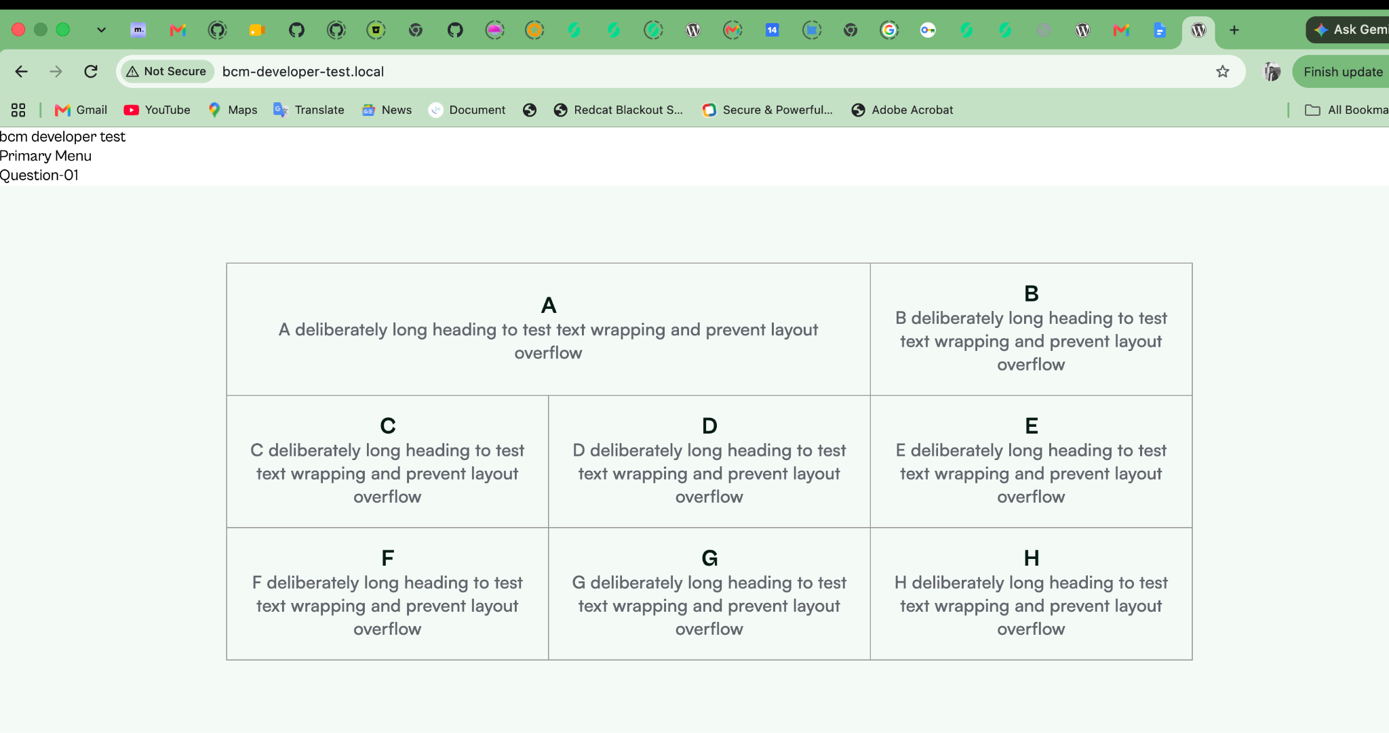
Mobile layout
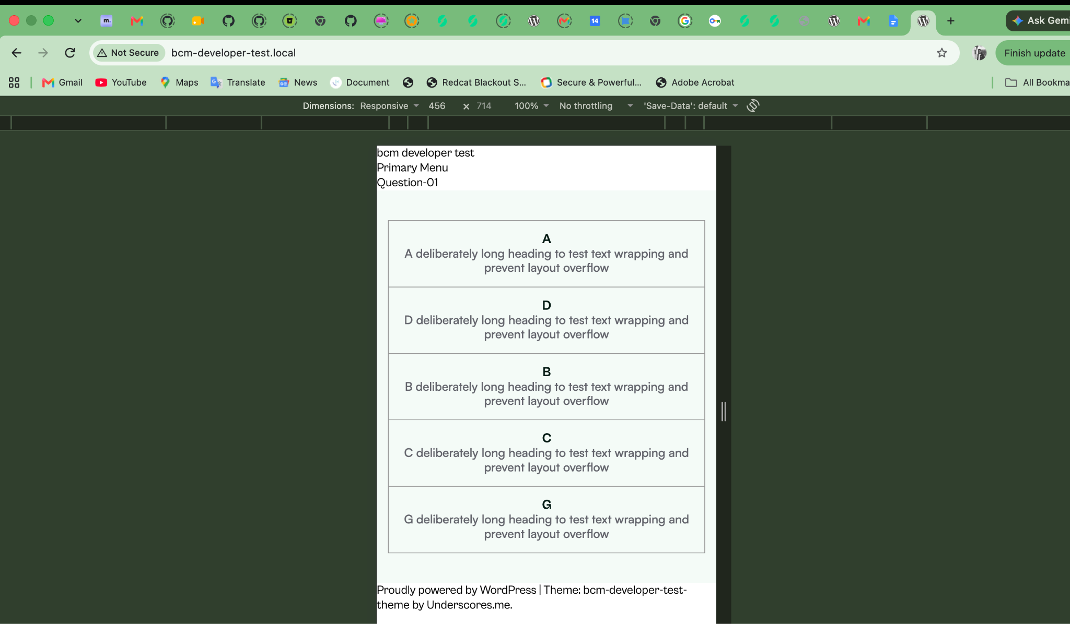
Explanation:
The HTML source order affects how screen readers read content and how keyboard users navigate interactive elements. CSS Grid can change the visual order without changing the source order, potentially causing the reading and navigation order to differ from the visual layout. Therefore, the HTML source order should follow the intended reading order as closely as possible to maintain accessibility.

Question 5
Full copy of the code is inside bcm-developer-test
Named: “question-5-&-6”
<!DOCTYPE html>
<html lang="en">

<head>
<meta charset="UTF-8">
<meta name="viewport" content="width=device-width, initial-scale=1.0">

<title>Hello, World | Example</title>

<meta name="description"
content="An example HTML page demonstrating paragraphs, links, abbreviations, images, and code formatting.">

<meta name="robots" content="index, follow">

<link rel="canonical" href="https://www.example.com/">

</head>

<body>
<main>
<section class="site_container">
<div class="auto_row">
<h1>Hello, world</h1>

<p>
Cras justo odio, dapibus ac facilisis in, egestas eget quam.
Aenean lacinia bibendum nulla sed consectetur. Aenean eu leo quam.
Pellentesque ornare sem lacinia quam venenatis vestibulum.
Vivamus sagittis lacus vel augue laoreet rutrum faucibus dolor auctor.
Vivamus sagittis lacus vel augue laoreet rutrum faucibus dolor auctor.
Cras mattis consectetur purus sit amet fermentum.
Morbi leo risus, porta ac consectetur ac, vestibulum at eros.
</p>

<p>
Integer posuere erat a ante venenatis dapibus posuere velit aliquet.
Etiam porta sem malesuada magna mollis euismod.
Nulla vitae elit libero, a pharetra augue.
Donec sed odio dui. Integer posuere erat a ante venenatis dapibus posuere velit aliquet.
</p>

<p>
Duis mollis, est non commodo luctus, nisi erat porttitor ligula,
eget lacinia
<a href="https://www.bigcabal.com">
odio sem nec elit. Sed posuere
</a>
consectetur est at
<abbr title="Lobortis">lbrt</abbr>.
Maecenas faucibus mollis interdum. Aenean lacinia
<img src="<?php echo esc_url(get_template_directory_uri() . '/images/container.png'); ?>" alt="">
bibendum nulla sed consectetur. Praesent
<code><b>commodo cursus magna, vel scelerisque nisl consectetur et.</b></code>
</p>

<button type="button">Hit me</button>

</div>
</section>
</main>
</body>

</html>

Question 6
Full copy of the code is inside bcm-developer-test
Named: “question-5-&-6”

document.addEventListener("DOMContentLoaded", function () {
// Get the paragraph container and add button.
const container = document.getElementById("paragraph-container");
const addButton = document.getElementById("add-paragraphs");

if (!container || !addButton) return;

// Save the original paragraphs as templates for new copies.
const originalParagraphs = [...container.querySelectorAll(":scope > p")];
let imagesHidden = false;

// Create a button to hide or show image paragraphs.
const toggleButton = document.createElement("button");
toggleButton.type = "button";
toggleButton.textContent = "Hide image paragraphs";
addButton.after(toggleButton);

function updateSeparators() {
// Remove existing separators to prevent duplicates.
container.querySelectorAll(":scope > hr").forEach((hr) => hr.remove());

const paragraphs = [...container.querySelectorAll(":scope > p")];

// Add a separator after every second paragraph, except the last.
paragraphs.forEach((p, index) => {
if ((index + 1) % 2 === 0 && index < paragraphs.length - 1) {
p.after(document.createElement("hr"));
}
});
}

function logTestResults(action) {
// Count paragraphs, separators, and hidden image paragraphs.
const paragraphs = [...container.querySelectorAll(":scope > p")];
const separators = container.querySelectorAll(":scope > hr").length;
const hiddenImages = paragraphs.filter(
(p) => p.querySelector("img") && p.hidden,
).length;

// Display the latest test results in the browser console.
console.clear();
console.log("Action:", action);
console.log("Total paragraphs:", paragraphs.length);
console.log("Total separators:", separators);
console.log("Hidden image paragraphs:", hiddenImages);
}

addButton.addEventListener("click", function () {
// Clone the original paragraphs for each click.
const copies = originalParagraphs.map((p) => p.cloneNode(true));

// Randomize the order of the copied paragraphs.
for (let i = copies.length - 1; i > 0; i--) {
const j = Math.floor(Math.random() * (i + 1));
[copies[i], copies[j]] = [copies[j], copies[i]];
}

// Preserve the current image visibility when adding copies.
copies.forEach((p) => {
if (p.querySelector("img")) {
p.hidden = imagesHidden;
}
container.appendChild(p);
});

// Rebuild separators and log the updated results.
updateSeparators();
logTestResults("Clicked Hit me");
});

toggleButton.addEventListener("click", function () {
// Toggle the visibility of all image paragraphs.
imagesHidden = !imagesHidden;

container.querySelectorAll(":scope > p").forEach((p) => {
if (p.querySelector("img")) {
p.hidden = imagesHidden;
}
});

// Update the button label to match the current state.
toggleButton.textContent = imagesHidden
? "Show image paragraphs"
: "Hide image paragraphs";

// Refresh separators and log the updated results.
updateSeparators();
logTestResults(
imagesHidden ? "Hid image paragraphs" : "Showed image paragraphs",
);
});

// Set up separators and log the initial page state.
updateSeparators();
logTestResults("Initial page load");
});

Explanation:

Testing and Verification
- Initial load: Confirmed that 3 paragraphs and 1 separator appeared. (Screenshot 1)
- Repeated clicks: Clicked “Hit me” multiple times and verified that each click added 3 paragraphs in random order. (Screenshot 2)
- Toggle functionality: Hid and showed image paragraphs, confirming that the total paragraph count remained unchanged. (Screenshot 3)
- Adding while hidden: Hid image paragraphs, added more paragraphs, and confirmed that new image paragraphs stayed hidden until shown again. (Screenshot 4)
- Separators: Checked that separators remained correctly positioned after every pair of paragraphs, including hidden paragraphs.

(Screenshot 1)
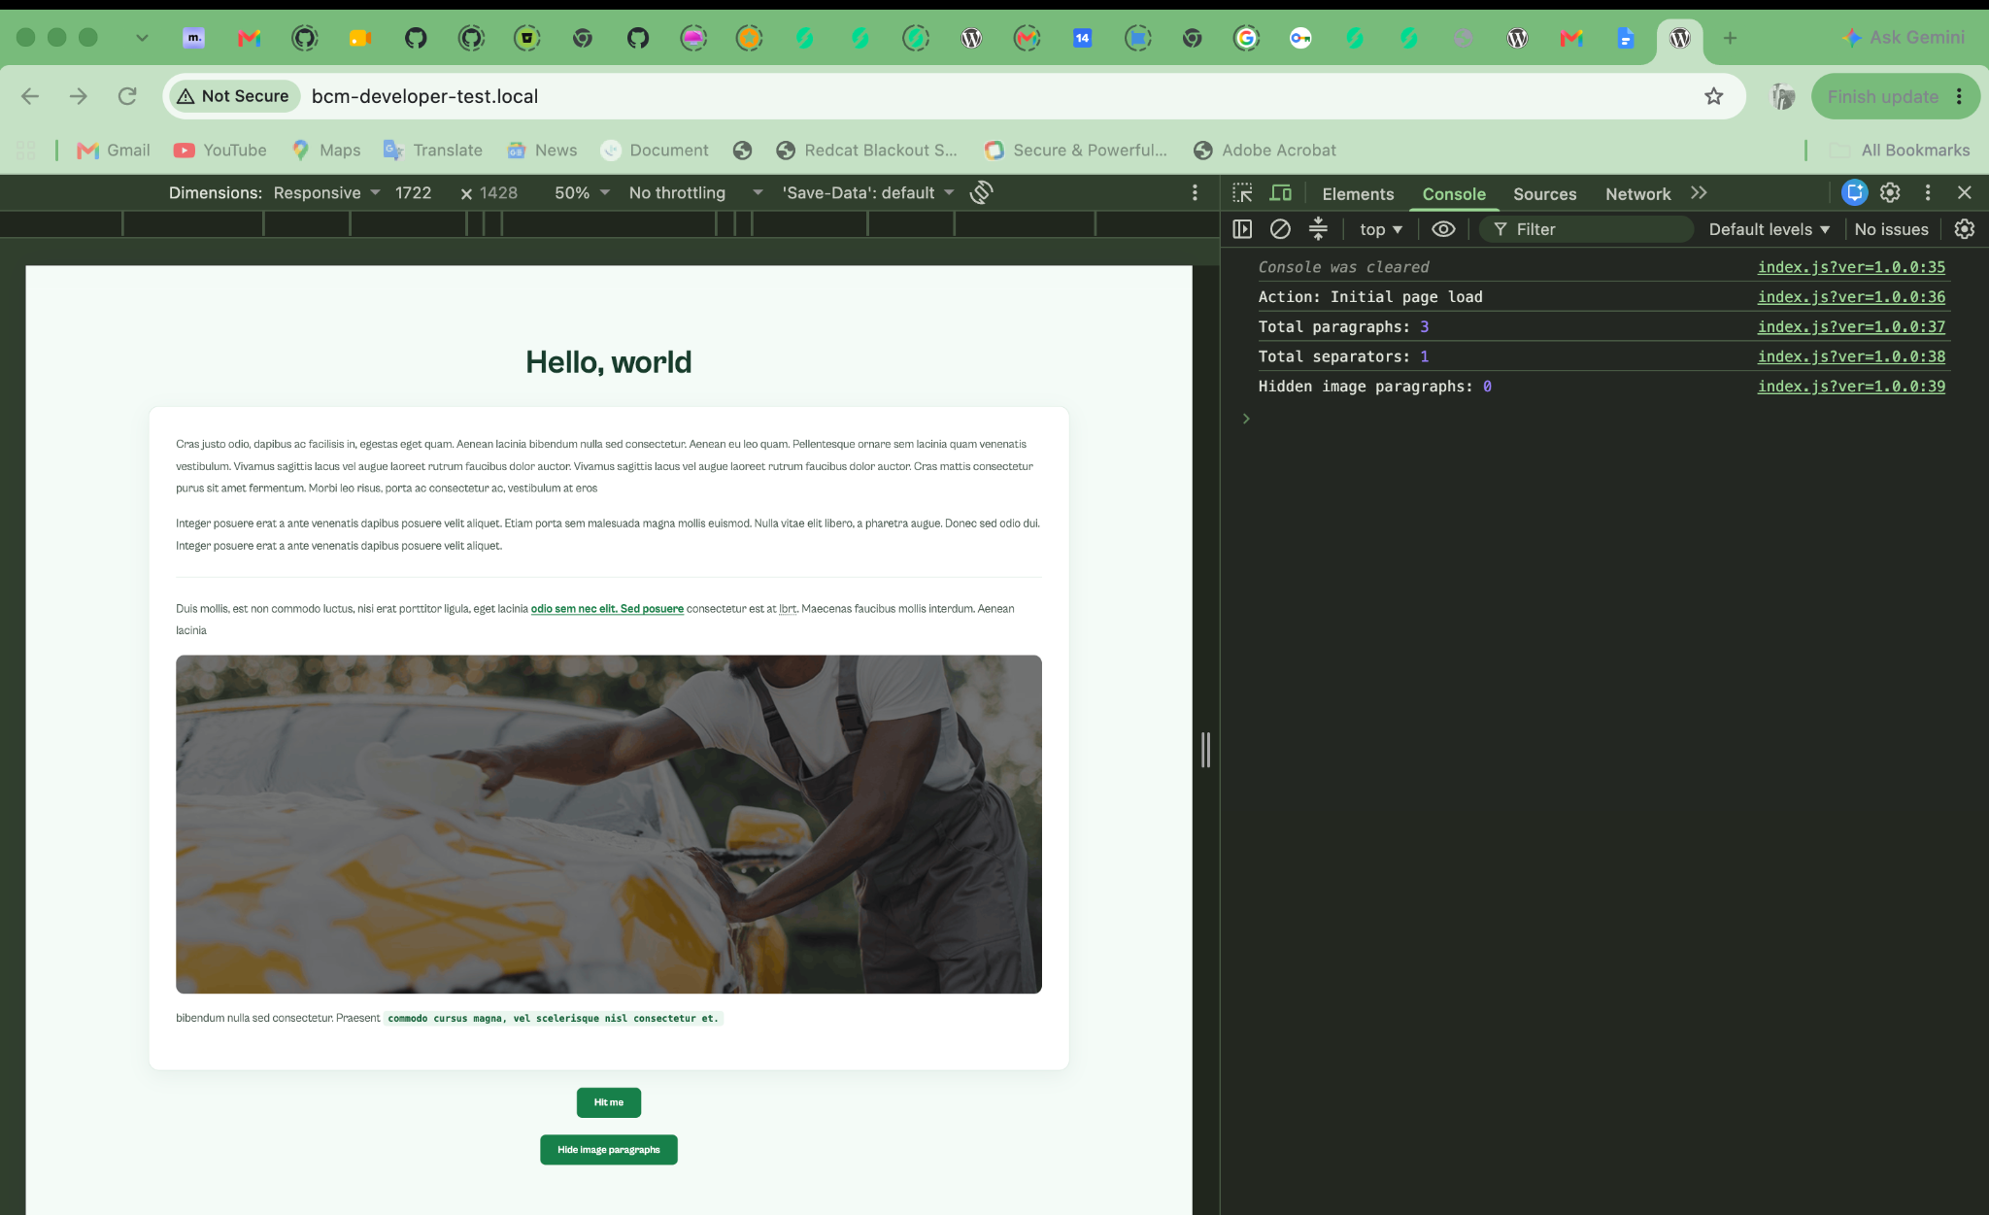
(Screenshot 2)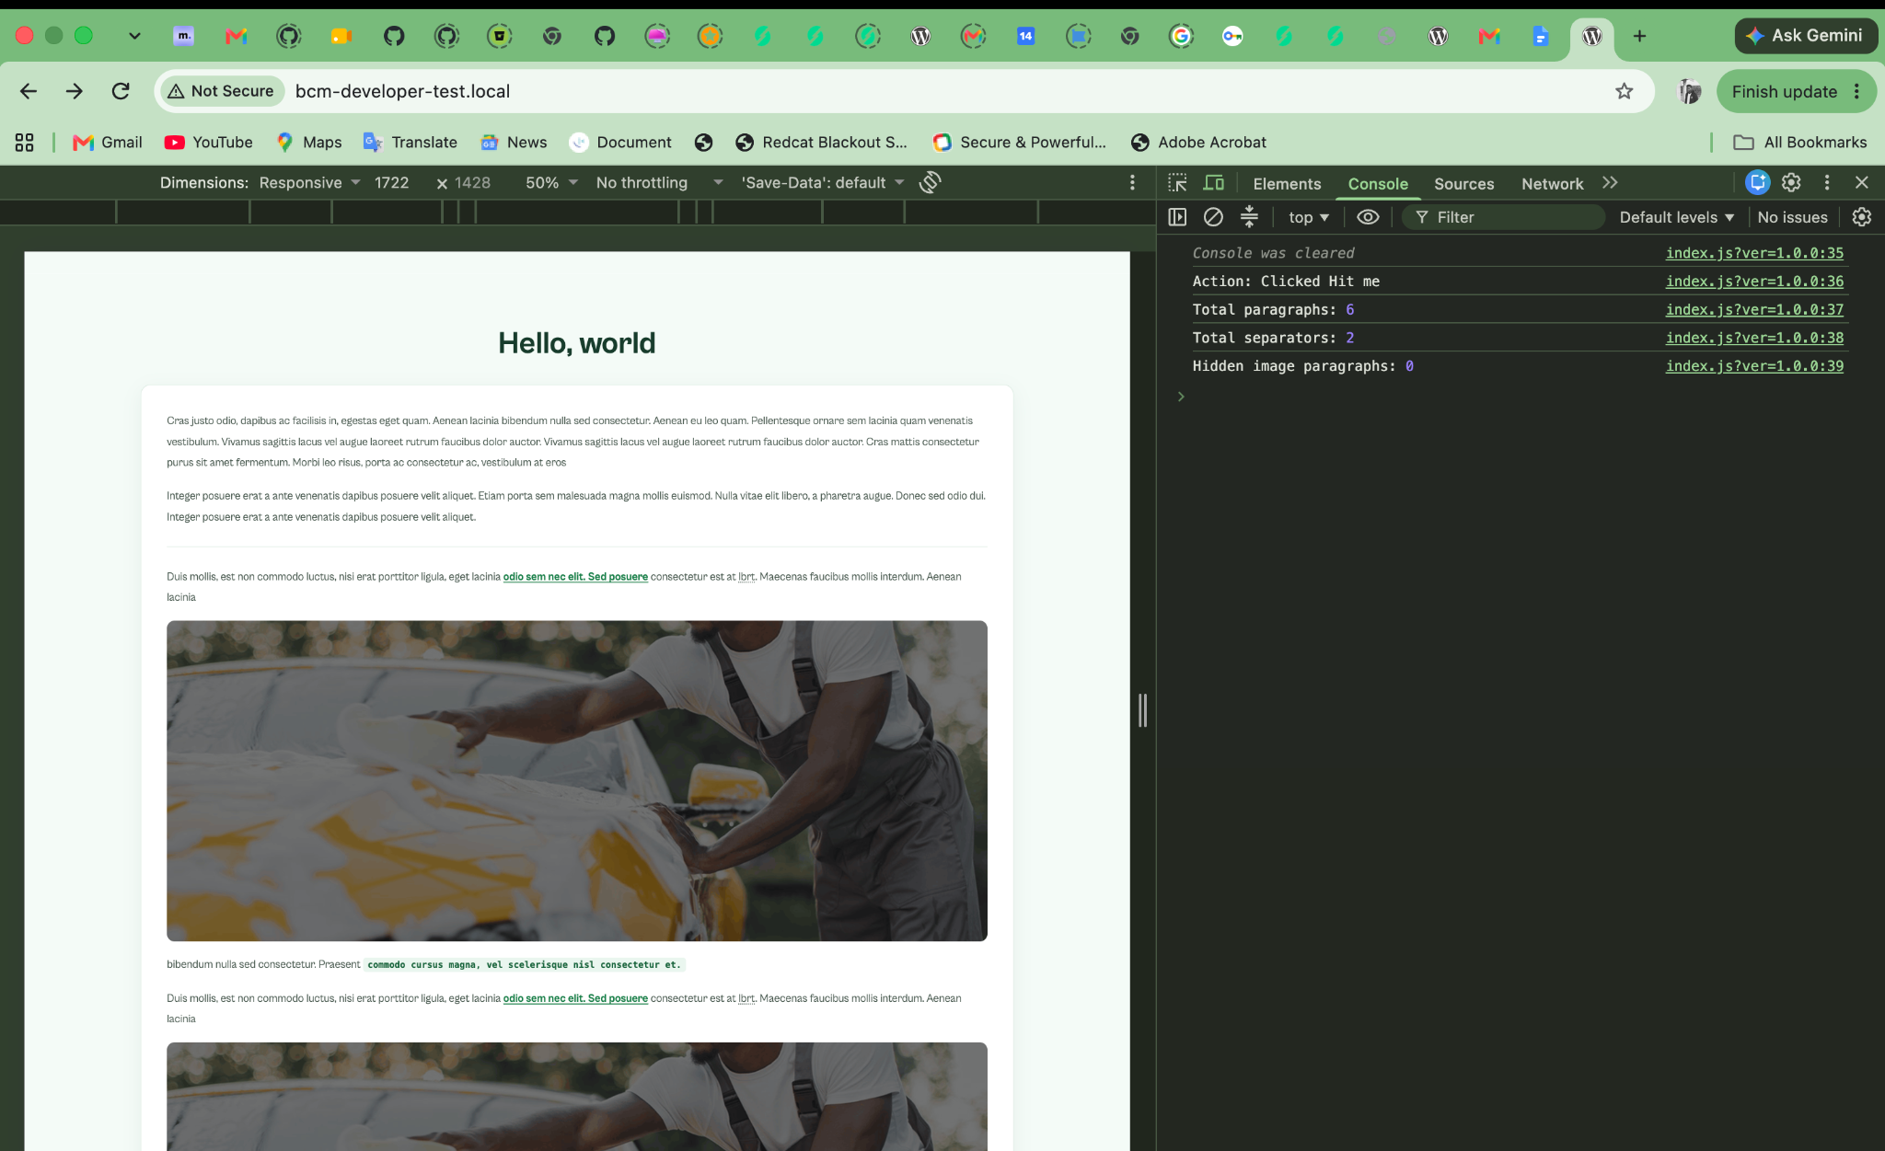
(Screenshot 3)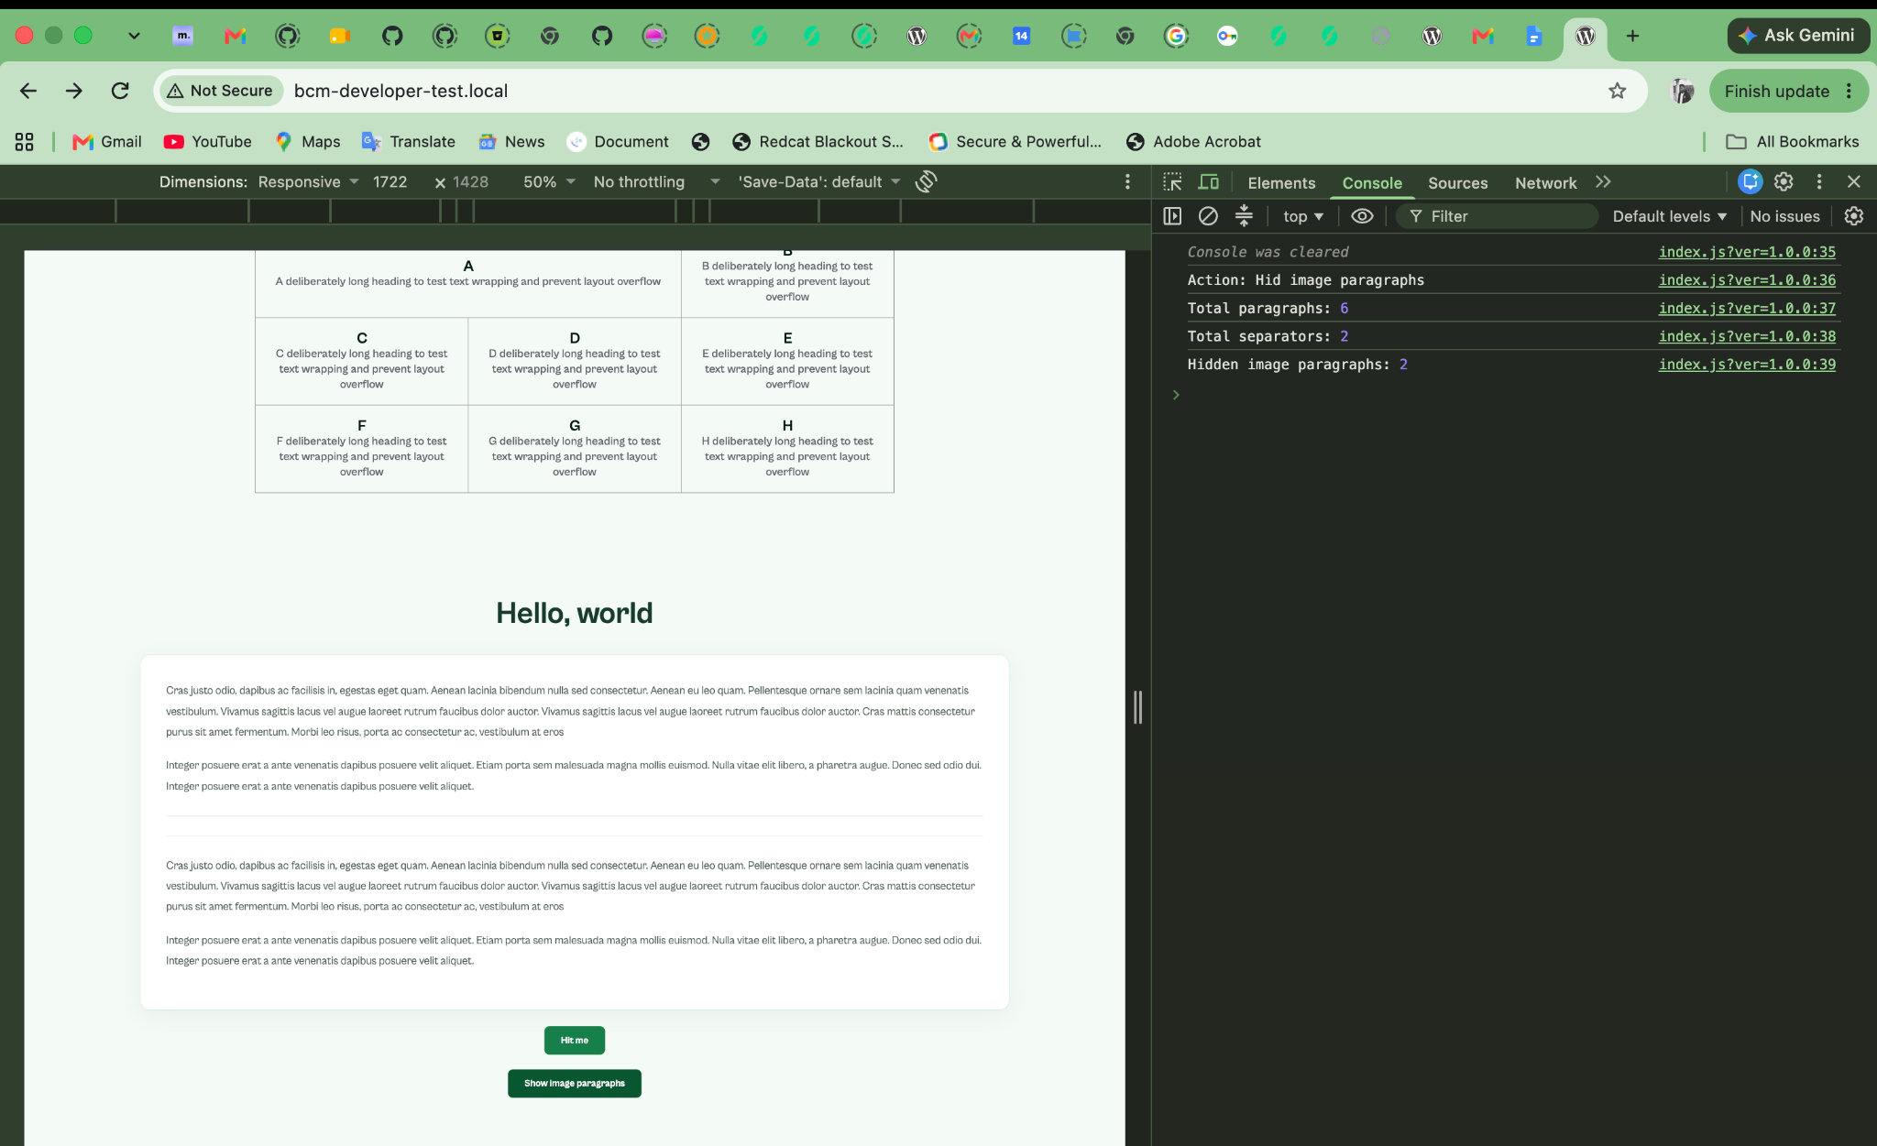
(Screenshot 4)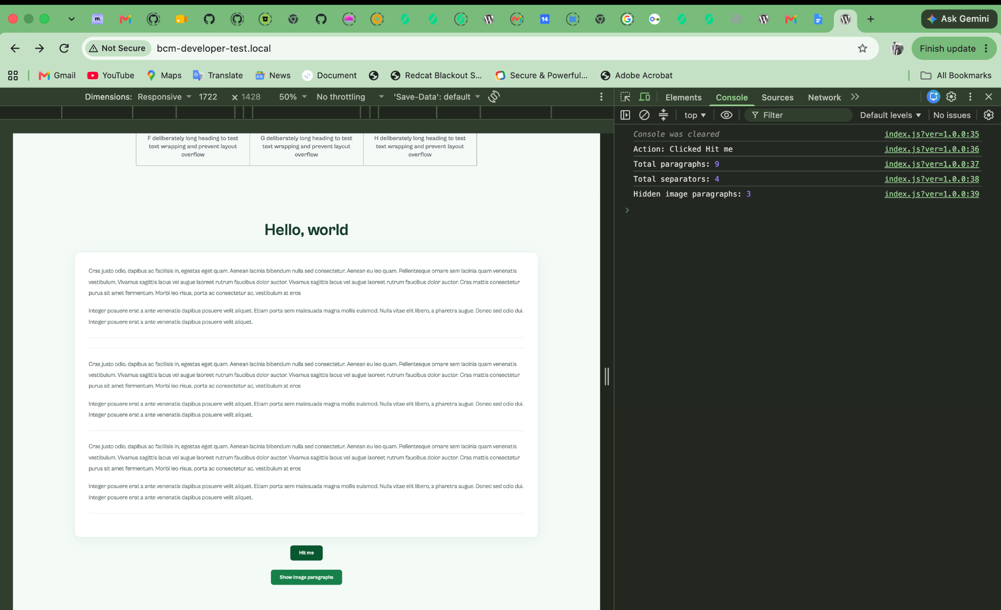

Question 7

First Three Checks
1. Check caching: I would open the article in a private browser window and check whether the issue persists. I would then clear or bypass the browser, CDN, and WordPress page caches to see whether readers receive the updated version consistently.
2. Check the content: I would confirm that the corrected article was saved and published in WordPress. I would also check its content and last-modified time.
3. Check the release: I would review deployment logs, theme versions, PHP errors, and recent code changes to identify any failed deployment or issue causing outdated content to appear.

How I Would Identify the Cause
If WordPress contains the correct content but some readers still see an older version, caching is a likely cause. If the content in WordPress is outdated or the current theme fails to display the saved changes, I would investigate publishing or code issues. These findings would guide my investigation but would not confirm the cause on their own.

Rollback and Recovery
I would roll back if a recent release caused a confirmed or strongly suspected regression affecting readers and could not be fixed safely straight away. After the rollback, I would verify the deployed version, check the article across browsers, review the logs, and confirm that the correct content appears consistently.

Update to the Editor
<text color="secondary" size="sm">Suggested message</text>
I’m checking the cache, published article, and deployment logs to find out why readers are seeing different versions. I’ll confirm the likely cause before making further changes or rolling back, and I’ll update you once I’ve verified the fix.

Question 8

Understanding the Problem
What I would check first: I would ask the editor to walk me through their publishing process so I could understand which tools they use, what information they repeatedly copy, and where mistakes usually happen.
Smallest useful improvement: I would start with a simple WordPress admin feature that displays the article title, public URL, and featured image together, with buttons to copy the relevant information. If that is more than they need, I would start with a shared publishing checklist or document.
Why I would choose this approach: I would first consider the simplest solution that addresses the problem. If a checklist solves it, there would be no need to build a new feature. If copying information remains time-consuming, I would develop the small admin feature within the one-day limit.
Editorial control: Editors would still review and approve the title, URL, and featured image before publishing. My improvement would simply make these details easier to access and copy.
Testing and success: I would test the solution with one editor using a real draft, verify that all three fields are correct, and ask for feedback. I would consider it successful if it reduced the time spent copying information and helped prevent mistakes.

Similar Improvement I Have Made
In a previous project, I noticed that editors repeatedly recreated similar content and features. I implemented a duplication function that allowed them to copy existing work and reuse it instead of starting from scratch. This made the workflow faster and easier.
That experience showed me that small, practical improvements can reduce repetitive work, save time, and improve productivity.

Question 9

Approach: I would save each signup locally and use a unique idempotency key to prevent duplicate subscribers when retrying requests. The newsletter API must support idempotency keys or provide a way to check existing subscribers.
Pseudocode (PHP):
function signup($email, $signup_id, $api) {
if (!is_email($email)) {
return 'invalid_email';
}

save_signup($email, $signup_id, 'pending');

try {
// Reuse the same key for every retry.
$response = $api->create_subscriber(
$email,
$signup_{i}d);if($response->status === 429) {
// Keep pending and retry after Retry-After.
return 'retry_later';
}

if (in_array($response->status, [200, 201], true)) {
save_signup($email, $signup_id, 'confirmed');
return 'confirmed';
}

if ($response->status === 409) {
// Confirm only if the API verifies it exists.
if ($api->subscriber_{e}xists($email)) {
save_signup($email, $signup_id, 'confirmed');
return 'confirmed';
}
}

save_signup($email, $signup_id, 'failed');
return 'failed';

} catch (TimeoutException $e) {
// The service may already have accepted the signup.
save_signup($email, $signup_id, 'unknown');
return 'retry_same_key';
}
}
Notes:
- Store: Signup ID, email, idempotency key, status, and retry count.
- Log: Request ID, response status, and retry count. Avoid logging authentication tokens or unnecessary personal information.
- Timeout test: Simulate the service accepting the signup before timing out. Retry with the same key and verify that only one subscriber exists.
- Rate-limit test: Simulate HTTP 429 and retry after the Retry-After period.
- Invalid email test: Confirm that invalid emails are rejected before an API request is made.

Question 10
Review: Hiding the button is not enough because users can send requests directly to the endpoint. The server must verify every request before allowing an article's status to change.
Required server-side checks:
- Confirm the user is authenticated.
- Verify the nonce to protect against CSRF.
- Validate the article ID and requested status.
- Confirm the article exists and is the expected post type.
- Check whether the user has permission to edit that specific article.
- Allow only approved status values before updating the article.
Pseudocode (PHP):

function update_article_status() {
if (!is_user_logged_in()) {
return new WP_Error('unauthorized');
}

if (!check_ajax_referer(
'update_article_status',
'nonce',
false
)) {
return new WP_Error('invalid_nonce');
}

$id = absint(
$_POST['article_id'] ?? 0
);

$status = sanitize_key(
$_POST['status'] ?? ''
);

$post=get post($id);

if (
!$post ||
$post->post_type !== 'post'
) {
return new WP_Error(
'invalid_article'
);
}

if (!current_user_can('edit_post', $id)) {
return new WP_Error('forbidden');
}

$allowed = [
'draft',
'pending',
'publish',
];

if (!in_array($status, $allowed, true)) {
return new WP_Error('invalid_status');
}

return wp_update_post([
'ID' => $id,
'post_status' => $status,
], true);
}

Two tests that should be rejected:
- An unauthenticated user sends a direct request to publish an article.
- An authenticated user without permission to edit a particular article attempts to change its status.
Raising the issue: I would explain during code review that hiding the button only affects the interface and does not secure the endpoint. I would demonstrate how a direct request could bypass the interface and allow unauthorized changes.
Before release: I would require server-side authentication, nonce verification, permission checks, and status validation, followed by security tests confirming that unauthorized requests are rejected.

