Quantitative Analysis of Lifestyle Impacts on Climate Change in US Aanchal Adhikari, Mauricio Camacho, Aaron Kang, Dushica Milosavljevikj, James Sinclair, Shi Wang

How sustainable living can help 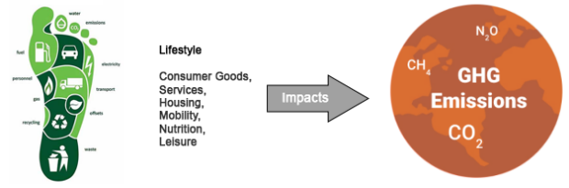

counter the climate crisis?

The world is now warming faster than at

any point in recorded history that threaten

our survival, so our impact on the natural

world is an obvious concern.

Research shows that lifestyle changes

could help the planet slash emissions by up

to 70 per cent by 2050.

Approaches'

Ù Data: Collecting national data (statistics) for each state in U.S to define the average consumption for the six consumption domains in addition to carbon dioxide (CO₂) emissionH

Ù Model: This historical data is put into a multi-variate time series analysis model (Erophet), which then predicts future CO₂ emissionH Ù Interactive visulization product: Users can test different lifestyle change scenarios to visualize how their potential actions would affect the

Data Characterization:

Temporal Variable

'H The proxy for climate change is carbon dioxide emission (metric tons), which is the majority greenhouse gas emission of the USH

)H This study classifies household resource consumption into six domains in unites of current Dollars:

output if everyone did the same thingH

Ù Innovation: Erovide INTERACTIVE product to track climate change due to change in consumptionH

Ù How it helps? Active user engagement increases eco-accountability and

Ù NutritioÌ

Ù Consumer goodÍ Ù Housing

Ù Leisurç Ù Servicç Ù Mobility

encourages environmentally responsible lifestyles. 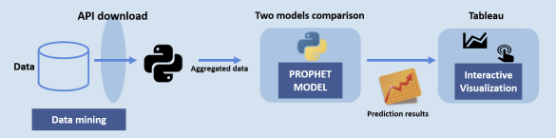

Data Size: Raw datasets are greater than 800K rows, after cleaning, reformatting, the aggregated datasets are around 220K rows

Data Resources '

Ù U.S Bureau of Economic AnalysiÍ

Ù U.S Environmental Erotection Agenc

Ù U.S. Energy Information Administration

Experiments and results:

We used two multivariate time series models to estimate the impacts of comsumptions on CO2 emission. Vector Auto Regression (VAR) VS. Facebook Prophet

Interactive Visulization Product:

We used three different visualizations to illustrate the impact of a user’s lifestyle on CO₂ emissionsH

'H US CO₂ emission heatma

)H CO₂ emissions prediction by user’s lifestyle choicç

Scan Me

See Your Impact

H Linechart for consumption expenditures per year Viz Link

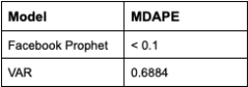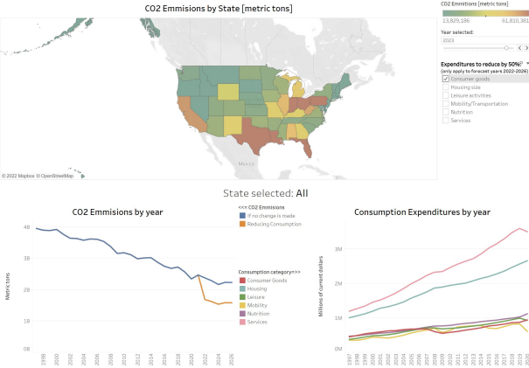

How does it compare with each others?

Cross Validation

5 years of historical data (2017-2021) were

taken out of the fitting data set, and used for

predictions. Using the predictive models, we got

‘predicted’ values for 2017-2021, which were

compared to the actual, historical data.

Error Matrix

Metric median absolute percentage error

(MDAEE) to compare the performance of the

two models

Table 1. MDAEE between the CO₂ emission predictions and

their corresponding actual values across all states.